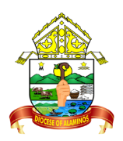
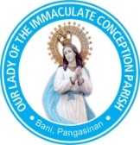
The Roman Catholic Diocese Of Alaminos
OUR LADY OF THE IMMACULATE CONCEPTION PARISH
2407 Bani, Pangasinan

Certificate of Death
This is to certify that
_________________________________________________
A resident of barangay ______________________________________ municipality of _____________________________________ Province/City of _______________________________
Single, son/daughter of _______________________________ and ____________________________
Husband or wife (widowed) of ____________________________________ died on the __________
Day of ___________, _____________ at the age of ________ years and was buried in the Roman Catholic Cemetery of this, Parish Municipality of ____________________________________________
On the ___________ day of ______________, _______________. The cause of death was ______________________________________. He /She received the last sacraments of Confession, Anointing of the Sick and Holy Viaticum before death (or) He/ She was not able to receive any Sacrament before death.
This certificate is issued based on the official Confirmation Record maintained by Our Lady of the Immaculate Conception Parish.
Record No. ____________ Date Issued: __________________
In witness thereof I affix my signature and place the seal of this Parish of Immaculate Conception on the _____________ day of ________________, ________________________.
______________________________________
Parish Priest

