Requirement Specification (PUZ-BUG)
1. Introduction
1.1 Purpose of Project
Debugging is an essential part of software testing. It refers to finding the errors in the code and fixing them. As a software developer, this is an important skill that one must possess. The purpose of this project is to develop a puzzle debugging game called ‘Puz-Bug’ which will enable the students to learn the skill of debugging.
1.2 Acronyms, Abbreviations, Definitions
1. Puzzle Pieces - Pieces of picture that need to be properly positioned upon solving the code snippet.
2. Bugs – Errors in the code snippets that need to be found and debugged.
3. Hints – Help provided to the gamer for debugging the code.
2. General Description of Project
2.1 Context of Product
This project will be in the personal computer environment. The goal is that younger people who are just starting to learn to manage their cash could use this program to learn budgeting basics, then continue using it as a basic budgeting aid later. It will, therefore, be on low to mid-range computers.
2.2 Domain Model with Description
In our domain model, we have the following objects:
- User
- Puzzle
- Piece
- Code Snippet
- Hint
- Bug
- Solution
- Quit
The User object has an attribute called ‘name’ and the User can solve 0 or more puzzles which is split into 1 or more number of pieces. Each of the pieces have an Id linked to it. Also, each of the pieces has a code snippet linked to it. The code snippets have an Id, number of hints and the level of difficulty as its attributes.
The code snippets have 1 to 2 hints linked to each one of them and each snippet has 1 or more bugs in it. The User will find 0 or more bugs in the snippet and will debug 0 or more of them.
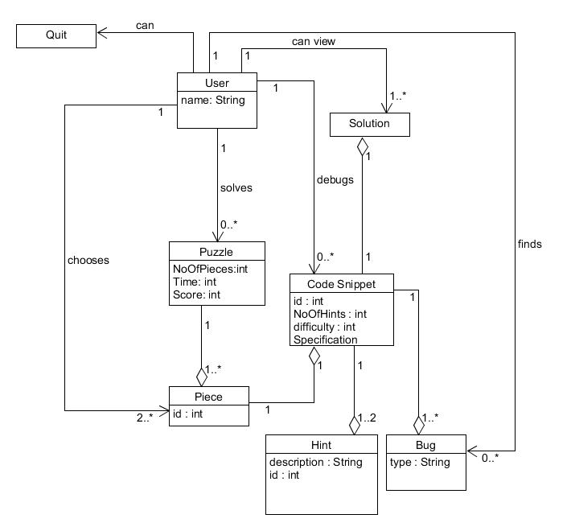
2.3 Product Functions
The product will be able to keep track of a person's expenses by letting them make budgets. It allows the user to create different categories for which the budget needs to be allotted and provides predefined categories. The user can add expenses under each category and the application will display the remaining amount for each category and the total remaining budget as well based on the different expenses the user enters.
The application also has the functionality of providing warnings if the user if the user reaches a certain amount.

2.4 Constraints
This system cannot be run on mobile.
2.5 Assumptions and Dependencies
The only external requirement is that our application is written in Java and hence can only run in Java environment.
3. User Stories
1. As a student I want to learn the types of bugs that might exist in a code so that I can identify them.
Elaboration: There are various types of bugs in a code - Arithmetic, Logic, Syntax etc. The user will be given the code snippets that will have different types of bugs embedded in it, thereby helping the user in gaining a knowledge of the same.
Constraints: Only some types of bugs will be included in the code snippets.
Effort estimation: 5
Acceptance Testing: Once the user identifies a bug and runs the code snippet successfully, he/she will be shown a prompt that will explain the type of bug the lines of code had.
2. As a user, I want to be given some hints when I'm stuck with a particular code so that it helps me in debugging the code.
Elaboration: Each code snippet will be associated with two hints that the user can make use of whenever he/she is stuck with a particular code. The user will have access to them through a hints button
Constraints: Only two hints per code snippet.
Effort estimation: 5
Acceptance Testing: Whenever the user clicks on ‘Show Hint’ button, the hint should be displayed.
3. As a gamer, I want the game to be interesting and hence, I would like to have the puzzle divided into different number of pieces based upon my choice, so that there is some level of difficulty in the game
Elaboration: User will be given the ability to select the difficulty level which will determine the number of pieces the puzzle is broken into.
Constraints: Limited to a maximum of 6 puzzle pieces.
Effort estimation: 8
Acceptance Testing: When the user begins to play, he is asked to select a level which will determine the number of pieces the puzzle will be divided into.
4. As a student, I want to view the correct code so that if I am not able to debug, I am aware of my mistakes and learn something from those.
Elaboration: Upon clicking ‘I Give Up’ button for a particular code snippet, the user will be allowed to view the debugged code. This will not only help them learn their mistakes but also engage them in the game by letting them solve the next snippet, in case they were not able to debug the current one.
Constraints: Only one correct solution will be shown.
Effort estimation: 5
Acceptance Testing: When the user clicks ‘I Give Up’ button, he should be shown the debugged code.
5. As a gamer, I want to be able to select the difficulty level so that my interest in the game is retained.
Elaboration: User will be given the ability to select a level of his/ her own choice from the three levels of difficulty - Easy, Medium and Hard. Based upon the level selected the puzzle will be divided into 2, 4 and 6 pieces respectively. Each piece will have a code snippet linked for the user to debug. The number of code snippets to be debugged will introduce a level of difficulty in the game and keep the gamer engrossed.
Constraints: It is a 3-level game.
Effort estimation: 2
Acceptance Testing: When the user begins to play, he should be asked to select a level to begin with.
6. As a student, I want to get the ability to run my code so that I can figure out errors in it.
Elaboration: Since the game involves debugging a code, a runtime debugging environment will be provided to the user. This will enable the user to edit and run the code to check if they fixed any error or not.
Constraints: If the code has errors, only the number of errors and not the description will be shown.
Effort estimation: 13
Acceptance Testing: The user should be able to edit and run the code snippet.
7. As a user, I want to know the time taken by me to debug the code so that I can be competitive.
Elaboration: For each code snippet, a timer will keep track of the time taken by the user to debug the code. This will help the user beat their own time record.
Constraints: None
Effort estimation: 3
Acceptance Testing: When the user clicks on the puzzle piece, a code snippet should be shown and the timer must begin.
8. As a user, I want to be have the ability to switch to a different puzzle piece so that if I am stuck at fixing a particular error, I can solve the other puzzle and return to the unfixed one later on.
Elaboration: The user will be able to click on a puzzle piece other than the current puzzle piece and start debugging the code snippet attached to it. This will save the user’s time and effort. Once they have debugged the code, they can click on the previous puzzle piece to continue debugging it.
Constraints: None
Effort estimation: 3
Acceptance Testing: On clicking a puzzle piece, the user will be shown the code to debug and the user must be able to switch to a previous puzzle piece.
9. As a user, I want to be provided with option of selecting different pictures for the puzzle so that I don't lose interest in the game.
Elaboration: The user will have the option to select a picture from a pre-defined pool of pictures.
Constraints: The choices will be limited
Effort estimation: 5
Acceptance Testing: When the user clicks on 'browse', he should be able to view a pool of pictures, one of which he can select for his puzzle.
10. As a user, I want to be able to have control over the puzzle pieces in the main puzzle frame so that I can set the positioning of the piece in the puzzle.
Elaboration: This will bring in a proper game element into the system. The user will be able to drag and position the puzzle pieces into the main puzzle frame.
Constraints: The puzzle piece can only be dragged if it has been successfully debugged.
Effort estimation: 8
Acceptance Testing: The puzzle pieces should be movable and the user should be able to drag and place them in the correct position.
11. As a user, I would like to know about the specifications of the code snippet so that I can understand what I need to do.
Elaboration: This will provide the description of the code snippet and from that, the user will be able to know about what changes need to be done in-order to fix the bug.
Constraints: None
Effort estimation: 3
Acceptance Testing: The specifications will appear along with the code once the user selects a specific set of puzzle.
12. As a student, I need to have an option to debug any errors irrespective of the order.
Elaboration: This will help the user to work on whatever bug he/she found easier to fix first, without spending too much time on difficult bug fixing.
Constraints: None
Effort estimation: 5
Acceptance Testing: The bugs will be available to the user so that he/she can select the particular bug that they want to fix.

