Abstract

With the continuous development of society and economy, data and information have also grown rapidly. For effectively organizing and managing huge data and information, strict and reasonable data management technology has become one of the urgent technical issues. Database technology is a new data management technology developed based on file systems in the late 1960s. It solved the problems of data duplication and independence in data management and organization in the past, and implementing data sharing, completeness, and security, effective goals. The development and widespread use of database technology have provided an alternative basis for the contradiction between human society and the information society.

The rapid popularity of the internet has brought an explosive growth of information. Following this trend, information platforms belonging to students have been created on campus. The B / S architecture-based campus second-hand goods trading website combines the various characteristics of students, and combines database management technology, so that students can find the information they are interested in on this platform, and publish their own second-hand goods information. The development of database technology makes it possible to manage and classify even more information.

**Describe the problem or task your database was designed to address.**

This system implements the construction of a second-hand commodity trading platform in a smaller range, and provides a trading platform for people's idle second-hand commodities.

A second-hand transaction system based on B / S structure with JSP as the development platform and SQLSERVER as the database was constructed. The campus second-hand transaction website revolves around the center of information releasing, searching, classification, and processing. It is based on users and organizes business processes for facilitating users to obtain information and transactions.

**Describe (briefly) the system you have created to address the problem or task**

We solved how to manage a second-hand book website through the design of the database. We created an administrator system to store buyer and seller data. Sellers can sell their used books on the website, and buyers can buy books and reviews on it. .We have also created a transaction system to solve the problem of online payment, so both sellers and buyers can manage their orders and wish lists in their own portals.

**A project design section where you discuss the different users of your system**

**The picture of the functionality:**

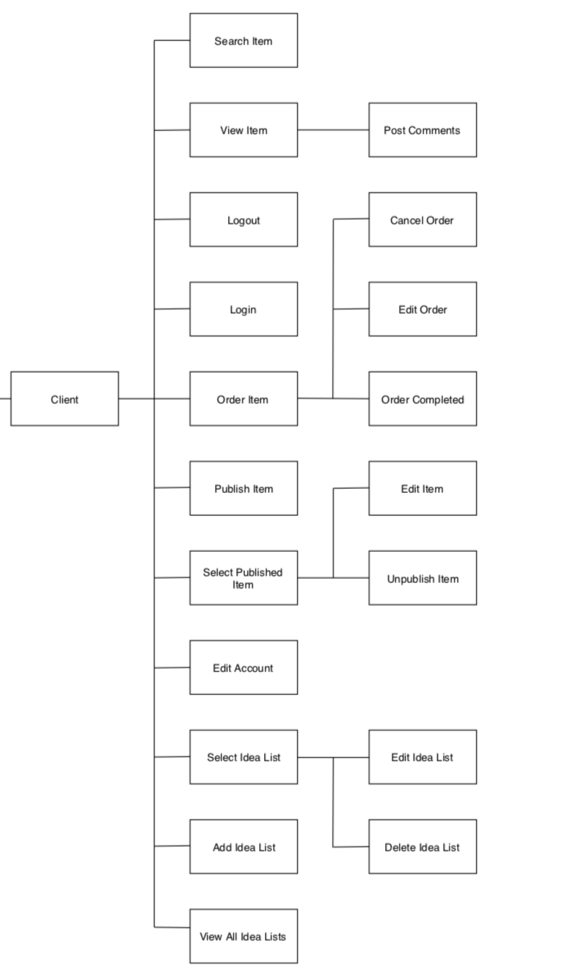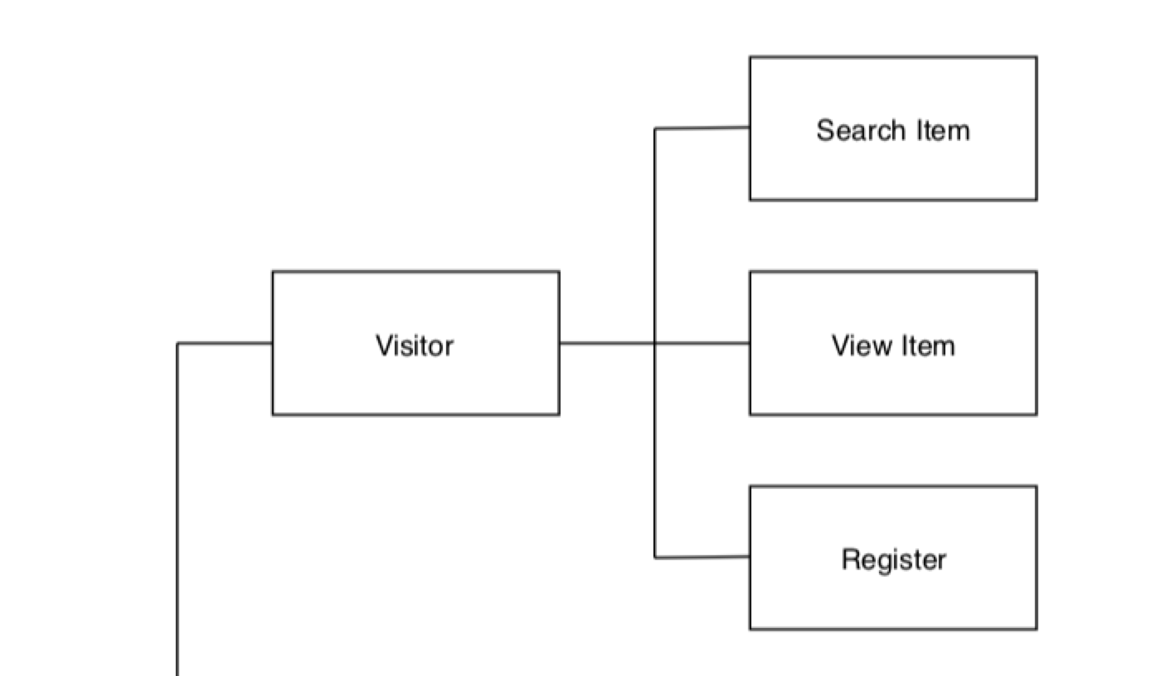

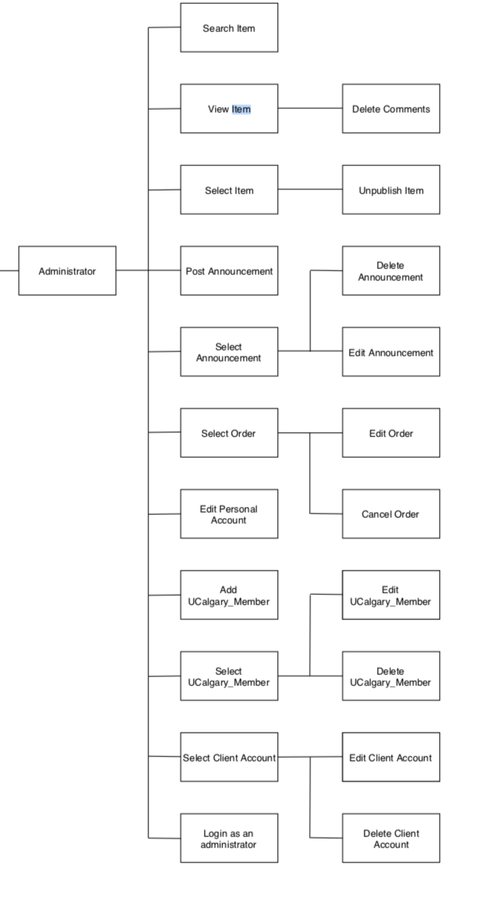

ER diagram:

The complete transaction collections are described below:

The visitors are allowed to view the websist