WADS Quiz — Answer Key
(Instructor Only)

Course : Web Application Development and Security (WADS)
Program : Computer Science — BINUS University International
Semester : Even Semester 2025/2026
Exam Type : Quiz Exam (A)
Project : Simple Blog Web Application (Lab)
Duration : 100 minutes
Total Questions : 20
Total Points : 100

Note:
Do not distribute to students before the exam.

Section 01
SECTION A — API Testing & DB Schema / ORM
Q1 Solution
Postman test script:
pm.test("Status code is 401", function () {
pm.response.to.have.status(401);
});
HTTP 401 Unauthorized means the client has not provided valid authentication credentials, or the credentials supplied are incorrect.

Q2 Solution
Equivalent raw SQL:
SELECT *
FROM users
WHERE email = 'test@mail.com'
LIMIT 1;
One advantage of using an ORM:
An ORM improves developer productivity by allowing database operations to be written in JavaScript/TypeScript objects and methods instead of raw SQL. It also helps reduce SQL injection risks through parameterized queries and works across different database systems.

Q3 Solution
Problem 1: total TEXT
- Monetary values should not be stored as text.
- Fix:
total DECIMAL(10,2)

Problem 2: date VARCHAR(50)
- Dates should use a date/time datatype, not a string.
- Fix:
date TIMESTAMP
Corrected example:
CREATE TABLE orders (
id INT PRIMARY KEY,
user_id INT,
items TEXT,
total DECIMAL(10,2),
date TIMESTAMP
);

Q4 Solution
Steps to test a REST API endpoint using Postman:
- Open Postman and create a new request.
- Select the HTTP method (e.g., POST) from the dropdown.
- Enter the endpoint URL (e.g., http://localhost:3000/api/login).
- To add a JSON body:
- Select Body → raw → JSON.
- Enter JSON data:
- Click Send.
- Check the response:
- Status code (e.g., 200, 401, 404)
- Response headers
- Response body
- Add an automated assertion in the Tests tab:
pm.test("Status code is 200", function () {
pm.response.to.have.status(200);
});

SECTION B — Authentication, Authorization & JWT
Q5 Solution
Concept | Meaning | Example
Authentication | Verifies who the user is. | A user logs in with email and password.
Authorization | Determines what the authenticated user is allowed to access. | An admin can access /admin, while a normal user cannot.

Q6 Solution
(a) Three parts of a JWT
- Header
- Payload
- Signature
(b) Meaning of the sub claim: sub stands for Subject and usually contains the unique identifier of the user (e.g., user ID 99).
(c) Importance of the signature
The signature verifies that the JWT has not been altered. If someone modifies the payload, the signature validation fails and the token is rejected.

Q7 Solution
CORS (Cross-Origin Resource Sharing) is a browser security mechanism that controls whether a web page can make requests to a different origin (domain, protocol, or port).
Browsers enforce CORS to prevent unauthorized websites from accessing resources on another site on behalf of a user.
Example:

- React frontend: http://localhost:5173
- Express API: http://localhost:3000
If the Express server does not send the appropriate Access-Control-Allow-Origin header, the browser blocks the request and a CORS error occurs.

Q8 Solution
Aspect | Session | Cookie
Where data is stored | On the server | In the user's browser
Security level | More secure because sensitive data stays on the server | Less secure because data is stored client-side and can be modified/read if not protected
Max data size | Limited mainly by server storage | Typically about 4 KB per cookie

SECTION C — Web Security, Validation & Middleware
Q9 Solution
(a) What type of attack is this?
SQL Injection
(b) Why is it dangerous?
If raw SQL is used, the attacker may bypass authentication, read sensitive data, modify records, or delete database contents.
(c) Safe parameterized query
Using Node.js with MySQL:
const sql = "SELECT * FROM users WHERE username = ? AND password = ?";
db.query(sql, [username, password], (err, results) => {
// handle result
});

Q10 Solution
Security problems:
- Exposes internal stack traces to users.
- Always returns HTTP 200 instead of an appropriate error status code.
Corrected version:
app.use((err, req, res, next) => {
console.error(err);

res.status(500).json({
error: "Internal Server Error"
});
});

Q11 Solution
Concept | Meaning | Example
Input Validation | Checks whether input meets required rules. | Verify email format and password length ≥ 8 characters.
Input Sanitisation | Cleans or modifies input to remove unsafe content. | Escape HTML tags from a username field to prevent XSS.

Q12 Solution
# | Middleware Name | Responsibility
1 | Authentication Middleware | Verify JWT/session and identify the user
2 | Authorization Middleware | Check whether the user is allowed to make transfers
3 | Validation Middleware | Validate transfer amount, account numbers, and required fields
4 | Error Handling/Transfer Controller | Execute the transfer and return success/error response

SECTION D — Docker, CI/CD & Deployment
Q13 Solution
Difference between Image and Container
- Docker Image: A read-only template containing application code, dependencies, and configuration.
- Docker Container: A running instance of a Docker image.
Dockerfile instructions
FROM node:22-alpine
Uses the lightweight Node.js 22 Alpine Linux base image.
WORKDIR /app
Sets /app as the working directory.
COPY package*.json ./
Copies package.json and package-lock.json into the container.
RUN npm ci --omit=dev
Installs production dependencies only.
CMD ["node", "server.js"]
Defines the command executed when the container starts.

Q14 Solution
(a) Why doesn't depends_on guarantee readiness?
depends_on only ensures the database container starts before the API container. It does not wait until the database is fully initialized and accepting connections.
(b) What should be added?
A health check to the database service and configure the API service to wait for the database to become healthy.
Example:
healthcheck:
test: ["CMD", "pg_isready", "-U", "postgres"]
interval: 10s
timeout: 5s
retries: 5

Q15 Solution
Role of GitHub Actions in CI/CD
GitHub Actions automates building, testing, and deploying applications whenever code changes occur.
When code is pushed to the main branch, the pipeline may automatically:
- Check out the source code.
- Install dependencies (npm ci).
- Run automated tests.
- Build the application or Docker image.
- Run security/linting checks.
- Deploy the application to the target environment.
(Any three valid steps earn full marks.)

Q16 Solution
(a) Command to check for startup message
docker compose logs api --tail=100 | grep "Server started on port 3000"
(b) Command that fails if a FATAL error exists
docker compose logs api --tail=100 | grep -q "FATAL" && exit 1
Alternatively:
! docker compose logs api --tail=100 | grep -q "FATAL"
(c) Most likely cause and fix
Cause:
The API is attempting to connect to the database using an incorrect username or password.
Fix:
- Verify database credentials in environment variables (DB_USER, DB_PASSWORD, etc.).
- Ensure the database user exists.
- Update the API configuration or database user password so they match.
- Restart/redeploy the services after correcting the configuration.

Section 02
Defects Summary
Q | Location | Bug | Fix
1 | app/api/todos/route.ts | ownerId instead of userId | Use userId: session.user.id
2 | .env.example / .env | NEXT_PUBLIC_FIREBASE_API_KY typo | Rename to API_KEY
3 | validators/todo.ts, DELETE route | No title min; no auth on DELETE | .min(1) + session check
4 | .env, Dockerfile | http:// Ollama; EXPOSE 4000 | https://ollama.csbihub.id; EXPOSE 3000

Q1 Solution
app/api/todos/route.ts:
const todo = await prisma.todo.create({
data: {
title: input.title,
description: input.description,
completed: input.completed ?? false,
priority: input.priority ?? "MEDIUM",
dueDate: input.dueDate ? new Date(input.dueDate) : null,
userId: session.user.id,
},
});

Remove as never cast.
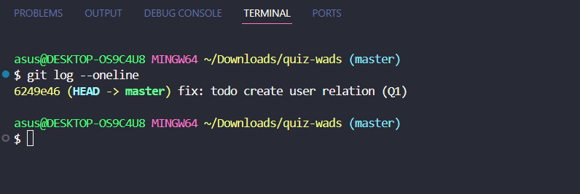

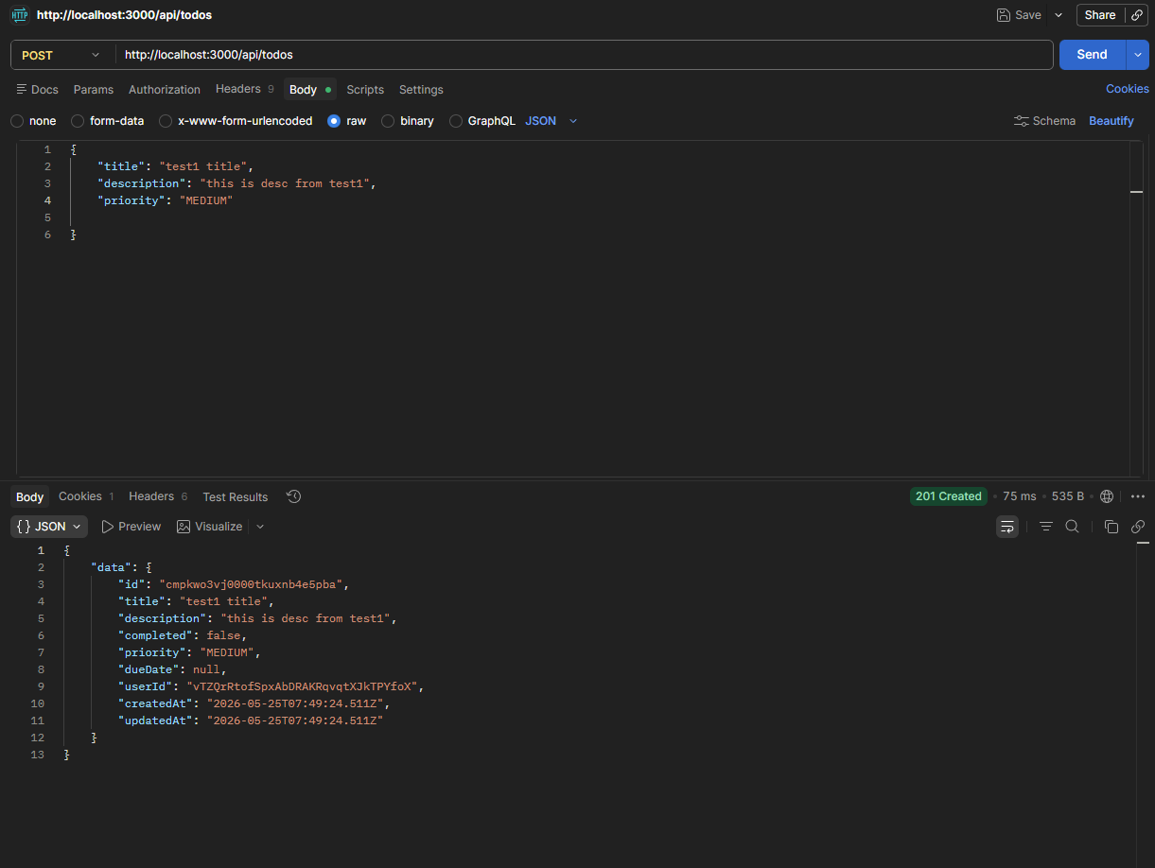

Q2 Solution
NEXT_PUBLIC_FIREBASE_API_KEY="your-key"
NEXT_PUBLIC_FIREBASE_AUTH_DOMAIN="your-project.firebaseapp.com"
NEXT_PUBLIC_FIREBASE_PROJECT_ID="your-project-id"
# ... other Firebase vars

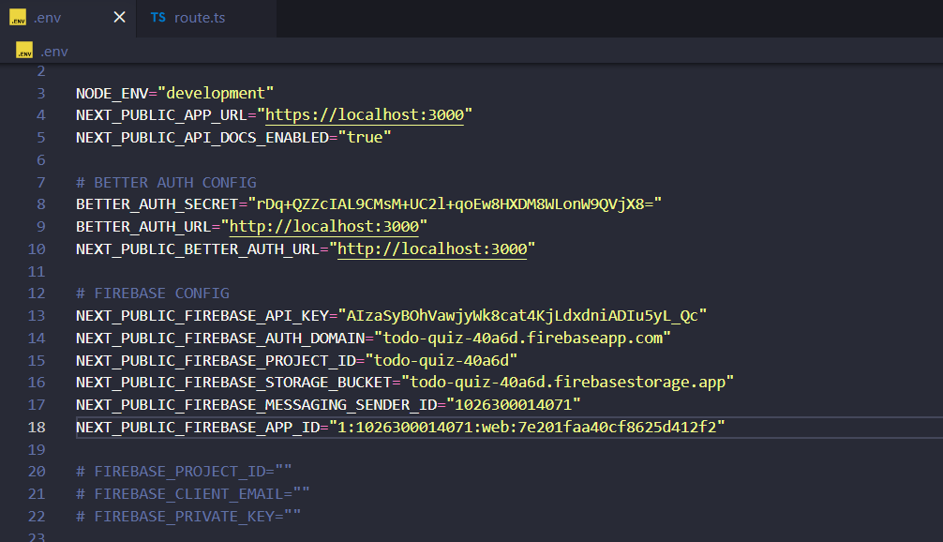
lib/firebase.ts reads NEXT_PUBLIC_FIREBASE_API_KEY — names must match exactly.
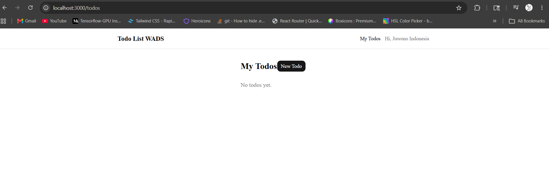

Q3 Solution
lib/validators/todo.ts:
title: z.string().min(1, "Title is required").max(200),

app/api/todos/[id]/route.ts DELETE:
export async function DELETE(request: NextRequest, context: RouteContext) {
const { id } = await context.params;
const session = await auth.api.getSession({ headers: request.headers });
if (!session?.user) return unauthorizedResponse();

const existing = await prisma.todo.findFirst({
where: { id, userId: session.user.id },
});
if (!existing) return notFoundResponse("Todo not found");

await prisma.todo.delete({ where: { id } });
return NextResponse.json({ message: "Todo deleted" });
}

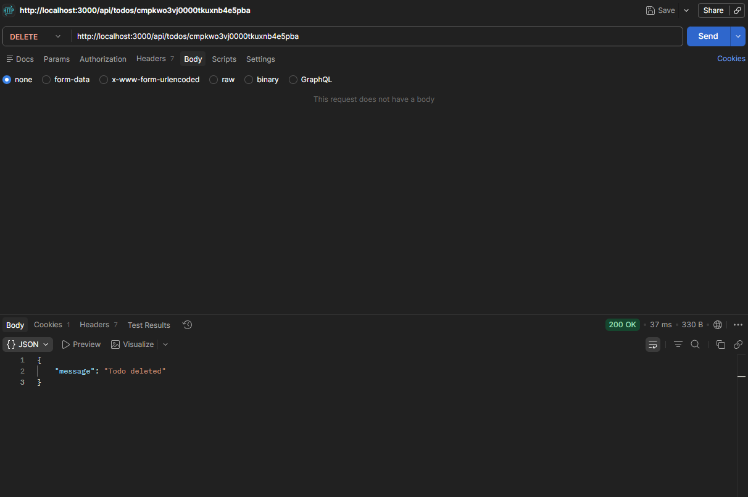
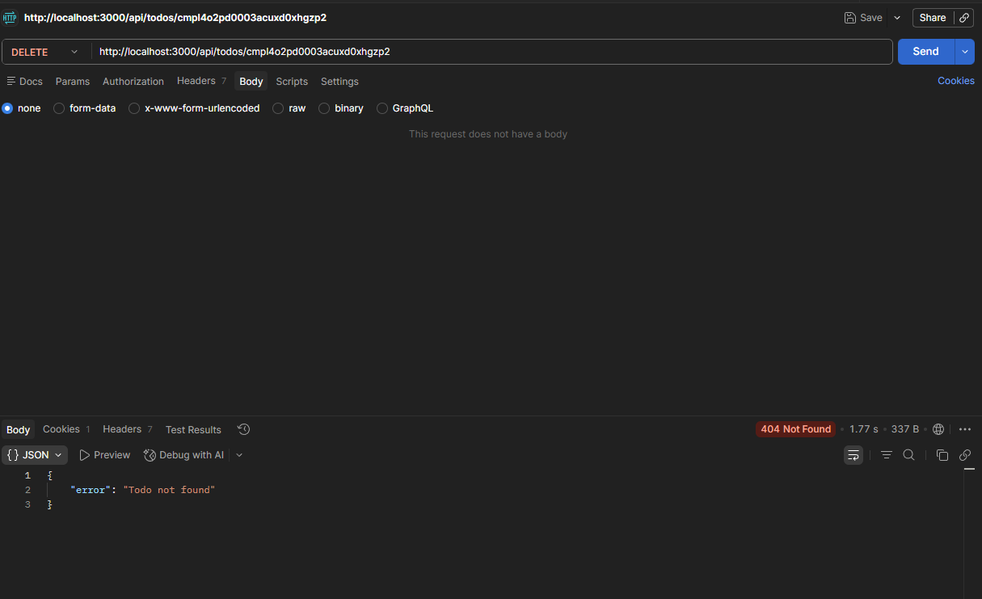

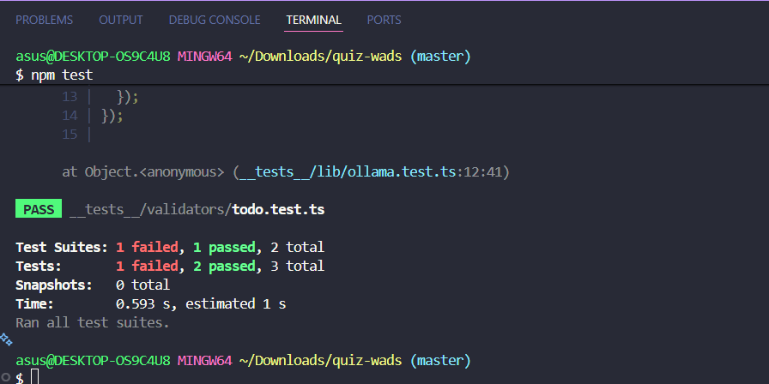
Q4 Solution
OLLAMA_BASE_URL="https://ollama.csbihub.id"
OLLAMA_MODEL="gemma4:26b"

Dockerfile: EXPOSE 3000

Run tests with env loaded:
OLLAMA_BASE_URL=https://ollama.csbihub.id
npm test
