WADS Quiz — Answer Key
(Instructor Only)

Course : Web Application Development and Security (WADS)
Program : Computer Science — BINUS University International
Semester : Even Semester 2025/2026
Exam Type : Practical Final Examination (Lab)
Project : Simple Blog Web Application
Duration : 120 minutes (2 hours)
Total Questions : 4
Total Points : 100

Note:
Do not distribute to students before the exam.

Defects Summary
Q | Location | Bug | Fix
1 | app/api/todos/route.ts | ownerId instead of userId | Use userId: session.user.id
2 | .env.example / .env | NEXT_PUBLIC_FIREBASE_API_KY typo | Rename to API_KEY
3 | validators/todo.ts, DELETE route | No title min; no auth on DELETE | .min(1) + session check
4 | .env, Dockerfile | http:// Ollama; EXPOSE 4000 | https://ollama.csbihub.id; EXPOSE 3000

Q1 Solution
app/api/todos/route.ts:
const todo = await prisma.todo.create({
data: {
title: input.title,
description: input.description,
completed: input.completed ?? false,
priority: input.priority ?? "MEDIUM",
dueDate: input.dueDate ? new Date(input.dueDate) : null,
userId: session.user.id,
},
});

Remove as never cast.
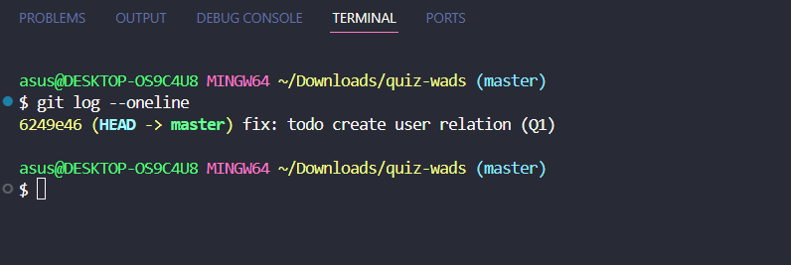

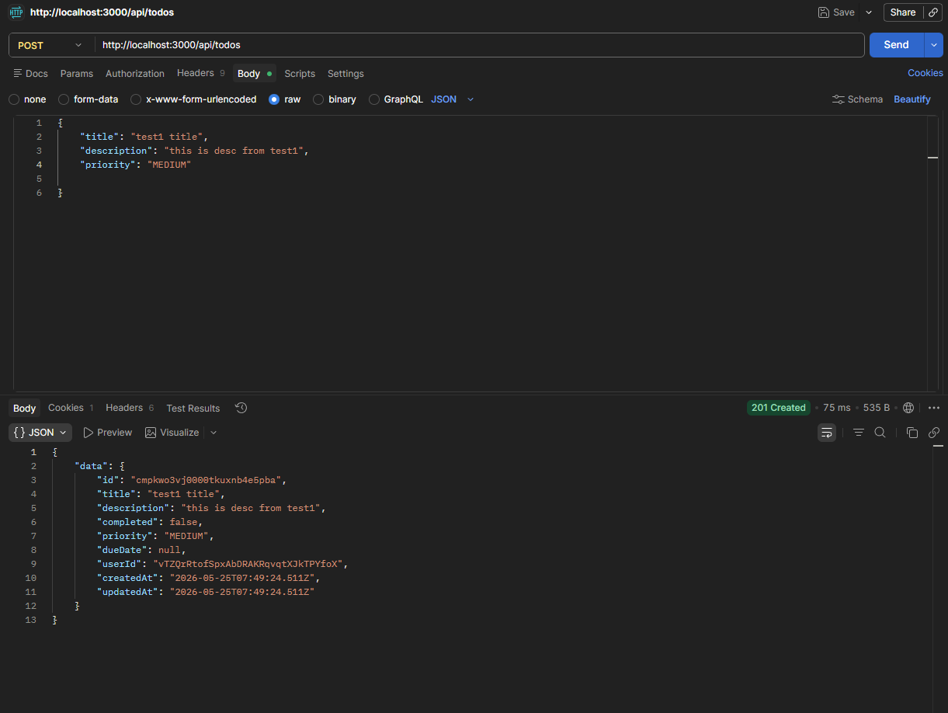

Q2 Solution
NEXT_PUBLIC_FIREBASE_API_KEY="your-key"
NEXT_PUBLIC_FIREBASE_AUTH_DOMAIN="your-project.firebaseapp.com"
NEXT_PUBLIC_FIREBASE_PROJECT_ID="your-project-id"
# ... other Firebase vars

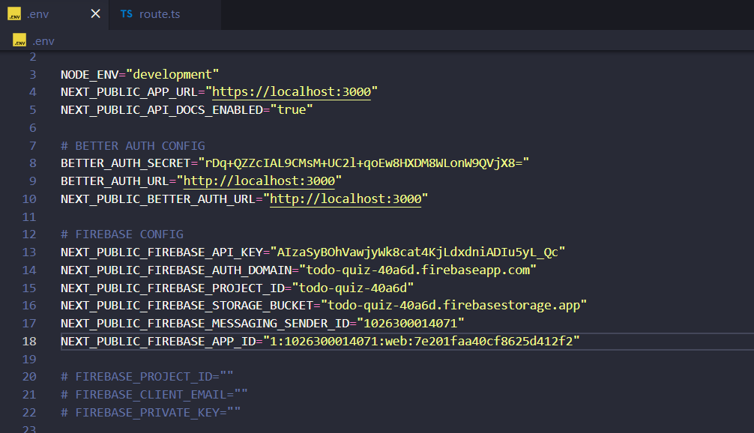
lib/firebase.ts reads NEXT_PUBLIC_FIREBASE_API_KEY — names must match exactly.
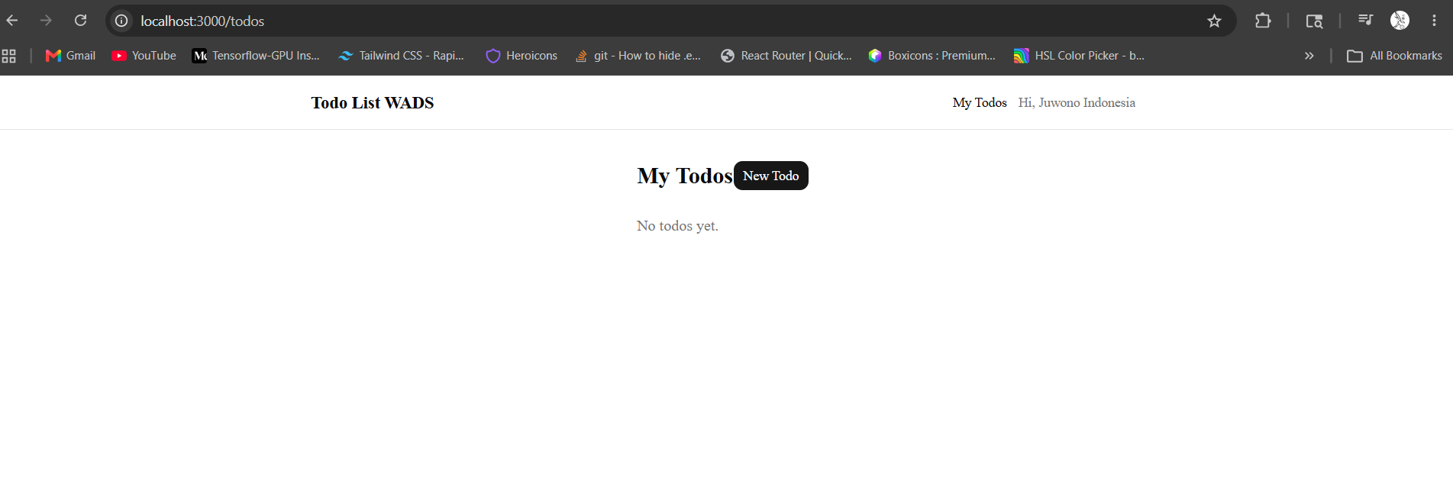

Q3 Solution
lib/validators/todo.ts:
title: z.string().min(1, "Title is required").max(200),

app/api/todos/[id]/route.ts DELETE:
export async function DELETE(request: NextRequest, context: RouteContext) {
const { id } = await context.params;
const session = await auth.api.getSession({ headers: request.headers });
if (!session?.user) return unauthorizedResponse();

const existing = await prisma.todo.findFirst({
where: { id, userId: session.user.id },
});
if (!existing) return notFoundResponse("Todo not found");

await prisma.todo.delete({ where: { id } });
return NextResponse.json({ message: "Todo deleted" });
}

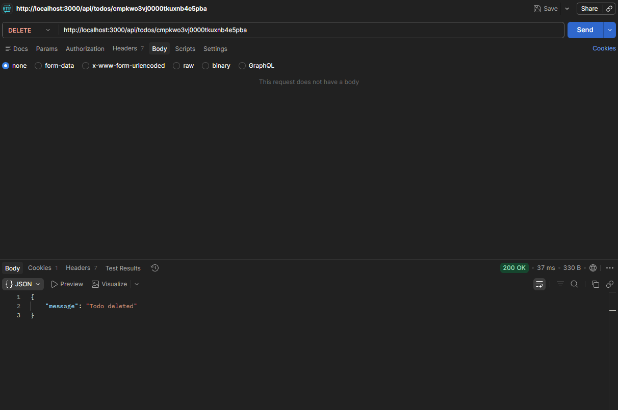
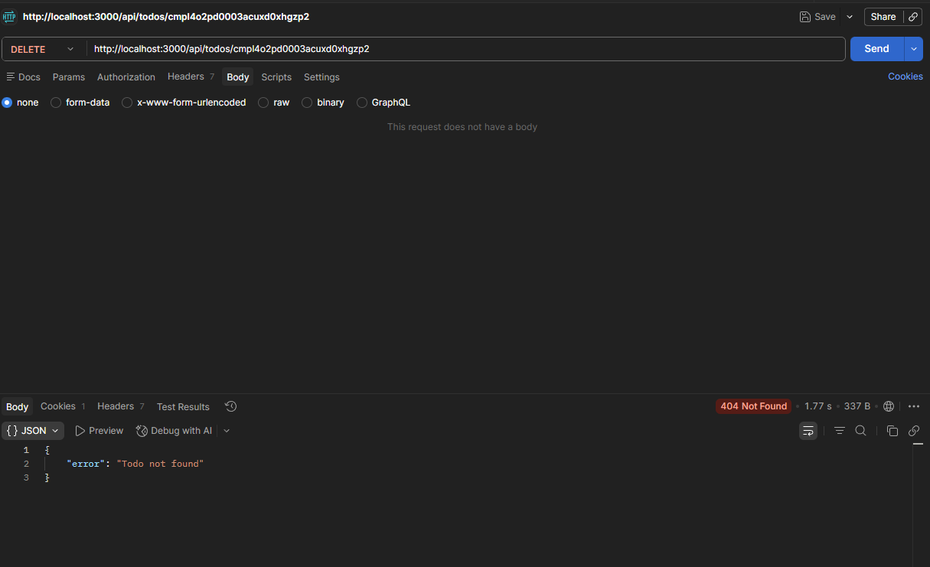

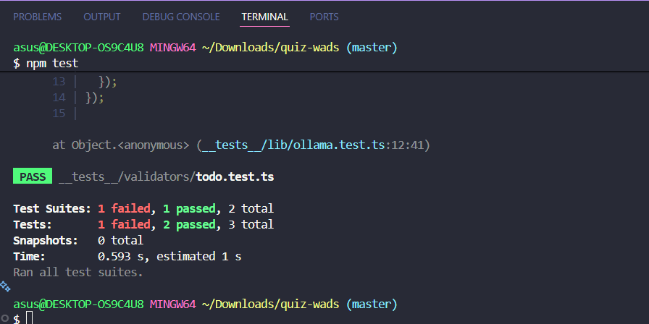
Q4 Solution
OLLAMA_BASE_URL="https://ollama.csbihub.id"
OLLAMA_MODEL="gemma4:26b"

Dockerfile: EXPOSE 3000

Run tests with env loaded:
OLLAMA_BASE_URL=https://ollama.csbihub.id
npm test
