San Jose State University

Department of Electrical Engineering

EE104, Fall 2021, Pham

Laboratory Assignment #9

# Objectives

This lab allows you to model the aspects of the COVID-19 Epidemiology.

**ep·i·de·mi·ol·o·gy**

/ˌepəˌdēmēˈäləjē/

*noun*

the branch of medicine which deals with the incidence, distribution, and possible control of diseases and other factors relating to health.

# Grading

Refer to the section **Python Programming** for grading criteria.

# Bibliography

References:

<https://www.cdc.gov/careerpaths/k12teacherroadmap/epidemiology.html>

## What is Epidemiology?

Epidemiology is the method used to find the causes of health outcomes and diseases in populations. In epidemiology, the patient is the community and individuals are viewed collectively. By definition, epidemiology is the study (scientific, systematic, and data-driven) of the distribution (frequency, pattern) and determinants (causes, risk factors) of health-related states and events (not just diseases) in specified populations (neighborhood, school, city, state, country, global). It is also the application of this study to the control of health problems (Source: [Principles of Epidemiology, 3rd Edition](https://www.cdc.gov/csels/dsepd/ss1978/index.html)).

SIDARTHE mathematical model is presented in this paper: <https://www.nature.com/articles/s41591-020-0883-7>

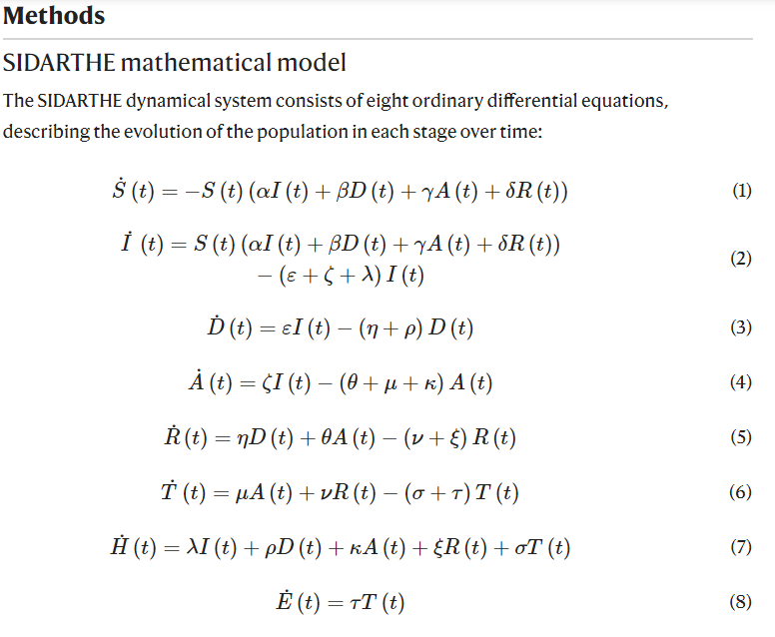

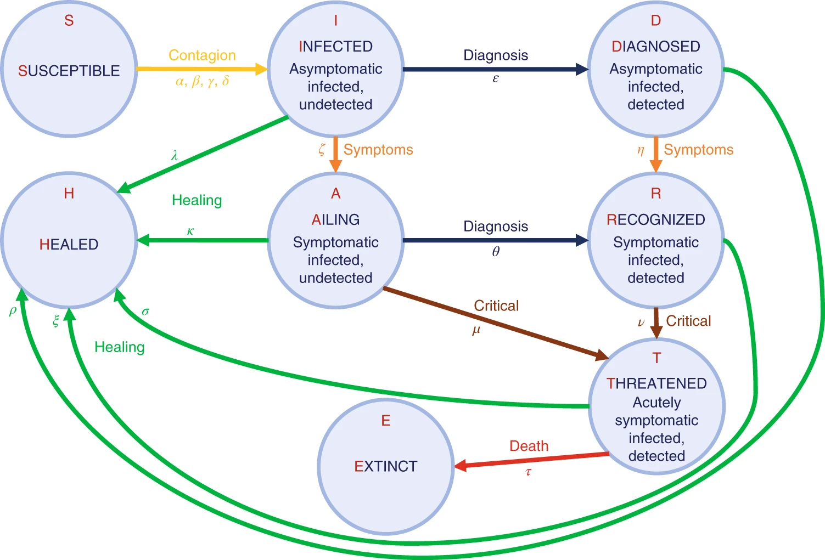

# Python Programming

#### Lab Submission

Once you learn the process and the code associate with each step in the process, you will be able to customize the program to implement in python the SIDARTHE mathematical model.

|  |  |  |
| --- | --- | --- |
| **Program or Requirement** | **Use Case** | **Earned Score / Max Score** |
| Implement S | SUSCEPTIBLE | _____ / 15 |
| Implement I | INFECTED | _____ / 15 |
| Implement D | DIAGNOSED | _____ / 10 |
| Implement A | AILING | _____ / 10 |
| Implement R | RECOGNIZED | _____ / 15 |
| Implement T | THREATENED | _____ / 15 |
| Implement H | HEALED | _____ / 15 |
| Implement E | EXTINCT | _____ / 5 |
|  | **TOTAL** | **100%** |

That’s all for this lab. Hopefully you found it useful and increase your interest in the Python world!

# Laboratory Hand-In Requirements

Once you have completed a working design, prepare for the submission process. You are required to demonstrate a working design. You are also required to submit an archive of your project in the form of a ZIP file. Use 7-Zip option to create the ZIP file. Name the archive lab#_yourlastname_yourfirstname.zip. Refer to Lab 1 for detail instructions.

You will submit your zip file to the instructor through Canvas by the due date and time. If the class will be on campus, then you will expect to demonstrate in the classroom. If we ever have to go back to an online mode, turn in your archive to Canvas along with a narrated video capturing the screen of your computer running your program demonstration. If your program is not completely functional by the due date, you should demonstrate and turn in what you have accomplished to receive partial credit. See the syllabus for the late penalty guideline