Tab 1
Department of Electrical Engineering
San Jose State University

EE198A Senior Project Proposal
Wireless Glove Interface for Real-Time Robotic Hand Mimicry

Antonio Rojas ID: 014974063
Raul Hernandez-Solis ID: 016319693
Matthew Men ID: 016601806

Date: 12/01/25

Project Advisor: Junaid Anwar
Table of Contents
1. Introduction 3
2. Methodology and Design 5
3. Schedule 9
4. References 11
5. Appendix 12

1. Introduction
The relationship between humans and machines continues to evolve rapidly over the years. Fields like prosthetics, telecommunication, robotics and virtual reality have made huge strides in functionality and widespread availability. However, highly articulate, human-like, real time wireless interfaces are still unattainable at a consumer level. Consumer grade examples similar to what we aim to build such as VR controllers, trade affordability for quality and accuracy.
Our team aims to create a functioning control system for a robotic hand apparatus using remote sensing of the human hand. Our methodology involves using field oriented control (FOC) for brushless DC motors (BLDCs) to drive human digits, offering finer control than tendon driven approaches.
There are numerous resources and similar projects available online, but our goal is to distinguish our work from simple hobbyist designs while keeping the project scope realistic for our skill level. Many DIY robotic hand projects use a tendon-like system consisting of a cable or string driven actuation, where servos mounted in the forearm pull the cables to bend the joints, similar to how muscles contract in an actual human arm. While this method is common and easy to implement, it often lacks the precision and responsiveness required for high accuracy and precise hand mimicry due to mechanical slack, limited torque bandwidth, and variable tension over time. On the opposite end of the spectrum, commercial robotic hands offer exceptional performance by incorporating multi-degree-freedom actuation, tactile sensors, and advanced control algorithms, but are typically too complex and far too expensive for the average user. With our project, we aim to strike a balance between developing a system that provides improved precision and control without sacrificing affordability or accessibility.

More research focuses on wearable sensing gloves used in teleoperation, rehabilitation, and virtual reality. These gloves commonly utilize either flex sensors, IMUs, or Hall-effect joint sensors to measure finger bend angles. Low-cost gloves typically use a single flex sensor per finger, which limits anatomical accuracy. With additional flex sensors, we can achieve a higher level of accuracy without adding too much complexity.

Advances in motor control systems have made high-precision actuation more accessible. Field-oriented control (FOC) has become more common for applications requiring smooth torque, high positional accuracy, and low-speed performance which is needed in robotic hands and manipulators.

Despite the continuous advances in these domains, there remains a void for an affordable yet accurate joint focused motion. Many consumer focused products focus on gesture controls rather than joint motion. Systems that do have a focus in joint control, either tend to be too simple and not accurate enough or too complex and advanced for a consumer's basic needs. Our project fills this gap by integrating Joint-level flex sensing for higher-resolution input, Wireless signal transmission for remote control, FOC-driven BLDC actuators for smooth and lifelike output all within a low-cost, modular design achievable with student-level resources.

2. Methodology and Design
What is Field Oriented Control?
Field-Oriented Control (FOC) is a vector-based motor control strategy widely used in high-performance applications requiring precise torque, speed, and position regulation. For this project, FOC is leveraged to enable a robotic hand that accurately mimics human finger motion in real time. Unlike similar robotic hands that use a single actuator per digit, resulting in uniform, coupled joint motion, our design integrates a compact brushless DC (BLDC) motor at each individual joint. This joint-level actuation enables finer control of articulation, improved dexterity, and synchronization with the real time operator.
Traditional scalar control methods regulate motor speed by adjusting frequency and voltage. While simple, scalar control suffers from poor low-speed performance, limited dynamic response, and significant torque ripple. In contrast, FOC allows for stable, smooth motor operation across the full speed range, including very low RPM—critical for applications that demand delicate, slow, or highly coordinated motion such as robotic grasping.
Implementing FOC requires two primary mathematical coordinate transformations:
- Clarke Transformation:
Converts the three-phase stator currents (ia, ib, ic) into a two-axis stationary reference frame (α, β). This simplifies the motor model and reduces computational complexity.
- Park Transformation:
Rotates the (α, β) frame into a synchronous rotating reference frame aligned with the rotor’s magnetic field. In this dq frame, the motor’s current vector becomes stationary, allowing Id and Iq to be controlled independently using standard PI controllers.
Rotor position and velocity feedback, obtained from Hall sensors, an encoder, or sensorless estimation is used to update the Park transformation and maintain alignment with the rotor’s field. The two PI controllers regulate Id and Iq to drive the motor toward the commanded torque and position generated by the wireless glove interface.
This combination of BLDC joint control, real-time feedback, and FOC-based torque regulation provides the precision, responsiveness, and stability required for natural human-to-robot motion mapping. The result is a robotic hand capable of high-fidelity, low-latency mimicry that closely follows the operator’s finger movements and applied forces.

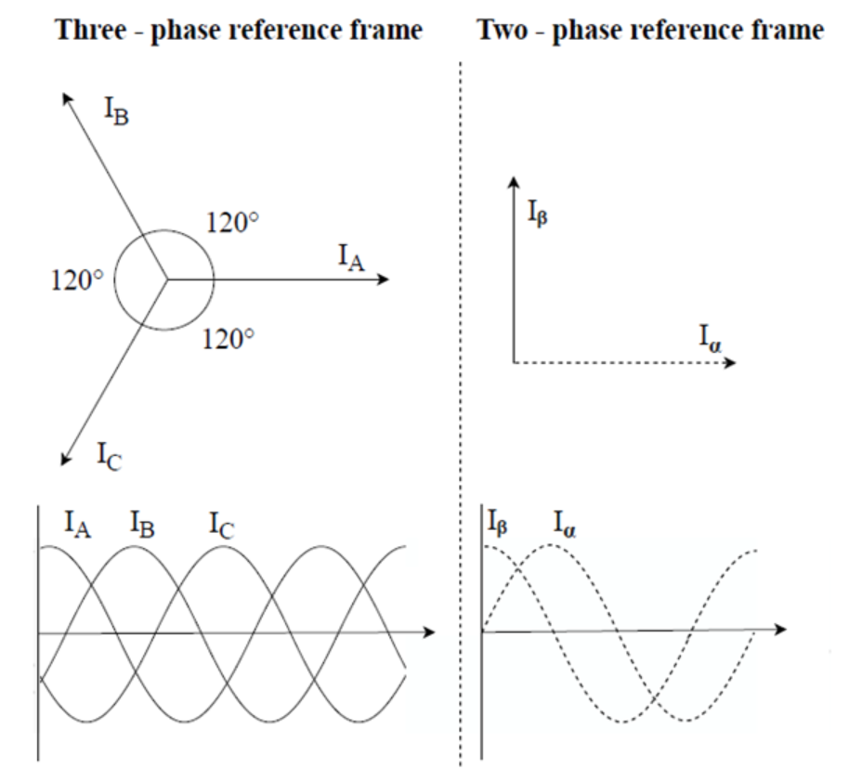
Figure 1

Glove Subsystem

The glove subsystem consists of a wearable glove equipped with multiple flex sensors placed along each joint of the finger, rather than using a single sensor per finger. This joint level sensing increases positional resolution and enables more accurate reconstruction of the user’s hand movements at the output. As each sensor bends, its resistance changes proportional to joint angle. The ESP32 microcontroller samples these values through an ADC, converts them into calibrated joint angles, and structures them into data packets.
The processed angle data is then transmitted wirelessly, via the ESP32’s built-in low energy bluetooth interface, to the receiver module on the robotic hand. Mapping algorithms translate the human joint angles into target BLDC positions suitable for FOC control.
MCU
BLDC Driver Circuit
BLDC
Encoder
MCU
ADC
Flex Sensor
Digit
x4
Glove
Figure 2. Control Flow Architecture [7]

Expected Materials
Item | Quantity | Price | Purpose
ESP32 | Min. 2 | Free ($8/ea) | Programming interface for sender and receiver, as well as driving motors and reading sensors. Will be scaled or altered as necessary to meet processing power specifications
Brushless DC Motor | x4/Finger | $15/ea | Move the finger joints
Encoder | x1/Motor | $5/ea | Provide feedback system for motor control system
Glove | 1 | $5 | Physical apparatus for input
3D Printed Hand | 1 | TBD | Physical apparatus for output. Printer provided by school facilities
Flex Sensor | x4/Finger | $5/ea | Sensing interface for wireless glove control
Motor Driver | TBD | TBD | Provide interface between microcontroller and motor (Off the shelf or custom design TBD)

3. Schedule
Gantt Chart
TASK TITLE | TASK OWNER | START DATE | DUE DATE | DURATION | NOTES
Research | GROUP | 8/16/25 | 12/17/25 | 1 Semester | Control Architecture
Code Prototyping & Selection | GROUP | 1/1/26 | 2/3/26 | ~1 Month | Establish FOC control codebase
Motor Prototyping | GROUP | 2/4/26 | 3/18/26 | ~1.5 Months | Interface FOC with BLDC motors
Robotic Hand Prototyping | ANTONIO | 2/4/26 | 3/18/26 | ~1.5 Months | Link BLDC motors with prototype joints
Control Hand Prototyping | RAUL | 1/1/25 | 3/18/26 | ~2.5 Months | Physical prototyping of sensors
Wireless Code Prototyping | MATTHEW | 1/1/25 | 3/18/26 | ~2.5 Months | Establish wireless control codebase
Integration Testing | GROUP | 3/19/26 | 4/30/26 | ~1.5 Months | Establish wireless control of robotic hand
Final Report | GROUP | 5/1/26 | 5/15/16 | ~0.5 Months | Synthesize literature and methodology
Presentation Poster | GROUP | 5/1/26 | 5/15/16 | ~0.5 Months | Shortform poster explaining project

4. References
[1] M. Kumar, S. Tiwari, V. Kumar, S. J. Sampathi and R. Kumar Jarial, "Implementation of Field-Oriented Control (FOC) Algorithm for Brushless DC (BLDC) Motor Speed Regulation," 2023 Second IEEE International Conference on Measurement, Instrumentation, Control and Automation (ICMICA), Kurukshetra, India, 2024, pp. 1-6, doi: 10.1109/ICMICA61068.2024.10732537.

[2] L. Qin, H. Wei, Y. Wang, J. Feng, and Y. Liu, “Brushless Motor FOC Control Method for Robot Arm,” Academic Journal of Science and Technology, vol. 7, no. 3, pp. 50–56, Oct. 2023, doi: 10.54097/ajst.v7i3.12716.

[3] Espressif Systems, “ESP32 Datasheet,” ESP32-D0WD, Version 1.0, Oct. 8, 2016. [Online]. Available: https://cdn.sparkfun.com/datasheets/IoT/esp32_datasheet_en.pdf
[4] E. Nazma and S. Mohd, “TENDON DRIVEN ROBOTIC HANDS: A REVIEW,” IJMERR, https://www.ijmerr.com/uploadfile/2015/0409/20150409025038924.pdf (accessed Dec. 2, 2025).
[5] P. Dhepekar and Y. G. Adhav, "Wireless robotic hand for remote operations using flex sensor," 2016 International Conference on Automatic Control and Dynamic Optimization Techniques (ICACDOT), Pune, India, 2016, pp. 114-118, doi: 10.1109/ICACDOT.2016.7877562.

[6] Martinek, R., Bílík, P., Baroš, J., Brablík, J., Kahánková, R., Jaroš, R., Danys, L., Rzidky, J., & Wen, H. “Design of a Measuring System for Electricity Quality Monitoring within the SMART Street Lighting Test Polygon: Pilot Study on Adaptive Current Control Strategy for Three-Phase Shunt Active Power Filters.” Sensors, vol. 20, no. 6, 2020, article 1718. doi:10.3390/s20061718

[7] “What is Field Oriented Control (FOC)?,” everything PE — community, Feb. 19, 2025. [Online]. Available: https://www.everythingpe.com/community/what-is-field-oriented-control-foc
. [Accessed: Dec. 1, 2025].

5. Appendix

Figure 1 [7]
MCU
BLDC Driver Circuit
BLDC
Encoder
MCU
ADC
Flex Sensor
Digit
x4
Glove
Figure 2. Control Flow Architecture

Meeting Log
Project Title: Wireless Glove Interface for Real-Time Robotic Hand Mimicry
Team Members: Raul Hernandez-Solis, Matthew Men, Antonio Rojas
Project Advisor: Junaid Anwar
____________________________________________________________________________
Meetings:
Date: 9/8/25 | Time: 7:30-9pm | Topic: Project Ideas | Action Items: Brainstorming
Attendees | Summary
Raul Hernandez-Solis | Ran multiple ideas by the professor. We decided we should focus on something that incorporates control theory because that is what professor Anwar specializes in.  We did not leave this meeting with a concrete idea.
Matthew Men
Antonio Rojas
Junaid Anwar

Date: 9/15/25 | Time: 10am-12pm | Topic: Project Ideas | Action Items: Brainstorming
Attendees | Summary
Raul Hernandez-Solis | We brainstormed a lot more ideas with a focus on control. We decided to go with a wireless glove interface for real-time robotic hand mimicry. This project not only has a lot of control theory, but also allows us to learn wireless communication.
Matthew Men
Antonio Rojas

Date: 9/29/25 | Time: 10am-12pm | Topic: Similar Projects | Action Items: Research
Attendees | Summary
Raul Hernandez-Solis | We looked into other projects that have been completed that are similar to what we aim to accomplish. We found that this project can be as simple or as complicated as we would like.
Matthew Men
Antonio Rojas

Date: 10/13/25 | Time: 10am-12pm | Topic: Motor Control | Action Items: Research
Attendees | Summary
Raul Hernandez-Solis | We looked for different ways to control the movement of the robotic fingers. Most robotic hands worked in a similar fashion, consisting of wires/strings and servos to control the tension. We aimed to have our robotic hand to be more precise, so we are thinking of implementing FOC for each joint.
Matthew Men
Antonio Rojas

Date: 10/20/25 | Time: 10am-12pm | Topic: Project Switch? | Action Items: Research
Attendees | Summary
Raul Hernandez-Solis | We looked into another project idea because we thought that we took on too much with our other project. We switched to a rocket thrust control computer but ultimately we went back to our original project but simplified it by minimizing our robotic hand to just two fingers.
Matthew Men
Antonio Rojas

Date: 10/27/25 | Time: 10am-12pm | Topic: Wireless Control | Action Items: Research
Attendees | Summary
Raul Hernandez-Solis | We looked into how to have our two controllers communicate wirelessly, but we realized that we need to confirm and settle on a MCU before going further into the wireless design.
Matthew Men
Antonio Rojas

Date: 11/3/25 | Time: 10am-12pm | Topic: FOC | Action Items: Research
Attendees | Summary
Raul Hernandez-Solis | We continued looking into how to utilize FOC for our project.
Matthew Men
Antonio Rojas

Date: 11/24/25 | Time: 10am-12pm | Topic: Final Proposal | Action Items: Research
Attendees | Summary
Raul Hernandez-Solis | We started talking about and working on our final proposal.
Matthew Men
Antonio Rojas

Sources
https://pmc.ncbi.nlm.nih.gov/articles/PMC11201696/

TMS320F2806xM InstaSPIN-MOTION Software User's Guide (Rev. C)

SimpleFOCproject | Home

https://arxiv.org/abs/2405.18730

https://crlab.cs.columbia.edu/humanoids_2018_proceedings/media/files/0155.pdf

Field-Oriented Control - MATLAB & Simulink

Design of joints for finger

Design of finger 2

remote sensing using flex

FOC:

What is Field Oriented Control (FOC)? - everything PE

https://arxiv.org/abs/2405.18730

Simple FOC:

Field Oriented Control | Arduino-FOC

https://www.researchgate.net/publication/375854818_Brushless_Motor_FOC_Control_Method_for_Robot_Arm

https://ieeexplore.ieee.org/document/10732537

https://www.ti.com/lit/ug/spruhj1i/spruhj1i.pdf?ts=1764572696769

Robotics:

Other:

