Department of Electrical Engineering
San Jose State University
EE 198B Senior Project Final Report
Qubit Readout Using Qiskit & HFSS

Eric Reyes (011351067)
Matthew Lewis (012354758)
Ashim Gautam (014556945)
Harsaroop Dhillon (012697594)

Date: 5/16/2022

Project advisor: Hiu Yung Wong

Executive Summary
This project focused on enhancing the knowledge of simulating quantum devices using HFSS and further the advancement of quantum computing. Currently, a high fidelity qubit device exists, however; the ability to distinguish qubits coupled to a single transmission line in a single readout is still lacking. To achieve the intended goals in this project, a quarter-wave coplanar resonator was designed which was then coupled to a transmission line which was also designed. The design for this project was done using Qiskit Metal and HFSS. Once the necessary structures were designed, the goal was to apply multiple structures and determine if it was possible to distinguish multiple qubits in the presence of noise. It was through the analysis process that several hidden caveats were discovered which stumped progress in this progress. Due to the lack of information about the simulation of quantum devices in simulation software, the project did not reach the intended phase of analyzing multiple qubits but various knowledge regarding the utilization of simulation software was discovered. The discovery of this knowledge is important since there is not a lot of information present regarding the simulation of quantum devices in HFSS. In this project, the design goal was achieved and the application of wire bonds, simulation type, and meshing was realized.

Table of Contents

- Introduction 4
- Methodology 5
- Results and discussion 10
- Conclusions and recommendations 14
- References 15
- Appendix 15

1. Introduction

In traditional computing, bits form the fundamental building block of classical computation. A similar concept is used called qubits in quantum computation. Qubits are similar to classical bits in the way that they can have a state of 0 or 1. However, they differ in the way that they can be in a superposition of these two states while a classical bit can only possess a single bit value. The motivation for this project was to attempt to see if it was possible to read multiple qubits coupled to a single transmission line in a single readout. In classical bits, once a bit possesses the value of 0 or 1. When read, they continue to possess the same value until that memory block is freed or modified. However, in qubits when information is read, it is destroyed. Due to recent advancements in quantum computing, the ability for superconducting qubits to sustain a state for a long period, fidelity, has been possible. This has allowed for a more realizable path toward a fault-tolerant quantum computer. However, when multiple qubits are present, the ability to distinguish them at their respective resonant frequencies in the place of external factors such as noise is lacking. By analyzing this issue, the path toward a quantum computer can be more realizable. The implications of quantum computing are immense. A quantum computer will allow for the solution to several unsolvable problems. This can be seen by the following modification to the Church-Turing thesis. “Any algorithmic process can be simulated efficiently using a probabilistic Turing machine”. This states that theoretically, a quantum mechanical algorithm may be more efficient than any classical algorithm. However, in reality, currently, the applications of quantum algorithms are not as broad. One of the implications in Physics is the ability to simulate a quantum mechanical system. Richard Feynman stated in 1982 that it may be possible that a quantum computer can simulate quantum mechanical systems. The other potential implication of Quantum Computing is that it can destroy our currently existing crypto ciphers, further the advancement of drug research and AI, and it may even help solve many unsolved problems such as NP-completeness. For this advancement to occur, a fault-tolerant and error-free, quantum computer is necessary. This project aims to tackle one of the problems associated with quantum computing by analyzing the readout portion, the part that determines the state of the qubit, in an effort to see if it is possible to distinguish between multiple qubits in the presence of noise.

2. Methodology
To simulate a qubit readout, it was necessary to design a quarter-wave resonator which would then be coupled to a transmission line. To do this the following design equation was used.
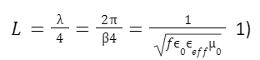
In this equation, the relationship between the length of the resonator and the resonant frequency can be seen. It is important to note here that setting one end to be shorted to ground and the other to be open to ground would result in a quarter-wave resonator. While setting both ends to either open to ground or shorted to ground would result in a half-wave resonator.
After designing a resonator, it was also necessary to design a coplanar transmission line. The following design equation was introduced for this part.

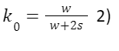
The k-factor was introduced which describes the geometry of the coplanar waveguide, whose structure is shown below.


Figure 1: Diagram of CPW
The k-factor was introduced since we want an impedance match of 50 ohms for the transmission line. The relationship between the k factor can be seen in the design equation below.

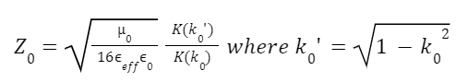
Using these two equations, a graph was generated from which the corresponding k value which produces an impedance match can be interpolated.

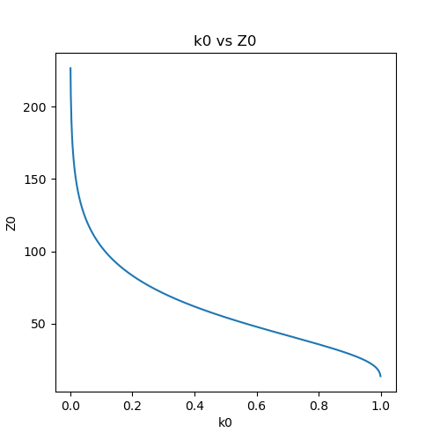
Figure 2: Interpolation of K0 and characteristic impedance
Using a software package called Qiskit Metal, the structures were designed. It was important to note here that it is necessary to use wire bonds on the coplanar waveguide since it allows for stronger coupling and in addition is how the structure is placed onto the substrate. In addition, an element called Launchpad should be utilized to feed the transmission line. Launchpad is a structure that has a pin at the back of the pad which is used for DrivenModal simulations.

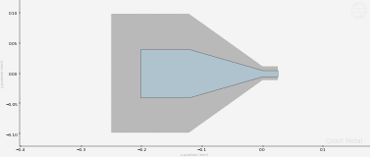
Figure 3: Transmission line feed

Once the structures are designed, simulations can be performed. However, it is necessary to use the following scheme when analyzing these structures. A dense mesh should be applied to all elements. This could be done using software; however, the naming convention that Qiskit chooses can be cumbersome to use with the external software package they use to interface with HFSS, called pyHFSS. Instead, the mesh is applied to all elements individually. It is necessary that the mesh is applied taking into consideration the resonant frequency of the device. In addition, another necessary step when performing eigenmode simulations is to do a fast sweep simulation to get a general idea of where the resonant frequency is. It is necessary to set the solution frequency here to near the resonant frequency calculated from the design equations.

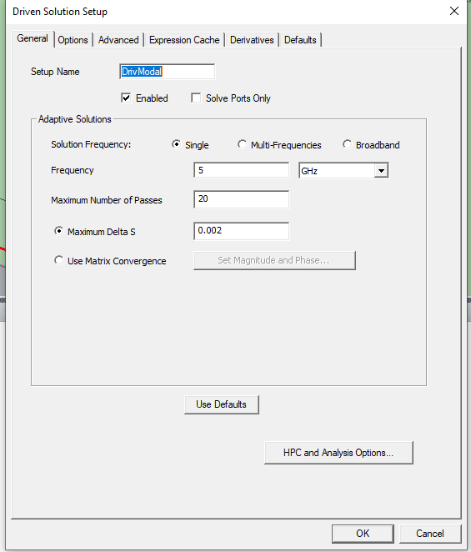
Figure 4: Driven modal solution setup
It is also necessary that all simulations that the maximum number of passes be set to a number that would ensure proper convergence.
.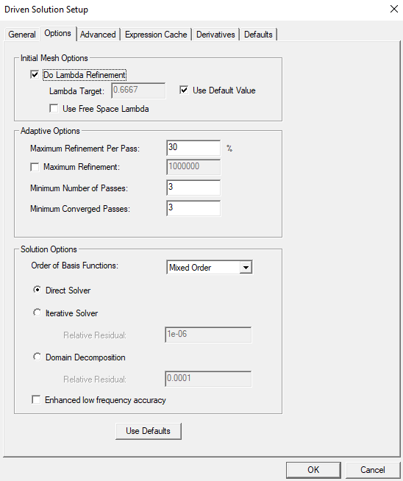
Figure 5: Modified driven solution setup
It is also necessary that the converged passes are at least 3. In addition, the basis of the functions being solved should be set to Mixed order.
Upon running a fast simulation sweep, this should be then further refined using a discrete simulation. Here a small delta S is necessary for the simulation setup in order to prevent errors, especially when dealing with small frequency changes.

3. Results and Discussion
Using python, software was written which utilized a software package called Qiskit. Qiskit would generate the necessary structure by interfacing with HFSS which allowed for simulation of the rendered device.

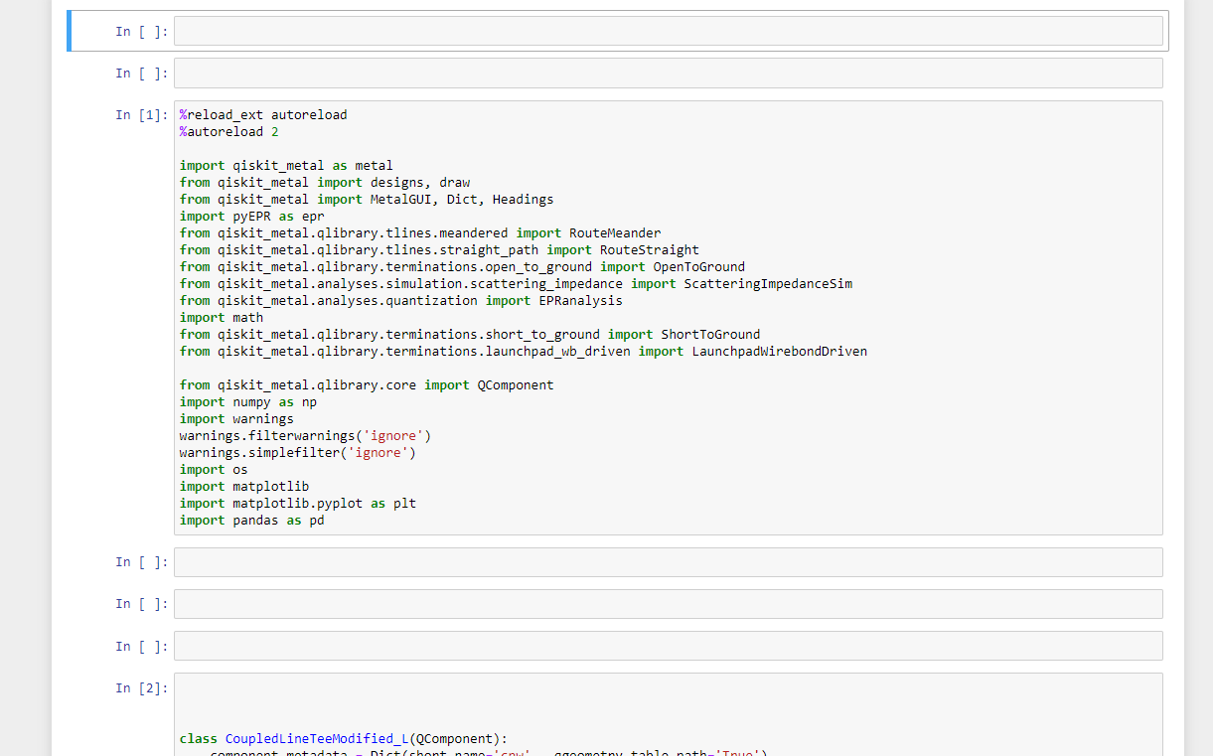
Figure 6: Qiskit code

Using this software, the designs for the coplanar waveguides were created along with the transmission line.

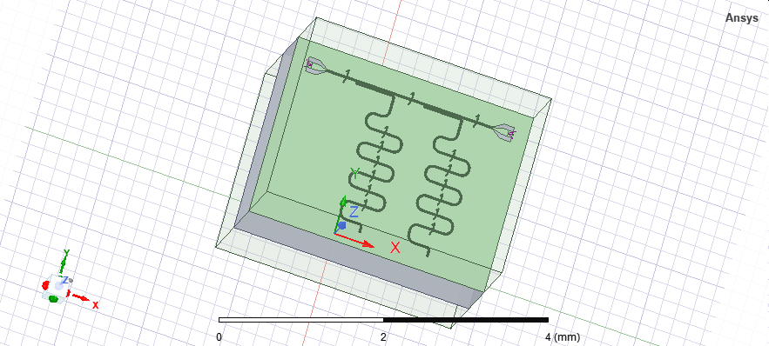
Figure 7: HFSS model of two CPWs
However, the majority of the semester was spent discovering the hidden caveats associated with HFSS. At first glance, our team did not use any design equations. Rather, we varied the length blindly but due to the lack of knowledge of the effect of the simulation type and the problem of meshing, the result was not clear.

This can be seen in the figure below where the length of the antenna was varied but the change in frequency was insignificant.

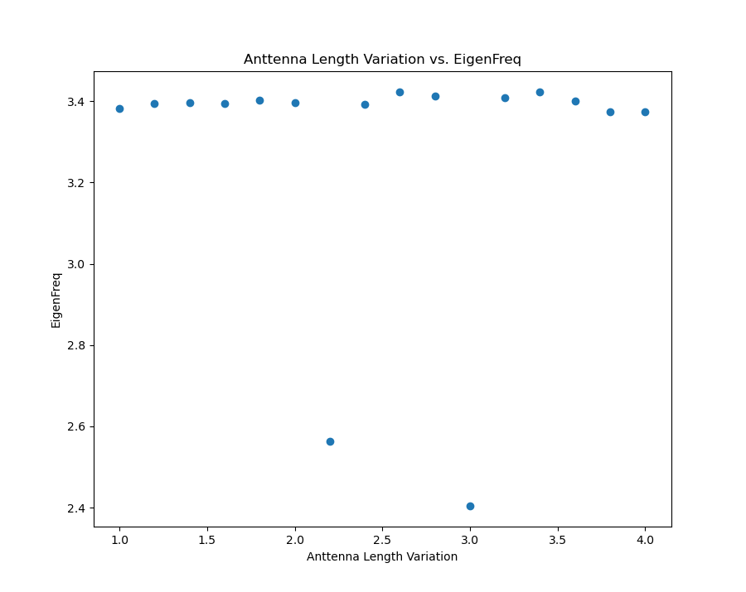
Figure 8: Eigenfrequency versus antenna length graph

It was then realized, by using the proper design equations, how to design a proper structure for the coplanar waveguide. By using the design equations, the problem became more clear that several changes to the structure had to be made. One of these changes was utilizing the Launchpad feature to feed the transmission line. After doing this, it was observed that the quality factor seen in HFSS was much smaller than what was expected.

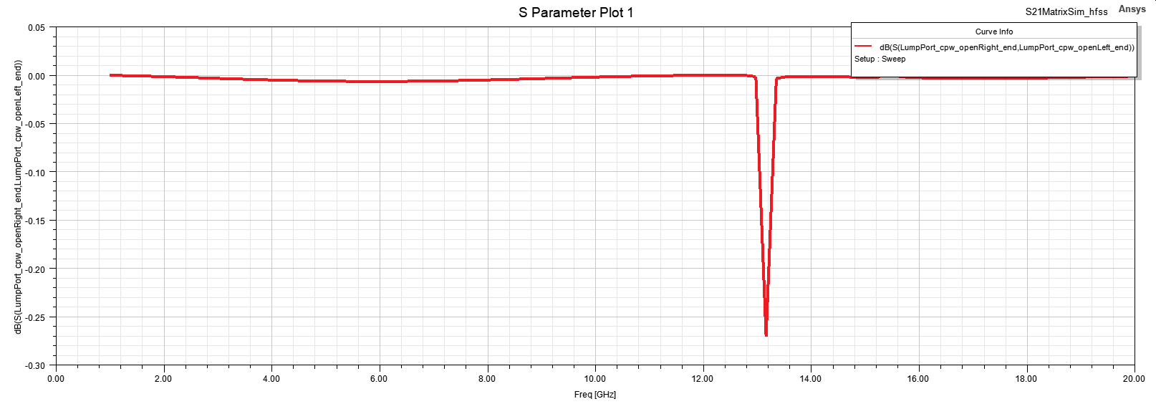
Figure 9: Fast sweep Q factor result

Here it was realized through trial and error that only through discrete sweeps can you resolve the quality factor properly.

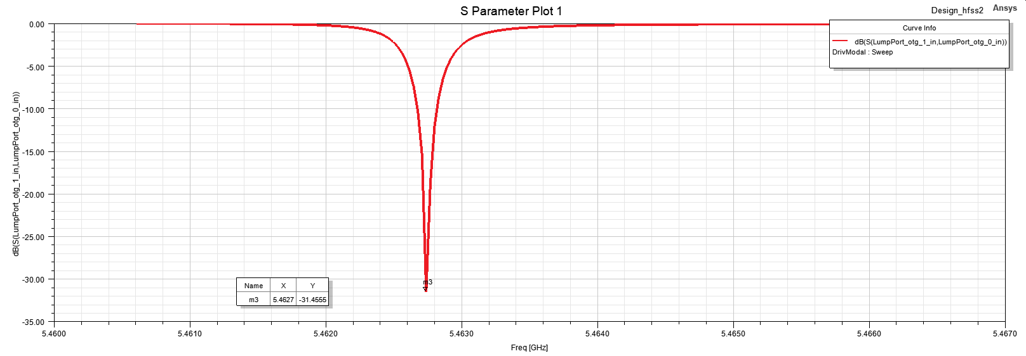
Figure 10: Discrete sweep Q factor result

In addition, it was also realized that wire bonds had to be utilized in order for the device to function properly. Due to the lack of information, the majority of the time was spent analyzing structures which were computationally heavy.

Although the end goal of the project was not achieved due to the lack of time, methods for simulating devices using Qiskit and HFSS were found.

4. Conclusions and Recommendations
The goal of this project was to contribute to quantum computing. The team successfully designed a coplanar resonator which was coupled to a transmission line. The coplanar waveguide was created in the simulation software HFSS with Qiskit. The goal was to use two resonators and couple them to the coplanar waveguide with a 10 MHz difference in eigenmode frequency. Simulations were performed on the system to detect the resonant frequency. At first, the simulations did not yield accurate results for the quality factor because they were fast sweeps. After using discrete simulations the true quality factor was found, which contributes to the goal of distinguishing multiple qubits in one readout. The project made a theoretical and experimental contribution to the problem of reading multiple qubits in one reading, as it shows the quality factor of a coplanar waveguide with multiple qubits. This data can be applied to other devices to determine the number of qubits that can be coupled to a coplanar waveguide and how to read more than one qubit in one readout. This project also revealed the importance of wire bonds to improve coupling as well as the functional differences between types of simulation in HFSS.

The potential impact of this project is in quantum computing, which is a quickly growing and important field. The incredible potential of quantum computing is starting to be realized, as leading companies and countries are investing heavily in developing this powerful technology. Quantum computing will be the next technological revolution to drive our systems forward. According to IBM, quantum computers could provide solutions to problems that are currently unsolvable. These include analyzing protein folding and superconductivity, modeling chemical reactions, and searching large encrypted databases. Quantum computing will completely change the world of security. It has the potential to be a game-changer for internet cryptography since today's encryption techniques will become utterly ineffective once quantum computers are available. Innovative algorithms are contributing to the study and analysis of complex data, providing better insights for fundamental science applications. Traditional problems related to physics, chemistry, materials research, environmental science, and computer science are being addressed in entirely new ways. Quantum computing will force a radical transition in the way we live and work. This project contributes to the practical aspects of quantum computing so it has the potential to help with all of these changes. Our recommendations based on this project are to use the correct simulation types, use wire bonds to improve coupling, and to use the data from this project to optimize qubit readout in a quantum computing device. In addition, utilizing GPUs for matrix calculations for EM simulations would help reduce the load on a systems PC.

5. References
Besedin, I., Menushenkov, A.P. Quality factor of a transmission line coupled coplanar waveguide resonator. EPJ Quantum Technol. 5, 2 (2018). https://doi.org/10.1140/epjqt/s40507-018-0066-3
Nielsen, M. A., & Chuang, I. L. (2021). Quantum Computation and Quantum Information. Cambridge University Press.
Schuster, D. I. (2007). Circuit quantum electrodynamics (thesis).
6. Appendix
https://qiskit.org/documentation/metal/
https://www.ansys.com/products/electronics/ansys-hfss

