Wandora

Use-Case Specification

Version <1.2>

Revision History
Date | Version | Description | Author
11/07/2026 | 1.0 | Initial draft for PA2 baseline requirements. | Đặng Nhật Minh
21/07/2026 | 1.1 | Revised USe-case Model architecture and refined all 11 core flow specification (including RBAC enforcement and GenAI fallback flows) for PA3 submission | Đặng Nhật Minh
10/08/2026 | 1.2 | Add usecase 2.12 (User Login and Authentication) | Nguyễn Hoài Đức
14/08/2026 | 1.2 | Added Login (UC 2.12), Review and Save AI Itinerary (UC 2.13), Group Member Interaction (UC 2.15), and Trip History (UC 2.17). Updated Trip Creation, AI Generation, and related post-planning rules based on PA3 feedback. Revised UC2.1, UC2.2 | Lê Thanh Hải

Table of Contents
1. Use-case Model 4
2. Use-case Specifications 5
2.1 Use-case: Trip Creation and Preference Input 5
2.2 Use-case: AI Itinerary Generator 6
2.3 Use-case: AI Itinerary Adjustment 6
2.4 Use-case: Manual Places and External Links 8
2.5 Use-case: Group Collaboration 9
2.6 Use-case: Role and Permission Management 10
2.7 Use-case: AI Packing Suggestions 10
2.8 Use-case: Shared Luggage Planning 11
2.9 Use-case: Manual Place Note Input 12
2.10 Use-case: Place Ratings and Reviews 12
2.11 Use-case: Share or Export Trip Plan 13
2.12 Use-case: User Login and Authentication (New) 14
2.13 Use-case: Continue Trip Details After AI Suggestion (New) 15
2.14 Use-case: Post-Scheduling Feature Access (New) 15
2.15 Use-case: Group Member Interaction (Voting and Comments) (New) 16
2.16 Use-case: Duplicate/Similar Trip Detection (New) 17
2.17 Use-case: Trip Creation History (New) 18

Use-case Model

The Wandora system supports authenticated users who create and manage private trip workspaces. A Trip Owner creates the trip and manages members; Editors may modify the itinerary; Viewers may view, comment, and vote but may not modify itinerary data. The GenAI System is a secondary actor that generates or revises itinerary suggestions.

The main planning lifecycle is: enter trip details → generate an AI preview → review, edit, regenerate, or add activities → save the trip → continue planning from the workspace. The features Packing List, Ratings & Reviews, and Share/Export become available after a saved itinerary exists. Duplicate checking is an alternative flow of Trip Creation, not a separate use case.

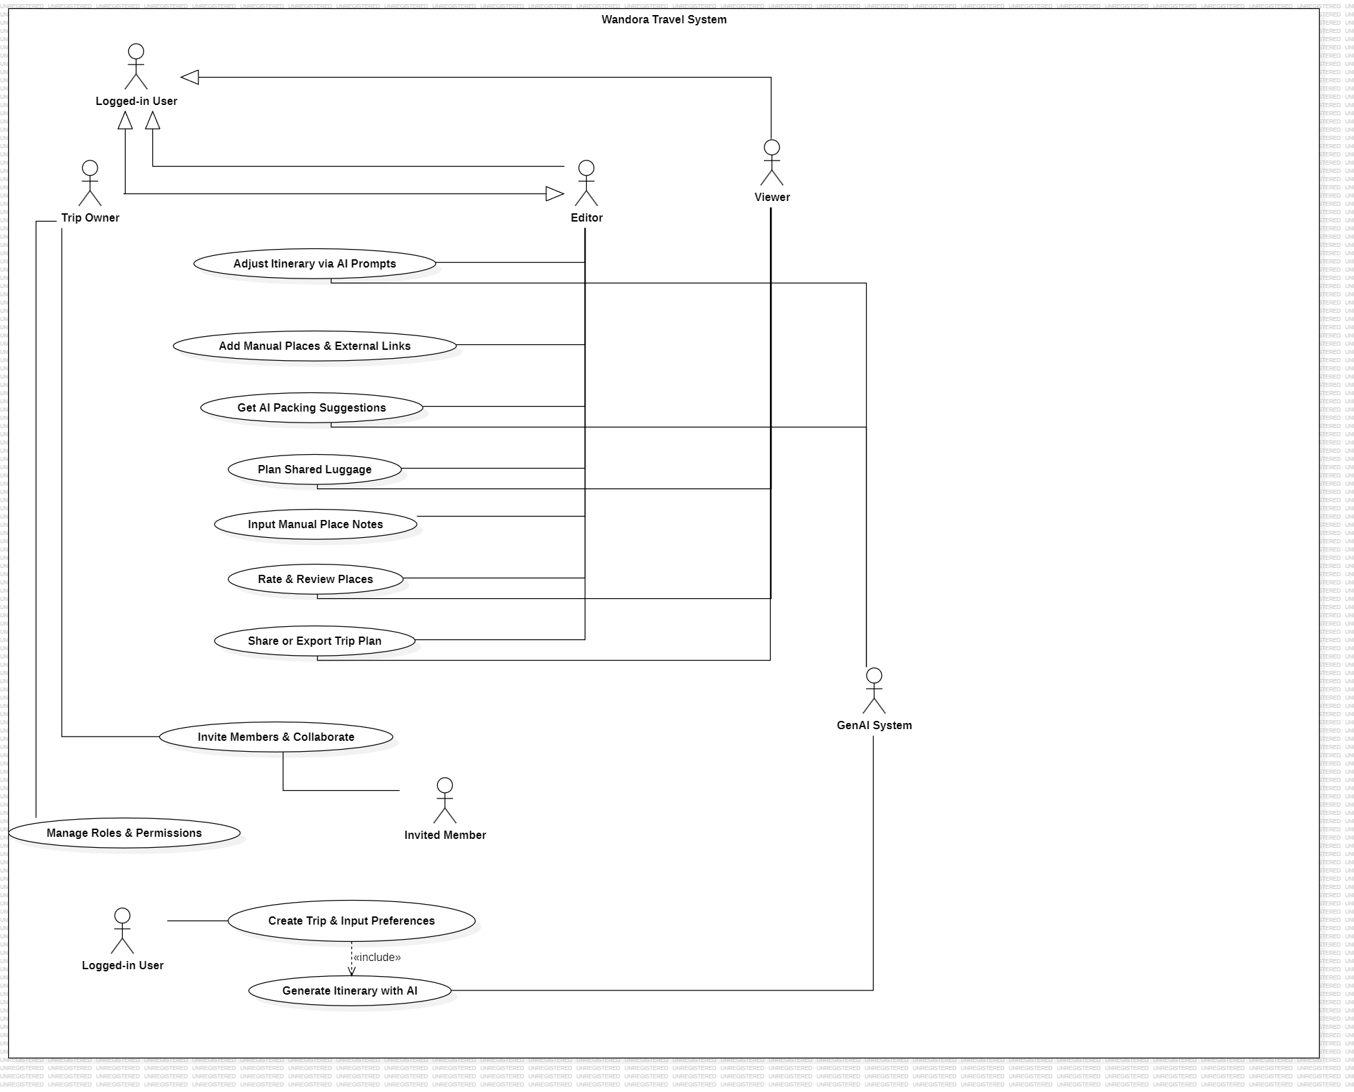

Use-case Specifications

2.1 Use-case: Trip Creation and Preference Input

Use case Name | Trip Creation and Preference Input
Brief description | Describes how a user initializes a new trip by configuring mandatory parameters required for the system and AI engine to understand their travel needs.
Actors | Logged-in User
Basic Flow | 1. The user clicks the "Create New Trip" button on the main dashboard.  2. The system displays a form requesting trip title, destination, start date, end date, group size, budget level, travel style, and optional notes.  3. The user enters the trip details and selects Continue.  4. The system validates required fields, date order, and numeric values.  5. The system checks the user's existing trips for a similar destination and overlapping dates.  6. If the user chooses to continue, the system starts UC 2.2 to generate an itinerary preview.
Alternative Flows | Alternative Flow 1: Missing or invalid details  If a required field is empty, the end date is before the start date, or group size/budget is invalid, the system identifies the invalid field and asks the user to correct it.  Alternative Flow 2: Similar trip found  The system shows matching trip title, destination, and dates. The user may open the existing trip, use its details as a starting point, or continue as a new trip. The system creates a new trip only after explicit confirmation.  Alternative Flow 3: Unauthenticated user  The system redirects the guest to the Login screen.
Pre-conditions | The user is authenticated.
Post-conditions | Valid trip details are available for AI preview generation.

2.2 Use-case: AI Itinerary Generator

Use case Name | AI Itinerary Generator
Brief description | Generates an initial itinerary preview from the trip details entered by the user.
Actors | Logged-in User, GenAI System (Secondary Actor)
Basic Flow | - The system converts the trip details into a request for the GenAI System.  - The system sends the request and waits for the result.  - The GenAI System returns a structured itinerary containing itinerary days and activities.  - The system validates the returned data and displays the itinerary as an editable preview.  - The user may edit the preview, regenerate it, or continue to UC 2.13.
Alternative Flows | Alternative Flow 1: AI Service Timeout / API Error or invalid response  1a. The system informs the user that AI generation failed and offers Retry or Start with a blank itinerary.  2a. If the user chooses to retry, the system resends the payload. If blank, a default empty schedule is initialized.
Pre-conditions | Valid trip details have been entered in UC 2.1.
Post-conditions | An AI-generated or blank itinerary preview is available for user review.

2.3 Use-case: AI Itinerary Adjustment

Use case Name | AI Itinerary Adjustment
Brief description | Allows an authorized trip member to request a revised itinerary after a trip has been saved.
Actors | Trip Owner, Editor; GenAI System (secondary actor)
Basic Flow | - The user enters a natural-language instruction, for example: “Replace the museum on Day 2 with an outdoor activity.”  - The system sends the instruction and current trip context to the GenAI System.  - The system displays the revised itinerary proposal.  - The user accepts the proposed revision or discards it.  - If accepted, the system saves the revised itinerary, retains manual activities, and records a new itinerary version
Alternative Flows | Alternative Flow 1: Permission Interception for Viewer Accounts  1a. If a user with 'Viewer' status submits an AI prompt, the system halts the execution flow before contacting the GenAI System and displays an error modal: "403 Permission Denied. Viewers cannot modify trip schedules."  Alternative Flow 2: Partial Acceptance  1b. If the user accepts only some proposed operations, the system applies only the selected operations and discards the rest; the change history log records exactly which operations were applied.  Alternative Flow 3: Prompt Rejection  1c. The user clicks "Discard" on the entire proposed change set; the system makes no changes to the itinerary and does not write a history entry.  Alternative Flow 4: Concurrent Edit Conflict  1d. If another editor modified the same ItineraryActivity after the change set was generated but before acceptance, the system detects the version mismatch via the Concurrency Control Service, rejects the stale change set, and prompts the user to regenerate the adjustment against the latest itinerary state.  Alternative Flow 5: AI Service Timeout / Invalid Change Set  1e. If the GenAI System fails to respond within the timeout threshold or returns a change set referencing invalid or nonexistent activities, the system discards the response and displays: "AI could not process that request. Please rephrase or try again."
Pre-conditions | An existing itinerary is open, and the user possesses Editor or Trip Owner privileges.
Post-conditions | The accepted revision becomes the current itinerary; a previous itinerary version remains available for restoration.

2.4 Use-case: Manual Places and External Links

Use case Name | Manual Places and External Links
Brief description | Enables users to manually insert custom locations, custom notes, or external URLs (e.g., Google Maps links, booking reservations) into specific time slots.
Actors | Editor, Trip Owner
Basic Flow | 1. The user selects a specific day slot and clicks "Add Activity / Place".  2. The system opens a input modal requesting place name, category, custom notes, and optional external URLs.  3. The user inputs the place details and submits.  4. The system validates the entries, saves the activity item, and updates the timeline view.
Alternative Flows | Alternative Flow 1: Invalid URL Format  1a. If an external URL is malformed, the system displays an inline warning: "Please enter a valid URL (e.g., https://...)" and prompts for correction.  Alternative Flow 2: Viewer Restriction  1b. Viewers attempting to access the "Add Activity" button will find the control disabled or receive a permission restriction notice upon clicking.
Pre-conditions | The trip schedule view is active.
Post-conditions | A custom activity location with optional external references is appended to the itinerary day slot.

2.5 Use-case: Group Collaboration

Use case Name | Group Collaboration
Brief description | Allows the Trip Owner to invite registered users to a saved trip workspace and assign an initial access role.
Actors | Trip Owner
Basic Flow | 1. The Trip Owner opens the "Members & Settings" modal.  2. The Trip Owner enters the invitee's email address and selects an initial role ('Editor' or 'Viewer').  3. The system dispatches an invitation link to the recipient email.  4. Upon link acceptance, the system links the invited user account to the Trip with the assigned role.
Alternative Flows | Alternative Flow 1: Non-Owner Role Restriction  1a. If an Editor or Viewer attempts to open member management, the system hides administration controls or displays "Only Trip Owner can manage member invitations."  Alternative Flow 2: User Already Invited  2a. If the email is already assigned to the trip, the system alerts: "This user is already a member of this trip."
Pre-conditions | The user is authenticated as the Trip Owner.
Post-conditions | An invitation is dispatched and member access rights are configured upon acceptance.

2.6 Use-case: Role and Permission Management

Use case Name | Role and Permission Management
Brief description | The Trip Owner configures specific permissions for each person in the group to control who can edit and who can only view the information.
Actors | Trip Owner
Basic Flow | 1. The Trip Owner opens the "Member Management" section within the trip settings.  2. The system displays a list of all accounts currently present in the workspace.  3. Next to each member's name, the Trip Owner clicks the dropdown menu and selects one of three roles: Owner, Editor, or Viewer.  4. The system saves the new permission configuration and applies it instantly.
Alternative Flows | Alternative Flow 1: Unauthorized Modification Attempt by a Viewer  1a. If an account with Viewer permissions attempts to click data-modifying buttons (such as adding locations or changing the schedule), the system displays an action-denied warning and maintains the read-only interface.
Pre-conditions | The executing user must strictly be the designated Trip Owner of that specific trip.
Post-conditions | The system successfully applies Role-Based Access Control (RBAC) filters to the members' accounts.

2.7 Use-case: AI Packing Suggestions

Use case Name | AI Packing Suggestions
Brief description | Generates a customized packing checklist based on trip destination weather forecast, duration, and planned activities.
Actors | Logged-in User, GenAI System (Secondary Actor)
Basic Flow | 1. The user navigates to the Packing List tab and clicks "Generate AI Checklist".  2. The system queries external weather metadata and compiles trip activity tags.  3. The system requests recommendations from the GenAI System.  4. The GenAI System returns categorized items (e.g., Clothing, Electronics, Documents).  5. The system populates the trip's packing checklist view.
Alternative Flows | Alternative Flow 1: AI Unavailability  1a. If the AI generator fails, the system loads a standard default packing template based on general travel standards.
Pre-conditions | A saved trip with destination and travel dates.
Post-conditions | A personalized packing checklist is generated for the trip.

2.8 Use-case: Shared Luggage Planning

Use case Name | Shared Luggage Planning
Brief description | Allows members to check off packing items, assign item responsibilities to specific participants, and add custom personal or group items.
Actors | Logged-in User
Basic Flow | 1. The user opens the Packing List section.  2. The user checks/unchecks completed items or assigns an item to a designated member.  3. The user can add custom items to group or personal lists.  4. The system the system saves the latest item state.
Alternative Flows | Alternative Flow 1: Concurrent Update Conflict  1a. If two members update the same item simultaneously, the system resolves state via timestamp and displays the latest status.
Pre-conditions | A packing checklist exists for the trip.
Post-conditions | Luggage assignment states and completion checkboxes are persisted.

2.9 Use-case: Manual Place Note Input

Use case Name | Manual Place Note Input
Brief description | Provides functionality to update or modify specific notes, tips, or reminder text attached to an itinerary activity node.
Actors | Editor, Trip Owner
Basic Flow | 1. The user selects a place item on the schedule and clicks "Edit Notes".  2. The system opens a text editor showing existing note content.  3. The user modifies the text and clicks "Save".  4. The system updates the place record and displays the refreshed note on the UI.
Alternative Flows | Alternative Flow 1: Permission Denied for Viewers  1a. If a Viewer attempts to edit notes via direct client invocation, the backend API rejects the request with a 403 status code, and the UI displays "Permission Denied".
Pre-conditions | An activity place node exists within the itinerary schedule.
Post-conditions | The activity note text is updated in the database.

2.10 Use-case: Place Ratings and Reviews

Use case Name | Place Ratings and Reviews
Brief description | Allows participants to submit star ratings and textual feedback for visited places within an itinerary.
Actors | Logged-in User
Basic Flow | 1. The user selects a visited location and clicks "Add Review".  2. The system presents a rating widget (1-5 stars) and a review text box.  3. The user selects a rating, enters optional text feedback, and submits.  4. The system logs the review and links it to the user and place entity.
Alternative Flows | Alternative Flow 1: Modifying Existing Review  1a. If the user has previously reviewed the place, the system loads the prior review, allowing editing and updating.
Pre-conditions | The trip is active or completed, and the place item exists.
Post-conditions | A rating and optional review are saved for the selected itinerary activity or place and are visible to trip members.

2.11 Use-case: Share or Export Trip Plan

Use case Name | Share or Export Trip Plan
Brief description | Allows a trip member to generate a shareable link to the itinerary or export the trip plan as a downloadable file for offline access.
Actors | Logged-in User
Basic Flow | 1. The user opens the trip and clicks "Share / Export".  2. The system presents two options: "Generate Shareable Link" or "Export as PDF".  3. If the user selects "Generate Shareable Link", the user chooses view-only or editable access, and the system creates a unique URL.  4. If the user selects "Export as PDF", the system compiles the trip details into a formatted document.
Alternative Flows | Alternative Flow 1: Link Revocation  1a. If the Trip Owner revokes a previously generated link, the system invalidates the URL and denies further access to anyone using it.  Alternative Flow 2: Export Failure  2a. If the PDF export process fails, the system displays an error message: "Export failed. Please try again."
Pre-conditions | The trip has an itinerary with at least one populated day or activity.
Post-conditions | A shareable link is generated and accessible to recipients, or an exported file is available for download.

2.12 Use-case: User Login and Authentication

Use case Name | User Login and Authentication
Brief description | Describes how an unauthenticated guest logs into the Wandora application using their registered credentials to establish a secure session and access personalized features.
Actors | Unauthenticated Guest
Basic Flow | 1. The user clicks the "Login" button on the landing page, or is automatically redirected to the Login screen by the system upon attempting unauthorized actions (e.g., trying to create a trip as a guest).  2. The system displays the Login form requesting the user's email address and password.  3. The user inputs their registered email and password, then clicks the "Sign In" button.  4. The system validates the credentials against the user database, authenticates the session, and redirects the user to the main dashboard.
Alternative Flows | Alternative Flow 1: Invalid Credentials  1a. If the entered email or password does not match any registered account, the system displays a validation error: "Incorrect email or password. Please try again."  2a. The system keeps the login form active for retry.  Alternative Flow 2: Missing Required Fields  1b. If the user leaves the email or password fields blank, the system displays an inline warning: "Please fill in all required fields."
Pre-conditions | The user is not currently logged into any active session in the Wandora application.
Post-conditions | A secure session is successfully established, the user is transitioned to the Logged-in User role, and their role-based permissions (RBAC) are fully initialized.

2.13 Use-case: Review and save AI Itinerary

Use case Name | Continue Trip Details After AI SuggestionReview and Save AI Itinerary
Brief description | Defines what the user can do after receiving an AI itinerary preview and before creating the saved trip workspace.
Actors | Logged-in User, GenAI System (Secondary Actor)
Basic Flow | - The system displays the itinerary preview with the trip details.  - The user reviews the days and activities.  - The user may edit a displayed activity, regenerate the preview, or add a manual activity.  - The user selects Save Trip.  - The system creates the trip workspace, saves the accepted itinerary, assigns the creator as Trip Owner, and sets the trip status to Planning.  - The system opens the saved trip workspace.
Alternative Flows | Alternative Flow 1: User return to details  The system returns to UC 2.1 and retains the entered details where possible.  Alternative Flow 2: User leave without saving  The system warns that the preview will not be saved as a trip.
Pre-conditions | UC 2.2 has produced an itinerary preview or a blank itinerary.
Post-conditions | A saved trip workspace and its accepted itinerary exist; the user can continue planning from the workspace.

2.14 Use-case: Post-Scheduling Feature Access

Use case Name | Post-Scheduling Feature Access
Brief description | Defines the shared precondition and entry points for the features that become available once a Trip has an accepted itinerary, consolidating logic that was previously implicit and undocumented across separate use cases.
Actors | Logged-in User, Editor, Trip Owner, Viewer
Basic Flow | 1. Once a Trip's status is "Planned" (per UC 2.13), the system unlocks the following tabs on the Trip workspace: Packing List (UC 2.7, UC 2.8), Ratings & Reviews (UC 2.10), and Share/Export (UC 2.11).  2. The user selects any unlocked tab; the system routes to the corresponding use case.  3. The system displays a completion indicator (e.g., "3 of 5 planning steps complete") on the Trip Overview screen summarizing which post-scheduling features have been used.
Alternative Flows | Alternative Flow 1: Feature Accessed Before Itinerary Exists  1a. If a user attempts to open the Packing List, Ratings, or Export tab while the Trip status is still "Draft", the system displays: "Generate or accept an itinerary before using this feature" and links back to UC 2.2 / UC 2.13.
Pre-conditions | The Trip status is "Planned" (an itinerary has been generated and accepted).
Post-conditions | The requested post-scheduling feature is presented to the user, and the Trip Overview's completion indicator is updated.

2.15 Use-case: Group Member Interaction (Voting and Comments)

Use case Name | Group Member Interaction (Voting and Comments)
Brief description | Allows trip members to discuss and vote on an itinerary activity or a proposed alternative before a Trip Owner or Editor changes the itinerary.
Actors | Trip Owner, Editor, Viewer
Basic Flow | 1. A member opens an activity or saved-place card.  The member writes a comment or proposes an alternative.  The system saves and displays the comment or proposal to trip members.  Members vote for an available option.  The system displays vote totals.  A Trip Owner or Editor may use the result as input for UC 2.3 or UC 2.4.
Alternative Flows | Alternative Flow 1: Viewer Voting Restriction  A Viewer can comment and vote but cannot apply a change to the itinerary.  Alternative Flow 2: Tie  The system displays “No consensus yet”; the Trip Owner makes the final decision.
Pre-conditions | The user is an authenticated member of a saved trip and an activity or saved place exists.
Post-conditions | Comments, proposals, and votes are available to trip members. The itinerary changes only when an authorized user applies a decision.

2.16 Use-case: Duplicate/Similar Trip Detection

Use case Name | Duplicate/Similar Trip Detection
Brief description | Prevents clutter and confusion from near-identical trips by detecting overlap with the user's existing trips at creation time, and offers to reuse or template from an existing trip instead of creating a redundant one.
Actors | Logged-in User, System
Basic Flow | 1. During step 3 of UC 2.1 (Trip Creation and Preference Input), after the user submits trip parameters but before the draft Trip is persisted, the system queries the user's existing Trips for matches on destination and overlapping date ranges.  2. If one or more matches are found, the system displays a comparison prompt: "You have [N] similar trip(s). Continue as a new trip, use one as a template, or open the existing trip?"  3. If the user selects "Use as template", the system pre-fills the new Trip's preference parameters (destination, travel style, budget level) from the selected existing Trip and proceeds to UC 2.2.  4. If the user selects "Open existing trip", the system discards the in-progress draft and navigates to the selected Trip's overview.  5. If the user selects "Continue as new", the system proceeds with UC 2.1 step 4 unchanged.
Alternative Flows | Alternative Flow 1: No Matches Found  1a. If no existing Trip matches, the system proceeds directly with UC 2.1 step 4 without displaying the prompt.
Pre-conditions | The user has submitted valid trip creation parameters (UC 2.1, step 3).
Post-conditions | Either a new Trip is created (fresh or templated from an existing one), or the user is redirected to an existing Trip; no duplicate Trip is created without explicit user confirmation.

2.17 Use-case: Trip History

Use case Name | Trip History
Brief description | Allows users to review and reopen their saved trips and restore a previous itinerary version when available.
Actors | Logged-in User
Basic Flow | 1. The user opens My Trips or Trip History from the dashboard.  2. The system lists trips in most-recently-updated order and shows title, destination, trip status, creation date, and last updated date.  3. The user selects a trip to open its workspace.  4. If the trip has previous itinerary versions, the user opens Version History and may restore one version.  5. The system restores the selected version and shows it as the current itinerary.
Alternative Flows | Alternative Flow 1: Empty History  The system displays “No trips yet” and offers Create New Trip.  Alternative Flow 2: No previous version  The system explains that a version is created after a later regeneration or revision.
Pre-conditions | The user is authenticated.
Post-conditions | The user has opened a saved trip or restored a previous itinerary version.

