WEEKLY REPORT - GROUP 11
Sprint 5 - Week 3
Wandora
AI-assisted Group Trip Planning and Management Application

Team Members
No. | Member Name | Student ID
1 | Lê Thanh Hải | 23127360
2 | Bùi Thế Anh | 23127021
3 | Đặng Nhật Minh | 24127077
4 | Nguyễn Hoài Đức | 24127344

1. Achievements since last week
No. | Description | Due Date | Responsible | Completion
1 | Frontend Completion & System Integration: Finalized frontend implementation and connected all completed frontend flows with backend services. | 01/09/2026 | Lê Thanh Hải | 100%
2 | Backend Review & Integration Fixes: Reviewed existing backend implementation, fixed remaining integration defects, and adjusted APIs where required for complete system operation. | 01/09/2026 | Lê Thanh Hải | 100%
3 | Automated Test Script Development: Developed the initial Selenium automated test scripts that were later reviewed, corrected, and executed during final integration. | 31/08/2026 | Nguyễn Hoài Đức | 100%
4 | Automated Test Refinement & Execution: Reviewed and corrected the existing Selenium automated test scripts, executed the automated test suite, analyzed results, and resolved execution issues. | 01/09/2026 | Lê Thanh Hải | 100%
5 | Automation Test Report: Documented automated testing scope, execution results, Pass/Fail status, and identified issues. | 04/09/2026 | Lê Thanh Hải | 100%
6 | Test Plan, Use Case & Test Case Review: Reviewed the Test Plan and Use-Case Specifications, corrected inconsistencies, and updated test cases to ensure coverage of implemented use cases. | 01/09/2026 | Lê Thanh Hải | 100%
7 | Manual Test Execution & Test Report: Executed manual test cases, recorded Actual Result, Pass/Fail status, Tester and Date Tested, and completed the final Test Report. | 01/09/2026 | Lê Thanh Hải | 100%
8 | Final System Integration & Documentation: Connected frontend, backend, and testing artifacts; reviewed final deliverables and prepared the weekly/final project documentation. | 01/09/2026 | Lê Thanh Hải | 100%
9 | Presentation slides and scripts | 03/09/2026 | Đăng Nhật Minh & Lê Thanh Hải | 100%

Issues and impacts
Issue: Several frontend-backend integration inconsistencies and unstable automated test cases were discovered during final system testing. In addition, test case review, manual test execution, automated test execution, and reporting were concentrated in the final week.
Impact: Additional fixes and repeated regression testing were required before final submission. This increased the workload during the final integration phase and required several test cases and automation scripts to be updated and re-executed.
Action Taken: The frontend and backend integration was reviewed and corrected, Selenium automation scripts were refined, affected test cases were updated, and both manual and automated regression tests were executed again. The Test Plan, Use-Case Specifications, Test Report, and Automation Test Report were also reviewed and finalized.
Responsible: Lê Thanh Hải
Action Date: August 31st to September 3, 2026

3. Final contribution
The following summary reflects each member’s actual contribution during this last PA. GitHub commit history, pull requests, and code changes are included as supporting evidence where applicable.
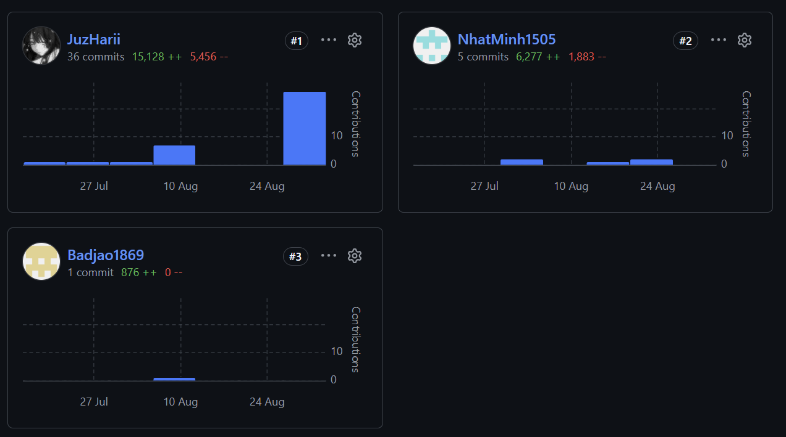
No. | Name | Github name | Main contribution
1 | Lê Thanh Hải | JuzHarii | Implemented the frontend throughout the project; reviewed and fixed backend implementation; completed frontend-backend integration; refined Selenium automated test scripts; executed automated and manual tests; reviewed Test Plan, Test Cases, and Use-Case Specifications; prepared Automation Test Report, Test Report, weekly reports, and final project integration.
2 | Đặng Nhật Minh | NhatMinh1505 | Implemented backend APIs and business logic for assigned use cases during the first two weeks of Sprint 5.
3 | Nguyễn Hoài Đức | Badjao1869 | Developed the initial Selenium automated test scripts for selected application flows.

