Wandora

Software Architecture Document

Version 1.3

Revision History
Date | Version | Description | Author
19/07/2026 | 1.0 | Initial draft | Nguyễn Hoài Đức
09/08/2026 | 1.1 | Revised. Added deployment and folder structure | Bùi Thế Anh
10/08/2026 | 1.2 | Rename keyclass and add Domain Model | Nguyễn Hoài Đức
11/08/2026 | 1.3 | Update pictures of rename classes | Bùi Thế Anh

Table of Contents
1. Introduction 4
2. Architectural Goals and Constraints 4
3. Use-Case Model 5
4. Logical View 6
4.1 Component: Web Client (UI) 6
4.2 Component: Backend Server 8
4.3 Component: AI Integration Module 9
4.4 Component: Collaboration & Persistence 9
5. Deployment 11
6. Implementation View 12

Software Architecture Document

Introduction
- Purpose: This Software Architecture Document (SAD) provides a comprehensive overview of the Wandora project's system structure. It describes critical architectural decisions, technical goals, and constraints to ensure the system meets both functional and non-functional requirements.
- Scope: Applied to the Wandora web application, which supports AI-integrated group trip planning.
- References: Vision Document, Software Development Plan (SDP), Use-case Specification.
- Overview: The architecture focuses on flexible integration with AI services (GenAI), real-time data management for group collaboration, and cross-device compatibility via a responsive web interface.

Architectural Goals and Constraints
Architectural Goals:
- Performance: The system must ensure that the AI responds and generates schedules within a short timeframe (measured in seconds) to avoid disrupting the user experience.
- Usability: The interface architecture must be simple and intuitive, suitable for students and young travelers, requiring no complex technical skills.
- Compatibility: The system must operate stably on popular browsers (Chrome, Edge, Safari) and automatically adapt to various screen sizes, from desktops (PC) to smartphones.
- Security & Access Control: The architecture must support secure invite link mechanisms (secure tokens) to protect shared workspaces. A Role-Based Access Control (RBAC) model is applied to manage editing permissions among Owners, Editors, and Viewers.
Architectural Constraints:
- Schedule: The project has a fixed 9-week schedule (from June 21, 2026, to August 23, 2026).
- Budget: The project operates on a zero budget; therefore, the architecture prioritizes the use of open-source technologies and free services.
- Functional Constraints: The architecture does not include or support modules for ticket booking, direct payments, or real-time price updates.
- Team Structure: The team consists of 4 members with specialized roles (Leader, Arch & DB, Backend & AI, Tester), requiring the architecture to be clearly modularized to support parallel work.
- Tools and Processes: GitHub is used for source code management and Jira for progress tracking. This requires CI/CD processes or branching strategies to be tightly integrated into the deployment structure.

Use-Case Model
The system supports 5 user roles, modeled as actors:
- Logged-in User: an authenticated user who can create trips and use the AI assistance features.
- Editor: a collaborator who can view and modify trip content.
- Trip Owner: the user who creates a trip and holds full administrative rights over members, roles, and settings.
- Viewer: a member with read-only access who can view the trip and rate or export it, but cannot modify it.
- Invited Member: a user who joins a shared workspace through an invitation link.
The AI system acts as a secondary actor, invoked through the backend for itinerary generation, itinerary adjustment, and packing suggestions.
The use-case model is defined in the Use-Case Specification. RBAC permissions restrict which actions each role may perform on the shared workspace.

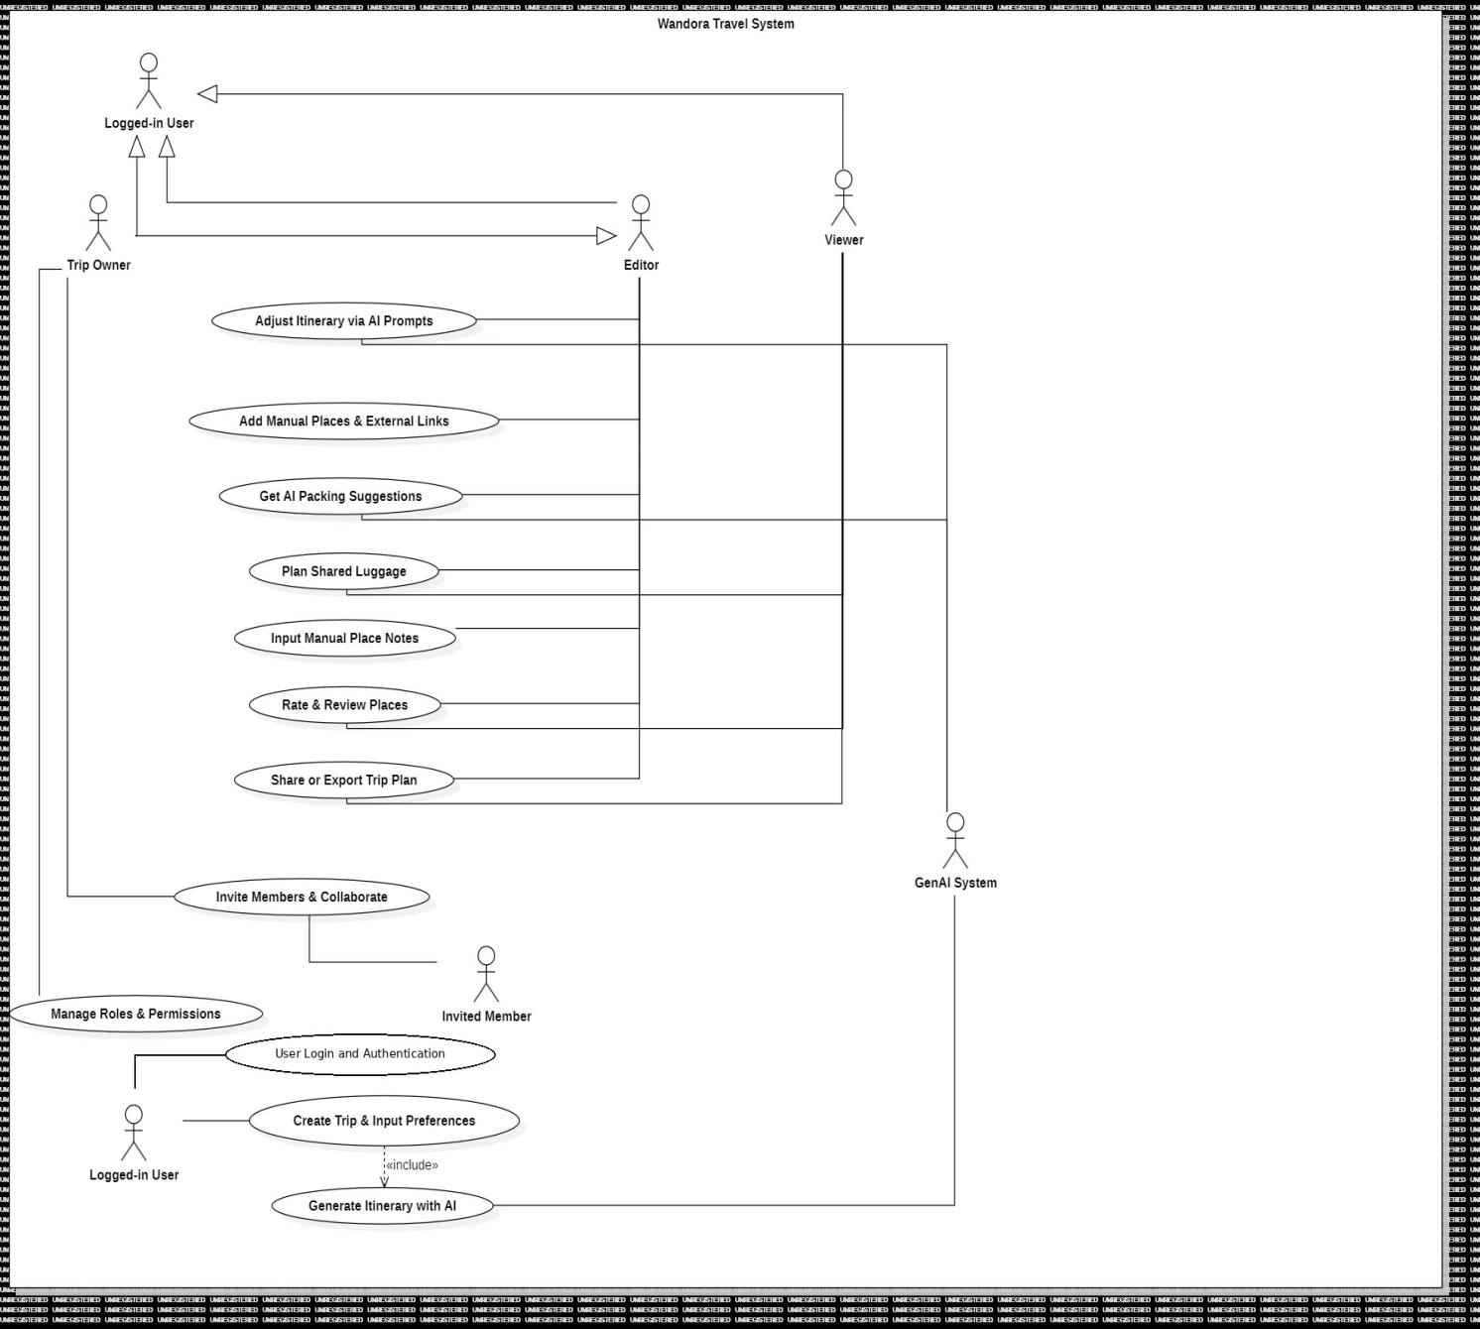
Domain Model:
- Trip: The top-level container a user creates via UC 2.1 (Trip Creation and Preference Input). A Trip holds the parameters supplied at creation including destination, travel dates, member capacity, budget level, and travel style along with its member list and each member's role (Owner, Editor, Viewer). A Trip exists as soon as it is created, before any itinerary has been generated. Over its lifecycle a Trip's status progresses: Draft → Planned (UC 2.13) → Completed.
- Plan / Itinerary: The schedule of activities belonging to a Trip. An Itinerary is produced by UC 2.2 (AI Itinerary Generator) and subsequently modified by UC 2.3 (AI Itinerary Adjustment) or UC 2.4 (Manual Places and External Links). Structurally, an Itinerary is composed of one or more ItineraryDay records, each containing one or more ItineraryActivity records. "Plan" and "Itinerary" are used interchangeably in user-facing text (Vision Document, UI Design) and should be treated as synonyms referring to this same entity; documentation should standardize on "Itinerary" in technical contexts and may use "Plan" only in user-facing copy.
- Relationship: A Trip has exactly one active Itinerary at a time. Trip (1) → Itinerary (1, generated) → ItineraryDay (many) → ItineraryActivity (many). Prior versions of an Itinerary are not discarded on edit — each accepted change set from UC 2.3 increments the Itinerary's version number and is retained in the Trip's change history (surfaced via UC 2.17), enabling audit and rollback.

Logical View
The system is designed based on the N-tier architecture model to ensure a clear separation between the user interface, business logic, and data storage. This architecture enables a team of four members to develop the UI/UX, Backend, Database, and AI components independently and in parallel.
The core focus of the architecture is the flexible integration with third-party AI services (GenAI) through APIs and the capability for real-time data updates, allowing members of a travel group to collaborate online. All communication between the layers is carried out through secure protocols such as HTTPS/REST and WebSockets to ensure data integrity.
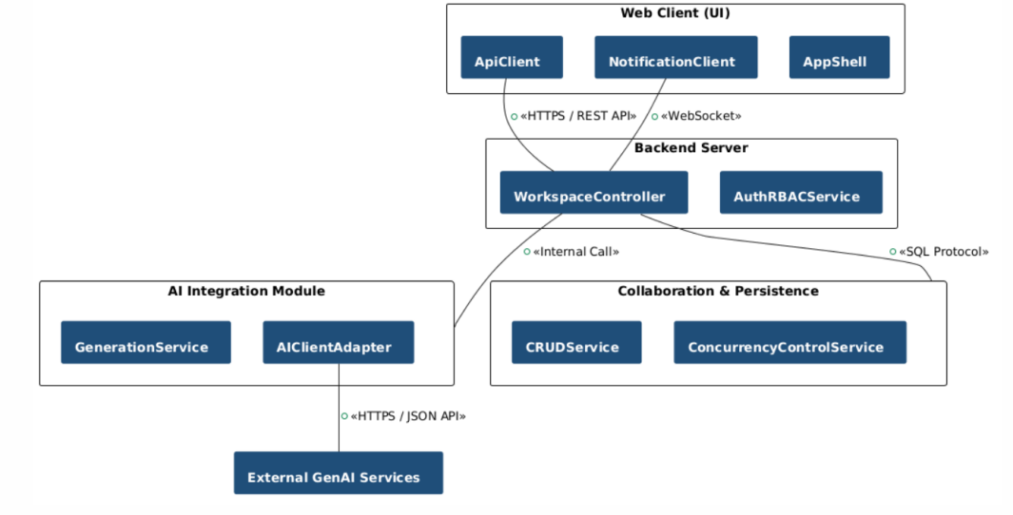

Component: Web Client (UI)
Responsibilities:
- Event Handling Service: Provides the interface for users to input trip preferences and a chat box to interact with the "AI Assistant".
- UI Rendering Service: Displays visual schedules in a Timeline format.
- Real-time Notification Service: Synchronizes real-time data for members within a collaboration group.
Key Classes:
- AppShell: The central navigation layer and application initialization.
- WorkspaceViewController: The main controller responsible for managing the workspace state of the trip.
- TimelineRenderer: The UI component responsible for rendering and displaying the itinerary in a timeline format.
- ChatWidget: The chat interface component that interacts directly with the AI Assistant.
- PackingListView: The UI component for managing and assigning the shared packing list.
- ApiClient: The service layer responsible for sending REST API requests to the Backend.
- NotificationClient & WebSocketClient: The service classes responsible for managing WebSocket connections for real-time data synchronization.
- Protocols: Communicates with the Backend via HTTPS/REST API and WebSockets for real-time updates.

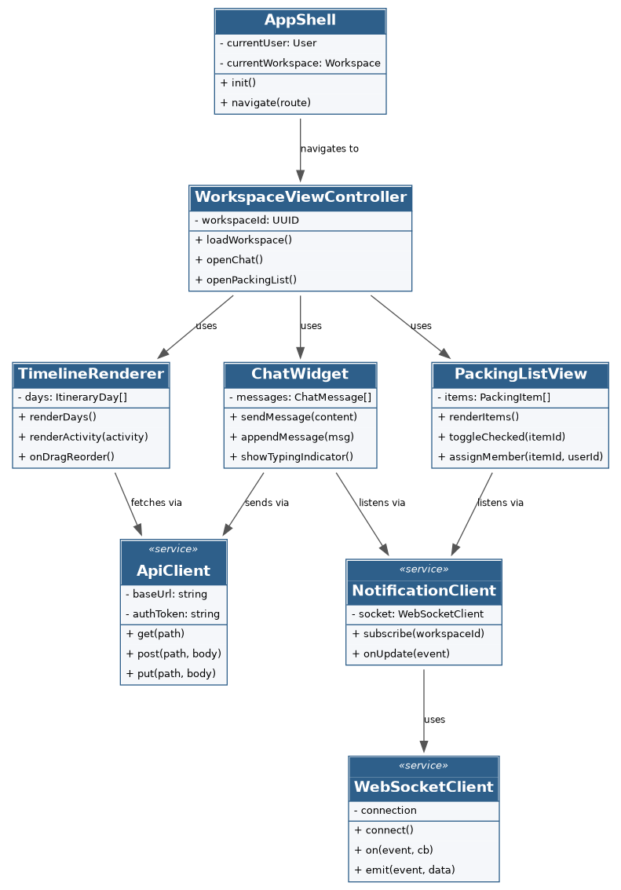

Component: Backend Server
Responsibilities:
- Handles core business logic for trip initialization and storage.
- Auth & RBAC Service: Manages role-based access control (Owner, Editor, Viewer).
- Export Service: Processes requests to export schedules as PDF or images.
Key Classes:
- AuthRBACService: The service responsible for user authentication and authorization checks (Owner, Editor, Viewer).
- TripService: The service responsible for handling the business logic for creating, updating trips, and managing members.
- ExportService: The service responsible for compiling trip data for export as a PDF or image file.
- User, Trip, TripMember, Rating: The entity classes representing account information, trip workspace, member roles, and reviews.
Protocols: Connects to the Database via database management system protocols and to the Frontend via HTTPS.
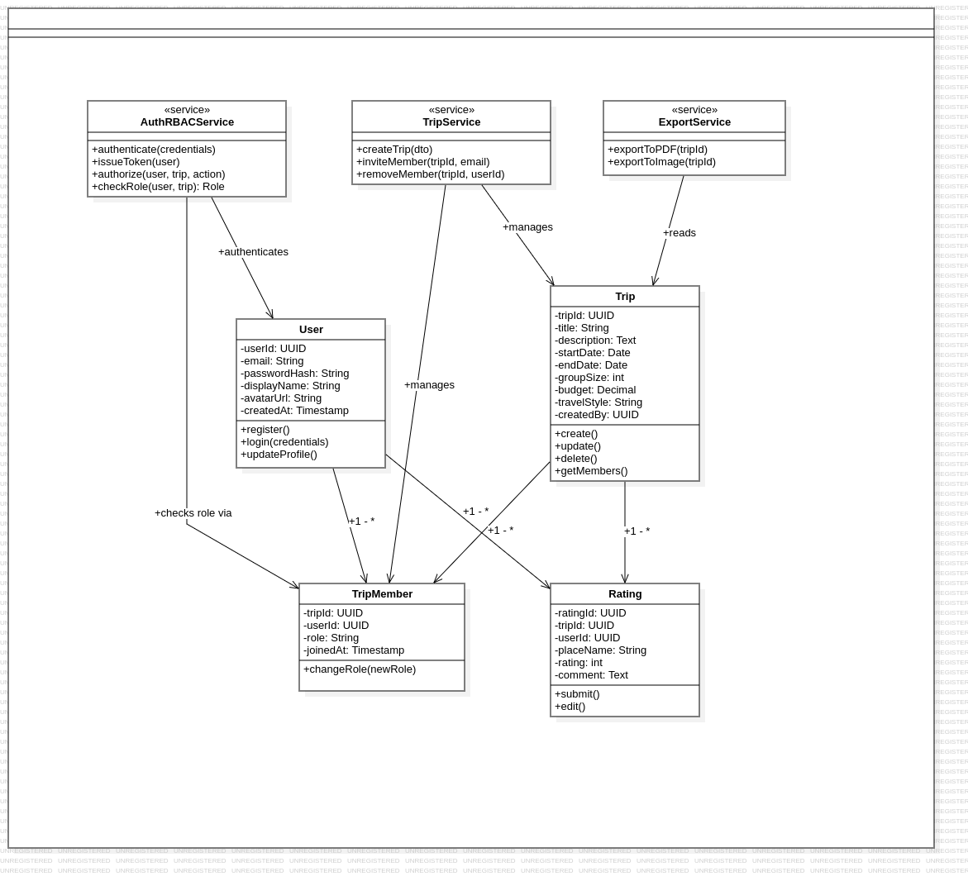

Component: AI Integration Module
Responsibilities:
- Generation Service: Receives preference data from the system and reformats it to send requests to the GenAI.
- NLP Service: Processes natural language commands from users to adjust schedules.
- Packing Suggestion Service: Analyzes weather and activities to provide luggage recommendations.
Key Classes:
- GenerationService: The service responsible for receiving preference filters to initialize and generate the itinerary automatically.
- NLPService: The service responsible for analyzing and processing itinerary modification commands in natural language.
- PackingSuggestionService: The service responsible for analyzing activity and weather data to suggest a packing list.
- AIClientAdapter: The Adapter class acting as a bridge to transform data and directly invoke third-party APIs (OpenAI/Gemini).
- ItineraryActivity, ChatMessage, PackingItem: The entity classes responsible for receiving and storing the results returned by the AI.
Protocols: Connects to third parties (OpenAI/Gemini API) via HTTPS/JSON.
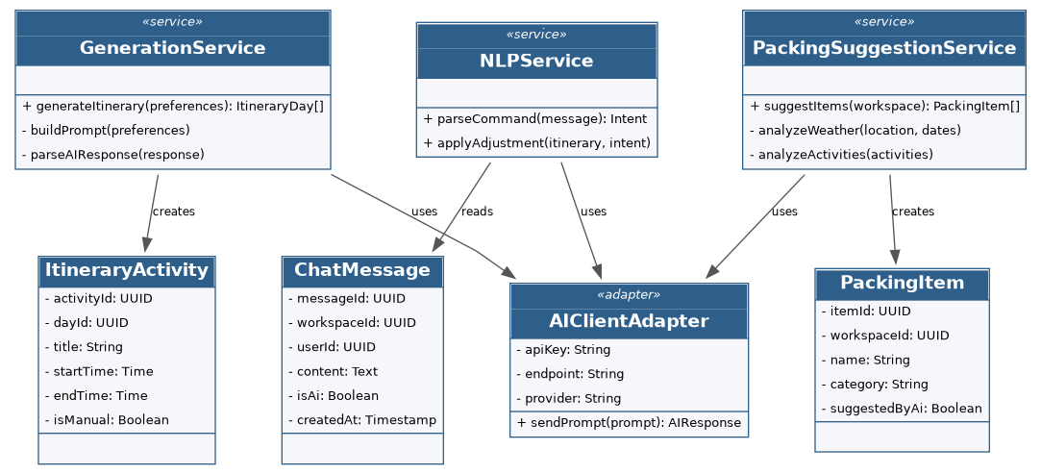

Component: Collaboration & Persistence
Responsibilities:
- Token Management Service: Manages shared Trips and invite links with secure tokens.
- CRUD Service: Stores and queries data, including location ratings and schedules.
- Concurrency Control Service: Ensures data integrity for "Read-only" states when the AI is editing or when multiple users are making simultaneous changes.

Database design:
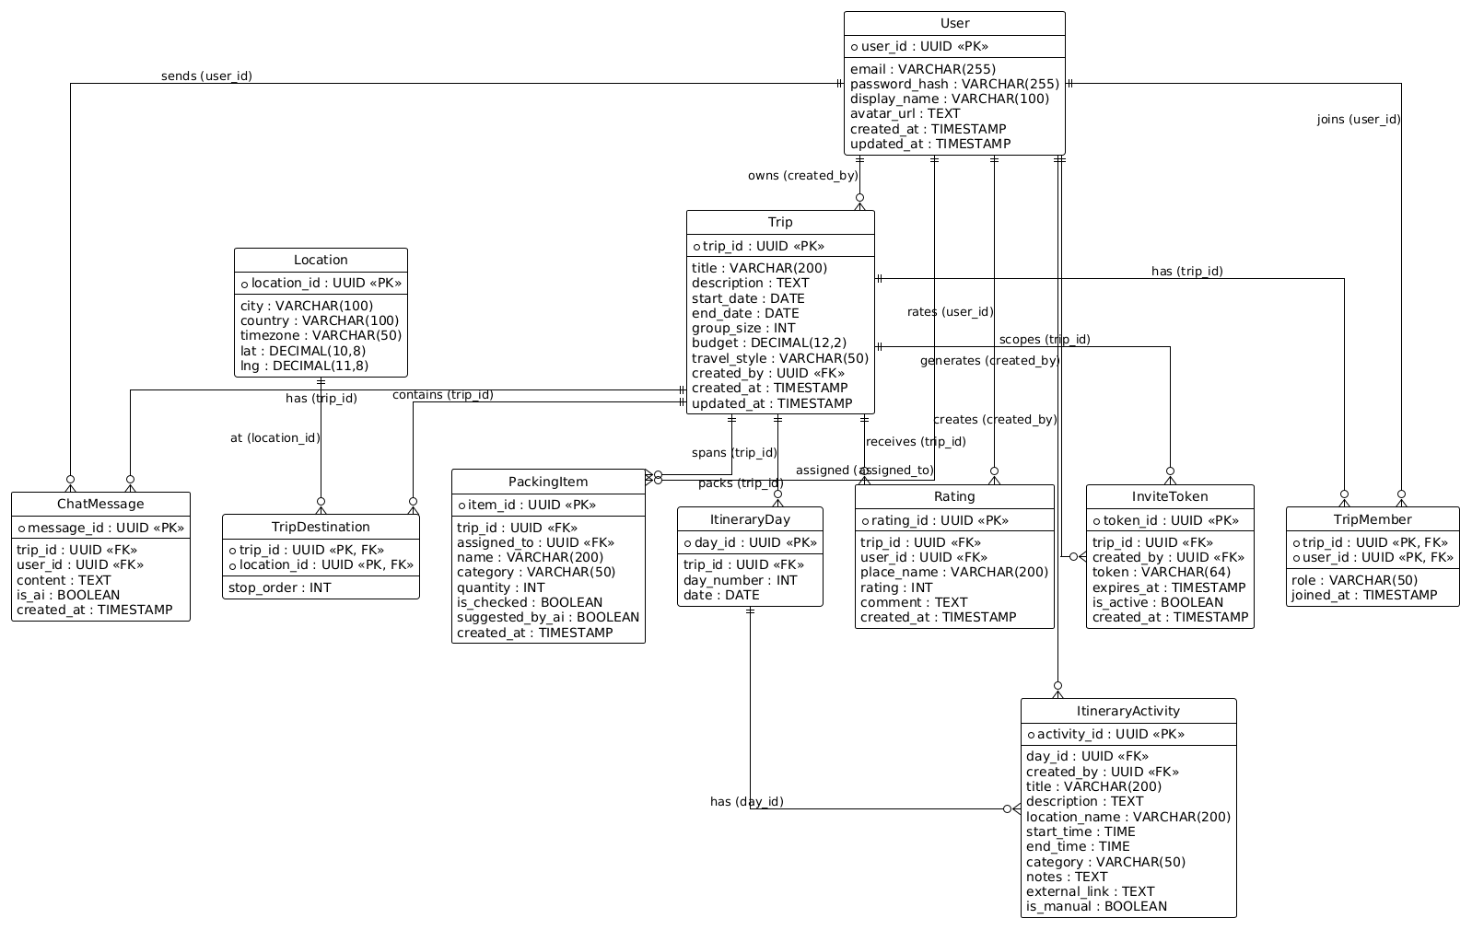

The workspace is the central aggregate that represents one trip:
- User: account data (email, name,...).
- Trip: data for one whole trip (title, start_date...).
- TripMember: links a user to a workspace and stores ownership via member role.
- TripDestination: an ordered stop along a trip's route, linking a trip to a location (trip_id, location_id, stop_order).
- InviteToken: a secure token for an invitation link that grants a user access to a trip (token_id, trip_id, created_by, token, expires_at, is_active, created_at).
- ItineraryDay: one day of the itinerary (date, trip_id...).
- ItineraryActivity: one activity or place on a day (start_time, end_time...).
- PackingItem: an item in the shared packing list (name, quantity...).
- Rating: a user rating for a destination (rating, comment...).
- ChatMessage: an AI assistant message (content, created_at...).
- Location: geographic data referenced by activities (city, country...).
A trip aggregates one or more itinerary days, packing items, ratings, and chat messages; each itinerary day aggregates one or more itinerary activities.
Key Classes:
- ConcurrencyControlService: The service responsible for controlling concurrent editing conflicts and locking data while the AI performs updates.
- TokenManagementService: The service responsible for creating, managing, and validating invitation links (Invite Links) containing security tokens.
- CRUDService: The service responsible for executing basic data query and storage operations in the database.
- InviteToken, TripDestination, ItineraryDay, Location: The entity classes responsible for storing invitation tokens, destination associations, itinerary days, and geographic location information.
Protocols: Provides data to the Backend Server via SQL queries and synchronizes status with the Web Client via WebSockets for updating shared packing lists.
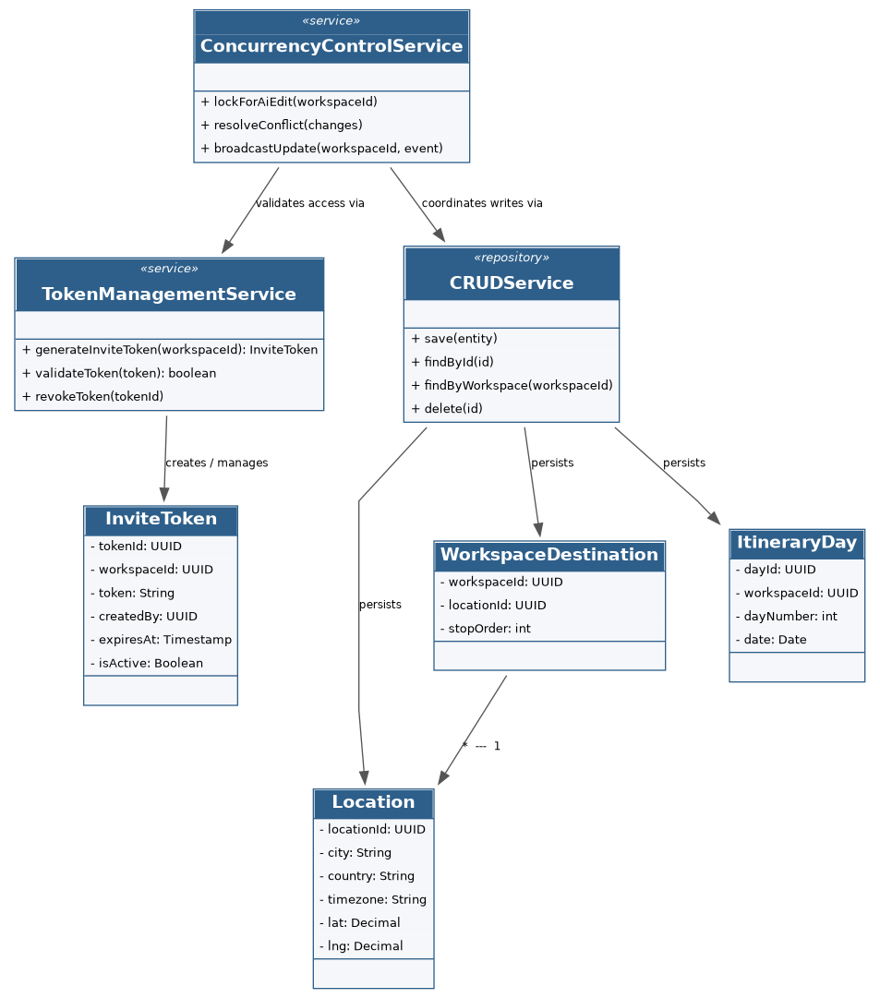

Deployment
The Wandora system is deployed as a client-server web application with the following nodes:
- Web Client: a browser (e.g. Chrome, Edge, Safari) rendering the single-page frontend.
- Web/App Server: the production host that serves the built frontend and runs the FastAPI backend; exposes the REST API over HTTPS and real-time updates over WebSocket.
- Database Server: a PostgreSQL instance reached over SQL/TCP on the internal network.
- GenAI System: an external AI provider (OpenAI/Gemini) invoked by the backend over HTTPS/JSON.
The clients communicate with the Web/App Server over HTTPS, with WebSocket used for real-time collaboration. The Web/App Server connects to the Database Server over SQL/TCP and to the GenAI System over HTTPS/JSON.
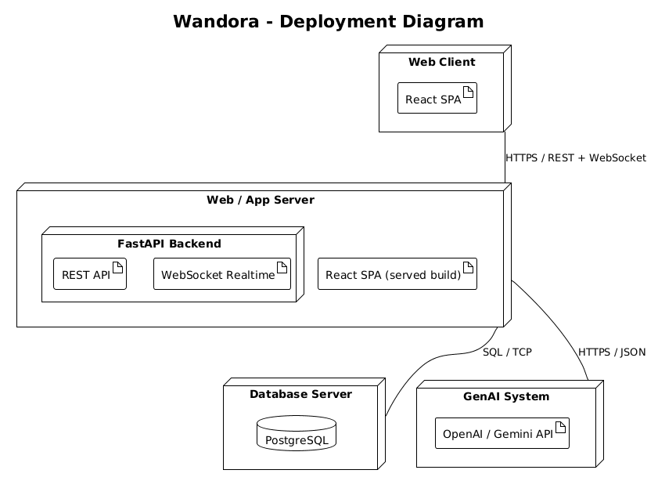

Implementation View
The project is organized as a monorepo containing the frontend and backend in the same repository. The folder structure is as follows:
wandora/
|-- docs/ (documentation)
|-- pa/
|-- tests/ (e2e and unit tests)
|-- src/
|-- frontend/ (React, Vite, TypeScript web client)
|-- backend/ (FastAPI application)
|-- migrations/
|-- app/
|-- api/v1/ (workspaces, itineraries, chat routers)
|-- core/ (config & security)
|-- db/ (database session)
|-- models/ (user, trip, itinerary, packing, chat)
|-- schemas/ (pydantic request and response models)
|-- services/ (business logic, AI integration)
|-- requirements.txt
|-- main.py

