Wandora

Software Development Plan

Version 1.0

Revision History
Date | Version | Description | Author
11/07/2026 | 1.0 | Initial draft | Nguyễn Hoài Đức, Đặng Nhật Minh, Lê Thanh Hải

Table of Contents
1. Introduction 4
2. Project Overview 4
2.1 Project Purpose, Scope, and Objectives 4
2.2 Assumptions and Constraints 4
2.3 Project Deliverables 4
3. Project Organization 5
3.1 Organizational Structure 5
3.2 Roles and Responsibilities 5
4. Management Process 6
4.1 Project Estimates 6
4.2 Project Plan 6
4.2.1 Phase and Iteration Plan 6
4.2.2 Releases 6
4.2.3 Project Schedule 7
4.3 Project Monitoring and Control 7
4.3.1 Reporting 7
4.3.2 Risk Management 7
4.3.3 Configuration Management 7

Software Development Plan

Introduction
This document provides a detailed development plan for the Wandora project, an AI-integrated application supporting group trip planning and management. The objective of this document is to guide the development team on the processes, schedule, and project management methods throughout the RUP phases.

Project Overview

Project Purpose, Scope, and Objectives
- Purpose: Resolve the fragmentation in group trip planning by providing an AI-integrated shared workspace.
- Scope: A web application supporting automatic itinerary creation, AI adjustment, management of luggage lists, costs, and member permissions. The project does not include booking or direct payment features.
- Objectives: Help users (students, young travelers) save time and minimize conflicts when dividing tasks and costs within the group.

Assumptions and Constraints
- The project has a fixed schedule lasting approximately 9 weeks, starting from June 21, 2026, and ending on August 23, 2026.
- Project budget is 0.
- The team consists of 4 members with clearly defined roles.
- The product must run stably on popular browsers (Chrome, Edge, Safari) and mobile devices.

Project Deliverables
Artifacts | Delivery Date | Phase
Project Proposal | 28/06/2026 | PA0
Software Development Plan (SDP - current version) | 12/07/2026 | PA1
Software Requirements Specification (SRS) | 12/07/2026 | PA2
Software Architecture Document (SAD) & Test Plan | 26/07/2026 | PA3
Working Software - Iteration 1 | 26/07/2026 | PA3
Implementation & Testing | 09/08/2026 | PA4
Final Working Software | 23/08/2026 | PA5
Final Project Reports | 23/08/2026 | PA5

Project Organization

Organizational Structure

Team Lead & Developer: Lê Thanh Hải

Developer(Arch & DB): Bùi Thế Anh

Developer(Backend & AI): Đặng Nhật Minh

Tester: Nguyễn Hoài Đức

Roles and Responsibilities

Person | Role
Lê Thanh Hải, Team leader  Bùi Thế Anh, Developer(Arch & DB)  Đặng Nhật Minh, Developer(Backend & AI)  Nguyễn Hoài Đức, Tester | Responsible for overall project management, scheduling tasks on Jira, tracking progress, chairing group meetings; simultaneously eliciting, analyzing, and documenting software requirements (SRS) and preliminary UI/UX design.  Responsible for designing system architectural structures, building database diagrams, developing main backend APIs, and configuring source code configuration management (GitHub).  Responsible for developing the core backend system, integrating AI algorithms for itinerary creation, and intelligent feature processing logic for the application.  Responsible for creating the Test Plan, designing test scenarios (functional testing, integration testing, UI compatibility), performing manual/automated testing, and tracking/managing bugs on Jira.

Management Process

Project Estimates

Project Plan

Phase and Iteration Plan

- Inception:
- Sprint 1 (21/6 – 28/6): Focus on project startup. The main objective is to establish the business case, conduct user interviews, define product scope at a high level, and deliver the Project Proposal (PA0).
- Elaboration:
- Sprint 2 (29/06/2026 – 12/07/2026): Focus on clarifying requirements and establishing a baseline plan. Objectives include refining user requirements, drafting the Software Development Plan (SDP), Software Requirements Specification (SRS), and designing UI wireframe prototypes (PA1 & PA2).
- Sprint 3 (13/07/2026 – 26/07/2026): Focus on architectural design and early implementation. Objectives include finalizing the Software Architecture Document (SAD), preparing the Test Plan, setting up the development environment, and building the first working software version (Iteration 1 Build) (PA3).
- Construction:
- Sprint 4 (27/07/2026 – 09/08/2026): Focus on core programming and continuous testing. The objective is to implement source code for AI itinerary creation features, group workspaces, and expense tracking, followed by integration testing (PA4).
- Sprint 5 (10/08/2026 – 23/08/2026): Focus on system integration, refinement, and final delivery. The objective is to optimize the application for stability on web browsers, fix bugs, export the final test log, and prepare the final product with a summary report (PA5).
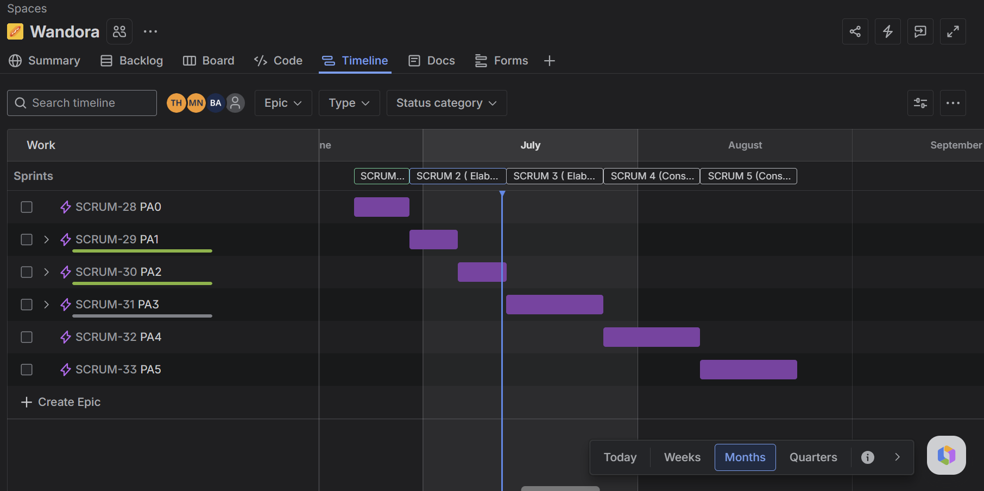

Releases
- Release 1 (End of Sprint 3): First working software version focusing on basic features.
- Release 2 (End of Sprint 4): Updated version after further implementation and testing of main features.
- Release Final (End of Sprint 5): Final completed product for PA5 submission.

Project Schedule

Main Activity | Sprint | Timeline | Expected Outcome
Propose the project idea and define the scope | Sprint 1 | 21/6 – 28/6 | Project Proposal
Conduct user interviews and analyze user needs | Sprint 2 | 29/6 – 7/7 | Interview findings
Define system requirements and product backlog | Sprint 2 | 8/7 – 12/7 | Requirements and prioritized backlog
Complete use cases and initial system design | Sprint 3 | 13/7 – 20/7 | Use cases, UI design, database design, and system architecture
Develop the first working software version | Sprint 3 | 21/7 – 26/7 | Basic authentication, trip creation, and itinerary planning
Develop AI itinerary generation and itinerary editing | Sprint 4 | 27/7 – 2/8 | AI-generated and editable itineraries
Develop group collaboration, expense management, and packing checklist | Sprint 4 | 3/8 – 9/8 | Integrated core features
Complete the remaining features and improve the user interface | Sprint 5 | 10/8 – 16/8 | Feature-complete software version
Perform testing, bug fixing, deployment, and final preparation | Sprint 5 | 17/8 – 23/8 | Final release and PA5 submission

Project Monitoring and Control

Reporting
- Regular meetings: The team meets in person or online once a week to update progress.
- Status reports: Daily/weekly work updates via common chat channel (Messenger) and the Jira task board.

Risk Management

Risk ID | Risk Description | Probability | Impact | Risk Exposure | Priority | Mitigation Strategy or Contingency Plan
 |  |  |  | =Probability * Impact

Configuration Management
- Document storage: Use Google Drive to share Word files, designs, and related documents.
- Source code management: Use GitHub as the main repository, adhering to branching processes for effective source code management.

