Wandora

Use-Case Specification

Version <1.0>

Revision History
Date | Version | Description | Author
<dd/mmm/yy | <x.x> | <details> | <name>

Table of Contents
1. Use-case Model 4
2. Use-case Specifications 4
2.1 Use-case: Add a product to cart 4
2.2 Use-case: Create a new account 5

Use-case Model

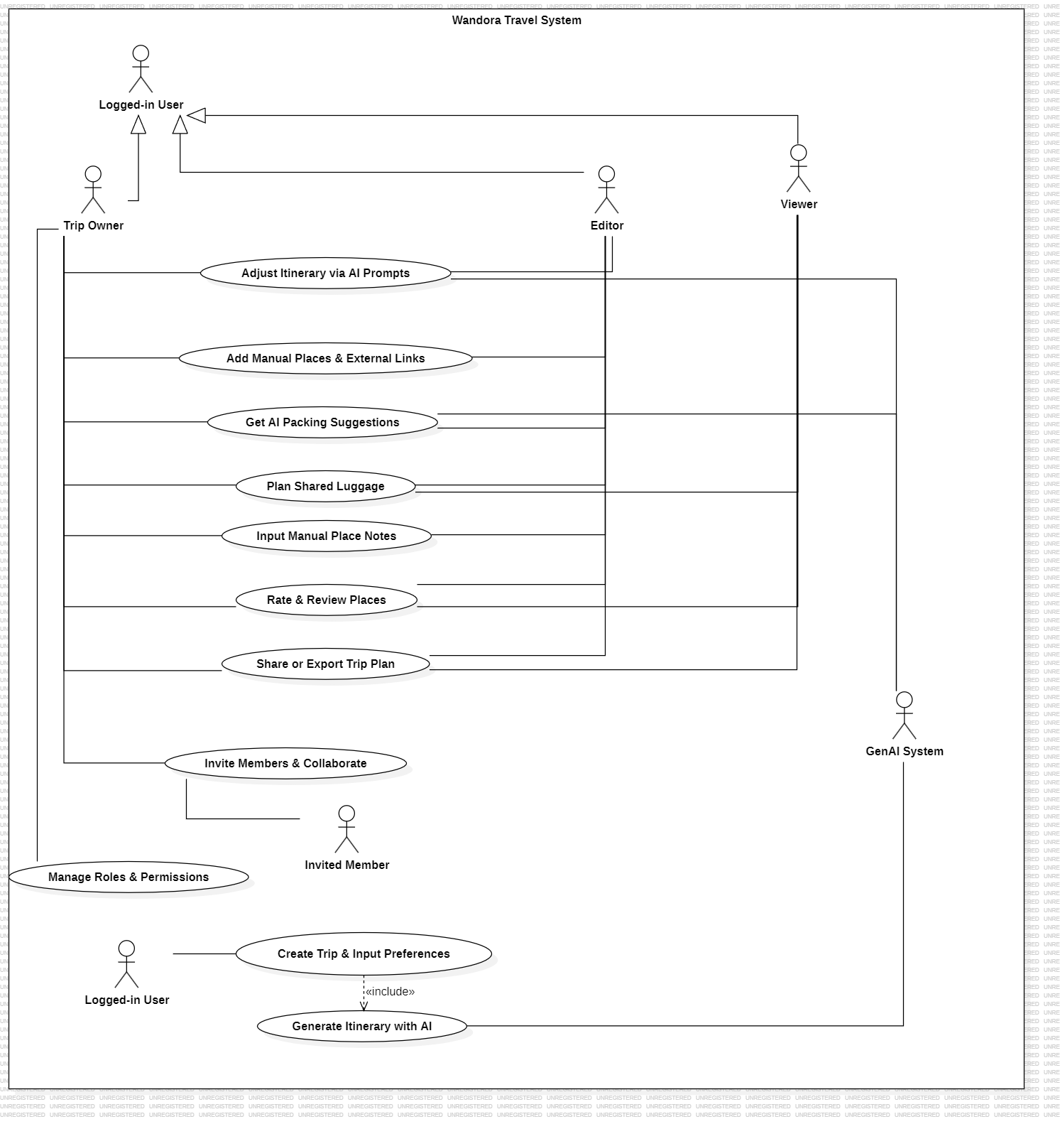

Use-case Specifications

2.1 Use-case: Trip Creation and Preference Input

Use case Name | Trip Creation and Preference Input
Brief description | Describes how a user initializes a new trip by declaring the necessary input parameters so that the system and AI can understand their travel needs.
Actors | Logged-in User
Basic Flow | 1.The user clicks the "Create New Trip" button on the main dashboard.  2.The system displays a form requesting: destination, departure/return dates, number of members, desired budget level, and travel style.  3.The user enters all required information and clicks the "Continue" button.  4.The system records the preference filters, saves a raw trip record, and prepares to transfer data to the GenAI module.
Alternative Flows | -Alternative Flow 1: Missing Required Destination or Dates  At Step 3, if the user leaves the destination or date fields blank, the system highlights those fields in red and disables the "Continue" button until all required fields are filled.
Pre-conditions | The user has successfully logged into their account.
Post-conditions | A new trip record along with the input preference dataset is successfully initialized in the database.

2.2 Use-case: AI Itinerary Generator

Use case Name | AI Itinerary Generator
Brief description | The system combines the preference data from UC1 with the Generative AI model to automatically build a detailed day-by-day travel itinerary.
Actors | Logged-in User, GenAI System (Secondary Actor)
Basic Flow | 1.Continuing from Step 4 of UC1, the system automatically sends a request (including the preference details) to the GenAI Service.  2.The GenAI System analyzes the data and returns a list of suitable activities categorized by Morning, Afternoon, and Evening for each travel day.  3.The system receives the itinerary structure and visualizes it directly on an interactive Timeline interface.  4.The user views the preliminary itinerary layout proposed by the AI.
Alternative Flows | -Alternative Flow 1: AI Service Connection Timeout  At Step 2, if the GenAI service does not respond after 10 seconds, the system displays an option: "Retry" or "Initialize a blank itinerary to fill manually".
Pre-conditions | The input data of the trip from UC1 must be valid
Post-conditions | An automated itinerary is successfully generated and saved into the trip's Workspace storage

2.3 Use-case: AI Itinerary Adjustment

Use case Name | AI Itinerary Adjustment
Brief description | Allows users to command the AI to modify or redesign the current itinerary by typing natural language prompts .
Actors | Trip Owner, Editor, GenAI System (secondary Actor)
Basic Flow | 1. The user opens the "AI Assistant" chat box integrated right next to the timeline schedule interface  2. The user enters a modification command (e.g., "Make day 2 cheaper and reduce travel distance") and clicks send.  3. The system forwards the current itinerary along with the user's new prompt to the GenAI System for processing.  4. The AI calculates adjustments and updates the locations/activities of the requested day.  5. The system displays the newly modified itinerary interface upon successful processing.
Alternative Flows | - Alternative Flow 1: Ambiguous AI Prompt  At Step 4, if the command is too vague, the AI responds in the chat box asking for clarification (e.g., "Do you want to reduce dining costs or sightseeing expenses?") while keeping the old itinerary unchanged.
Pre-conditions | The trip itinerary must already exist, and the user must have edit permissions.
Post-conditions | The specific time slots on the timeline are updated according to the requested command content.

2.4 Use-case: Manual Places and External Links

Use case Name | Manual Places and External Links
Brief description | Allows users to manually add custom locations, restaurants, or paste Google Maps links and article URLs as desired without relying on the AI.
Actors | Trip Owner, Editor
Basic Flow | 1. The user clicks the "Add Custom Place" button at any specific session on the Timeline.  2. The system opens a pop-up form requesting: Place Name, Address, Estimated Cost, Notes, and a URL paste field.  3. The user inputs the details, pastes the hyperlink (e.g., Google Maps location link), and clicks "Save".  4. The system displays this manually added place as a special card on the Timeline to distinguish it from AI-generated spots.
Alternative Flows | - Alternative Flow 1: Anti-AI Overwrite Protection Lock  When the user re-runs UC3 (requesting AI to modify the schedule), the system automatically flags these manually added locations as "Read-only" so the AI cannot delete or overwrite the group's manual data.
Pre-conditions | The user is inside the trip's Workspace interface and holds edit permissions.
Post-conditions | The custom location is permanently stored at the selected date and time slot within the itinerary.

2.5 Use-case: Group Collaboration

Use case Name | Group Collaboration
Brief description | Allows the trip owner to share a common workspace so that other members can access, view, and co-plan online simultaneously.
Actors | Trip Owner, Invited Member
Basic Flow | 1. The Trip Owner clicks the "Share / Invite Members" icon on the main toolbar.  2. The system generates a unique invitation link containing the trip's secure access token.  3. The Trip Owner copies this link and sends it to friends via chat applications.  4. The invited member clicks the link, logs into Wandora, and automatically joins the group's Workspace.  5. The system displays the new member's avatar on the active participant list.
Alternative Flows | - Alternative Flow 1: Expired or Invalid Invitation Link  At Step 4, if the secure token of the link has been refreshed or disabled by the Trip Owner, the system denies access and displays an error message requesting a new link.
Pre-conditions | The trip has been successfully initialized
Post-conditions | The new member's account is linked to the permission data array of this specific trip.

2.6 Use-case: Role and Permission Management

Use case Name | Role and Permission Management
Brief description | The Trip Owner configures specific permissions for each person in the group to control who can edit and who can only view the information.
Actors | Trip Owner
Basic Flow | 1. The Trip Owner opens the "Member Management" section within the trip settings.  2. The system displays a list of all accounts currently present in the workspace.  3. Next to each member's name, the Trip Owner clicks the dropdown menu and selects one of three roles: Owner, Editor, or Viewer.  4. The system saves the new permission configuration and applies it instantly.
Alternative Flows | - Alternative Flow 1: Unauthorized Modification Attempt by a Viewer  If an account with Viewer permissions attempts to click data-modifying buttons (such as adding locations or changing the schedule), the system displays an action-denied warning and maintains the read-only interface.
Pre-conditions | The executing user must strictly be the designated Trip Owner of that specific trip.
Post-conditions | The system successfully applies Role-Based Access Control (RBAC) filters to the members' accounts.

2.7 Use-case: AI Packing Suggestions

Use case Name | AI Packing Suggestions
Brief description | The AI automatically scans weather data, trip duration, and scheduled activities at the destination to provide a custom preparation checklist for the trip.
Actors | Trip Owner, Editor, GenAI System (Secondary Actor)
Basic Flow | 1. The user switches to the "Checklist" tab and clicks the "Get AI Suggestions" button.  2. The system automatically analyzes the weather forecasts and the nature of the current itinerary to build the contextual prompt.  3. The GenAI System processes the request and returns a list of required items grouped by categories (e.g., Documents, Clothing, Medical Supplies).  4. The system populates these smart recommendations into the group's public Checklist panel.
Alternative Flows | None.
Pre-conditions | The trip must have clear destination data and defined dates.
Post-conditions | The checklist panel is updated with smart luggage items generated by the AI.

2.8 Use-case: Shared Luggage Planning

Use case Name | Shared Luggage Planning
Brief description | Allows the group to delegate responsibilities, specifying who will carry shared items for the entire group (e.g., power banks, sunscreen, cameras).
Actors | Trip Owner, Editor, Viewer
Basic Flow | 1. The user opens the group's shared luggage checklist board.  2. In the "Assignee" field next to a shared item, the user selects a member's name from the dropdown list.  3. The system records the assignment, binds the member's name to the item, and synchronizes the UI instantly (Real-time) for all participants.  4. Once the assigned member finishes packing the item into their suitcase, they check the checkbox to notify the entire group.
Alternative Flows | None.
Pre-conditions | The shared luggage checklist has been initialized, and multiple members have joined the group.
Post-conditions | Responsibilities for preparing shared items are clearly designated and updated in real-time

2.9 Use-case: Manual Place Note Input

Use case Name | Manual Place Note Input
Brief description | Users write short notes, reminders, or assembly points directly inside a specific location's card on the itinerary timeline.
Actors | Trip Owner, Editor
Basic Flow | 1. The user clicks on any specific location card currently displayed on the Timeline interface.  2. The user clicks the "Add Note" button visible on the location card.  3. A text editor area opens up; the user inputs the reminder text (e.g., "Assemble at the main gate at 8 AM", "Remember to bring e-tickets") and clicks "Save Note".  4. The system saves the text string and displays the note content directly at the footer of that location card.
Alternative Flows | None.
Pre-conditions | The target location card must already exist on the itinerary Timeline.
Post-conditions | The text note is permanently attached to the location and displayed publicly for all group members to read.

2.10 Use-case: Place Ratings and Reviews

Use case Name | Place Ratings and Reviews
Brief description | Allows members to rate (star-rating) and leave comments regarding their actual experiences at locations after visiting them.
Actors | Trip Owner, Editor, Viewer
Basic Flow | 1. The user clicks on a visited location within the trip schedule.  2. The user selects the "Rate Location" option.  3. The system opens the rating panel; the user selects the number of stars (from 1 to 5 stars) and writes a short review (e.g., "Great food, but the service is a bit slow").  4. The user clicks "Submit Review".  5. The system stores the review data and updates the average rating score of that location within the trip Workspace.
Alternative Flows | None.
Pre-conditions | The user must be a valid member registered inside the trip Workspace.
Post-conditions | Individual review data is successfully archived to preserve memories or serve as experience benchmarks for future trips.

2.11 Use-case: Share or Export Trip Plan

Use case Name | Share or Export Trip Plan
Brief description | Users can package the entire itinerary data, luggage checklists, and total estimated expenses to export into external file formats or quick-copy boards.
Actors | Trip Owner, Editor, Viewer
Basic Flow | 1. The user clicks the "Export Itinerary" button on the application's main toolbar.  2. The system displays data export formatting options: Export as Itinerary Image, Export as Printable PDF, or Copy Plain Text to clipboard.  3. The user selects the desired format and clicks "Confirm Export".  4. The system compiles static data from all workspace tables and processes the file stream pipeline.  5. The browser automatically downloads the file to the user's local machine or displays a successful clipboard copy notification.
Alternative Flows | None.
Pre-conditions | The trip Workspace must contain actual itinerary or checklist data to execute the export function.
Post-conditions | An independent data file is successfully generated outside the system without altering the source records in the active database.

