Wandora

Use-Case Specification

Version 1.1

Revision History
Date | Version | Description | Author
11/07/2026 | 1.0 | Initial draft for PA2 baseline requirements. | Dang Nhat Minh
21/07/2026 | 1.1 | Revised Use-case Model architecture and refined all 11 core flow specification (including RBAC enforcement and GenAI fallback flows) for PA3 submission | Dang Nhat Minh

Table of Contents
1. Use-case Model 4
2. Use-case Specifications 4
2.1 Use-case: Trip Creation and Preference Input 5
2.2 Use-case: AI Itinerary Generator 6
2.3 Use-case: AI Itinerary Adjustment 7
2.4 Use-case: Manual Places and External Links 8
2.5 Use-case: Group Collaboration 9
2.6 Use-case: Role and Permission Management 10
2.7 Use-case: AI Packing Suggestions 11
2.8 Use-case: Shared Luggage Planning 12
2.9 Use-case: Manual Place Note Input 13
2.10 Use-case: Place Ratings and Reviews 14
2.11 Use-case: Share or Export Trip Plan 15

Use-case Model

The revised Use-Case diagram incorporates Role-Based Access Control (RBAC) via UML Generalization relationships ( Trip Owner → Editor → Logged-in User). This structure cleans up redundant direct associations while strictly enforcing permission scopes for viewing, editing, and administrative operations. Secondary integration with the GenAI System is established across automated planning, prompt adjustment, and packing recommendation use cases.

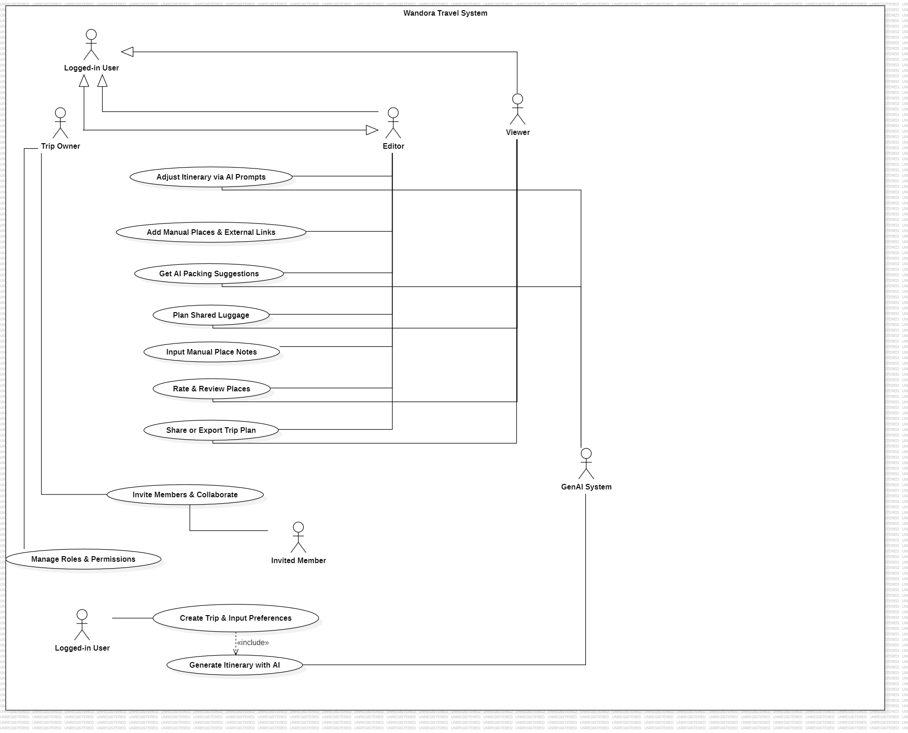

Use-case Specifications

2.1 Use-case: Trip Creation and Preference Input

Use case Name | Trip Creation and Preference Input
Brief description | Describes how a user initializes a new trip by configuring mandatory parameters required for the system and AI engine to understand their travel needs.
Actors | Logged-in User
Basic Flow | 1. The user clicks the "Create New Trip" button on the main dashboard.  2. The system displays an input form requesting destination, travel dates, member capacity, preferred budget level, and travel style.  3. The user fills out the required parameters and clicks "Continue".  4. The system logs the user preference filters, persists the draft trip record in the database, and automatically triggers the "Generate Itinerary with AI" use case via an «include» relationship.
Alternative Flows | Alternative Flow 1: Missing Required Fields  1a. If the user leaves mandatory parameters (e.g., destination, dates) empty, the system displays a validation alert: "Please fill in all required trip details."  2a. The user provides the missing inputs and resubmits.  Alternative Flow 2: Access Control Interception  1b. If an unauthenticated guest attempts to trigger trip creation, the system redirects the user to the Login screen.
Pre-conditions | The user is authenticated and logged into the Wandora application.
Post-conditions | A new Trip entity is created with 'Draft' status, and control is transferred to the AI Generation module.

2.2 Use-case: AI Itinerary Generator

Use case Name | AI Itinerary Generator
Brief description | Describes the automated synthesis of a detailed itinerary based on user preferences sent to the GenAI System.
Actors | Logged-in User, GenAI System (Secondary Actor)
Basic Flow | 1. The system formats the user's trip preferences into an optimized prompt payload.  2. The system sends an asynchronous API request to the GenAI System.  3. The GenAI System processes the parameters and returns a structured JSON payload containing daily schedules, activity items, and recommended places.  4. The system validates the payload, populates the Itinerary view, and presents the initial plan to the user.
Alternative Flows | Alternative Flow 1: AI Service Timeout / API Error  1a. If the GenAI System fails to respond within the timeout threshold or returns an invalid payload, the system displays a fallback message: "AI generation failed. Would you like to retry or start with a blank itinerary?"  2a. If the user chooses to retry, the system resends the payload. If blank, a default empty schedule is initialized.
Pre-conditions | A draft trip record with valid preference parameters has been initialized.
Post-conditions | An AI-generated initial itinerary is linked to the active Trip.

2.3 Use-case: AI Itinerary Adjustment

Use case Name | AI Itinerary Adjustment
Brief description | Allows authorized editors to refine existing itinerary schedules by submitting natural language modification prompts to the AI engine.
Actors | Editor, Trip Owner, GenAI System (Secondary Actor)
Basic Flow | 1. The user inputs a refinement instruction in the AI prompt box (e.g., "Replace museum with an outdoor activity on Day 2").  2. The system bundles the prompt with the current itinerary context and dispatches it to the GenAI System.  3. The GenAI System returns an updated schedule patch.  4. The system renders the modified schedule and requests user confirmation.  5. The user accepts the changes, and the system saves the updated itinerary state.
Alternative Flows | Alternative Flow 1: Permission Interception for Viewer Accounts  1a. If a user with 'Viewer' status submits an AI prompt, the system halts the execution flow and displays an error modal: "403 Permission Denied. Viewers cannot modify trip schedules."  Alternative Flow 2: Prompt Rejection  1b. The user clicks "Discard" on the proposed AI patch; the system restores the previous itinerary state.
Pre-conditions | An existing itinerary is open, and the user possesses Editor or Trip Owner privileges.
Post-conditions | The itinerary schedule is updated and synchronized across all trip members.

2.4 Use-case: Manual Places and External Links

Use case Name | Manual Places and External Links
Brief description | Enables users to manually insert custom locations, custom notes, or external URLs (e.g., Google Maps links, booking reservations) into specific time slots.
Actors | Editor, Trip Owner
Basic Flow | 1. The user selects a specific day slot and clicks "Add Activity / Place".  2. The system opens an input modal requesting place name, category, custom notes, and optional external URLs.  3. The user inputs the place details and submits.  4. The system validates the entries, saves the activity item, and updates the timeline view.
Alternative Flows | Alternative Flow 1: Invalid URL Format  1a. If an external URL is malformed, the system displays an inline warning: "Please enter a valid URL (e.g., https://...)" and prompts for correction.  Alternative Flow 2: Viewer Restriction  1b. Viewers attempting to access the "Add Activity" button will find the control disabled or receive a permission restriction notice upon clicking.
Pre-conditions | The trip schedule view is active.
Post-conditions | A custom activity location with optional external references is appended to the itinerary day slot.

2.5 Use-case: Group Collaboration

Use case Name | Group Collaboration
Brief description | Manages member invitations and role assignments (Editor or Viewer) for shared trip planning.
Actors | Trip Owner
Basic Flow | 1. The Trip Owner opens the "Members & Settings" modal.  2. The Trip Owner enters the invitee's email address and selects an initial role ('Editor' or 'Viewer').  3. The system dispatches an invitation link to the recipient email.  4. Upon link acceptance, the system links the invited user account to the Trip with the assigned role.
Alternative Flows | Alternative Flow 1: Non-Owner Role Restriction  1a. If an Editor or Viewer attempts to open member management, the system hides administration controls or displays "Only Trip Owner can manage member invitations."  Alternative Flow 2: User Already Invited  1b. If the email is already assigned to the trip, the system alerts: "This user is already a member of this trip."
Pre-conditions | The user is authenticated as the Trip Owner.
Post-conditions | An invitation is dispatched and member access rights are configured upon acceptance.

2.6 Use-case: Role and Permission Management

Use case Name | Role and Permission Management
Brief description | The Trip Owner configures specific permissions for each person in the group to control who can edit and who can only view the information.
Actors | Trip Owner
Basic Flow | 1. The Trip Owner opens the "Member Management" section within the trip settings.  2. The system displays a list of all accounts currently present in the workspace.  3. Next to each member's name, the Trip Owner clicks the dropdown menu and selects one of three roles: Owner, Editor, or Viewer.  4. The system saves the new permission configuration and applies it instantly.
Alternative Flows | - Alternative Flow 1: Unauthorized Modification Attempt by a Viewer  If an account with Viewer permissions attempts to click data-modifying buttons (such as adding locations or changing the schedule), the system displays an action-denied warning and maintains the read-only interface.
Pre-conditions | The executing user must strictly be the designated Trip Owner of that specific trip.
Post-conditions | The system successfully applies Role-Based Access Control (RBAC) filters to the members' accounts.

2.7 Use-case: AI Packing Suggestions

Use case Name | AI Packing Suggestions
Brief description | Generates a customized packing checklist based on trip destination weather forecast, duration, and planned activities.
Actors | Logged-in User, GenAI System (Secondary Actor)
Basic Flow | 1. The user navigates to the Packing List tab and clicks "Generate AI Checklist".  2. The system queries external weather metadata and compiles trip activity tags.  3. The system requests recommendations from the GenAI System.  4. The GenAI System returns categorized items (e.g., Clothing, Electronics, Documents).  5. The system populates the trip's packing checklist view.
Alternative Flows | Alternative Flow 1: AI Unavailability  1a. If the AI generator fails, the system loads a standard default packing template based on general travel standards.
Pre-conditions | A trip has defined destination and date parameters.
Post-conditions | A personalized packing checklist is generated for the trip.

2.8 Use-case: Shared Luggage Planning

Use case Name | Shared Luggage Planning
Brief description | Allows members to check off packing items, assign item responsibilities to specific participants, and add custom personal or group items.
Actors | Logged-in User
Basic Flow | 1. The user opens the Packing List section.  2. The user checks/unchecks completed items or assigns an item to a designated member.  3. The user can add custom items to group or personal lists.  4. The system updates item status and synchronizes states across active sessions in real time.
Alternative Flows | Alternative Flow 1: Concurrent Update Conflict  1a. If two members update the same item simultaneously, the system resolves state via timestamp and displays the latest status.
Pre-conditions | A packing checklist exists for the trip.
Post-conditions | Luggage assignment states and completion checkboxes are persisted.

2.9 Use-case: Manual Place Note Input

Use case Name | Manual Place Note Input
Brief description | Provides functionality to update or modify specific notes, tips, or reminder text attached to an itinerary activity node.
Actors | Editor, Trip Owner
Basic Flow | 1. The user selects a place item on the schedule and clicks "Edit Notes".  2. The system opens a text editor showing existing note content.  3. The user modifies the text and clicks "Save".  4. The system updates the place record and displays the refreshed note on the UI.
Alternative Flows | Alternative Flow 1: Permission Denied for Viewers  1a. If a Viewer attempts to edit notes via direct client invocation, the backend API rejects the request with a 403 status code, and the UI displays "Permission Denied".
Pre-conditions | An activity place node exists within the itinerary schedule.
Post-conditions | The activity note text is updated in the database.

2.10 Use-case: Place Ratings and Reviews

Use case Name | Place Ratings and Reviews
Brief description | Allows participants to submit star ratings and textual feedback for visited places within an itinerary.
Actors | Logged-in User
Basic Flow | 1. The user selects a visited location and clicks "Add Review".  2. The system presents a rating widget (1-5 stars) and a review text box.  3. The user selects a rating, enters optional text feedback, and submits.  4. The system logs the review and links it to the user and place entity.
Alternative Flows | Alternative Flow 1: Modifying Existing Review  1a. If the user has previously reviewed the place, the system loads the prior review, allowing editing and updating.
Pre-conditions | The trip is active or completed, and the place item exists.
Post-conditions | A place review record is saved and visible to trip members.

2.11 Use-case: Share or Export Trip Plan

Use case Name | Share or Export Trip Plan
Brief description | Allows a trip member to generate a shareable link to the itinerary or export the trip plan as a downloadable file for offline access.
Actors | Logged-in User
Basic Flow | 1. The user opens the trip and clicks "Share / Export".  2. The system presents two options: "Generate Shareable Link" or "Export as PDF".  3. If the user selects "Generate Shareable Link", the user chooses view-only or editable access, and the system creates a unique URL.  4. If the user selects "Export as PDF", the system compiles the itinerary, packing list, and expense summary into a formatted document and prompts a download.
Alternative Flows | Alternative Flow 1: Link Revocation  1a. If the Trip Owner revokes a previously generated link, the system invalidates the URL and denies further access to anyone using it.  Alternative Flow 2: Export Failure  2a. If the PDF export process fails, the system displays an error message: "Export failed. Please try again."
Pre-conditions | The trip has an itinerary with at least one populated day or activity.
Post-conditions | A shareable link is generated and accessible to recipients, or an exported file is available for download.

