Wandora

Software Architecture Document

Version 1.0

Revision History
Date | Version | Description | Author
19/07/2026 | 1.0 | Initial draft | Group11

Table of Contents
1. Introduction 4
2. Architectural Goals and Constraints 4
3. Use-Case Model 5
4. Logical View 6
4.1 Component: Web Client (UI) 6
4.2 Component: Backend Server 7
4.3 Component: AI Integration Module 8
4.4 Component: Collaboration & Persistence 9
5. Deployment 11
6. Implementation View 11

Software Architecture Document

Introduction
- Purpose: This Software Architecture Document (SAD) provides a comprehensive overview of the Wandora project's system structure. It describes critical architectural decisions, technical goals, and constraints to ensure the system meets both functional and non-functional requirements.
- Scope: Applied to the Wandora web application, which supports AI-integrated group trip planning.
- References: Vision Document, Software Development Plan (SDP), Use-case Specification.
- Overview: The architecture focuses on flexible integration with AI services (GenAI), real-time data management for group collaboration, and cross-device compatibility via a responsive web interface.

Architectural Goals and Constraints
Architectural Goals:
- Performance: The system must ensure that the AI responds and generates schedules within a short timeframe (measured in seconds) to avoid disrupting the user experience.
- Usability: The interface architecture must be simple and intuitive, suitable for students and young travelers, requiring no complex technical skills.
- Compatibility: The system must operate stably on popular browsers (Chrome, Edge, Safari) and automatically adapt to various screen sizes, from desktops (PC) to smartphones.
- Security & Access Control: The architecture must support secure invite link mechanisms (secure tokens) to protect shared workspaces. A Role-Based Access Control (RBAC) model is applied to manage editing permissions among Owners, Editors, and Viewers.
Architectural Constraints:
- Schedule: The project has a fixed 9-week schedule (from June 21, 2026, to August 23, 2026).
- Budget: The project operates on a zero budget; therefore, the architecture prioritizes the use of open-source technologies and free services.
- Functional Constraints: The architecture does not include or support modules for ticket booking, direct payments, or real-time price updates.
- Team Structure: The team consists of 4 members with specialized roles (Leader, Arch & DB, Backend & AI, Tester), requiring the architecture to be clearly modularized to support parallel work.
- Tools and Processes: GitHub is used for source code management and Jira for progress tracking. This requires CI/CD processes or branching strategies to be tightly integrated into the deployment structure.

Use-Case Model

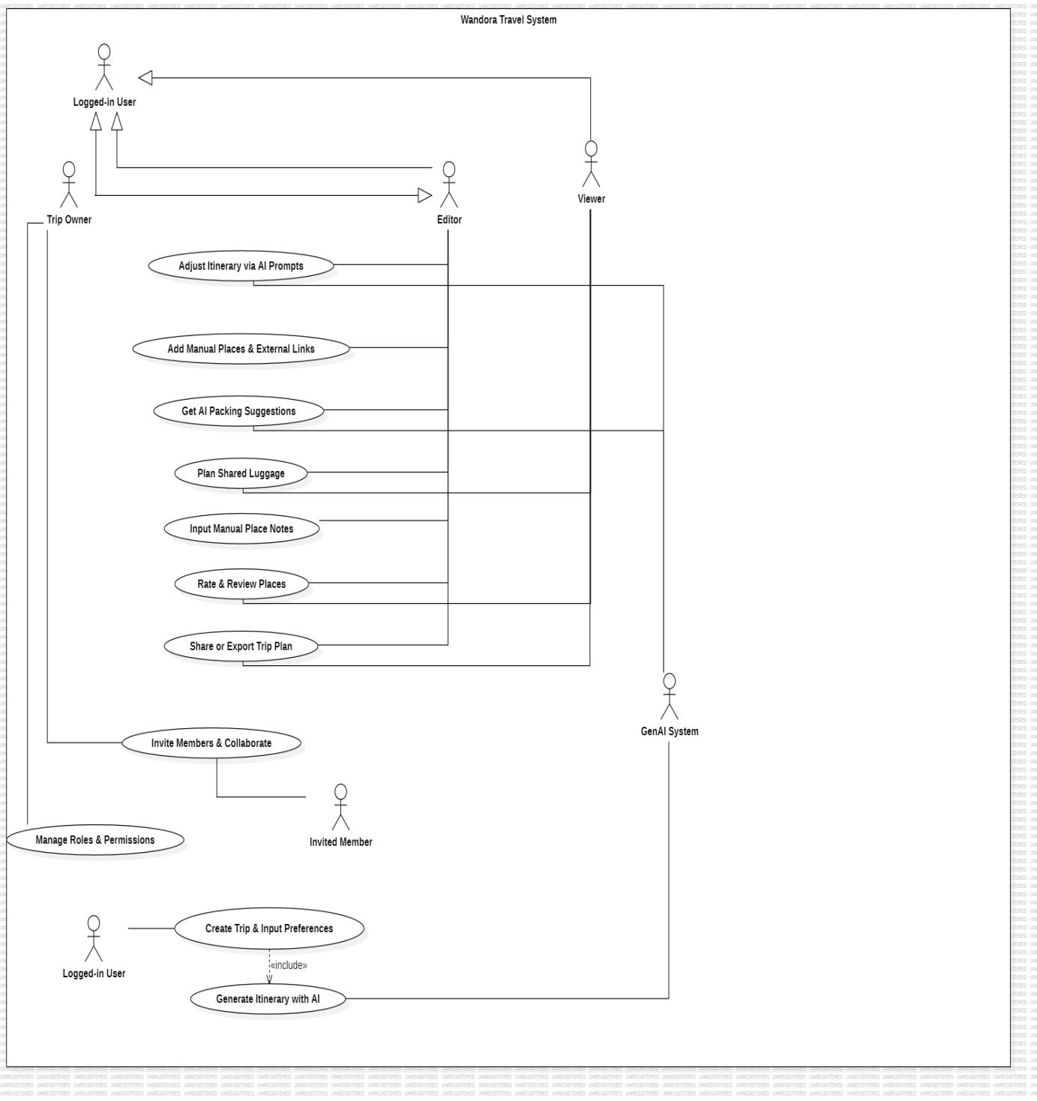

Logical View
Wandora is designed based on the N-tier architecture model to ensure a clear separation between the user interface, business logic, and data storage. This architecture enables a team of four members to develop the UI/UX, Backend, Database, and AI components independently and in parallel.
The core focus of the architecture is the flexible integration with third-party AI services (GenAI) through APIs and the capability for real-time data updates, allowing members of a travel group to collaborate online. All communication between the layers is carried out through secure protocols such as HTTPS/REST and WebSockets to ensure data integrity.

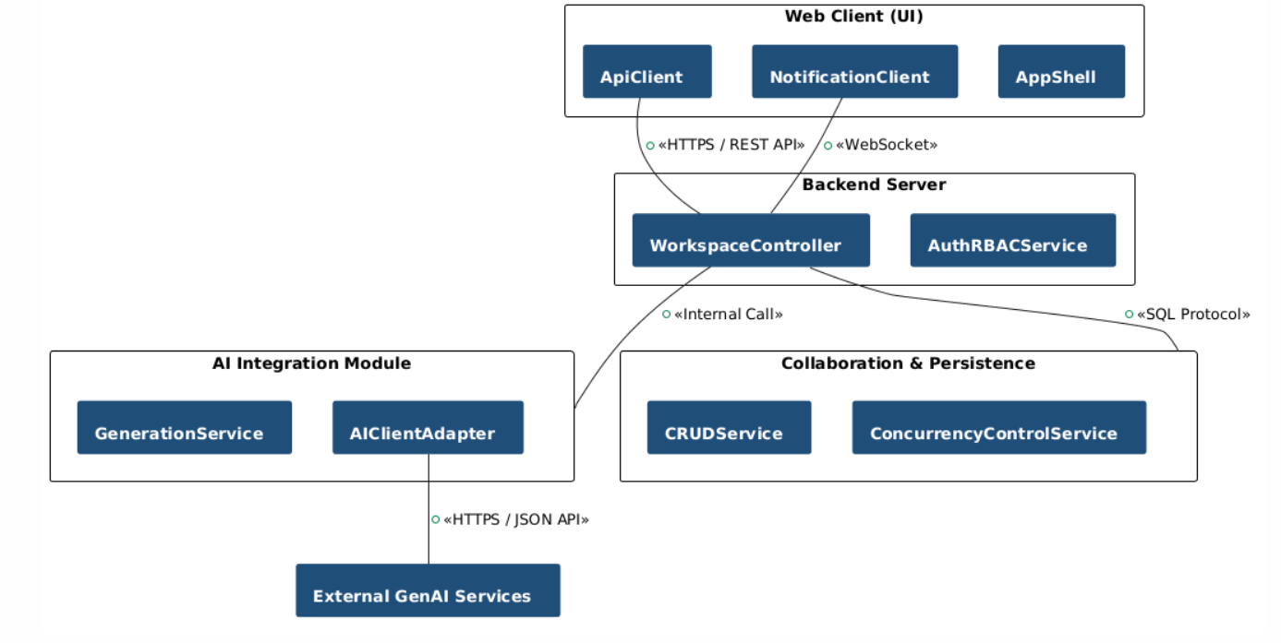

Component: Web Client (UI)
Responsibilities:
- Event Handling Service: Provides the interface for users to input trip preferences and a chat box to interact with the "AI Assistant".
- UI Rendering Service: Displays visual schedules in a Timeline format.
- Real-time Notification Service: Synchronizes real-time data for members within a collaboration group.
Key Classes:
- AppShell: The central navigation layer and application initialization.
- WorkspaceViewController: The main controller responsible for managing the workspace state of the trip.
- TimelineRenderer: The UI component responsible for rendering and displaying the itinerary in a timeline format.
- ChatWidget: The chat interface component that interacts directly with the AI Assistant.
- PackingListView: The UI component for managing and assigning the shared packing list.
- ApiClient: The service layer responsible for sending REST API requests to the Backend.
- NotificationClient & WebSocketClient: The service classes responsible for managing WebSocket connections for real-time data synchronization.
- Protocols: Communicates with the Backend via HTTPS/REST API and WebSockets for real-time updates.
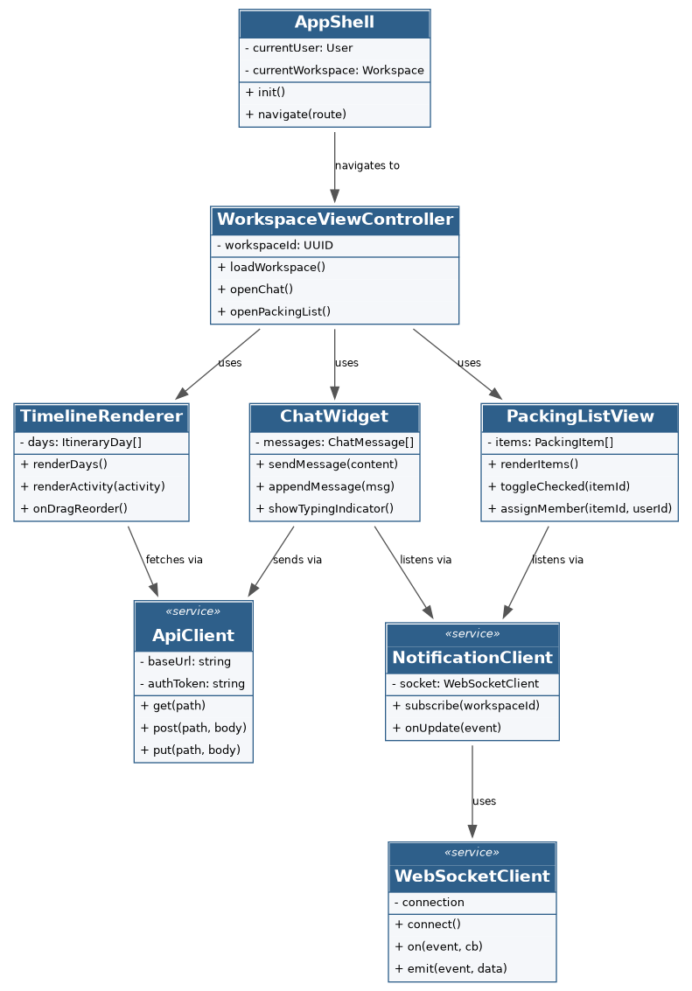

Component: Backend Server
Responsibilities:
- Handles core business logic for trip initialization and storage.
- Auth & RBAC Service: Manages role-based access control (Owner, Editor, Viewer).
- Export Service: Processes requests to export schedules as PDF or images.
Key Classes:
- AuthRBACService: The service responsible for user authentication and authorization checks (Owner, Editor, Viewer).
- WorkspaceService: The service responsible for handling the business logic for creating, updating trips, and managing members.
- ExportService: The service responsible for compiling trip data for export as a PDF file or image format.
- User, Workspace, WorkspaceMember, Rating: The entity classes representing account information, trip workspace, member roles, and ratings.
Protocols: Connects to the Database via database management system protocols and to the Frontend via HTTPS.
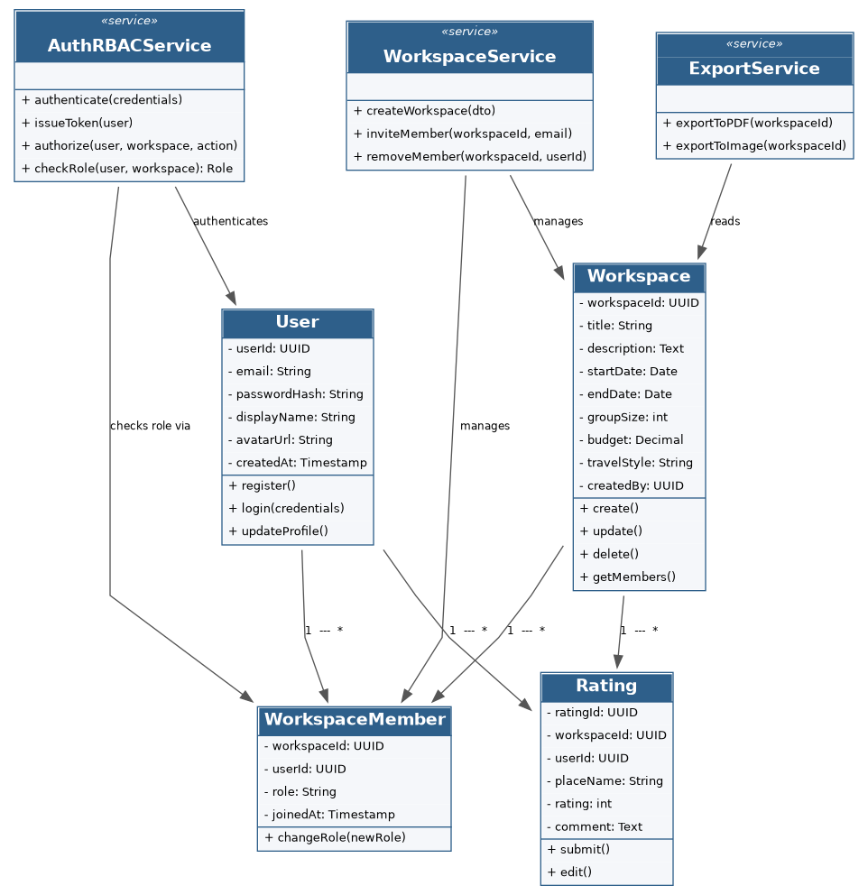

Component: AI Integration Module
Responsibilities:
- Generation Service: Receives preference data from the system and reformats it to send requests to the GenAI.
- NLP Service: Processes natural language commands from users to adjust schedules.
- Packing Suggestion Service: Analyzes weather and activities to provide luggage recommendations.
Key Classes:
- GenerationService: The service responsible for receiving preference filters to initialize and generate the itinerary automatically.
- NLPService: The service responsible for analyzing and processing itinerary modification commands in natural language.
- PackingSuggestionService: The service responsible for analyzing activity and weather data to suggest a packing list.
- AIClientAdapter: The Adapter class acting as a bridge to transform data and directly invoke third-party APIs (OpenAI/Gemini).
- ItineraryActivity, ChatMessage, PackingItem: The entity classes responsible for receiving and storing the results returned by the AI.
Protocols: Connects to third parties (OpenAI/Gemini API) via HTTPS/JSON.
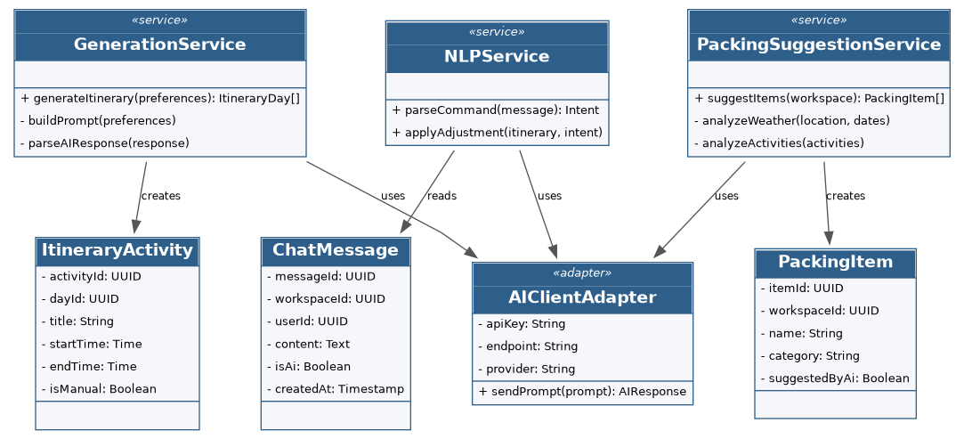

Component: Collaboration & Persistence
Responsibilities:
- Token Management Service: Manages shared Workspaces and invite links with secure tokens.
- CRUD Service: Stores and queries data, including location ratings and schedules.
- Concurrency Control Service: Ensures data integrity for "Read-only" states when the AI is editing or when multiple users are making simultaneous changes.

Database design:
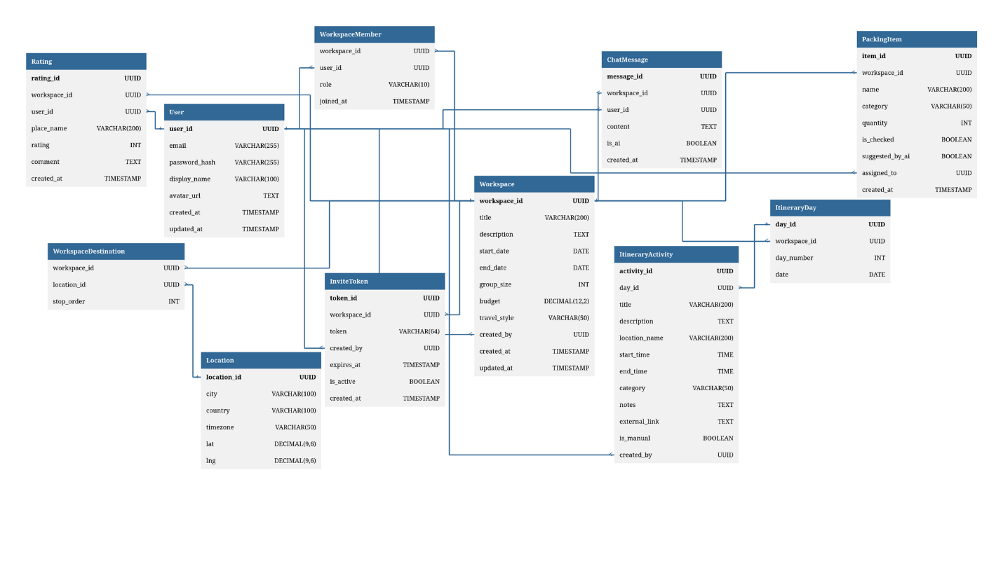
Key Classes:
- ConcurrencyControlService: The service responsible for controlling concurrent editing conflicts and locking data while the AI performs updates.
- TokenManagementService: The service responsible for creating, managing, and validating invitation links (Invite Links) containing security tokens.
- CRUDService: The service responsible for executing basic data query and storage operations in the database.
- InviteToken, WorkspaceDestination, ItineraryDay, Location: The entity classes responsible for storing invitation tokens, destination associations, itinerary days, and geographic location information.
Protocols: Provides data to the Backend Server via SQL queries and synchronizes status with the Web Client via WebSockets for updating shared packing lists.
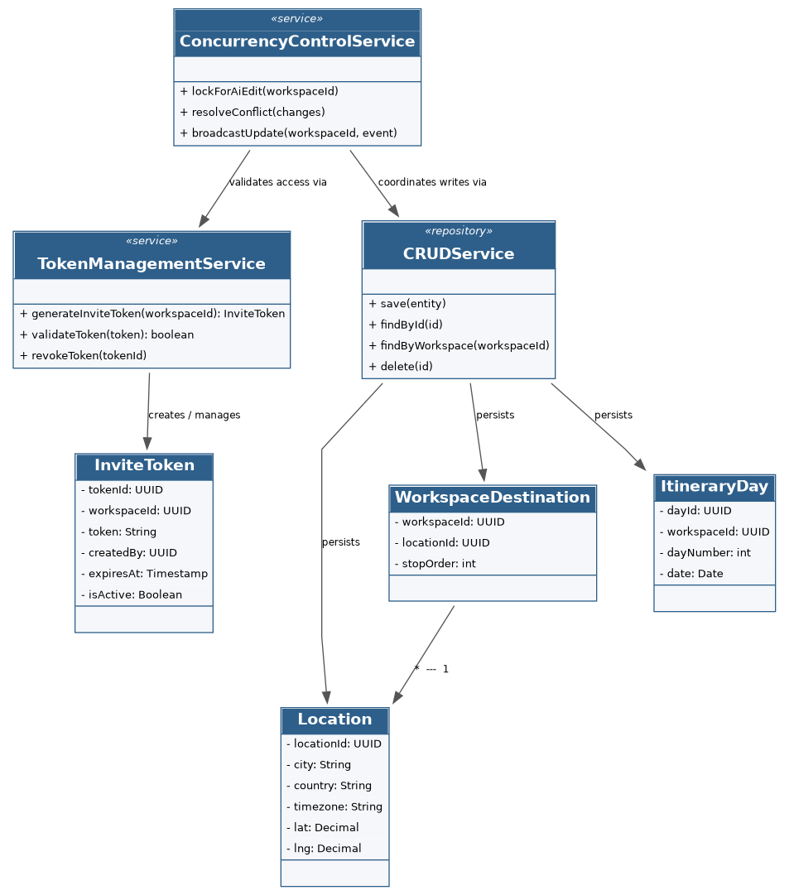

Deployment

Implementation View

