**Computer Network Essentials**

- Network Topology Creation Using Cisco Packet Tracer

- Jaideep Vishnu Kathiresan 22MIA1196

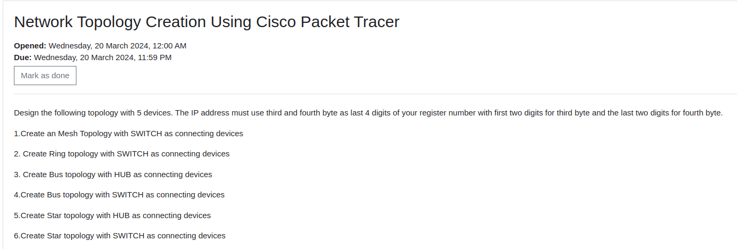  
  
  
Mesh Topology :

Connection:

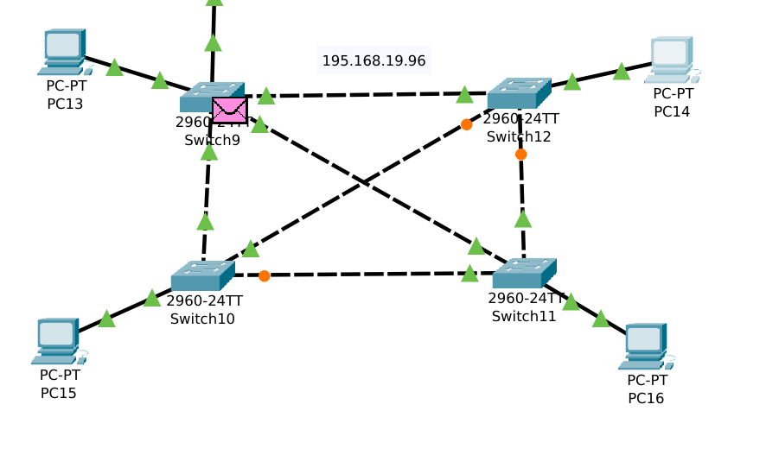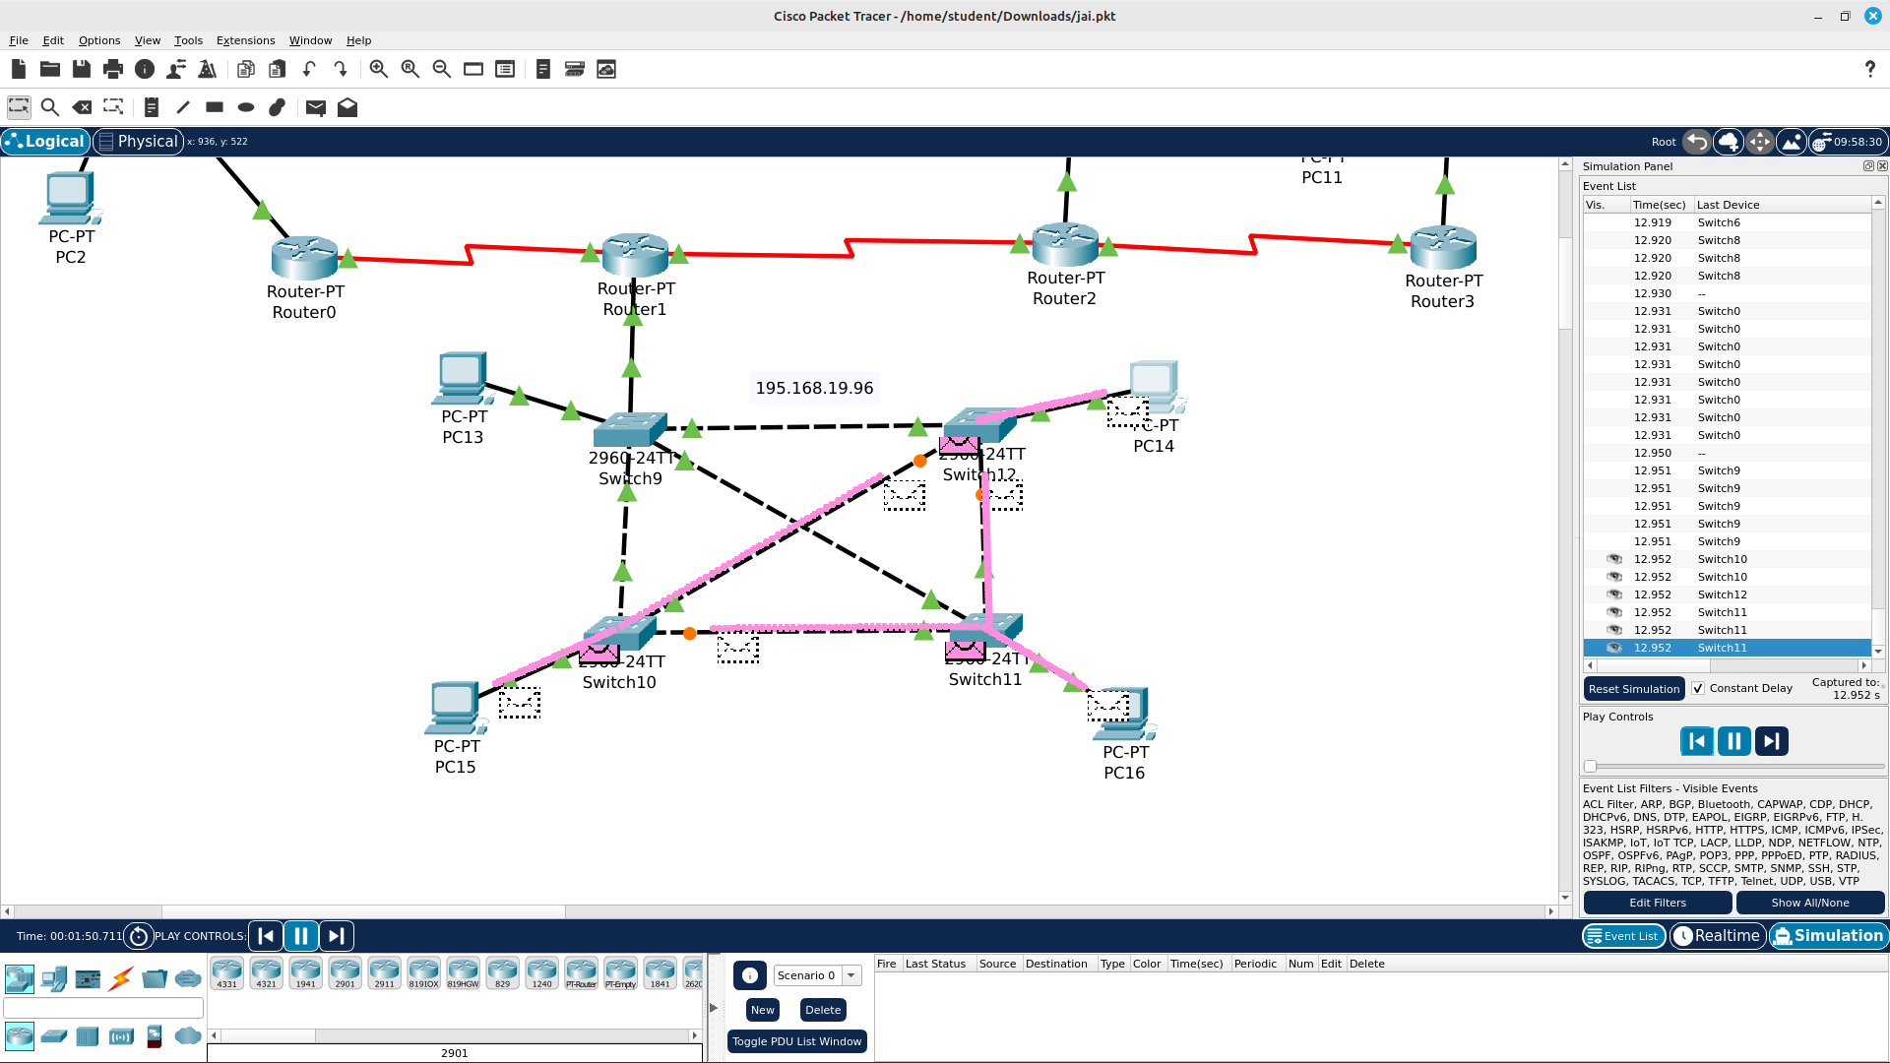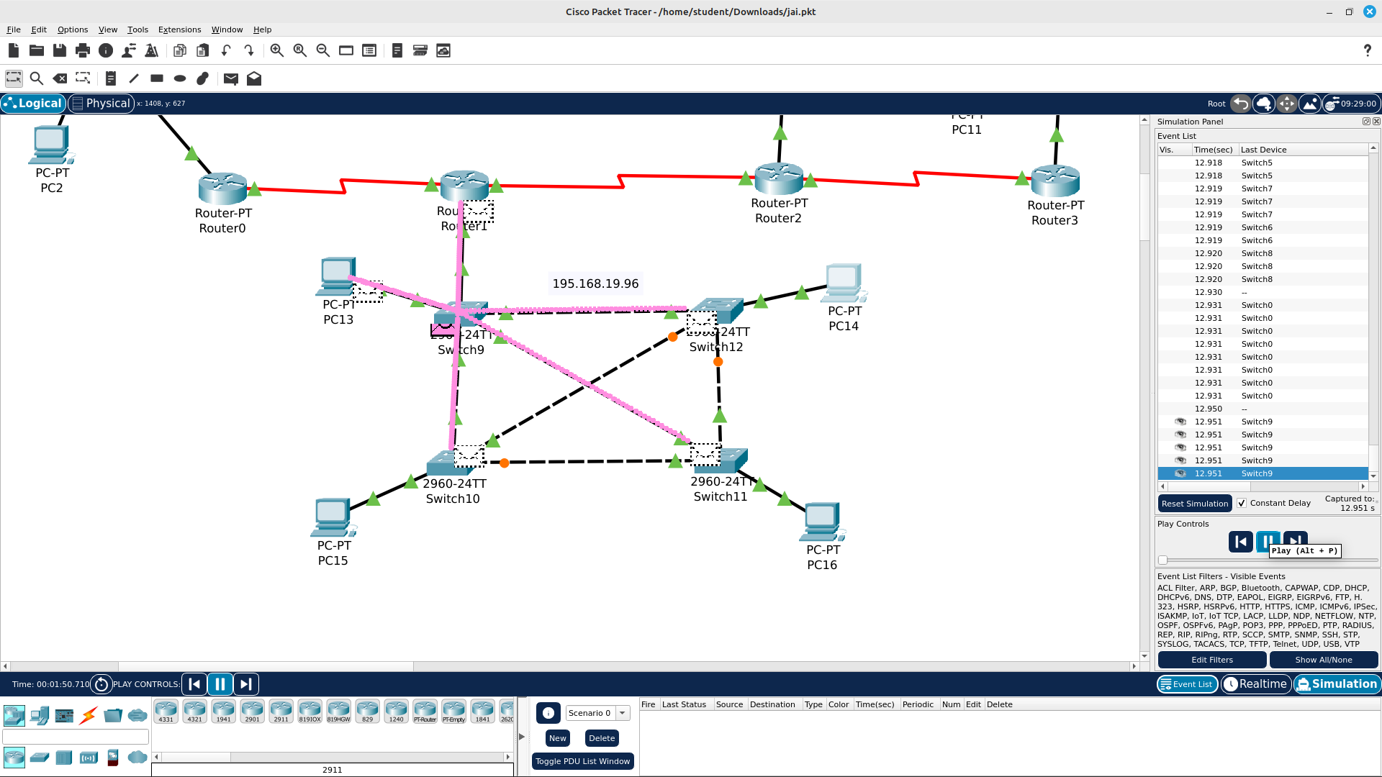

  
  
  
  
  
  
  
  
  
  
  
  
Ring Topology:

Ring Topology:

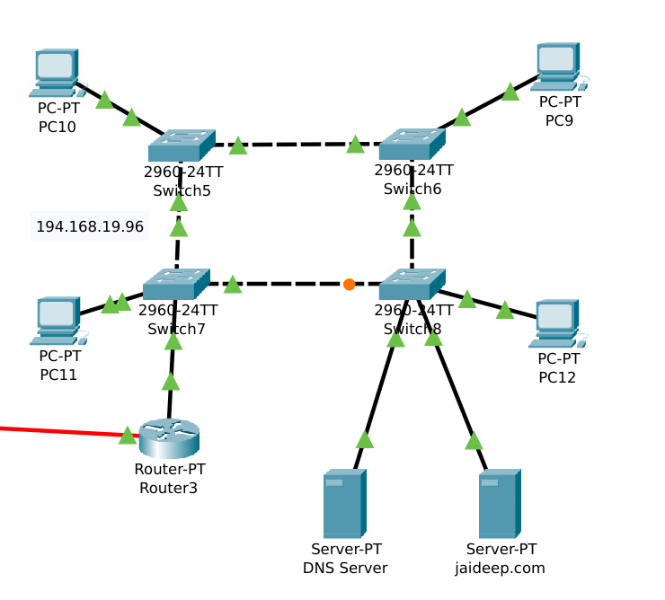

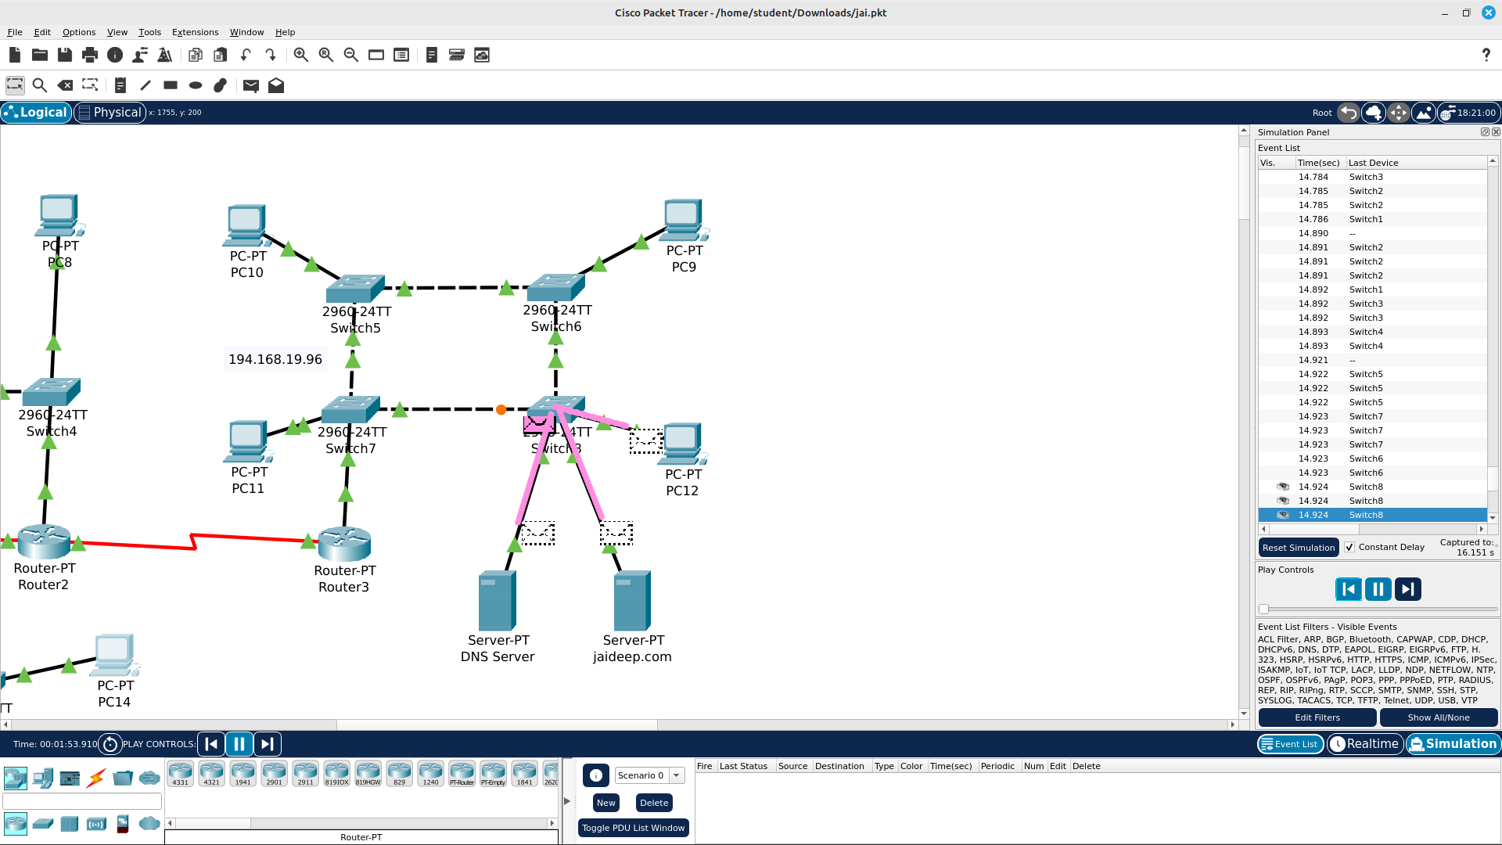

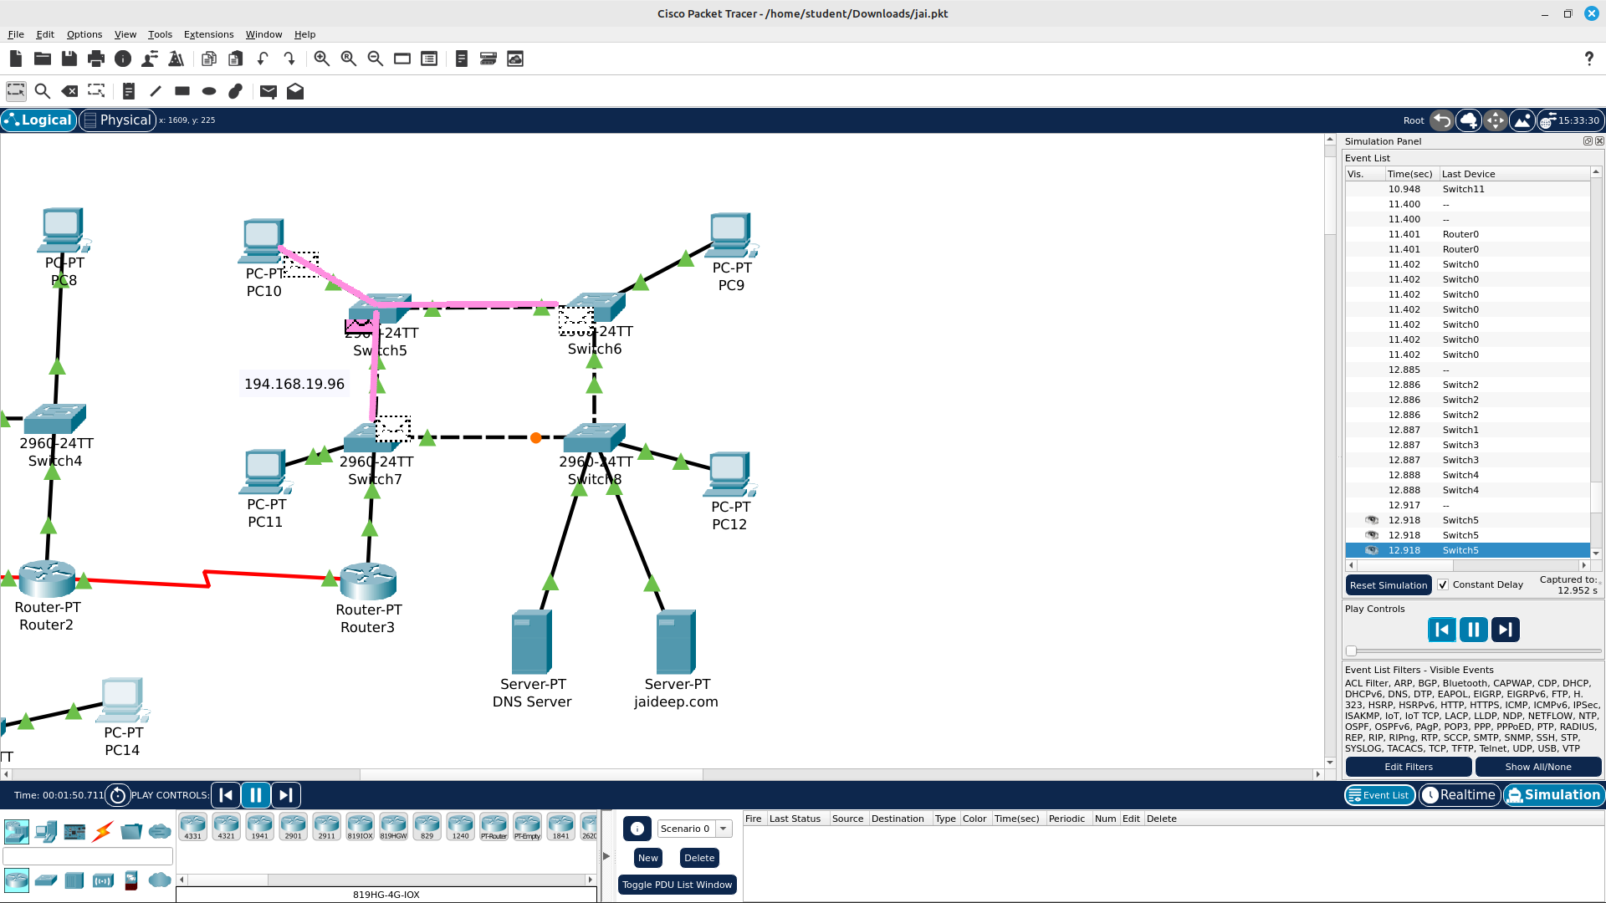  
  
  
  
  
  
  
  
  
  
  
  
  
  
  
  
  
  
  
  
  
  
  
  
Bus Topology:

