ECE101-1L – FUNDAMENTALS OF ELECTRONIC CIRCUITS (LAB)

Activity #3: Diode Wave Shaping and Zener Diode Voltage Regulation

**Objectives:**

* Use Multisim and TinkerCAD for this activity
* Use diodes with bias voltages as clippers, clampers, and DC restorers.
* Measure and Observe the performance of a typical Zener diode

**Procedures:**

**Part A. Multisim**

1. Define Clippers in Electronics (include the 2 types)
2. Define Clampers in Electronics (include the 2 types)
3. Open Multisim
4. Create the schematic diagram shown below

(*Function Generator, Resistor, Switch, Diode, DC Interactive Voltage) See Video for Details*

**XFG1**

COM



**R1**

**1kΩ**

**S1**

**Key = Space**

**S2**

**Key = Space**

**R2**

**100kΩ**

**D1 1N4001**

**D2**

**1N4001**

**V2**

**Key = A 0V**

**V1**

**Key = A 0V**

1. Adjust Function Generator and DC Interactive Voltage Settings shown below

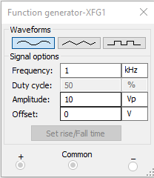

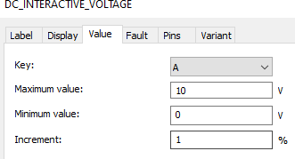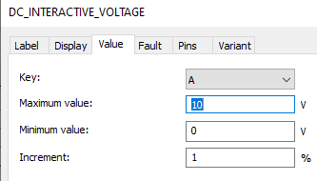

1. Place an Oscilloscope at the Output and Run the Simulation
   1. Screenshot the output waveform shown in oscilloscope
   2. measure the voltage (Vpk-pk)
2. While the simulation is running, Turn the switch (S1 and S2) to CLOSED position and observe the Output at the oscilloscope
   1. Screenshot the output
   2. Explain what happens
3. Switch the S1 to OPEN position and observe the waveform
   1. Screenshot the output
   2. What function does S1 /D1 Part do? (Positive Clipper or Negative Clipper)
4. Switch the S1 to CLOSED and S2 to OPEN position and observe the waveform
   1. Screenshot the output
   2. What function does S2 /D2 Part do? (Positive Clipper or Negative Clipper)
5. Create the schematic shown below (similar to previous circuit but change the resistor to “CAPACITOR ELECTROLYTIC” with a value of 0.1uF, *be careful of the polarity*

**XFG2**

**Space**



COM

**C1**

**0.1µF**

**S3**

**S4**

**Key = Space**

**Key =**

**R6**

**100kΩ**

**D5**

**1N4001**

**D6 1N4001**

**V6**

**V5**

**Key = A**

**0V**

**Key =**

**0V**

**A**

1. Place and Oscilloscope at the output
2. Run the Simulation and Switch the S3 to CLOSED position
   1. Screenshot the output
   2. Base on your answer in Question #2 and Question 12.a what type of Clamper is this?
   3. Switch S3 to OPEN Position
3. Switch the S4 to CLOSED position
   1. Screenshot the output
   2. Base on your answer in Question #2 and Question 13.a what type of Clamper is this?
   3. Switch S4 to OPEN Position
4. What is a Zener Diode?
5. What is the Symbol of Zener diode?
6. Create the Schematic shown below “DIODE VIRTUAL>>ZENER”. Change the settings of Zener Diode Breakdown Voltage to 10V

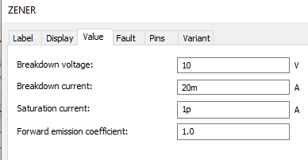**R5**



**100Ω**

**D7**

**10V** Vout

**V7**

**15V**

**R7**

**10Ω**

1. Measure the Voltage output using Multimeter
   1. Vout:
   2. Is the Zener Diode Forward Biased or Reversed Biased?
2. Change the Zener Diode Orientation

**R5**



**100Ω**

**D7**

**10V** Vout

**V7**

**15V**

**R7**

**10Ω**

VR7

1. Measure the Voltage output using Multimeter
   1. Vout:
   2. Is the Zener Diode Forward Biased or Reversed Biased?
2. Adjust the V7 (DC Voltage to the Values shown below and complete the table Calculate the Current (Ir7) using the formula (VR7/R7)

|  |  |
| --- | --- |
| **V7 (Supply Voltage)** | **Current (IR7)** |
| 0 | 0 |
| 2 |  |
| 4 |  |
| 6 |  |
| 8 |  |
| 10 |  |
| 12 |  |
| 14 |  |
| 16 |  |
| 18 |  |
| 20 |  |

1. Change all Values to NEGATIVE (V7) and Current (IR7). Graph the Values V7 Supply voltage at the horizontal axis and the Current IR7 for the Vertical Axis. Screenshot the Graph you obtain *You can use MSExcel to Plot your graph (Scatter with Lines)*

# Part B. TinkerCAD

1. Create the Circuit Diagram using TinkerCAD

*(Function Generator, Power Supply, Resistor, Diode)*

**R1**

**ey = A**



**1kΩ**

**D1**

**V2**

**10Vpk 1kHz 0°**

**R2**

**100kΩ**

**V1**

**K 0V**

1. Place an Oscilloscope at the Output
2. Adjust the **DC Supply** at 1.8 V level
   1. Screenshot the output waveform
   2. Is the Circuit a Positive Clipper or Negative Clipper?
3. Create the circuit diagram using tinkerCAD

*(Function Generator, Power Supply, Resistor, Diode)*

**R1**

**0V**

**1kΩ**

**D1**

**V2**

**10Vpk 1kHz 0°**

**R2**

**100kΩ**

**V1**

**K**

**ey = A**

1. Place an Oscilloscope at the Output
2. Adjust the **DC Supply** at 1.8 V level
   1. Screenshot the output waveform
   2. Is the Circuit a Positive Clipper or Negative Clipper?
3. Create the Circuit shown below using tinkerCAD

**C1**

**10V**



**0.1µF**

**D1**

**V2**

**10Vpk 1kHz 0°**

**R2**

**100kΩ**

**V1**

**K**

**ey = A**

1. Place an Oscilloscope at the Output
2. Slowly Adjust the DC Supply Voltage to 2V
   1. What do you observe?
   2. Screenshot the Output of the oscilloscope
   3. Identify the type of Clamper used
3. Create the Schematic Shown below

**C1**

**10V**

**0.1µF**

**D1**

**V2**

**10Vpk 1kHz 0°**

**R2**

**100kΩ**

**V1**

**K**

**ey = A**

1. Place an Oscilloscope at the Output
2. Slowly Adjust the DC Supply Voltage to 2V
   1. What do you observe?
   2. Screenshot the Output of the oscilloscope
   3. Identify the type of Clamper used
3. Create the Circuit Using TinkerCAD

# R5

**100Ω**

**D7**

**10V** Vout

**V7**

**15V**

**R7**

**10Ω**

1. Screenshot your Circuit
2. Measure the Output Voltage

# Discussions: