**Laboratory Activity 3**

Name: Jayvee N Mapote Student Number:2020161610

Course/Section: A11 Professor: Kenneth Kim Castro

1.

Problem:

Create a program that accepts 10 positive integers then displays the integers in ascending and descending order. Additionally, the average, the highest, the lowest of all inputs is shown at the end of output.

Code:

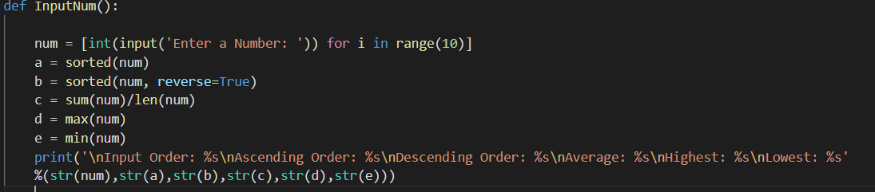

Output:

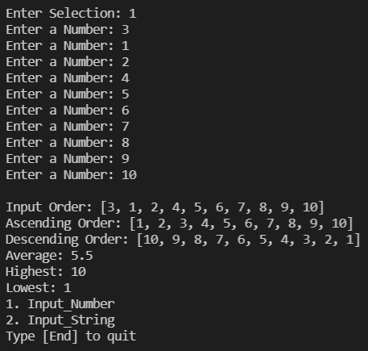

2.

Problem:

Create a program that accepts 5 String inputs. These string inputs may consist of more than 1 word. Afterwards, the list shows all elements it contains in the same order as it was inputted and in reverse order.

Using the program above as a base, expand the program such that it allows 3functions:

The user can append to the list any string input.

The user can insert to the list at any position any string input.

The user can remove a certain word from the list.

Code:

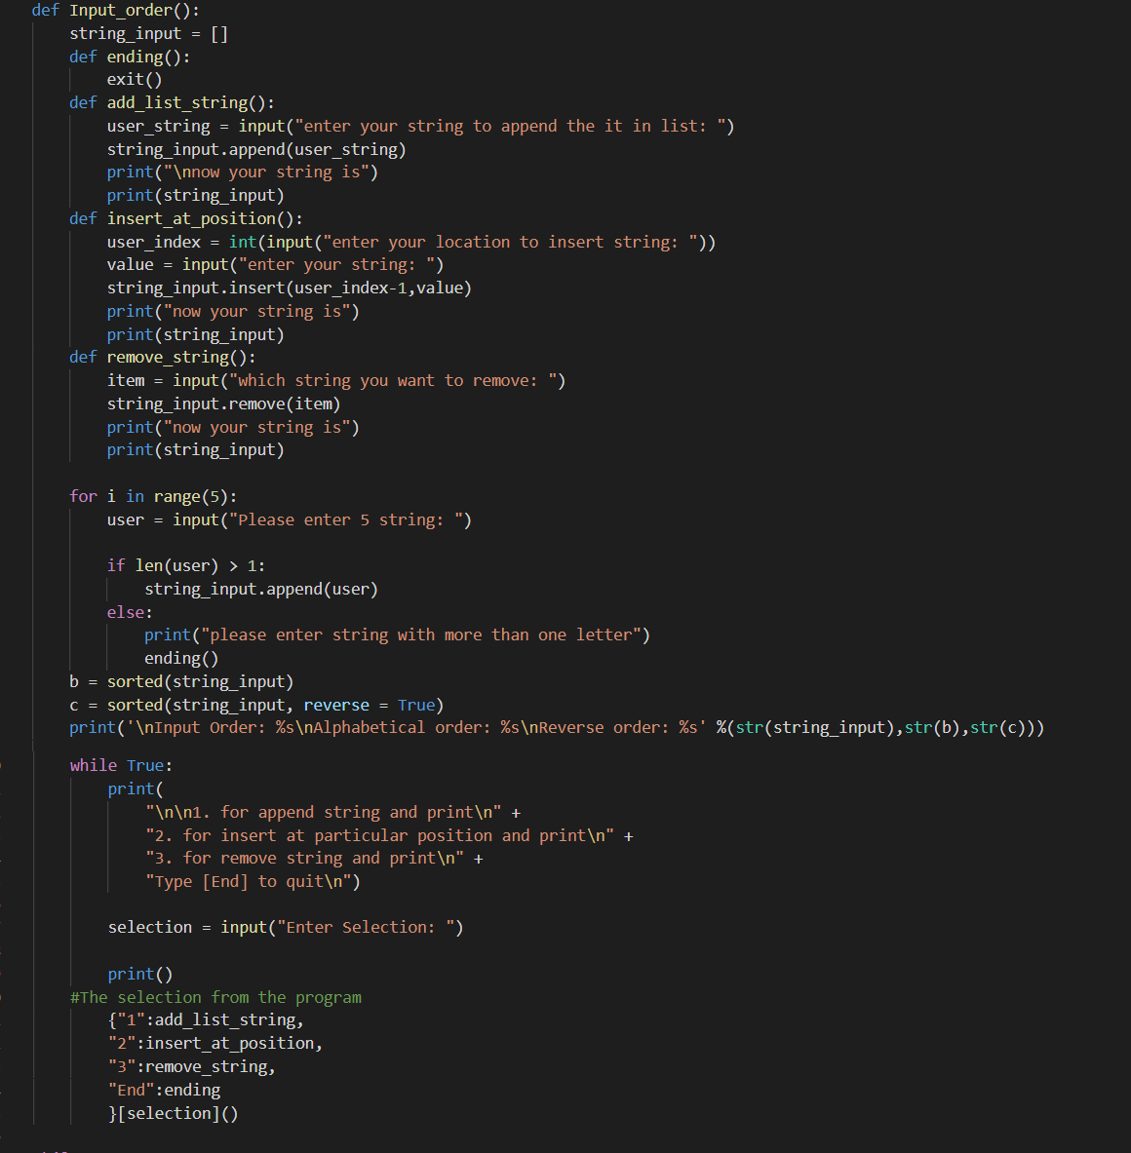

Output:

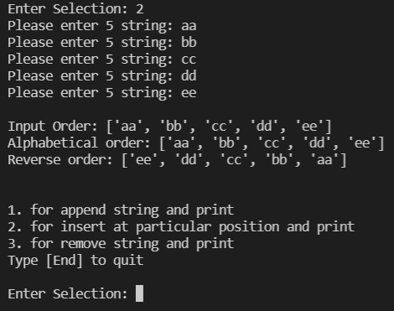

#Append:

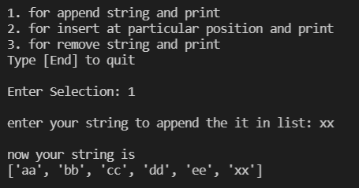

#Insert:

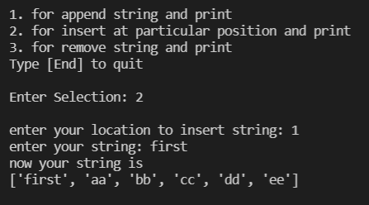

#Remove:

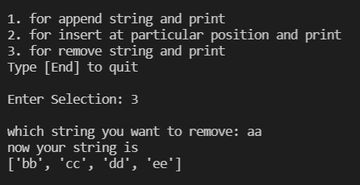

Google Drive\SharePoint Link: https://drive.google.com/drive/folders/1_wJ88GXvnKb3qcpbilA-qLW_xrbMjPja?usp=sharing