1. Docker Compose Setup
Figure 1 shows the successful build and startup of Docker containers for FastAPI, PostgreSQL, and pgAdmin.
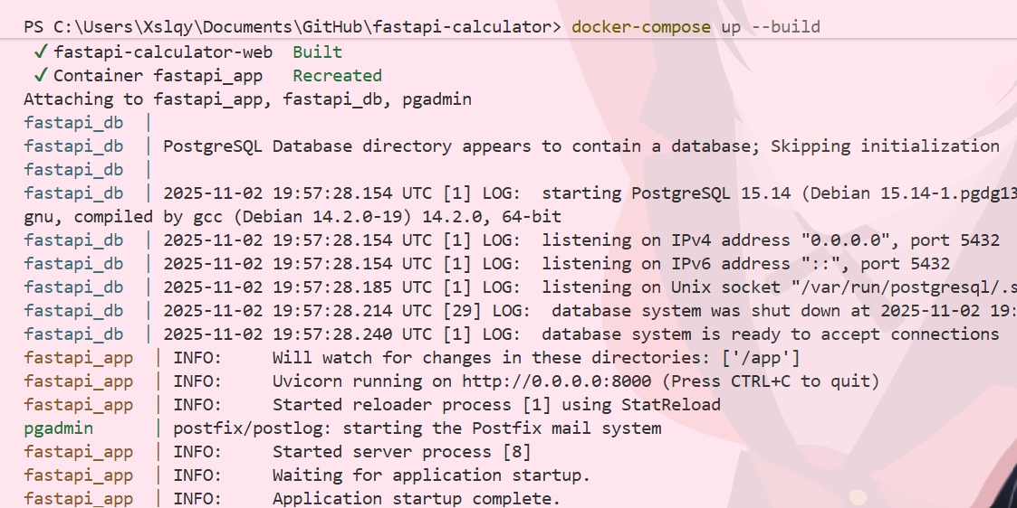
Figure 1. Successful Docker Compose build and container startup.

2. Table Creation (pgAdmin)
Figure 2 shows the successful creation of the 'users' and 'calculations' tables using SQL commands executed in pgAdmin.
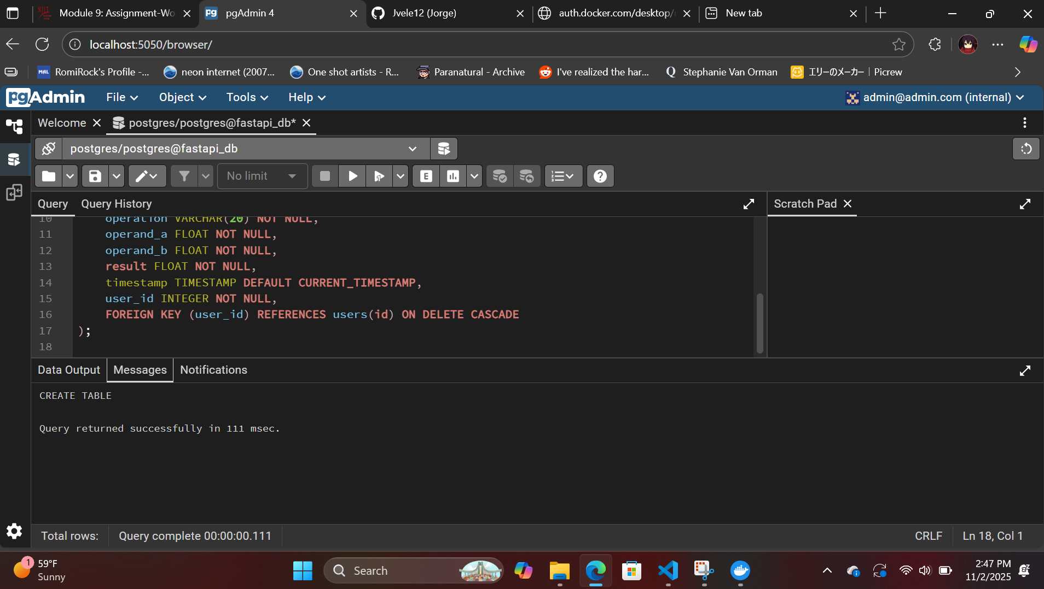
Figure 2. Created tables successfully in pgAdmin.

3. Data Insertion
Figure 3 shows successful insertion of user and calculation records into the database.
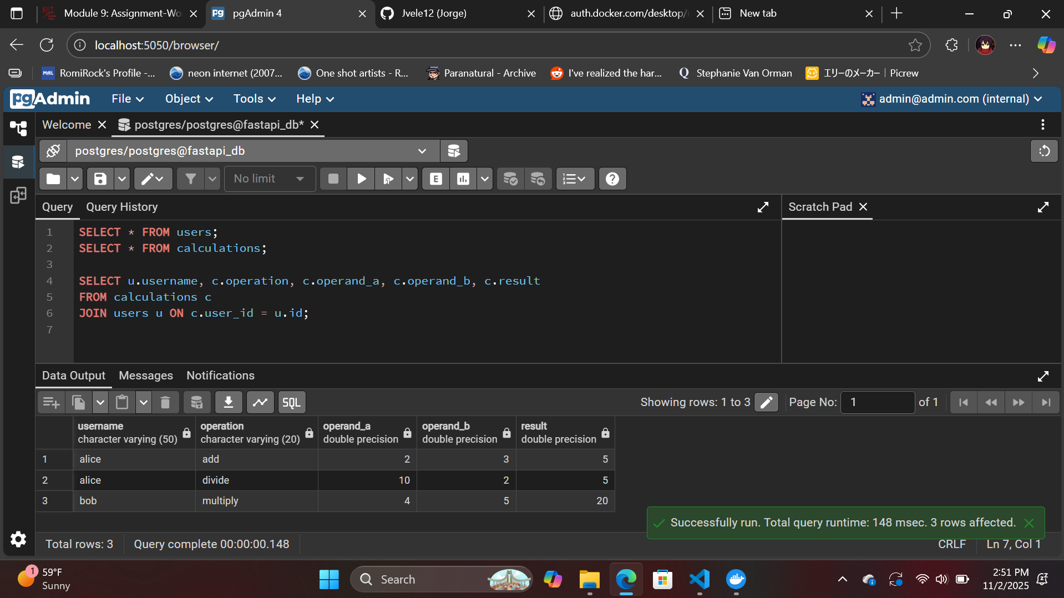
Figure 3. Inserted records successfully.

4. Data Querying and Joins
Figures 4 and 5 show the results of SELECT queries displaying all users and calculations, as well as a JOIN query linking both tables.
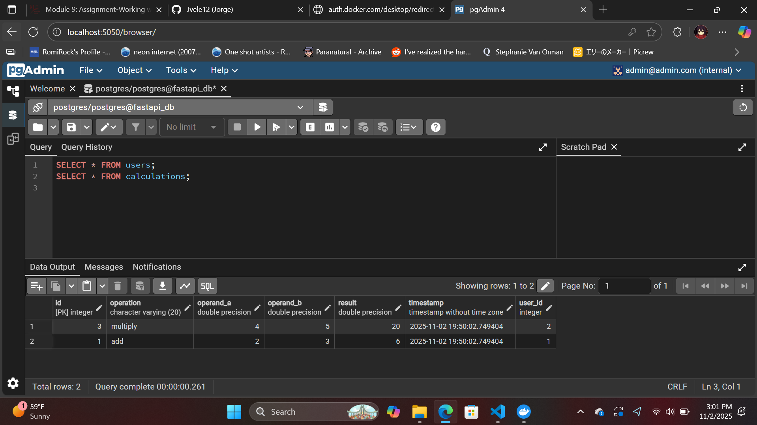

Caption: Figure 4. Queried all data from users and calculations.
Figure 5. Performed JOIN query successfully.

5. Update and Delete Operations
Figures 6 and 7 show successful execution of UPDATE and DELETE commands in pgAdmin, demonstrating proper CRUD functionality.
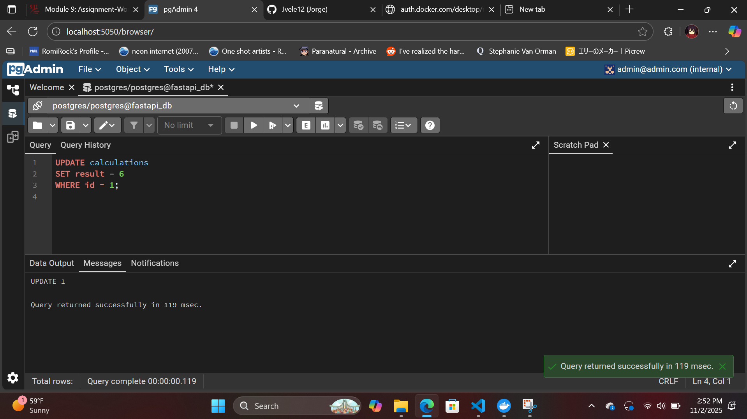

Figure 6. Updated calculation record successfully.
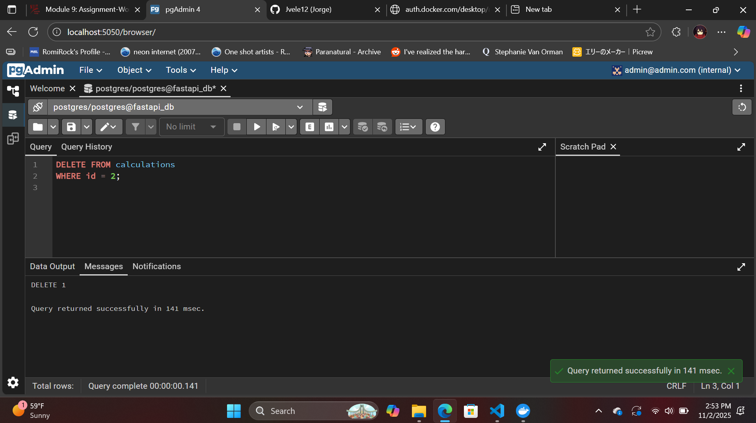

Figure 7. Deleted calculation record successfully.

Reflection
Setting up these APIs and pgAdmin environment with Docker was a valuable hands-on experience that helped me understand how databases, and containerization all work together. I learned how each service for data storage and management communicates through Docker networks. It was pretty cool to see everything connect successfully after configuring the environment variables and confirming the containers were running properly.
One of the main challenges I faced was getting Docker Desktop and pgAdmin to communicate correctly. Since the connection settings had to match and link accordingly to the docker-compose.yml file and ensure all containers start in the correct order. Running SQL commands through pgAdmin also was different as it made me go back and reflect my understanding of how relational databases use tables, foreign keys, and joins.

Overall, this assignment not only helped put into practice more containerized deployment but also showed how important clear configuration files and consistent testing are in real-world DevOps workflows.

