**Game Mechanics and Gameplay Design (CRE342) – Analysis of I Don’t give a Duck**

**Part 1A: Game Concept Critical Evaluation of Core Game Concept**

* 1) Asses the effectiveness of click-based mechanics or player engagement
* 2) Analyse the game’s potential scaling from 12 levels to 100+ levels
* 3) Identify design strengths and limitations with supporting evidence
* 4) Consider accessibility, player psychology, and technical constraints (mobile)

**1)** Click based mechanics within games can be effective at keeping players engaged through different psychological factors that go into how developers orient games towards their audience. An example of how they do this is by taking into consideration aspects such as immediate gratification theory. Immediate gratification theory is the theory that players would get instant feedback leading to sooner in game progression, therefore, experiencing a ‘better’ gameplay experience. This theory feeds off the player’s impulsive behaviours to give them an instant response, and this can also be found within the game “I Don’t Give a Duck”. Throughout every level as clicking the ducks produce feedback, whether it be positive negative, or neutral, this is also the case for other games of the same genre. Figure 1, Figure 2, and Figure 3 are examples of the different games within the same genre, with simple game mechanics and concepts as performing an action within those games also provide the player with an immediate response from the game.

Another psychological factor is the feel of the mechanic, as it can be engaging for the player is they reach a certain ‘flow’ within the game as the simplicity of the mechanics would allow for the game to be accessible and understood by the majority of player demographic. This could also tie into the fact that the game has a low “cognitive load”. This theory explains that the more information and action a player experiences at once, the more difficult it is for them to become emersed within the game they are playing and take in any new information being presented to them. However, in this case, “I Don’t Give a Duck” has a low cognitive load for the player as they only have to focus on a minimal number of tasks such as focusing on thew different ducks to click and their score without having to take in a substantial amount of new information until potentially later levels.

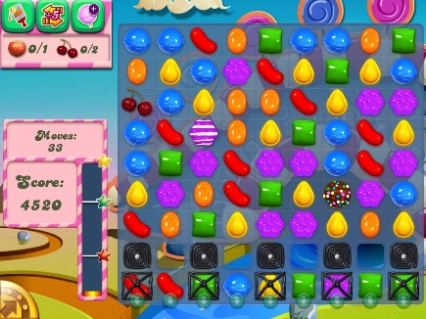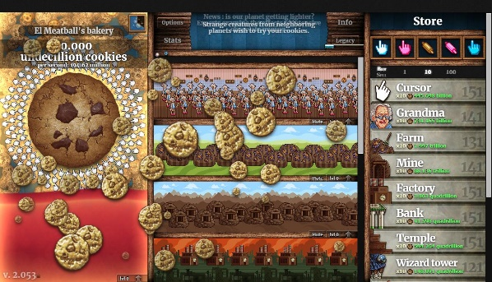

Figure : Candy Crush Saga Figure : Fruit Ninja Figure : Cookie Clicker

**2)** The game’s potential level scalability can depend on different factors that must be taken into consideration by the developers to make gameplay feel fresh and prevent it from feeling stale. Factors that this refer to include content scalability, which considers the need for additional content without a substantial drop in the quality of said additional content. For the game “I Don’t Give a Duck”, this could be a change that it needs to keep it refreshing and sustainable for players by adding features such as a narrative story, cosmetics and more difficult challenges.

However, I feel like doing this over a span over 100+ levels could turn the game mundane to players which could lead to another factor that developers need to take into account. One of the said factors that developer would need to pay attention to is player fatigue; this is the possibility and theory that players could get bored of a game through a number of aspects that could eventually lead them to stop playing in most cases, whether it be the repetitive gameplay, insufficient or lack of rewards and additional content, or naturally getting bored of a game with time. This is one of the biggest issues I have evaluated while going through the game of “I Don’t Give a Duck”. It’s lack of reasoning to reach a higher difficulty ceiling within the different levels would only make it feel like a chore to complete rather than a fun and engaging task to complete which would highly contribute to the factor of potential players of the game getting ‘burned out’ and abandoning it.

**3)** One of the design strengths of the game would be the main concept of the game, the click-based mechanics would cater to the interests of the player demographic that have an interest towards this genre of games.

On the contrary, even though this mechanic can be enjoyable in smaller increments, having a game dedicated around click-based mechanics could be difficult to balance and turn the game mundane due to the limiting mechanical depth allowed from such a simple feature, making it difficult for the player fully immerse within the experience, even with its low cognitive load. I feel that the player would eventually find the gameplay boring due to the lack of thematic cohesion within the game, e.g. The lack of narrative, reasoning and cohesion behind the different themes behind “I Don't Give a Duck”.

Although I previously mentioned the lack of thematic cohesion, I believe that the overall theme of the game could lead to a more accessible, positive game for more age groups and audiences, but the execution was poorly portrayed, simple fixes would be adding visual effects, or a clear narrative to drive the player into feeling motivated to playing instead of blindly clicking ducks and advancing to further levels.

**4)** There is a range of different aspects that play a part into player psychology that could affect the user’s experience and enhance or be a hinderance if not considered. This builds up the player experience and make it enjoyable and sustainable for the player experience, or on the contrast, limit and prohibit the player from enjoying the experience from flaws that the developers forgot to consider such as instant gratification theory. This would play into the player’s desire to get instant feedback and allow them to feel like they are within the game world to immerse themselves within the experience as previously mentioned.

Furthermore, the developer would also need to take into account the different accessibility features and settings their game would need to have for the game for players that are physically impaired such as being colourblind, and other settings such as being able to customise the colours within the UI or turn the volume up higher than the standard level for those that struggle to hear which the current game of “I Don’t Give a Duck” currently lacks.

Finally, the game also lacks has technical constraints to being limited to computer and laptop-based devices. To make the game available to more platforms, the developer would need to consider different UI and game elements that would need to be altered such as making the clicking mechanics able to be implemented on touch screen devices and adjusting the UI size to meet the different screen sizes.

**Part 1B: Game Concept Mitigation Techniques & Enhancement Strategies**

* 1) Suggest methods to maximise variety within the 100-level constraint
* 2) Propose solutions for mechanical depth without compromising accessibility
* 3) Recommend approaches to expand thematic potential in a compact experience
* 4) Address pacing and difficulty progression issues over fewer levels

**1)** There are a range of different changes that could be made to maximise the 100-level constraint for “I Don’t Give a Duck”. Some of these changes include Dynamic difficulty adjustment. This is typically a feature within games that tracks a player's current skill level within the game using stats and adjusts the difficulty towards their similar capabilities such as making enemies easier to defeat. This would be beneficial for “I Don’t Give a Duck” as players would feel like their skills are being challenged instead of feeling like they are playing the same level repetitively to get a more difficult challenge further along the way.

Another change that could be beneficial for “I Don’t Give a Duck” would be environmental variation between levels so users can get a further sense of progression within the game, this could also help the lack of thematic cohesion, letting the game feel like it’s themes are trying to tell a story and properly immerse the player within the game.

**2)** One of the simple ways that could potentially make “I Don’t Give a Duck” feel like a more immersive game would be to add mechanics such as a combo system. Games with mechanics like this would be Guitar Hero and Piano Tiles. These combos would lead to features such as score boosters and in some cases, be the only way to progress certain levels. I think this would be beneficial for the game as it would give the player a reason to pay more attention to the different ducks and build up their score with combos or potential boosts from achieving a certain combo.

Progressive skill development could also be another way to introduce different mechanics to the game, such as slowly adding more decoy or bad ducks within the levels to allow the players to use previously built knowledge to apply to their experience and give them a sense of achievement.

**3)** Approaches that could be taken to expand thematic potential within the game could be to add environmental storytelling to “I Don’t Give a Duck”. This could be done by adding little details such as new backgrounds or maps that could let the player portray how the story is meant to be told. This would add to the player’s curiosity and allow them to keep playing the game to see how the story unfolds.

Another method games use to keep players coming back would be to add seasonal content such as new maps, cosmetics or content. Examples of games that would add seasonal content would be Angry Birds or Animal Crossing as seen in Figure 4 and Figure 5. This could be in the form of adding different maps to match a theme such as Halloween or Christmas, adding limited time cosmetics for players to purchase or earn. This could be done through “I Don’t Give a Duck” by adding certain cosmetics to the ducks such as adding hats to the ducks before they are clicked to reduce player burnout and feel like the game is being taken cared of and they have content to look forward to, and a reason to return to the game.

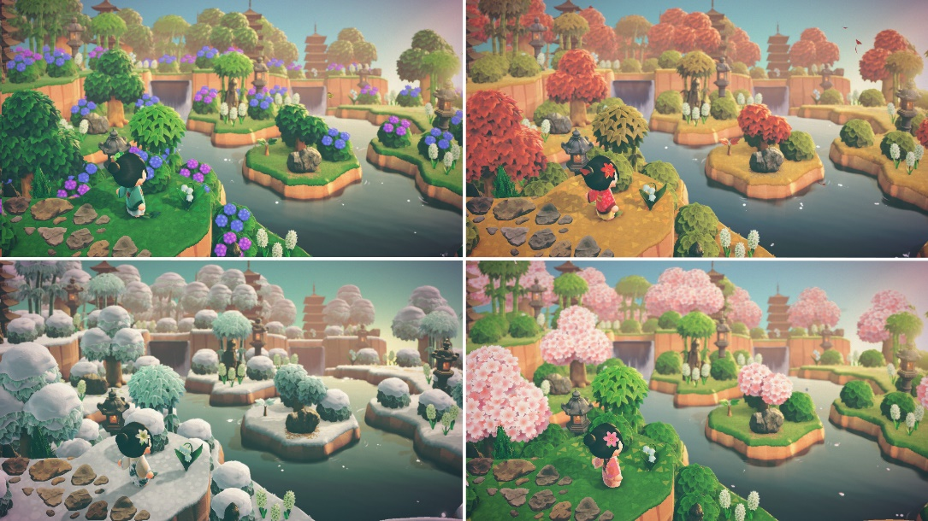

Figure : Animal Crossing

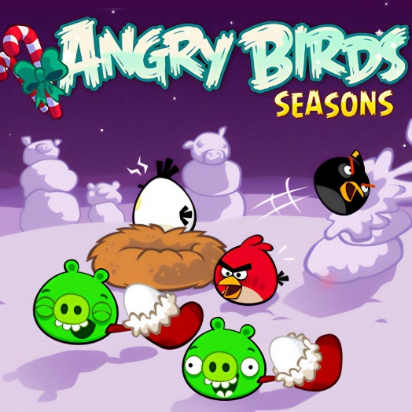

Figure : Angry Birds Seasons

**4)** The pacing and difficulty progression of “I Don’t Give a Duck” could be adjusted to the to better match player capabilities from using adaptive difficulty. This feature is similar to dynamic difficulty adjustment. This feature adjusts the difficulty of the game based on the player’s recent performances. This could be beneficial for the game as it would prevent the levels within the game from being too easy or too difficult which could cause boredom or frustration from the player leading to them abandoning the game. An app that utilises this would be Duolingo; It utilises the user’s recent experience to assist with learning which would be on way that integrated learning is used within apps or games.

I also feel that fewer levels would make it hard for the game to get an accurate gauge of player skill. What I mean by this is that the pacing of the game would be affected by factors such as having to rush and portray the narrative of the game within a shorter time frame which could make it feel rushed, as well as making it harder to sustain player retention. A way to combat this would be to update the game and add further levels for players to reach, similar to the likes of Candy Crush through level gating shown in Figure 6.

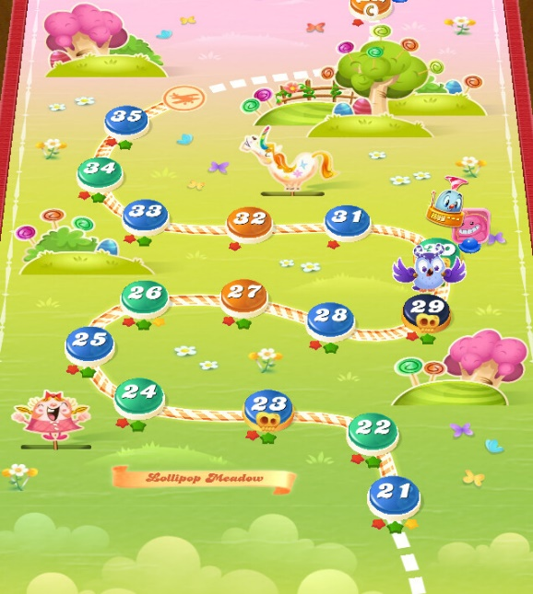

Figure : Candy Crush Level Gating

**Part 1C: Critical Evaluation of Current Gameplay**

* 1) Identify gameplay elements that distract or disengage players from the core experience
* 2) Analyse positive and engaging aspects of the current gameplay implementation
* 3) Evaluate the effectiveness of the 12-level progression structure and pacing
* 4) Assess user interface, feedback system, and overall player experience quality

**1)** Some of the elements that may distract the player include the different theories mentioned throughout this document such as cognitive load theory. If the game has too many factors that could overwhelm the player’s mind during gameplay such as too many new mechanics being thrown their way at once, or too much information being put into the interface, this could break their immersion or even cause frustration for the player. In “I Don’t Give a Duck” this could be a case where the lack of features and mechanics to keep the player engaged, it could cause boredom for the player since the game wouldn’t feel too challenging in its current state.

There could also be a frustration point in the lack of accessibility features. Players with visual or auditorial impairments could potentially struggle to fully immerse themselves within the game due to a range of different aspects such as not being able to see the text, ducks or being able to hear the audio cues that could indicate progression or in game events such as when a duck is on the screen. This would put some players at a disadvantage and prevent them from being able to fully experience the game at its full potential.

**2)** Some of the positive and engaging aspects of the game would be that it is a casual game with a low cognitive load. This means that the player would be more likely to become immersed within the game as they aren’t being constantly bombarded with new information constantly.

The lack of more complex features and simple mechanics within the game’s current state allow for the game to contribute to the instant gratification theory previously mentioned that provide the player with immediate feedback to tend to their need for a responsive and dynamic player feedback loop.

**3)** The 12-level progression of the game has flaws as there are no save points within the game. As previously mentioned, this is very punishing for the player and could lead to frustration, which could in turn, break the player’s sense of flow state while playing the game and lead to less immersion during their gameplay which could generally kill the motivation to keep playing. This could be improved by adding save points within the game such as by allowing for the player to pick up from where they left off without having to constantly restart the game from the beginning. This would generally also improve the pacing of the game, allowing the player to feel a sense of achievement when beating further and harder levels.

In contrast to this, the 12-level structure of the game would allow the progression of the game to stay linear. This would be beneficial for the player and shows that the developers of the game have taking into consideration the difficulty curve needed for the game. This is needed to keep the experience exciting while testing the player’s newly learned skills without making the challenge too frustrating to break immersion and the overall flow of the game. This could give the player a sense of motivation to continue to progress their skills within the game and keep them coming back to play the game.

**4)** The interface design within “I Don’t Give a Duck” could be drastically improved. I feel like the layout could be more spaced out instead of being all cluttered together. This would allow for the game to maintain the low cognitive load is has for the users which in turn could lead to them engaging with the game more. An alternative to this could also be to make some of the elements of the interface such as the score to fade and appear again, similar to games such as Call of Duty when earning points or kills as seen in Figure 7. Another way that the interface could be improved was to allow the player to customise their UI layout to their preference which allows for creativity and better accessibility within the player feedback loop.

On the other hand, the foundation of the game is simple and solid, the feedback system is quite effective at carrying out its purpose, allowing the click mechanic to let players progress through the game onto further levels. However, I feel that there could be more polish towards the general concept of the game, by adding small but impactful changes such as new mechanics that could keep the game fresh and entertaining to players, or more thematic coherence between the game’s elements, the backgrounds, audio cues, or little animations to improve the overall interactivity and game feel.



Figure : Call of Duty

**Part 1D: Gameplay Improvement Proposals**

* 1) Propose mechanical enhancements to improve core gameplay loop and payer satisfaction
* 2) Suggest audio-visual polish improvements (sound design, particle effects, animations)
* 3) Recommend UI/UX optimisations for better engagement and information clarity
* 4) Address state transformation improvements to create smoother gameplay flow and experience continuity

**1)** One of the mechanical changes that could be implemented for the game would be to add a combo system, similar to games such as Piano Tiles or Guitar Hero. This would allow the player to build up a streak of the number of ducks that they have clicked. This in turn would create a sense of urgency and possibly intrinsically motivate the player to continue their streak and achieve a higher score. This could also be aided by potential rewards or cosmetics that players could earn by accumulating a certain score or combo.

Furthermore, power ups could be added to the game to enhance the mechanical feel of the game. Features such as being able to slow down or freeze the timer similar to Figure 8, provide the player with a temporary score booster that could give them a higher score with each duck they click as seen in Figure 9, or be able to make the ducks bigger and easier to click like Figure 10. These powerups would all be ways that the player feedback loop and mechanical feel of the game could be improved. This could help the player fall into a sense of flow while also raising the cognitive load of the game slightly as the game in its current state lacks features to fully allow the player to immerse fully within the game.



Figure : Time Freeze Powerup

Figure : Score Booster Powerup

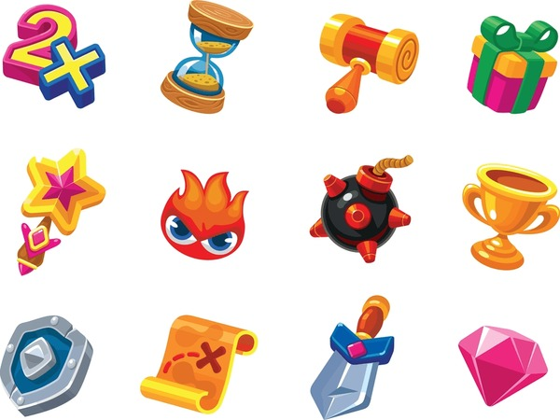

Figure : Game Object Size Enhancer

**2)** I think that there are a range of different audio and visual improvements that could be made for “I Don’t Give a Duck”, with one being making it easier to determine which ducks the player is meant to be clicked as it may be harder to determine for newer players as seen in Figure 11. As there are a range of different ducks with no colour coordination between them. This could be done by keeping the colours of ducks simple, one colour could be used to represent a good duck that the player should click, another colour to differentiate the bad ducks, and potentially a third colour that could be used for decoy ducks within the game that would catch the player off guard.

Another improvement that could be made visually to add to the thematic coherence of the game would be to change the backgrounds of the game, this could either be to choose a better background to match the theme of ducks, or backgrounds that change every few levels to portray the narrative of the game or indicate to the player that they are progressing through the game. This could be in the form of water in the background with some additional changes for this would be to add little animations such as little ripples in the water when the ducks move to make the game feel more interactive and responsive, as well as splashing sounds of the water when a duck is clicked with music to add intensity.

Figure : Image of IDGAD

**3)** To improve the UI of the game, there are a variety of changes that could be considered. To expand on this, there are elements of the user interface that could be changed such as the adjusting the font of the game that could make it easier to read for the players or changing the style to something more tailored to the theme of ducks, such as a more cartoon, fun type of font for better thematic coherence. For the timer, there could also be an improvement made that makes it flash red when it is almost finished to indicate to the player that they are running out of time to add pressure to the game and to allow important information to be presented in a way that doesn’t disrupt the flow of the game.

On the other hand, there could be interface considerations for if the game were to be available on mobile and other devices such as mobile or tablets as seen in Figure 12. This would mean that there would need to be a dedicated area of play within the screen size as occasionally, the ducks would spawn within the user interface, which could block vital information needed to be seen by the player which could cause frustration if it negatively affects the gameplay loop.

Alongside different devices, the game would need to take into account the accessibility features for players with impairments. This could be adjusting the font size, being able to choose different colours for players that are colourblind, or visual indicators such as arrows or animations to guide players with audial impairment.



Figure : Tablet and Mobile Devices

**4)** There are different ways to improve the transformations and transitions within the game to improve the user experience flow. Methods to do this would be to add small animations between the different screens as I feel that from the moment the player presses the play button, they should be able to be able to fully feel immersed within the game with an interactive experience to keep them coming back to play the game.

To transform the player’s experience further, cosmetics could be added for the player to be able to personalise the ducks to their liking, potentially adding hats, or changing their cursor. This would add a sense of novelty, making players want to keep coming back to the game as they would feel like their efforts and time went into earning rewards, as to not wanting to waste their efforts. This could be a psychological method that the developers could use if there was a specific achievement or item that was difficult to obtain giving it rarity and potential bragging rights for players to show off to others.