TITLE: BLOOD BANK SYSTEM
PROBLEM STATEMENT
Blood donation is essential for saving lives, yet many patients face delays due to the unavailability of specific blood types at critical moments. Poor inventory management, lack of real-time tracking, and inadequate coordination between hospitals and blood banks contribute to these shortages. Rural areas suffer the most due to limited storage facilities and accessibility challenges. Low donor turnout, misinformation, and fear of donation further worsen the situation. An efficient Blood Bank Management System with real-time tracking, automated alerts, and better coordination can help bridge the gap, ensuring timely blood availability and saving lives.
- Introduction
  - Purpose
The purpose of a Blood Bank System is to efficiently manage the collection, storage, and distribution of blood and its components to ensure availability for patients in need. It serves as a centralized platform for donors, hospitals, and recipients.
1.2 Scope
The Blood Bank System manages donor registration, blood donation, and inventory tracking while ensuring safe storage and distribution. It facilitates blood requests, matches donors with recipients, and handles emergencies efficiently. Quality control ensures compliance with health standards, and reports provide insights into blood demand and supply trends. Security measures, including data encryption and role-based access, protect sensitive information.
1.3 Definitions, Acronyms and Abbreviations
1.4 Reference
- Overall Description
  - Product Perspective
This system includes both offline and online components. Blood collection is done manually through Blood Donation Camps, where donors can either register on the Blood Bank website or have their registration completed by camp authorities. An online database stores donor information, and collected blood is safely stored. A Blood Inventory Database tracks all collected units, and samples are sent to a Testing Unit to check their usability. Lab technicians generate reports, and unfit blood is discarded. Hospitals place orders, and records of orders and payments are maintained. Once payment is made, the Blood Bank staff delivers the order. A database also keeps records of all staff working in the Blood Donation Camp and Blood Bank.

  - Product Functions
Donors can create an account from home or register at a blood donation camp before donating. The Hospital Manager must register the hospital as an acceptor. The Inventory Manager updates and maintains blood availability, which is confidential and accessible only to administrators. Registered hospitals can place online orders, which the Inventory Manager processes by checking blood stock. If the required blood type is available, the hospital is notified, and once the order is confirmed, the details are sent to them.

  - User Characteristics
- Donor: Registers online or on-site and donates blood.
- Receptionist: Assists donors, maintains donor details, and updates the database.
- Blood Camp Doctor: Collects and packages blood, then sends samples to the Lab Technician and the rest to inventory.
- Lab Technician: Tests blood samples and sends reports to the Inventory Manager.
- Inventory Manager: Reviews reports, discards unfit blood, updates inventory, and tracks storage & expiry dates.
- Hospital Manager: Places blood orders, confirms payment, and maintains hospital records.
- Delivery Boy: Delivers blood units safely to hospitals after order confirmation and payment.

  - Constraints
- The Donor and the acceptor are constrained to create an account first to avail the services.
- The internet connection is also a constraint for this web application.
- The web application is also constrained by the database capacity so it works well with a smaller number of donors and hospitals.

  - Assumptions and Dependencies
- Users need a mobile or computer that supports the web application.
- Online payments are managed by respective bank administrators.
- The database is managed using Oracle and MySQL.
- The front end is built with HTML, PHP, and Bootstrap.

- Specific Requirements
  - Functional Requirements
- Access Website: Users can access the web app from any browser on a phone or computer without restrictions.
- User Registration: Users can register by providing their name, gender, blood group, location, contact, username, and password.
- Automatic Updates: When a new version is released, the web app updates automatically upon access.
- User Login: Registered users can log in, and their login details are stored for future use.
- Search Donors: Users can search for donors, displaying up to 10 results with name, gender, blood group, location, and contact.
- Request Blood: Hospitals can request blood by specifying the blood group, location, required date, and contact details.
- Manage Requests: The blood bank can view, search, and respond to blood requests based on blood group and availability.
- Check Blood Stock: When a hospital places an order, the inventory is checked for availability before confirming the request.
- View Orders: Hospitals and blood banks can track orders, including order details, hospital info, and delivery tracking.
- Delivery Status: Hospitals and blood banks can monitor delivery progress and contact the delivery person if delayed.

  - Non-Functional Requirements
- 24/7 Availability: The system, both online and offline, should be accessible at all times.
- Reliable Recovery: In case of database failure, backups restore data and update it to the latest state.
- Strong Security: The system must have a secure database to protect sensitive information.
- Accurate Matching: Blood units must match hospital requests and be delivered to the correct location.
- Proper Maintenance: The Inventory Manager must keep accurate blood stock records.
- Standardized Pricing: Blood unit costs should be fixed and consistent.
- Future Expansion: The system should support adding new features if needed.

  - Databases
  - Object Oriented Models

DFD for Admin page

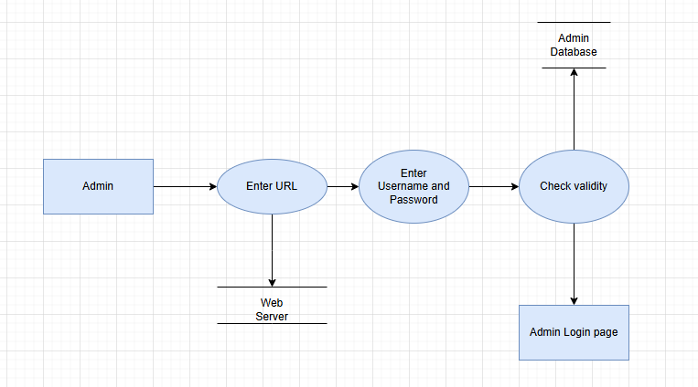

DFD for User page:

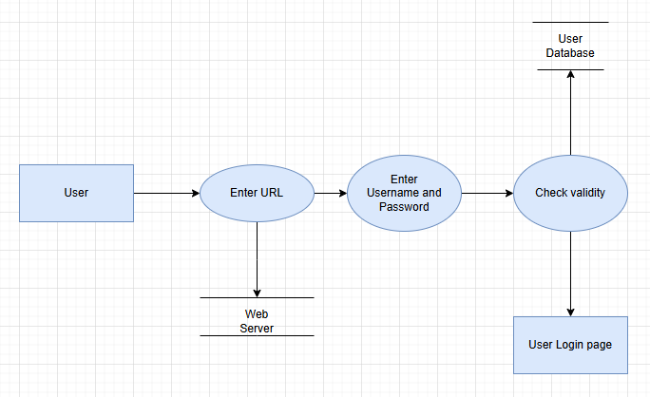

Level 0:

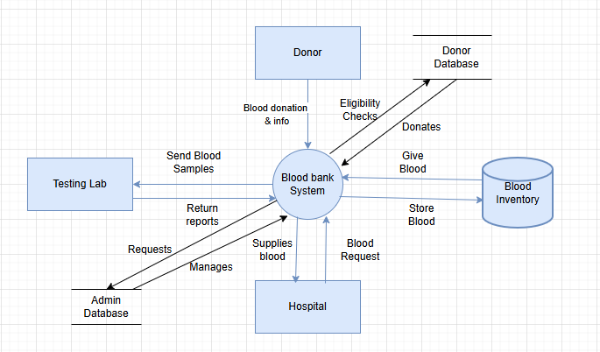

Level 1:

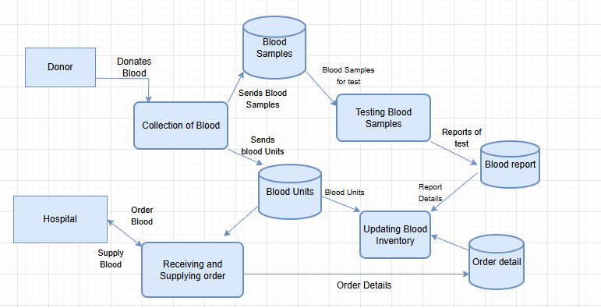

Use Cases:

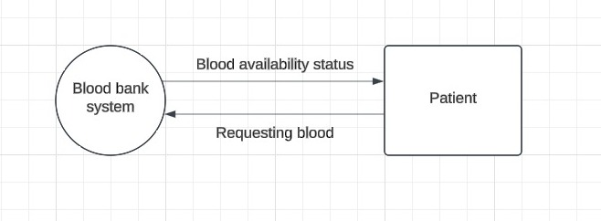

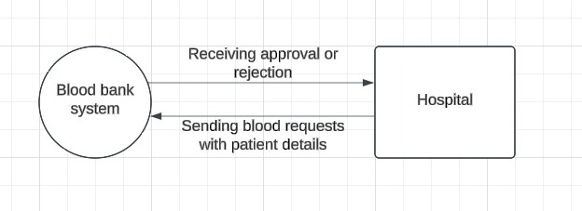

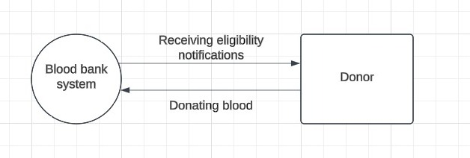

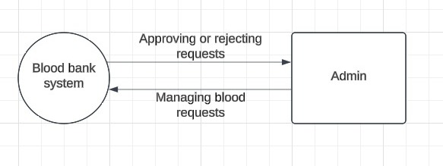

General blood bank use case diagram

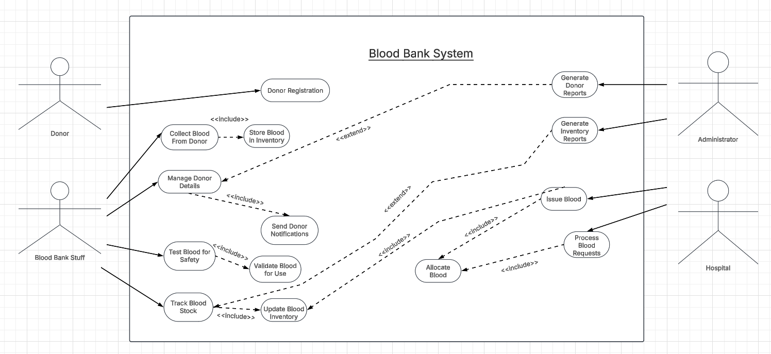

Reciever side:
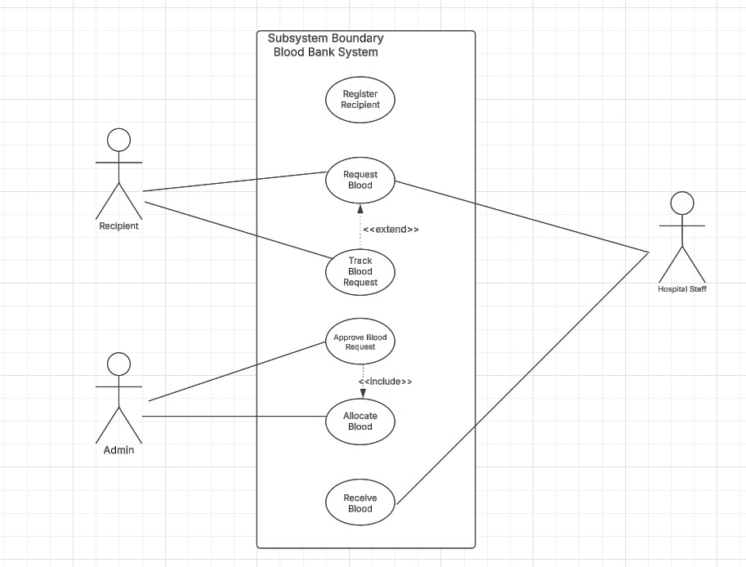

Blood inventory:
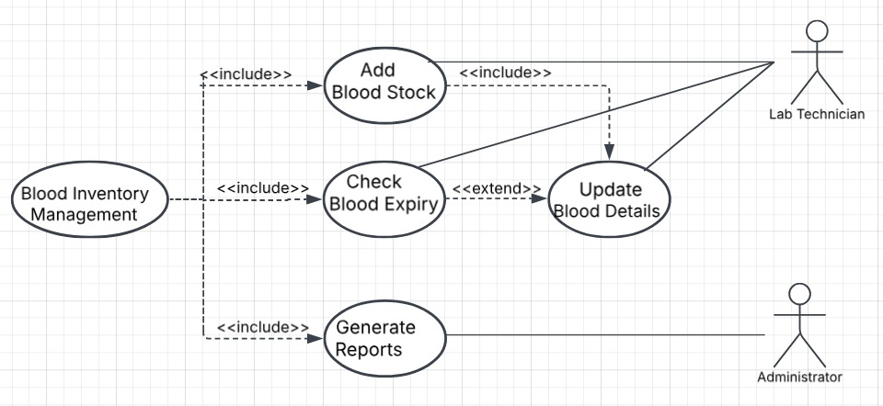

Admin use case:

