**Midterm Exam(AI6315)**

Name : Younkyung Jwa

Student ID : 20214035

*Describe the question below with a screeshot.

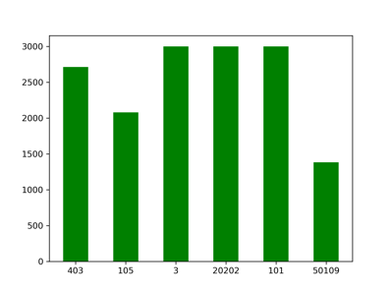**1. Check distribution by object.(3 points)**

1.1 Train data class distribution

{'403': 2712, '105': 2077, '3': 3000, '20202': 3000, '101': 3000, '50109': 1381}

1.2 Train data RGB mean, std

print(meanR, meanG, meanB) # 0.29392457 0.30366316 0.29798967

print(stdR, stdG, stdB) # 0.15284057 0.14239912 0.14335868

**2. Dataloader – explain the dataloader with code(6 points)**

2.1 extract paths from data folder

tr_image_paths, tr_labels = utils.load_path(filepath='Midterm/data/train', train=True)

ts_image_paths, _ = utils.load_path(filepath='Midterm/data/test_3000_nolabel', train=False)

2.2 set dataset with transform and load data

tr_dataset = utils.LandmarkDataset(tr_image_paths, class_to_idx, tr_transform)

ts_dataset = utils.LandmarkDataset(ts_image_paths, None, ts_transform)

tr_loader = torch.utils.data.DataLoader(

tr_dataset, batch_size=batch_size, shuffle=True, num_workers=2)

ts_loader = torch.utils.data.DataLoader(

ts_dataset, batch_size=batch_size, shuffle=False, num_workers=2)

**3. Train and test explain the train and test model with code(6 points)**

3.1 set network, criterion, optimizer

net = SimpleDLA(num_classes=len(class_to_idx))

3.2 train

for epoch in range(start_epoch, start_epoch+epochs):

train_loss, train_acc = train(epoch)

3.3 test and extract the csv file

test_labels = test()

result_df = pd.DataFrame(

{'imagename': test_id,

'predicted': test_labels

})

result_df.to_csv("Midterm/result/results.csv", index=False)

**5. Describe how you improved your accuracy (5 points)**

5.1 Test Accuracy with two models

|  |  |  |
| --- | --- | --- |
| Epoch | Simple CNN | Simple DLA |
| 50 | 0.936 | 0.96266 |
| 100 | 0.95133 | 0.96533 |
| 150 | **0.96133** | **0.97933** |
| 200 |  | 0.97533 |

5.2 SimpleDLA Test Accuracy with/without Dropout

|  |  |  |
| --- | --- | --- |
| Epoch | with Dropout | without Dropout |
| 150 | 0.96733 | **0.97933** |
| 200 | **0.97933** | 0.97533 |
| 250 | 0.97533 |  |