Know the Changed password from Centrify:
- Login into https://na.my.centrify.com/
- Go to Secrets
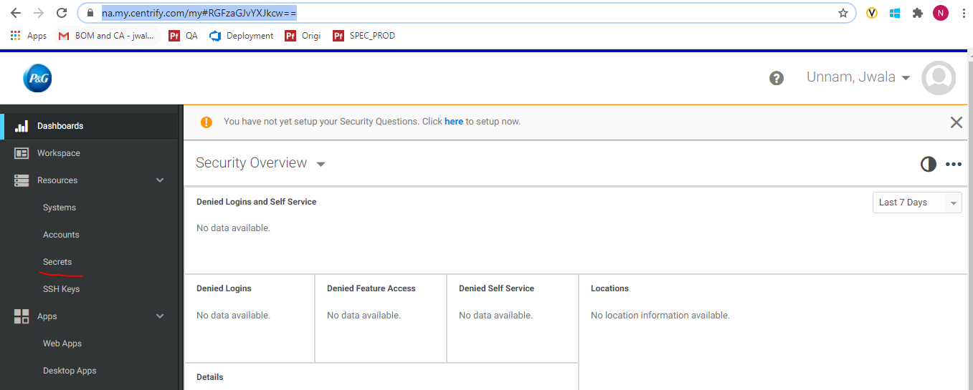
- Check the checkbox for sys_ops doc and under actions click on “Retrieve”
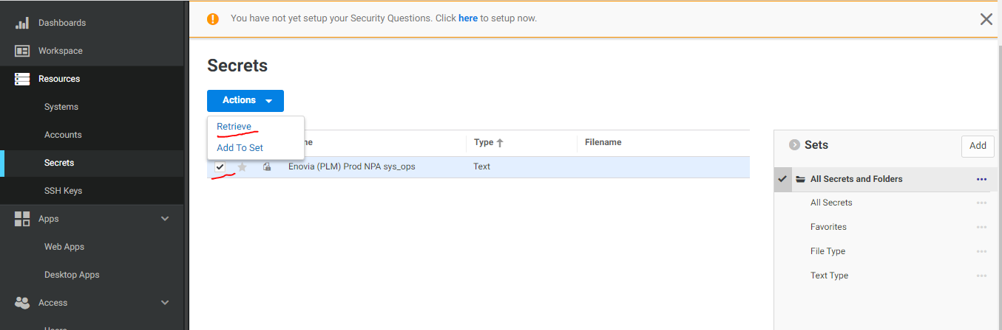
- Click on “Show Text”. We should be able to see new password
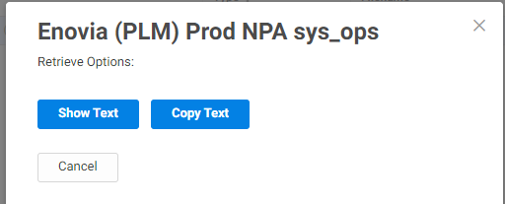
Modify or Update the password for sys_ops:
Login to GitHub
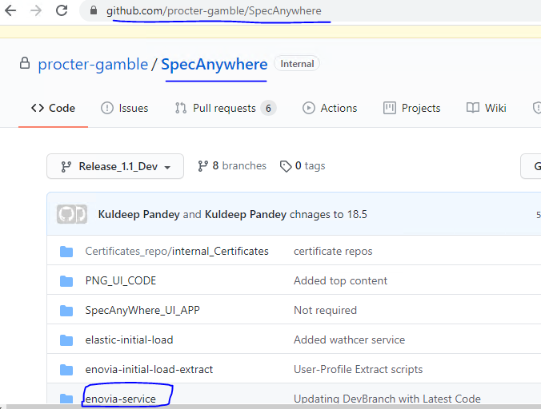

Navigate to the following path: (Latest release Branch)
https://github.com/procter-gamble/SpecAnywhere/tree/Release_1.0.1_Prod_HF/enovia-service/src/main/resources
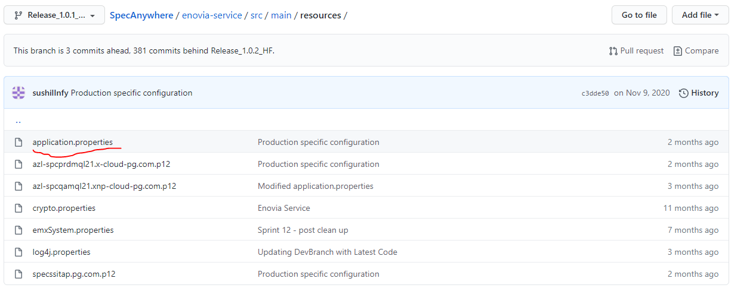

Edit the file above and update this variable for Production:
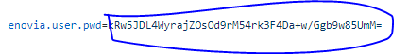
Commit and push the changes to Git.
Pipeline Deployment:
Go to
https://dev.azure.com/specsanywhere

Navigate to Pipelines
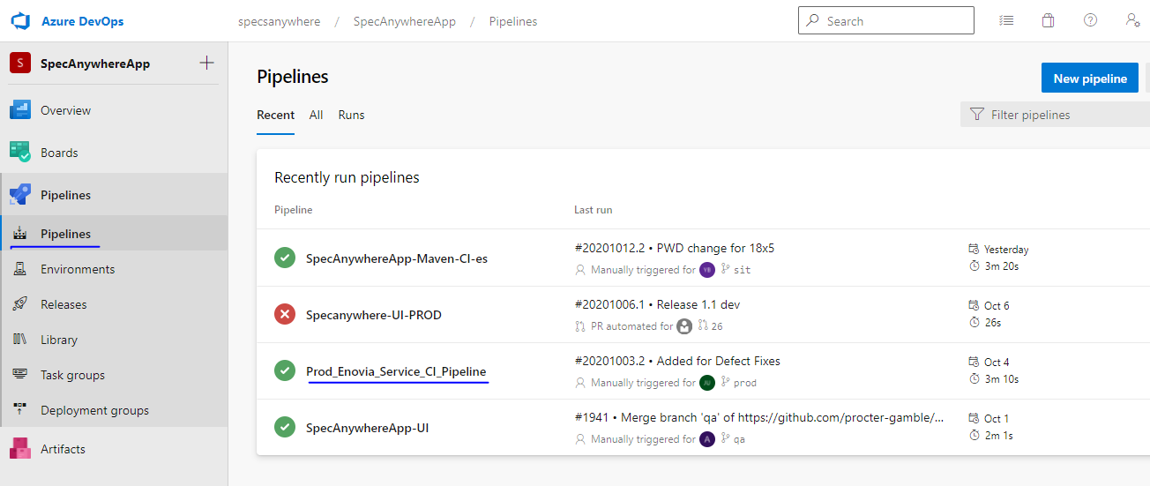

Select Run PIpline:
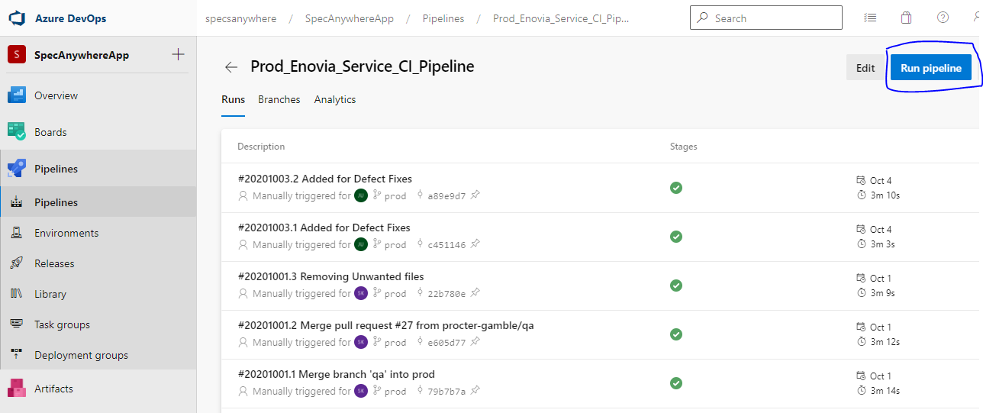

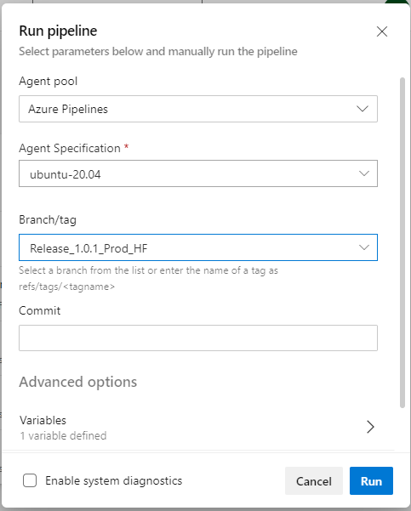

Once it is executed the Agent job must complete:
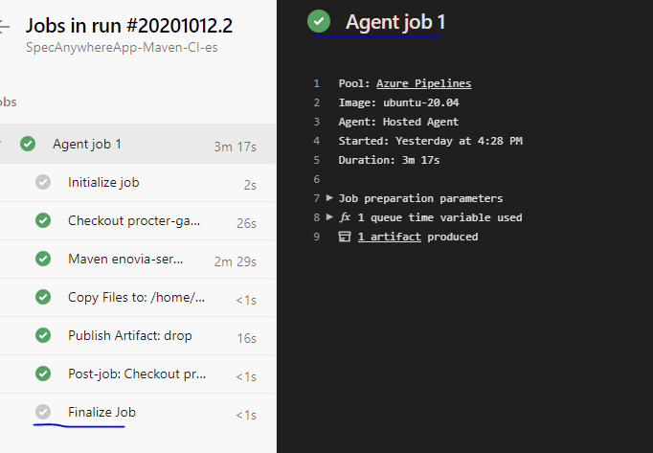

Start Service on all nodes:
PROD Servers:
azl-spcprdmql21 | 10.123.64.25
azl-spcprdmql22 | 10.123.64.33
azl-spcprdmql23 | 10.123.64.37
azl-spcprdmql24 | 10.123.64.40

Steps to Start MQL services in PROD:
1. Deploy the build from Pipeline
2. Navigate to /enovia_jar
3. execute SyncEnoviaJars.sh (Only if we do any new deployment we execute this script to take old jar backup and place new jar)
4. run below command to start service
nohup ./Enovia_Service_HF16.sh >/enovia_jar/specsanywhere_enovia_service.log &
tail -100f specsanywhere_enovia_service.log (to check logs)

Sucessful Run Log:
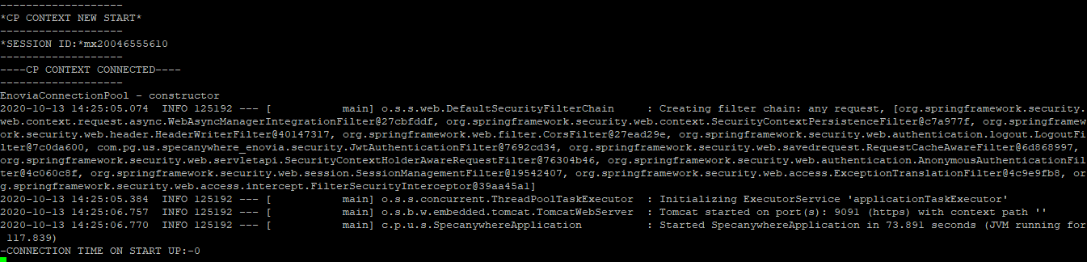
If the password in incorrect at this point there will be errors in the logs (with the message “invalid password”)
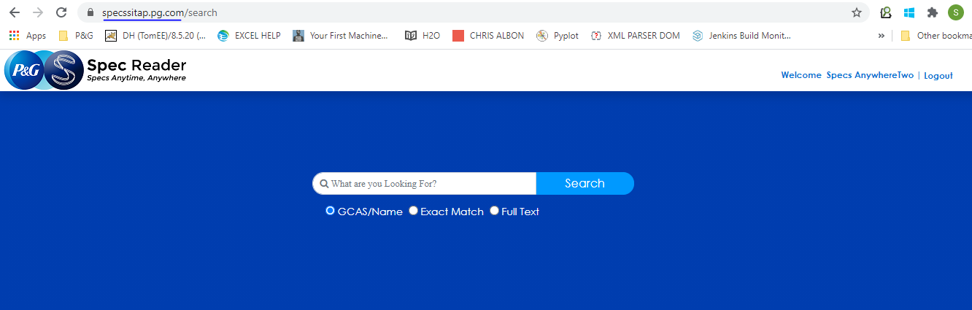

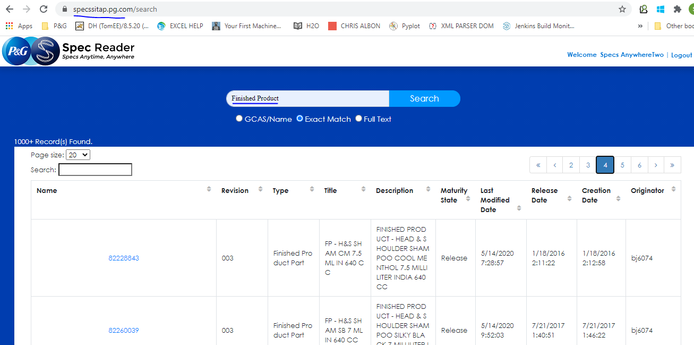

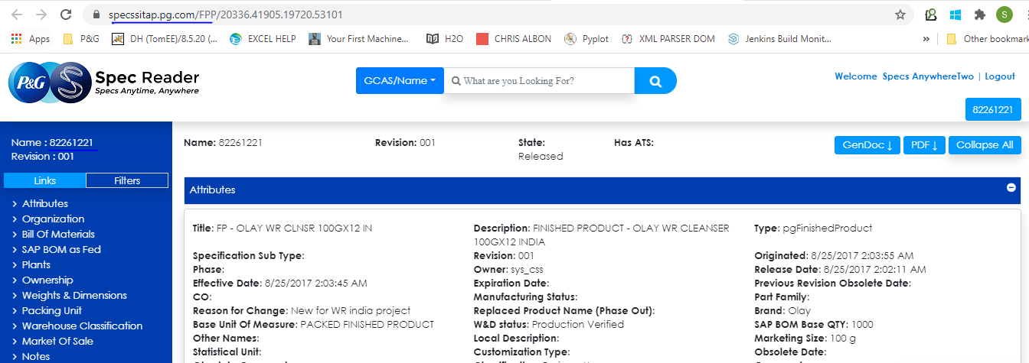

Operations scripts: User Profile Script // Delta // OTR // Initial Load

Go to this path on: azl-spcprdmql01.xnp-cloud-pg.com
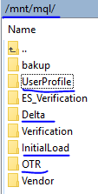

Modify the encrypted password in:

Line to be modified:

In order to generate the encrypted password, one can use the java command in the same script as mentioned in the snapshot above.
Example:
java –cp $CLASSPATH com.pg.us.specanywhere_enovia.utility.EncryptCrypto Encrypt “PASSWORD_TO_ENCRYPT”

