Installing/configuring Elastic search , Logstash , Rclone, fscrawler.

RCLONE:
- Rclone needs to be installed on all the following VMs:
  - Logstash server
  - MQL Initial Load/Delta server
  - Kibana (Fscrawler) server
- Installation command:
  - curl https://rclone.org/install.sh | sudo bash
- Install Fusermount to unmount rclone when required.
  - yum install fuse
- Create rclone config on each environment as per the container:
STEPS:
- rclone config
- enter name of the container account (example: enovia-csv-container)
- select option 22 = Microsoft Azure blob (cross check to be sure based on version of rclone installed)
- Skip all the next steps (select default) until sas_url
- Get sas_url from azure portal and enter it here
- Select all other default options and quit.
- Here are commands for each server to mount the azure storage:
  - FSCrawler server
rclone mount enovia-docs-container:enovia-docs-container/store /etc/HVR_STORE --daemon --log-file=rclonelog.txt
  - MQL Server
rclone mount enovia-csv-container:enovia-csv-container/store /usr/etc/enovia-csv-content --daemon --log-file=rclonelog.txt
  - Logstash server
rclone mount enovia-csv-container:enovia-csv-container/store /usr/etc/enovia-csv-content --daemon --log-file=rclonelog.txt

- Upload a file to any one of the container paths to verify if the drive is mounted:
  - rclone ls enovia-csv-container:enovia-csv-container
Above command should return the file you have uploaded on the portal into this container “enovia-csv-container”

Logstash:

- Edit logstash configuration already shared, double check the mounted drive path:
  - vi /etc/logstash/logstash-sample.conf
- verify the mounted drive path:
  - verified /etc/enovia-csv-content
- Go to bin folder:
  - cd /usr/share/logstash/bin
- Run logstash:
  - nohup ./logstash -f /etc/logstash/logstash-sample.conf >> /var/log/logstash/logstash_log.txt &

FSCrawler:

- Run fscrawler first time with the following command to create the empty project:
  - ./fscrawler.sh qadocs
- Change permissions at
  - /root/.fscrawler/qadocs/_settings.yaml
- Edit the configuration file at this path only:
  - /root/.fscrawler/qadocs/_settings.yaml
PFA
- Insert Database/Index for Fscrawler in ES:
  - curl -v -XPUT "10.123.192.49:9303/qadocs"

Elastic Search checks:

- provide access on /mnt*/logs and */data/ folders
- edit the configuration file
  - /etc/elasticsearch/elasticsearch.yml
- Go to
  - /usr/share/elasticsearch/bin
  - Insert schema PFA into respective servers of the cluster
- Start service:
  - nohup ./elasticsearch >/mnt/elasticsearch/logs/esqa.log &
- Verify status of cluster or node:
  - curl GET '10.123.192.49:9303?pretty'
  - ps -ef | grep elasticsearch
- Check all indices created in the cluster:
  - curl GET '10.123.192.49:9303/_cat/indices?pretty'
  - This command will list out both indexes: qaspec and qadocs as well.

Enovia MATRIX-R

Once the DB is ready MQL and DB connectivity can be evaluated as follows:
- Go to cd /usr/DassaultSystemes/enoviaV6R2018x/server/scripts
- Run the following command in root prompt:
  - ./mql -install -b MATRIX-R -user plmprd3admin -password 3admin_Plmprd -host //azl-spcqaora01.xnp-cloud-pg.com:1524/specq1.ap.pg.com -driver 'Oracle/OCI80'
- This will create MATRIX-R file under:
  - /usr/DassaultSystemes/enoviaV6R2018x/server
  - Now navigate to /usr/DassaultSystemes/enoviaV6R2018x/server/scripts/mql
- MQL should launch and DB connectivity can be tested.

Running UI application :

$ sudo forever start -a Server.js
$ sudo forever stop Server.js

Opening ports for integration VMs. :
Execute yum install firewalld
firewall-cmd --permanent --add-service=https
firewall-cmd --permanent --add-port=7000/tcp
firewall-cmd --permanent --add-port=7001/tcp
firewall-cmd --permanent --add-port=7002/tcp
firewall-cmd --permanent --add-port=7003/tcp
firewall-cmd --permanent --add-port=7004/tcp
firewall-cmd --permanent --add-port=7005/tcp
firewall-cmd --permanent --add-port=7006/tcp
firewall-cmd --permanent --add-port=7007/tcp
firewall-cmd --permanent --add-port=7008/tcp
firewall-cmd --permanent --add-port=7009/tcp
firewall-cmd --permanent --add-port=7010/tcp
firewall-cmd --permanent --add-port=7011/tcp
firewall-cmd --permanent --add-port=7012/tcp
firewall-cmd --permanent --add-port=7013/tcp
firewall-cmd --permanent --add-port=7014/tcp
firewall-cmd --permanent --add-port=7015/tcp
firewall-cmd --permanent --add-port=7016/tcp
firewall-cmd --permanent --add-port=7017/tcp
firewall-cmd --permanent --add-port=7018/tcp
firewall-cmd --permanent --add-port=7019/tcp
firewall-cmd --permanent --add-port=7020/tcp
firewall-cmd --permanent --add-port=7021/tcp
firewall-cmd --permanent --add-port=7022/tcp
firewall-cmd --permanent --add-port=7023/tcp
firewall-cmd --permanent --add-port=7024/tcp
firewall-cmd --permanent --add-port=7025/tcp
firewall-cmd --permanent --add-port=7026/tcp
firewall-cmd --permanent --add-port=7027/tcp
firewall-cmd --permanent --add-port=7028/tcp
firewall-cmd --permanent --add-port=7029/tcp
firewall-cmd --permanent --add-port=7030/tcp
firewall-cmd --permanent --add-port=7031/tcp
firewall-cmd --permanent --add-port=7032/tcp
firewall-cmd --permanent --add-port=7033/tcp
firewall-cmd --permanent --add-port=7034/tcp
firewall-cmd --permanent --add-port=7035/tcp
firewall-cmd --permanent --add-port=7036/tcp
firewall-cmd --permanent --add-port=7037/tcp
firewall-cmd --permanent --add-port=7038/tcp
firewall-cmd --permanent --add-port=7039/tcp
firewall-cmd --permanent --add-port=7040/tcp
firewall-cmd --permanent --add-port=7041/tcp
firewall-cmd --permanent --add-port=7042/tcp
firewall-cmd --permanent --add-port=7043/tcp
firewall-cmd --permanent --add-port=7044/tcp
firewall-cmd --permanent --add-port=7045/tcp
firewall-cmd --permanent --add-port=7046/tcp
firewall-cmd --permanent --add-port=7047/tcp
firewall-cmd --permanent --add-port=7048/tcp
firewall-cmd --permanent --add-port=7049/tcp
firewall-cmd --reload
sudo yum install postgresql postgresql-server
service postgresql initdb
service postgresql start

psql "host=spcqapgres.postgres.database.azure.com port=5432 dbname=postgres user=hosting@spcqapgres password=Welcome90 sslmode=require"

# su - postgres
service postgresql restart
postgres=# CREATE DATABASE rhq OWNER spcqapgres;
CREATE DATABASE

https://access.redhat.com/documentation/en-us/red_hat_jboss_operations_network/3.1/html/installation_guide/setting-up-dbs
CREATE DATABASE hosting@spcqapgres
psql "host=spcapspgres.postgres.database.azure.com port=5432 dbname={your_database} user=hosting@spcapspgres password={your_password} sslmode=require"

Installing Live collaboration server ::
Install lsb core package before LCS installation .
yum install redhat-lsb-core -y
go to installable , opt/matrix

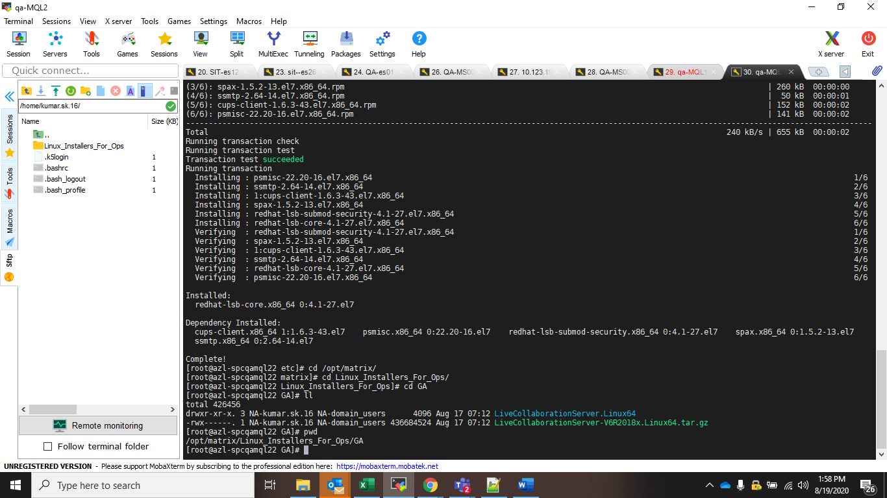

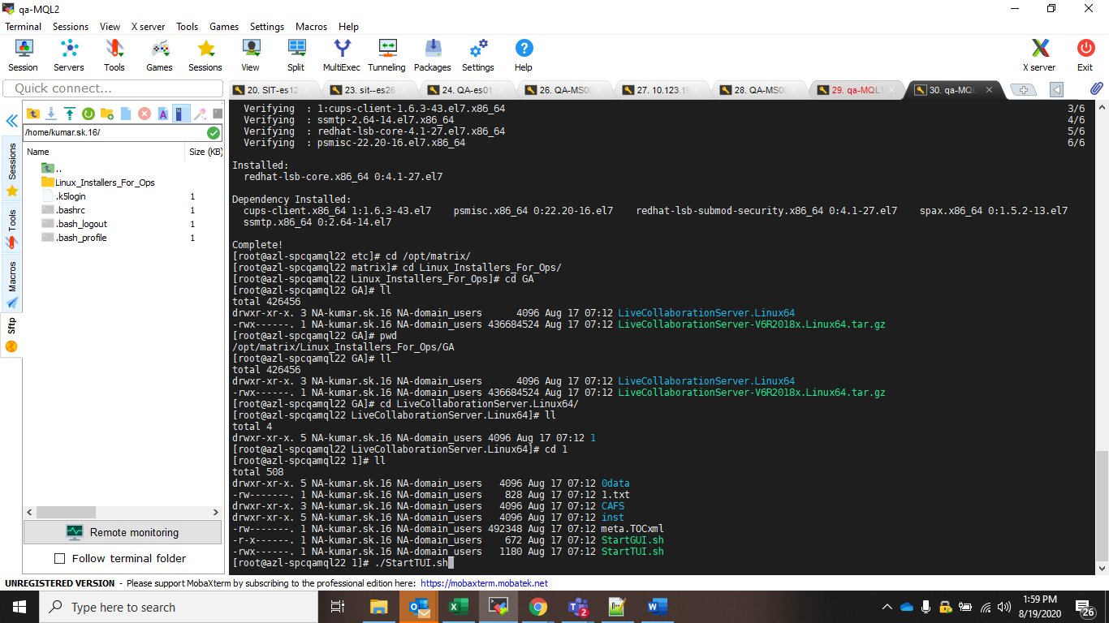

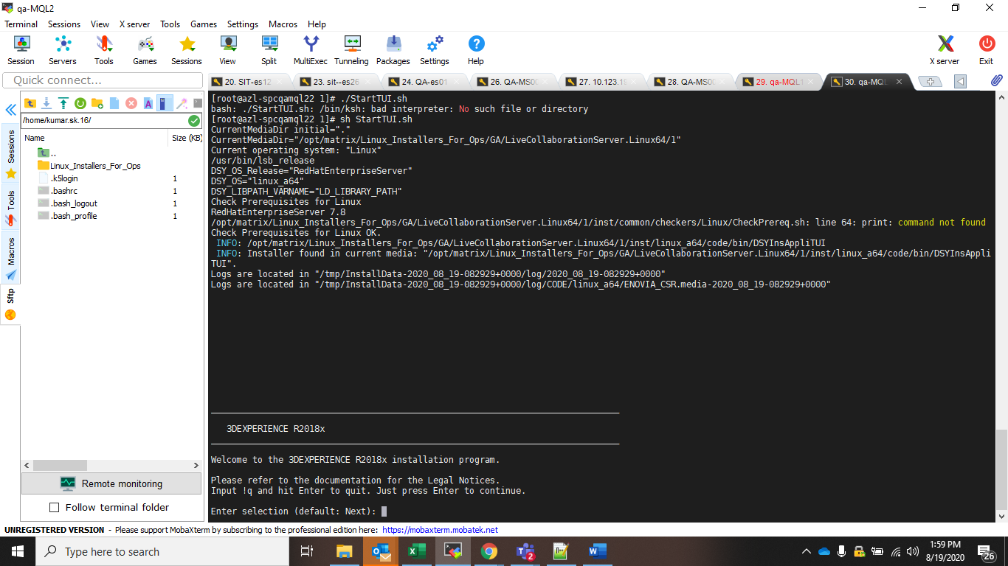

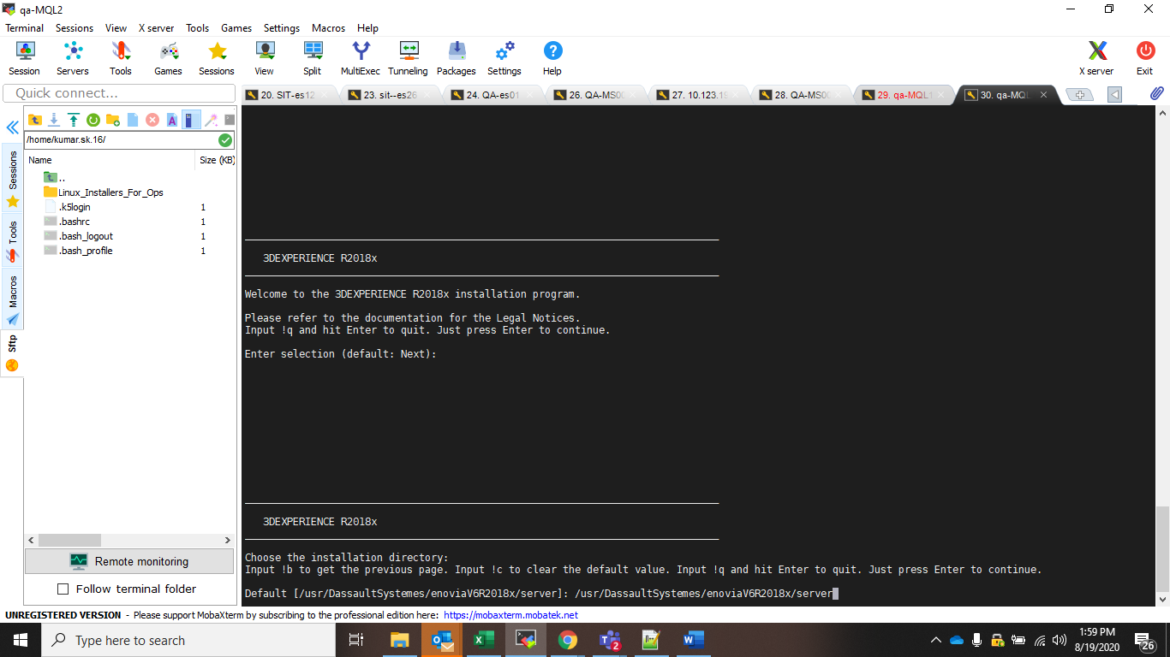

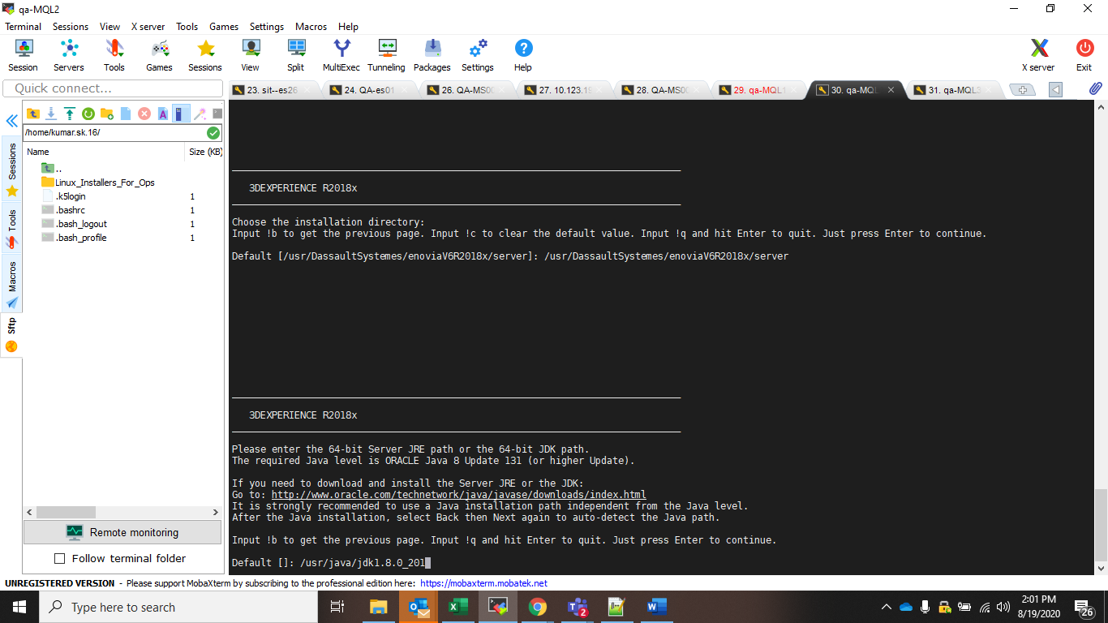

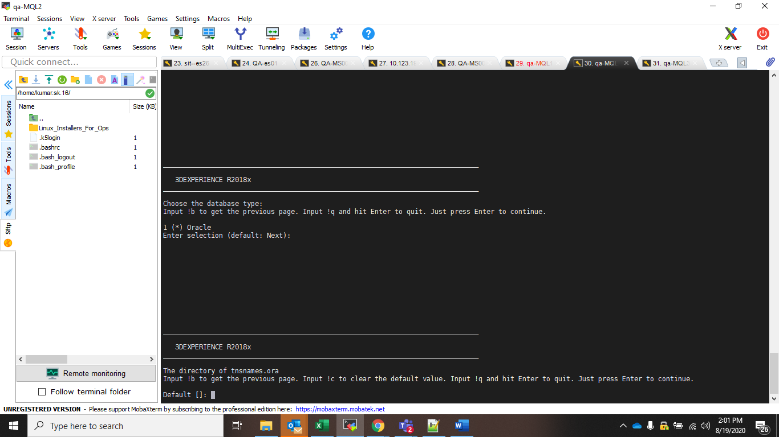

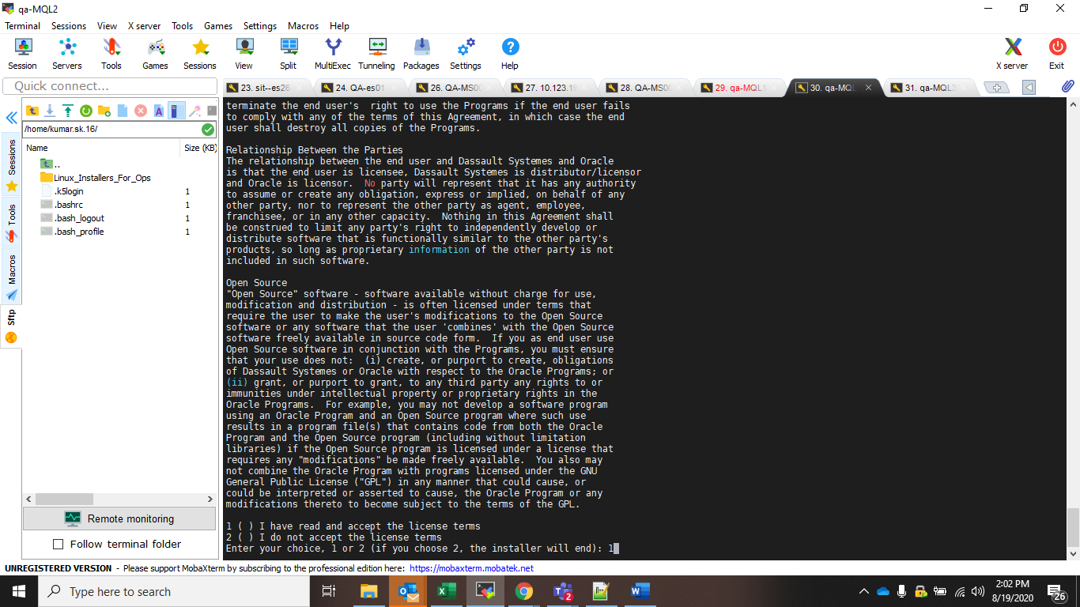

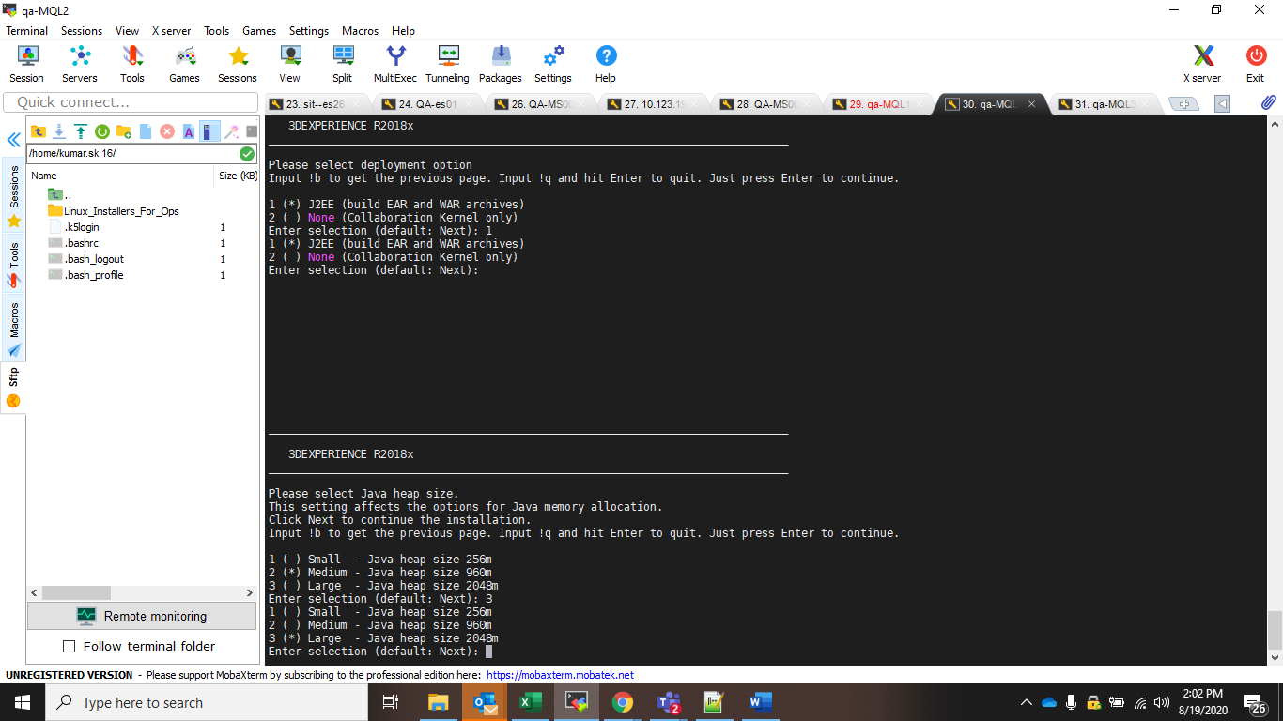

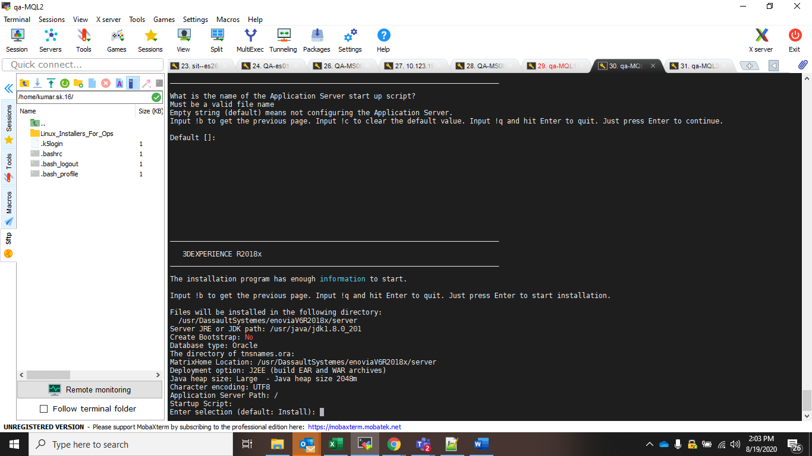

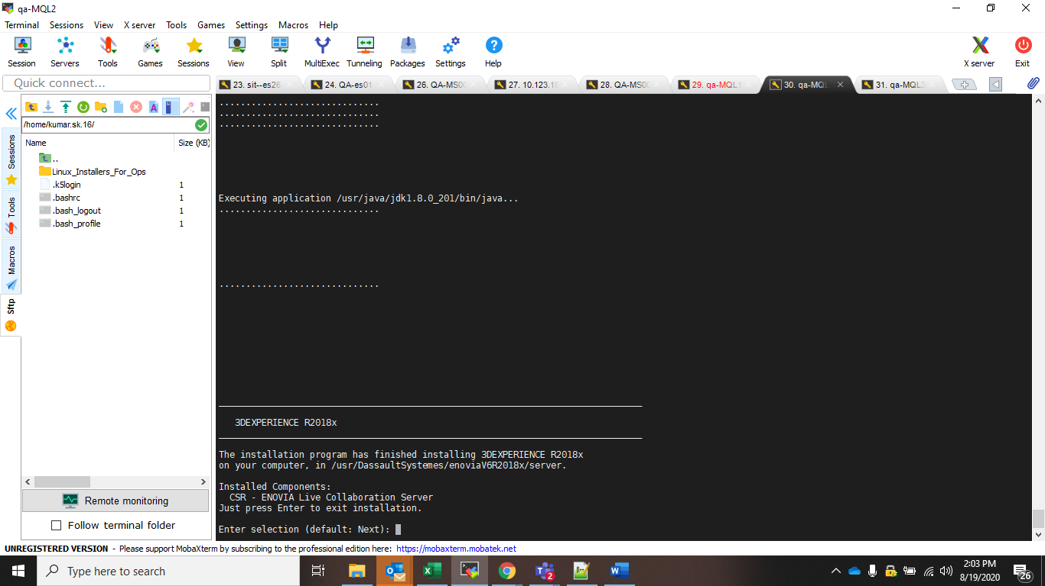

Installing hotfix for live collaboration server :;
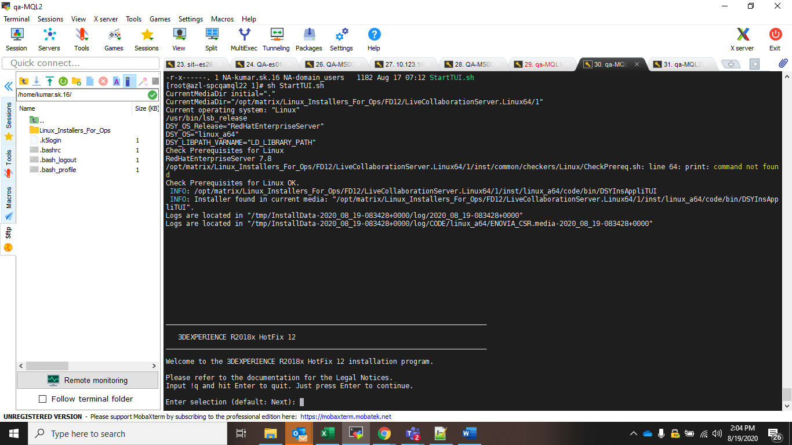

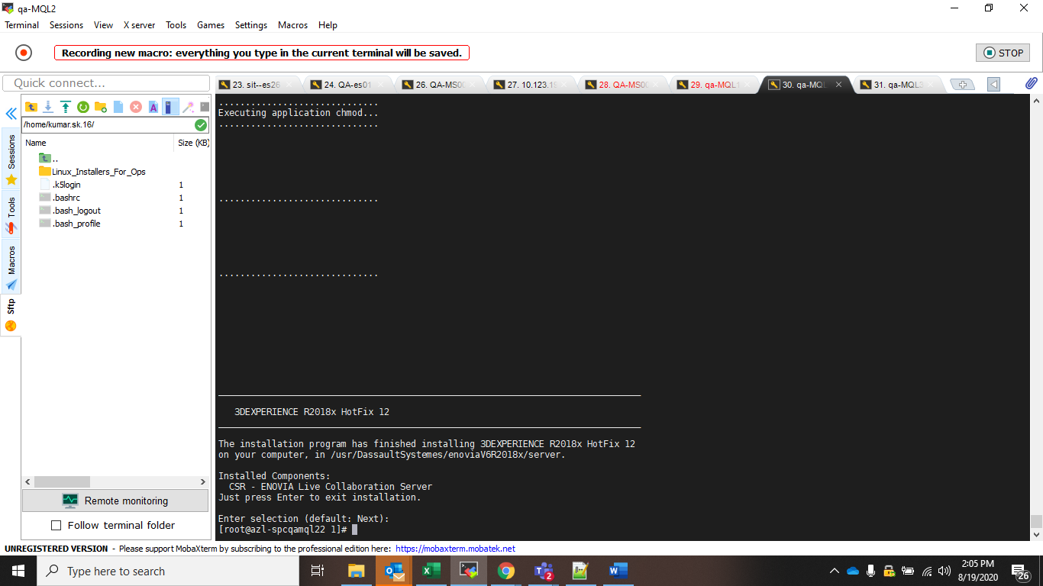
/usr/DassaultSystemes/enoviaV6R2018x/server.

Installing logstash ::

https://www.elastic.co/guide/en/logstash/current/installing-logstash.html

Installing kibana :
https://www.elastic.co/guide/en/kibana/current/rpm.html
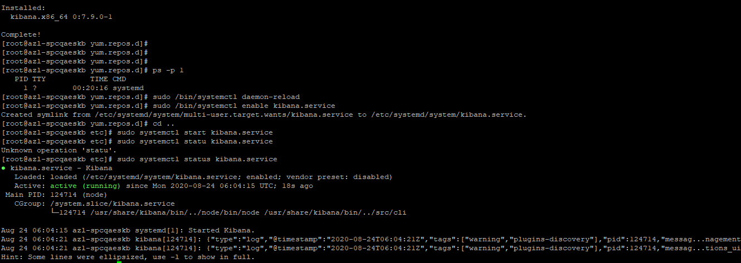
installing elastic search :
https://www.elastic.co/guide/en/elasticsearch/reference/current/rpm.html
/usr/java/jdk1.8.0_201/jre/bin

Etc/sysconfig/elasticsearch
JAVA_HOME=/usr/share/elasticsearch/jdk

Rclone installation::
https://rclone.org/install/

Elk configuration :
- Configure elasticsearch file at /usr/share/elasticsearch/bin

# ES_JAVA_OPTS="-Xms8g -Xmx8g" ./bin/elasticsearch
JAVA_HOME=/usr/share/elasticsearch/jdk
ES_JAVA_OPTS="-Djna.tmpdir=/var/lib/elasticsearch/tmp"

- Update etc/elasticsearch/elasticsearch.yml

bootstrap.system_call_filter: false
cluster.name: esqa
node.name: QaEsNode3
path.data: /mnt/elasticsearch/data
path.logs: /mnt/elasticsearch/logs
discovery.seed_hosts: ["10.123.192.45","10.123.192.47","10.123.192.49"]
network.host: 0.0.0.0
#network.bind_host: 10.123.192.30
node.master: true
node.data: true
#discovery.zen.minimum_master_nodes: 2
#discovery.type: single-node

- Change permission for below :
/etc/sysconfig
/etc/elasticsearch/
/var/lib/elasticsearch/tmp/
/etc/security/limits.conf
/var/log/elasticsearch/gc.log
- Change /etc/security/limit.conf :

#
* - nofile 65535
#* soft core 0
#* hard rss 10000
#@student hard nproc 20
#@faculty soft nproc 20
#@faculty hard nproc 50
#ftp hard nproc 0

Rclone installation ::
https://rclone.org/install/
/usr/bin
Rclone config

[12:49 PM] YaminiShashank Boindala
Mql ;:

rclone mount /usr/etc/enovia-csv/ enovia-csv-container:enovia-csv-container

[12:50 PM] YaminiShashank Boindala
rclone mount enovia-csv-container:enovia-csv-container /etc/enovia-csv-contents

fscrawler :

/home/boindala.y/fscrawler-es7-2.7-SNAPSHOT by YaminiShashank Boindala
YaminiShashank Boindala1:13 PM
/home/boindala.y/fscrawler-es7-2.7-SNAPSHOT/

{
"name" : "qadocs",
"elasticsearch" : {
"nodes" : [
{ "host" : "azl-spcapsesn12.xnp-cloud-pg.com", "port" : 9303, "scheme" : "HTTP" },
{ "host" : "azl-spcapsesn13.xnp-cloud-pg.com", "port" : 9303, "scheme" : "HTTP" }
]
}
}

Index Name:
qaspec

data folder :
/mnt/elasticsearch/data
log folder:
/mnt/elasticsearch/logs

Schema:
curl -v -XPUT "10.123.192.45:9303/qaspec" -H 'Content-Type: application/json' -d '
{
"settings": {
"index": {
"number_of_shards": 2,
"number_of_replicas": 2
},
"analysis": {
"filter": {
"autocomplete_filter": {
"type": "edge_ngram",
"min_gram": 1,
"max_gram": 20
}
},
"analyzer": {
"autocomplete": {
"type": "custom",
"tokenizer": "standard",
"filter": [
"lowercase",
"autocomplete_filter"
]
}
}
}
},
"mappings": {
"properties": {
"id": {
"type": "keyword"
},
"type": {
"type": "text",
"analyzer": "whitespace"
},
"name": {
"type": "text",
"analyzer": "standard",
"search_analyzer": "autocomplete"
},
"revision": {
"type": "keyword"
},
"title": {
"type": "text",
"analyzer": "standard",
"search_analyzer": "autocomplete"
},
"description": {
"type": "text",
"analyzer": "standard"
},
"originated": {
"type": "date",
"format": "M/d/yyyy h:m:ss a"
},
"modified": {
"type": "date",
"format": "M/d/yyyy h:m:ss a"
},
"ipClass": {
"type": "keyword"
},
"classifiedItem": {
"type": "text"
},
"company": {
"type": "text"
},
"plant": {
"type": "text"
},
"ownership": {
"type": "text"
},
"filename": {
"type": "text"
},
"filepath": {
"type": "text"
},
"relatedspec": {
"type": "text"
},
"masterspec": {
"type": "text"
},
"phase": {
"type": "text"
},
"releasedate": {
"type": "date",
"format": "M/d/yyyy h:m:ss a"
},
"brand": {
"type": "text"
},
"displaytype": {
"type": "text"
},
"tag": {
"type": "text"
},
"originator": {
"type": "keyword"
},
"orgsource": {
"type": "text"
},
"doctype": {
"type": "text"
},
"ShareWithSupplier" : {
"type": "boolean"
},
"gendoc" : {
"type" : "text"
},
"nonrenderabledoc" : {
"type": "text"
},
"otherrefdoc":{
"type" : "text"
}
}
}
}
'

PATH TO RUN ES:
/usr/share/elasticsearch/bin
nohup ./elasticsearch >/mnt/elasticsearch/logs/essitstress.log &

CHECK STATUS:
curl GET '10.123.192.45:9303?pretty'

license file for the plm serer :
/var/DassaultSystemes/Licenses

curl GET 'https://10.123.192.45:9200?pretty'
curl -XGET 'http://localhost:9200/_cluster/state?pretty'
This is Mandatory for all MQL instances:
yum install ksh
yum install libXt

licenese file :
/var/DassaultSystemes/Licenses

Following steps are are required to be done for environment setup (SIT/QA/PROD) which were missing earlier.
Please add these in to your documentation:

