Styled components – use extension to vsc called vscode-styled-components for supporting syntax and highliting errors.
If you want to style build in html elements from 3rd library like navlink from react router you can put it inside brackets
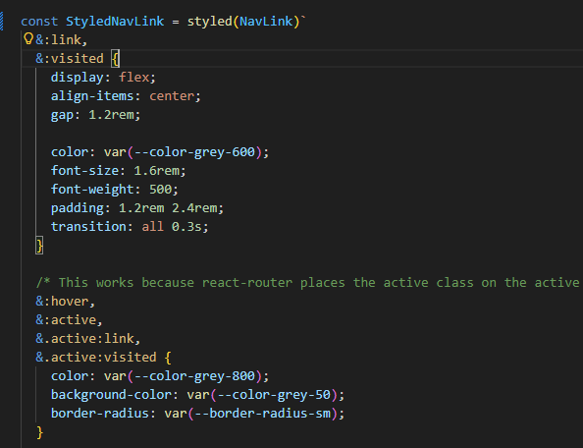



React-icons Is great icons library.

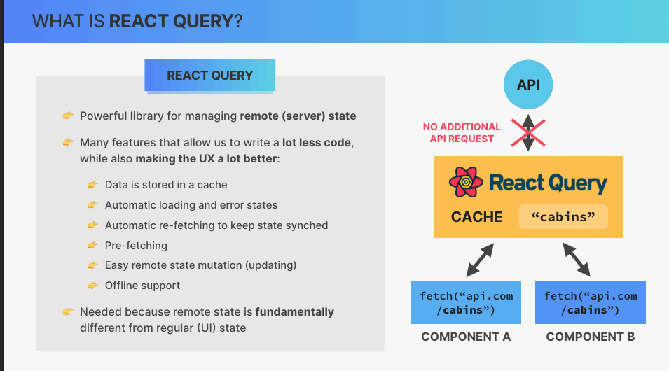

For better accessible for browser when we working with styled components use “role”
Then browser is sure its exatly table or row
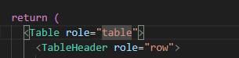
Verry pupular libarary to manipulation or calculation with dates 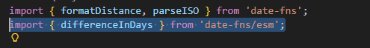
React-hot-toast – toast react library

