Product & Buyer Management System
User Manual
Version 1.0 | June 2026

1. Getting Started - Login
The PBMS application requires authentication to access any feature. All users must log in with their registered email and password.

Step 1: Open the Login Page
Navigate to the PBMS application URL. You will see the login screen with the PBMS branding, an email field, and a password field.
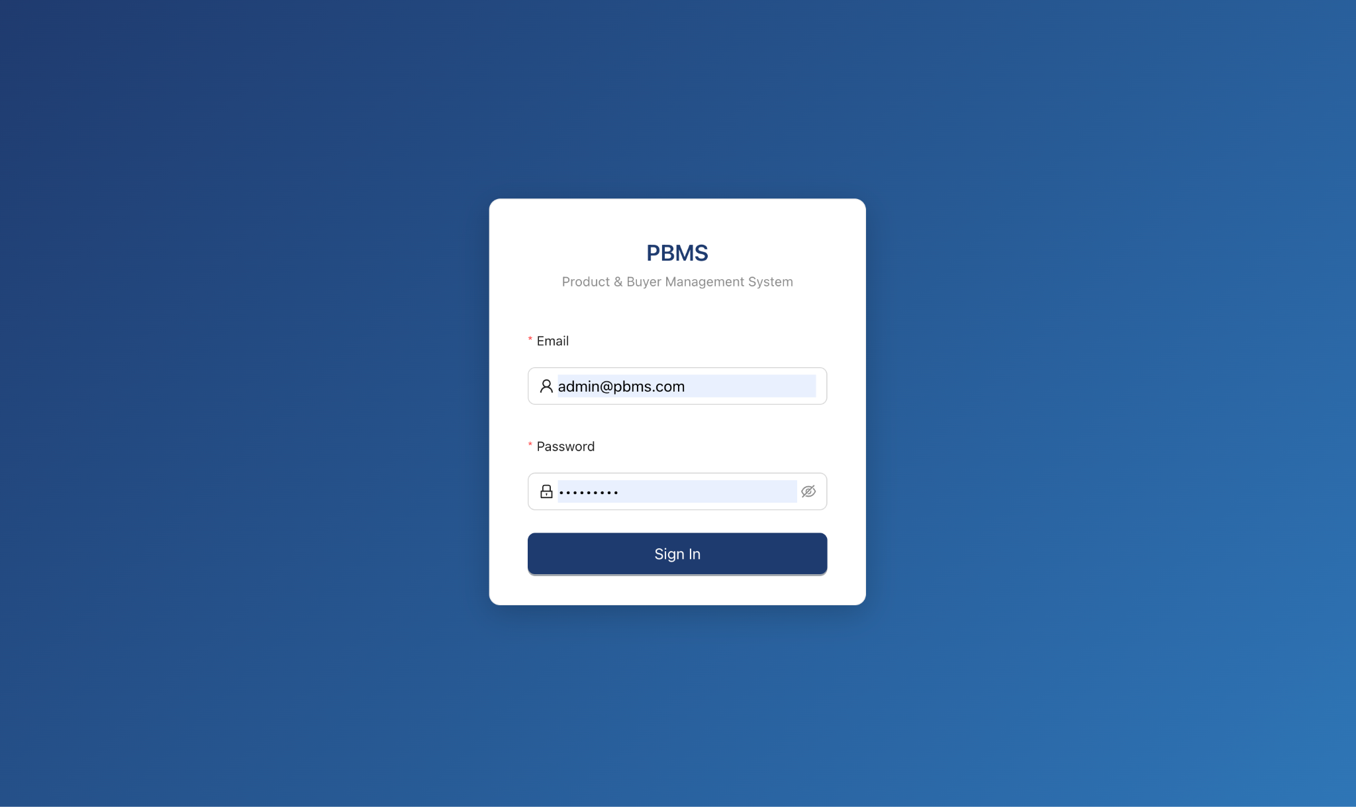
Figure 1.1 - Login Page

Step 2: Enter Your Credentials
Step 1: Type your registered email address in the "Email" field.
Step 2: Type your password in the "Password" field.
Step 3: Click the "Sign In" button.
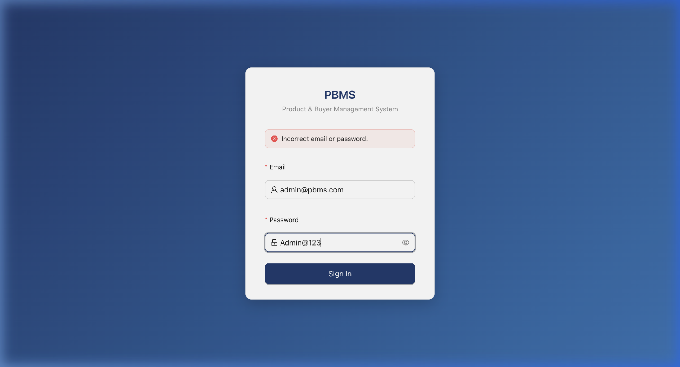
Figure 1.2 - Login Form with Wrong Credentials
📝 Note: If you enter incorrect credentials, an error message will appear. After multiple failed attempts, your account may be temporarily locked for security purposes.

2. Dashboard
After a successful login, you are taken to the Dashboard, the home page of the application. The dashboard provides a high-level overview of your data.
What You See:
- Summary Cards: Total counts of Products, Companies, Contacts, and Mappings.
- Charts: Visual representation of data trends (e.g., products added per month).
- Recent Activity Table: A live feed of the latest actions taken across the system.
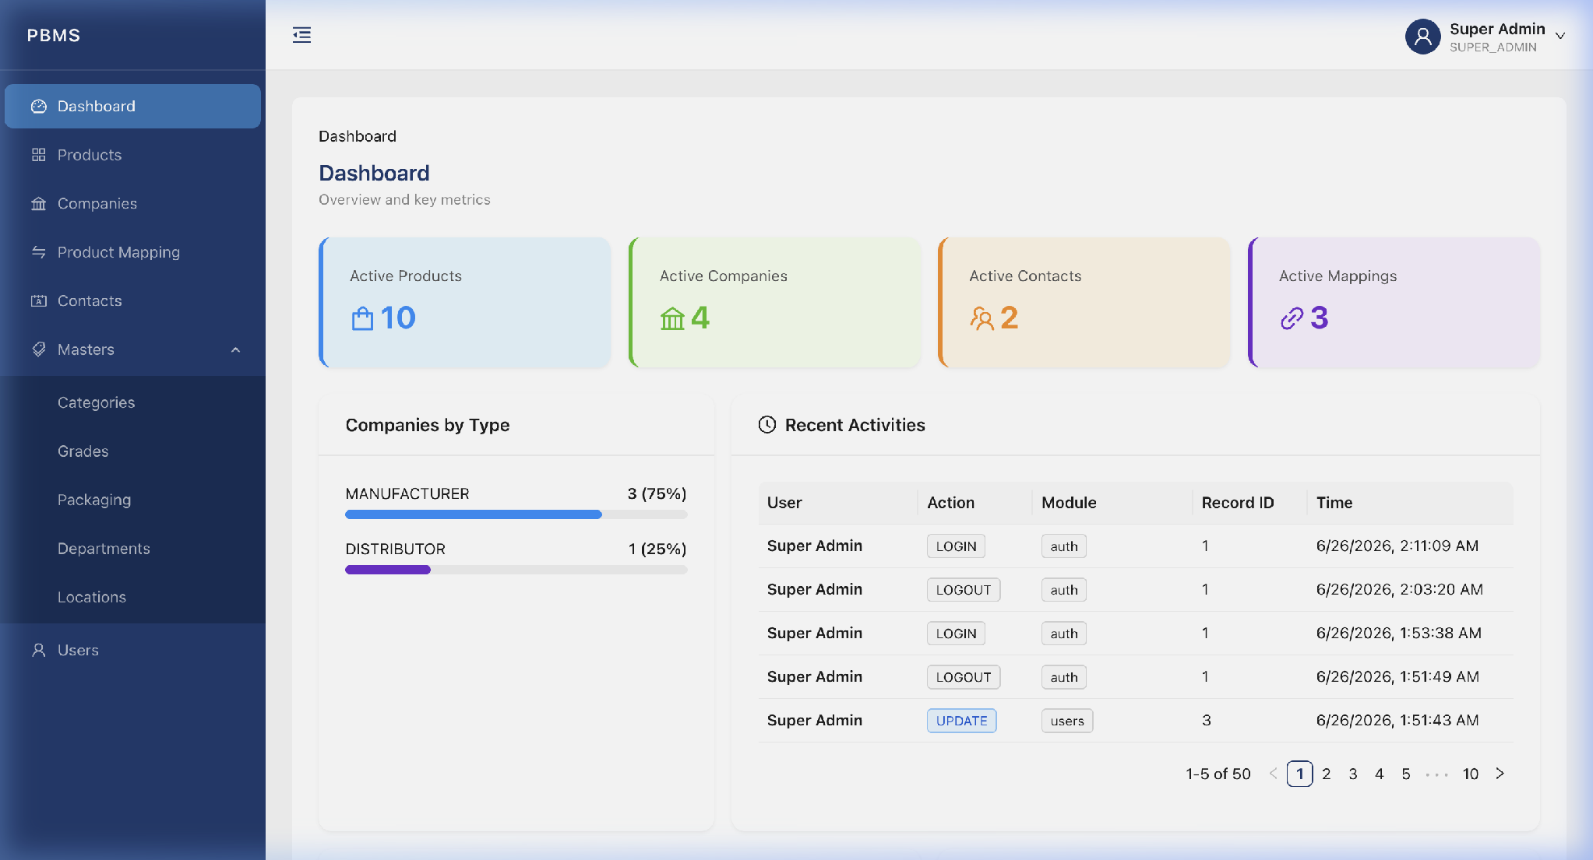
Figure 2.1 - Admin Dashboard
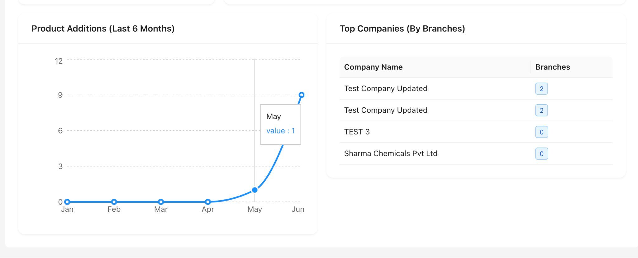
Figure 2.2 — Admin Dashboard

3. Products Module
The Products module allows you to manage your entire product catalog. You can add, view, edit, deactivate, import, and export products.

3.1 Products List
Click "Products" in the left sidebar to see the full list of products in a paginated table.
- Search Bar: Search by product name, SKU, CAS number, or mapped company name.
- Filter Dropdowns: Filter by Category, Grade, or Status (Active/Inactive).
- Column Selector: Click the gear icon to show/hide specific columns.
- Pagination: Navigate between pages at the bottom of the table.
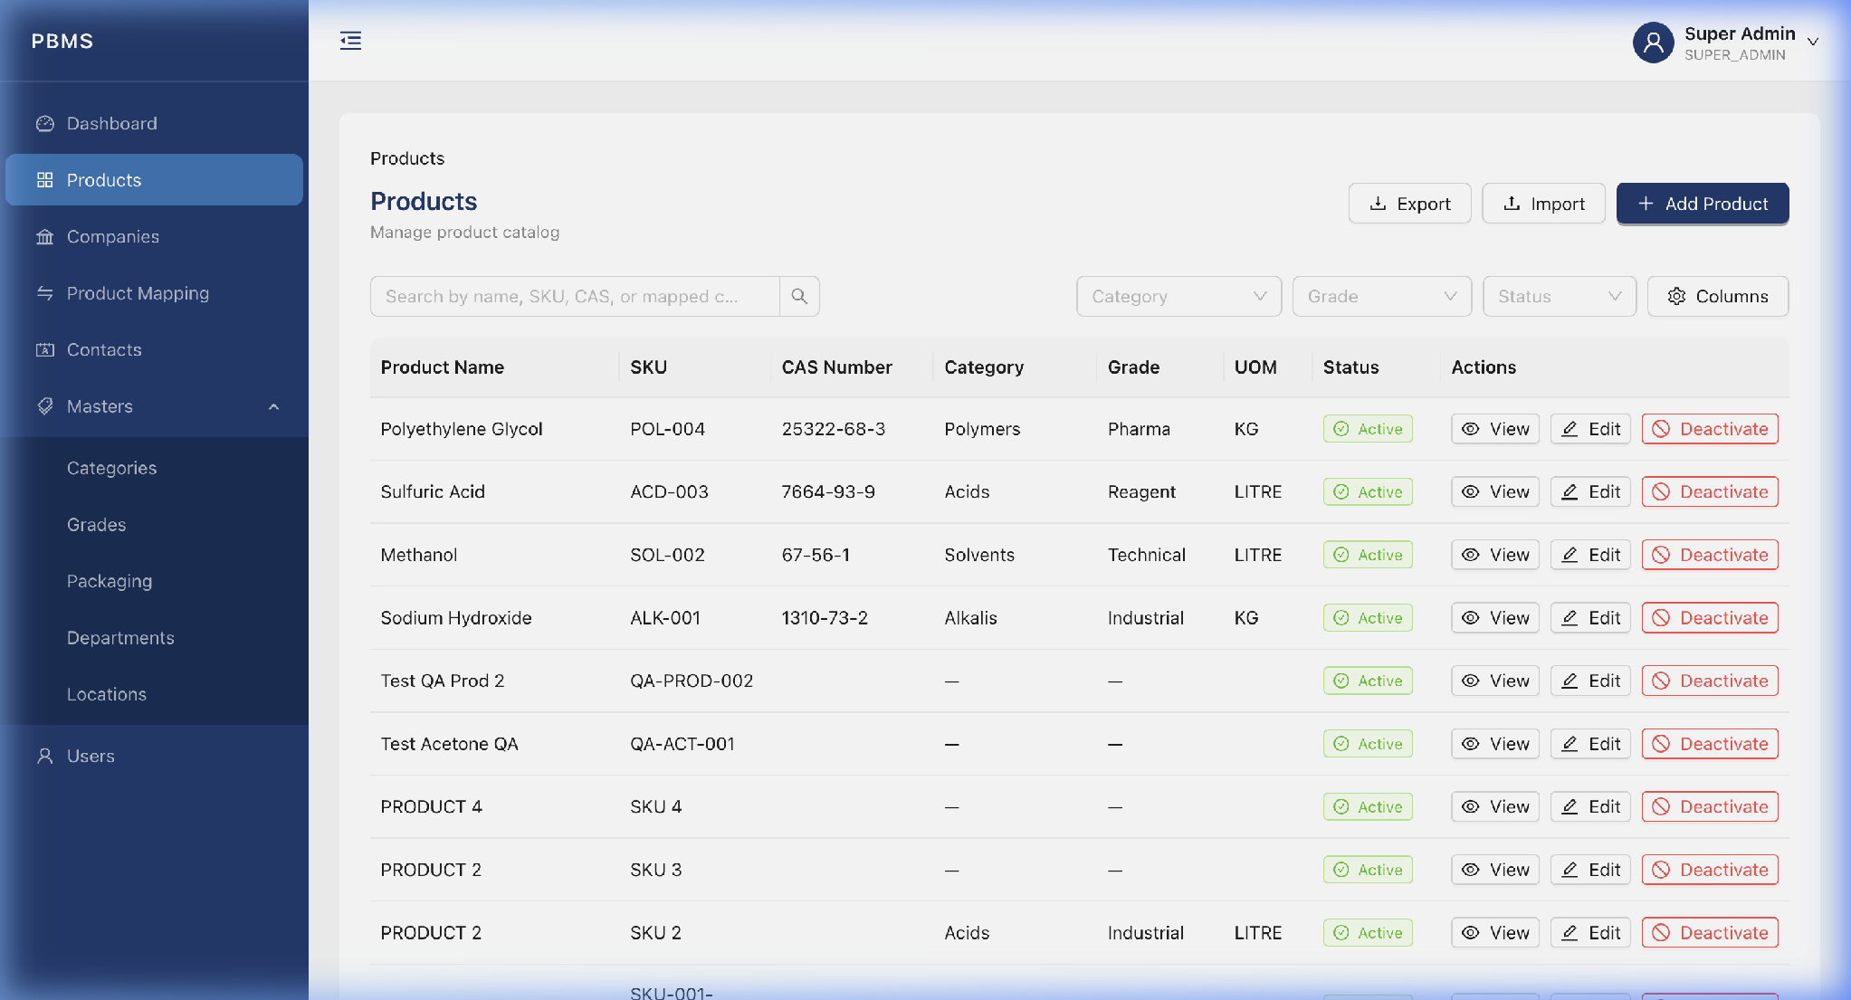
Figure 3.1 - Products List View

3.2 Add a New Product
Step 1: Click the "Add Product" button (top-right corner).
Step 2: A modal will appear with two tabs: "Basic Info" and "Business Info".
Step 3: Fill in the required fields (Product Name is mandatory).
Step 4: Select the Category, Grade, and Packaging from the dropdown menus.
Step 5: Click "Submit" to save the new product.
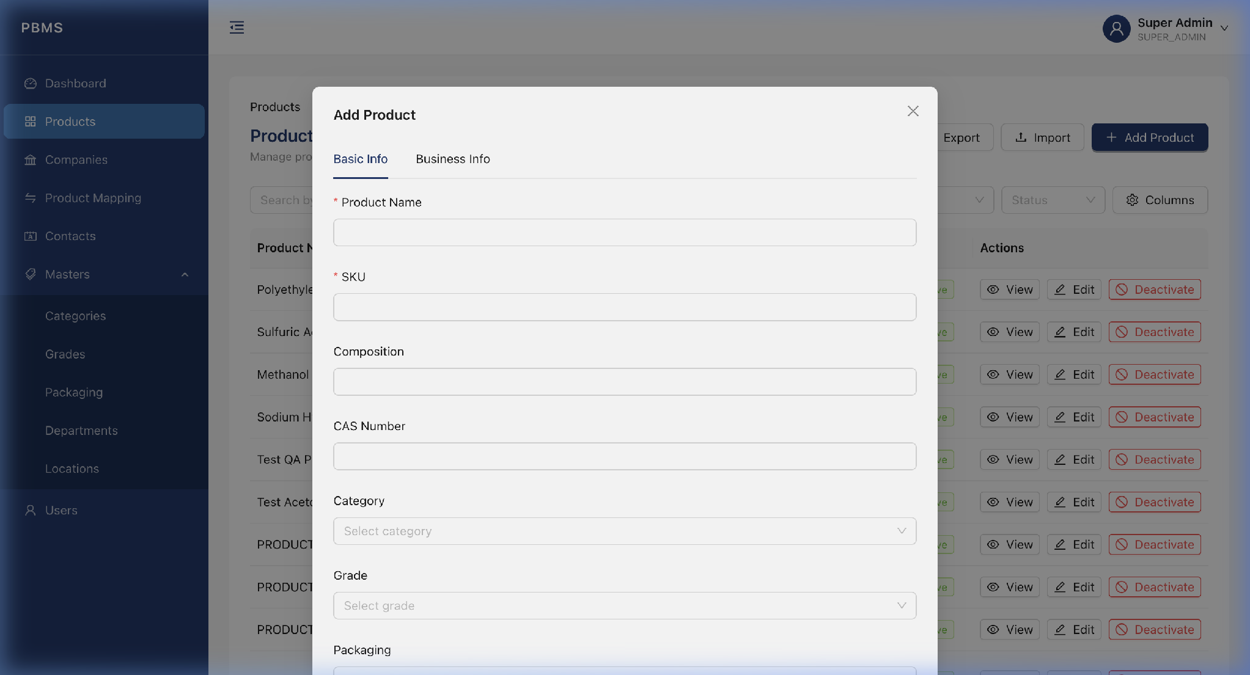
Figure 3.2 - Add Product Modal

3.3 Edit a Product
Step 1: Find the product you want to edit in the table.
Step 2: Click the "Edit" button on that row.
Step 3: The edit modal opens with the existing values pre-filled.
Step 4: Make your changes and click "Submit".
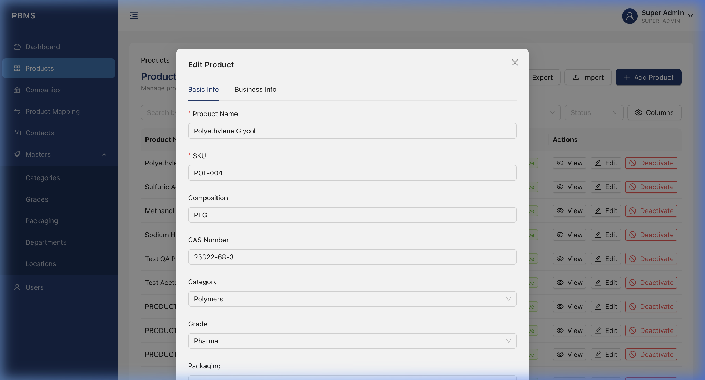
Figure 3.3 - Edit Product Modal

3.4 View Product Details
Step 1: Click the "View" button on any product row.
Step 2: A detailed drawer slides in from the right showing all product information, including mapped companies and attached documents.
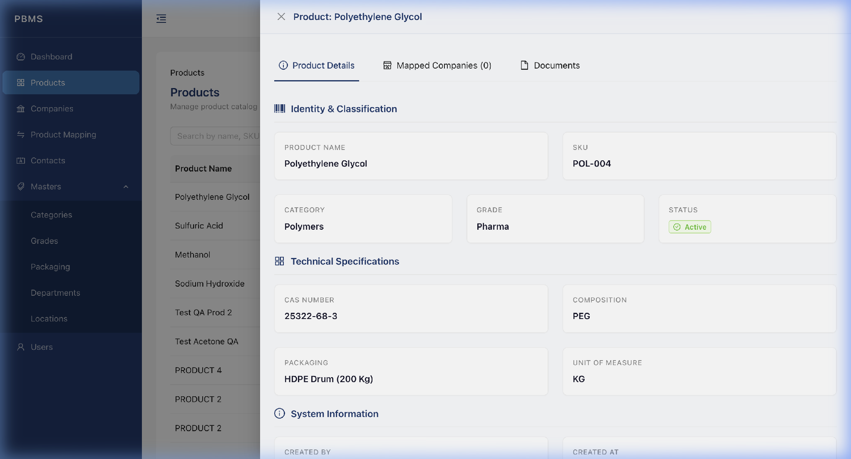
Figure 3.4 - Product Detail View Drawer
📝 Note: The View feature with the detail drawer is available across all modules including Companies, Contacts, Mappings, and all Master Data pages (Categories, Grades, Packaging, Departments, Locations).

3.5 Deactivate a Product
Step 1: Click the "Deactivate" button on an ACTIVE product row.
Step 2: A confirmation dialog appears asking you to confirm the action.
Step 3: Click "Deactivate" to confirm, or "Cancel" to abort.
⚠️ Warning: If the product is currently mapped to one or more companies, the system will block the deactivation. You must first remove or deactivate the mappings from the Mapping page.
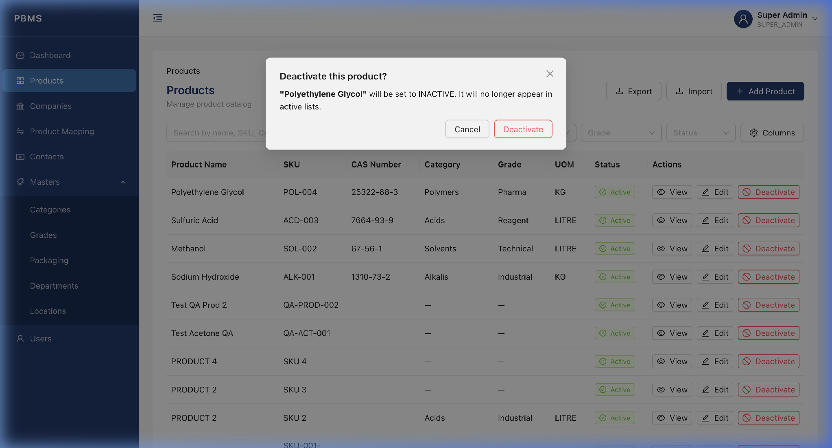
Figure 3.5 - Deactivate Confirmation Dialog

4. Companies Module
The Companies module manages the businesses you work with: manufacturers, suppliers, buyers, and distributors.

4.1 Companies List
Click "Companies" in the left sidebar. The table displays all companies with company name, type, city, state, status, and action buttons.
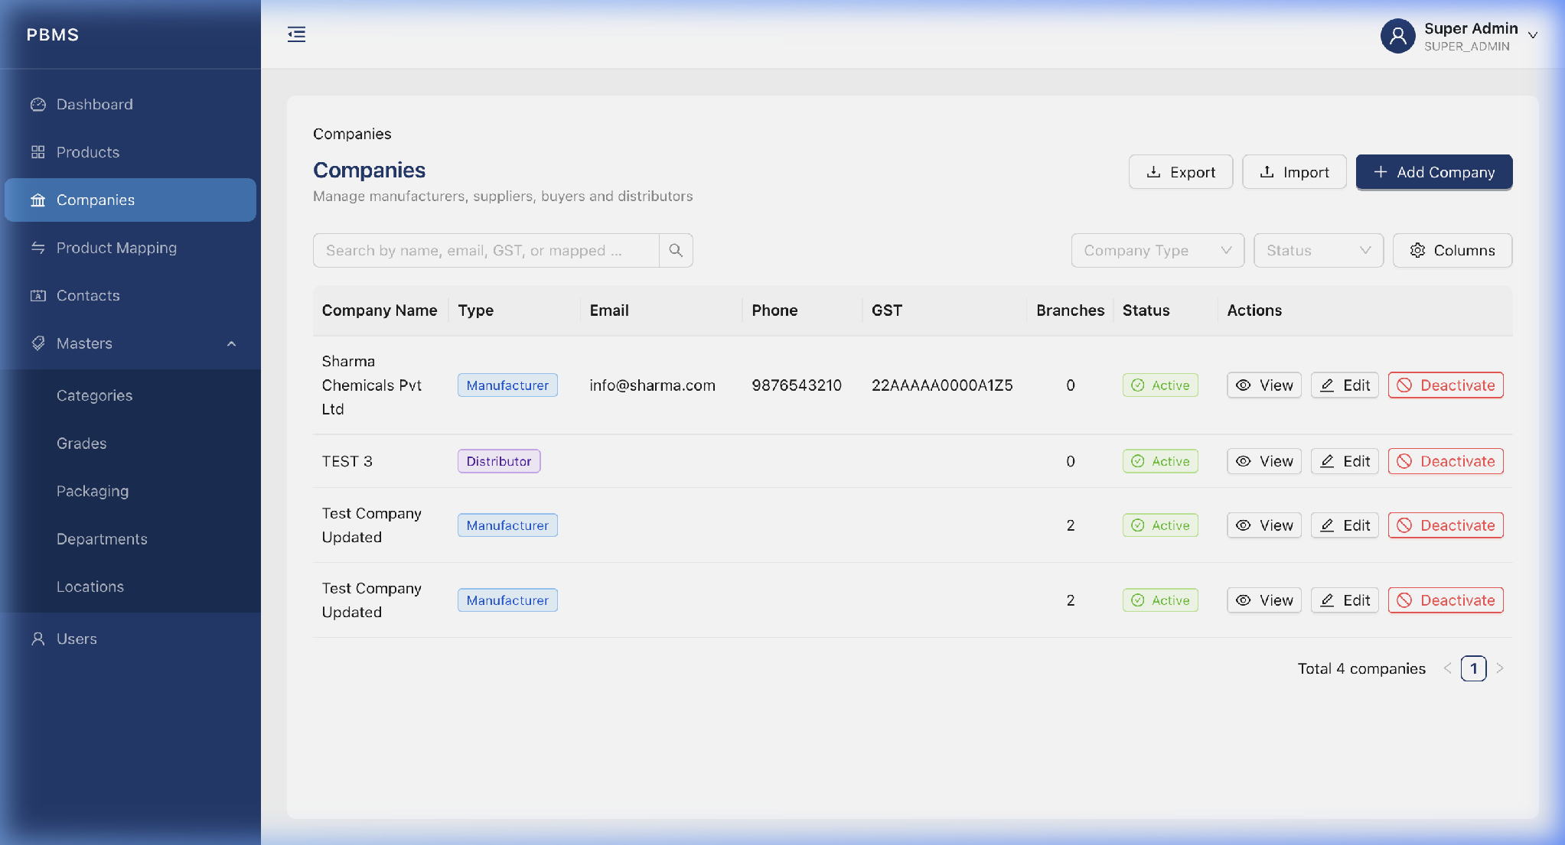
Figure 4.1 - Companies List View

4.2 Add a New Company
Step 1: Click the "Add Company" button.
Step 2: Fill in the company details: Name, Type, Address, Contact info, GST Number, etc.
Step 3: Click "Submit".
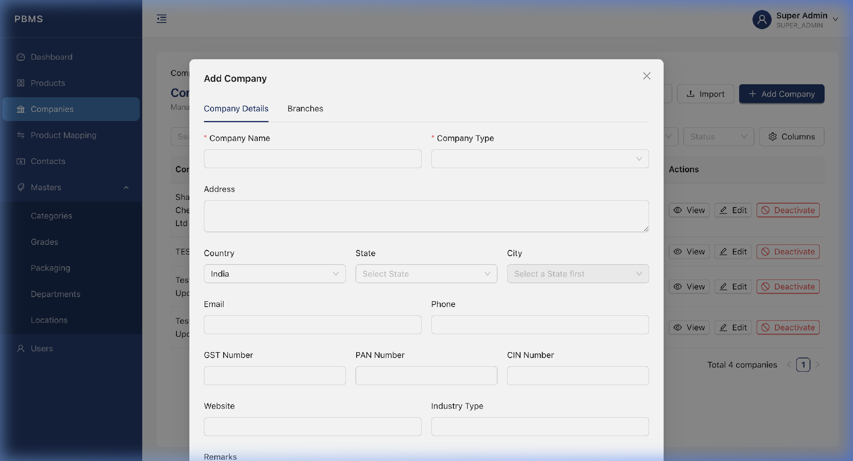
Figure 4.2 - Add Company Modal

4.3 Edit a Company
Step 1: Click the "Edit" button on any company row.
Step 2: The edit modal opens with the company's current data pre-filled.
Step 3: Make your changes and click "Submit".
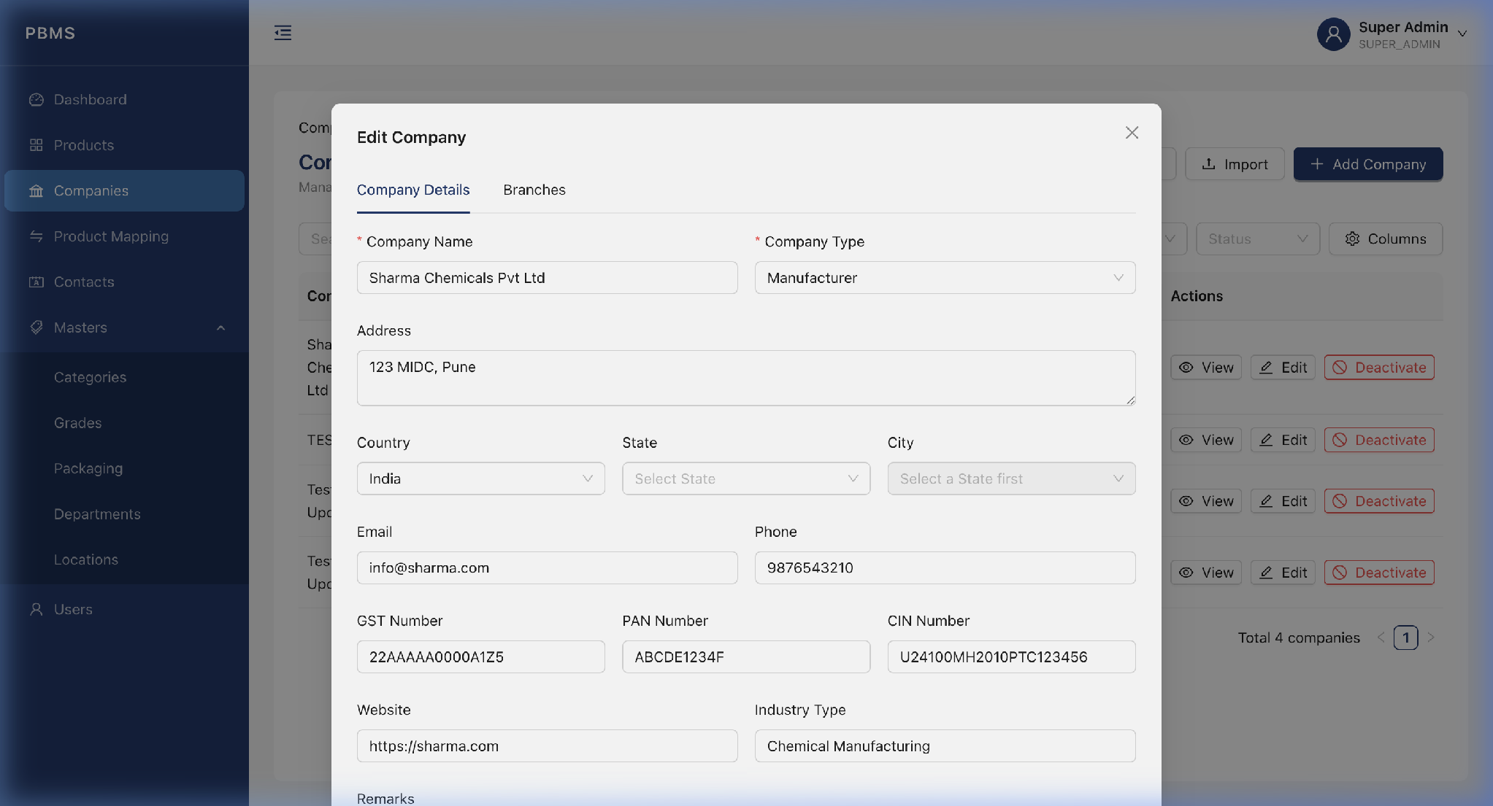
Figure 4.3 - Edit Company Modal

4.4 Import Company (Bulk)
The Bulk Import feature allows you to upload a CSV file containing multiple company records and import them into the system in one step.
Step A: Upload the CSV File
Step 1: Click the "Import" button (next to Add Company).
Step 2: The Bulk Import modal opens. Click "Download CSV Template" to get a template showing the required columns and format.
Step 3: Prepare your CSV file with the required columns (company_name and company_type are mandatory).
Step 4: Click "Upload" or drag-and-drop your CSV file into the upload area.
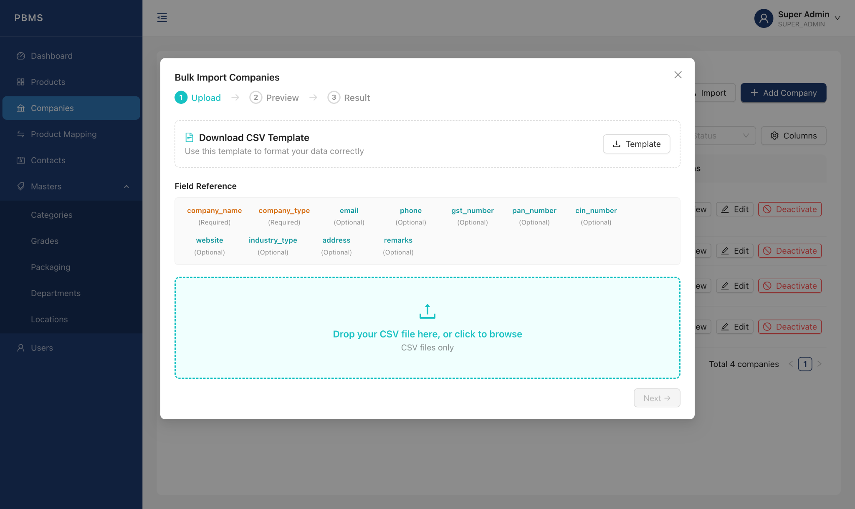
Figure 4.4 - Bulk Import Modal (Upload Step)
Step B: Preview, Duplicate Detection and Row Selection
After the file is uploaded, the system automatically runs two levels of duplicate detection and displays the results in a preview table:
- Intra-CSV Duplicate Check: The system scans the uploaded file internally. If two or more rows share the same unique key (company name for companies, SKU for products) within the same CSV file, they are flagged with a "Duplicate in CSV" tag in the Status column.
- Database Duplicate Check: The system sends all unique key values from the file to the backend, which queries the database to check if any of them already exist. Matching rows are flagged with an "Already in DB" tag in the Status column.
The preview table displays all rows from the CSV file. Each row has a checkbox on the left side. Rows that were detected as duplicates (either intra-CSV or already in the database) are automatically unchecked, so they will not be imported by default. You can uncheck any additional row to exclude it, or re-check a duplicate row to force-import it. The "Select All" checkbox in the header lets you quickly select or deselect all rows at once. The "Import" button at the bottom shows the exact count of selected rows (e.g., "Import 8 of 10 rows").
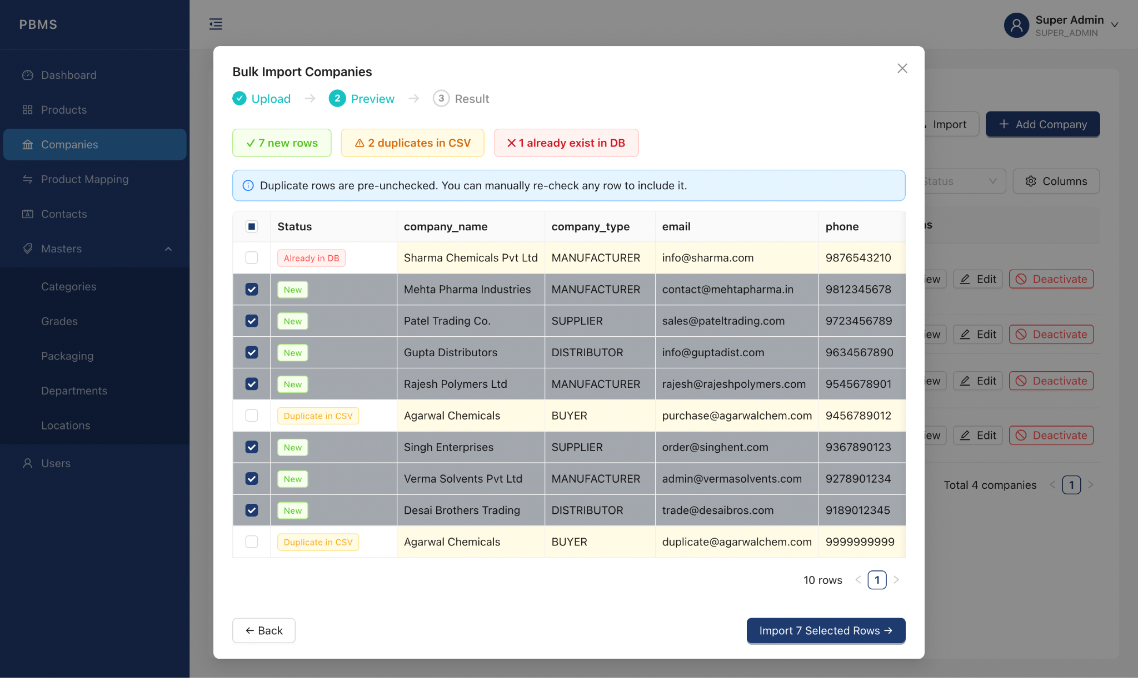
Figure 4.5 - Import Preview Table with Duplicate Detection and Row Selection

Step D: Import
Step 1: Review the preview table and ensure only the desired rows are checked.
Step 2: Click the "Import Selected" button.
Step 3: The system imports each selected row one by one. If any row fails validation (e.g., invalid email or phone number format), that row is skipped and the remaining rows continue to be imported.
Step 4: A summary message appears showing how many rows were successfully imported and how many were skipped, with specific error reasons for each skipped row.
📝 Note: The same bulk import feature is also available on the Products, Contacts, and all the Master pages with the same duplicate detection and preview functionality.

4.5 Export Company
Click the "Export" button to download all active companies as a .csv file. The file will be saved to your default Downloads folder.
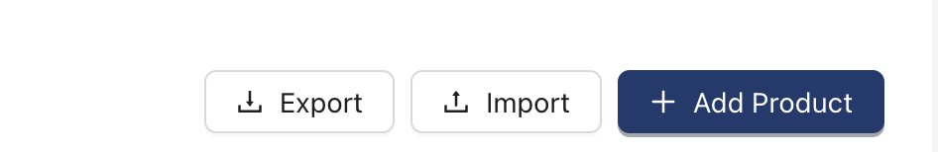
Figure 4.6 - Bulk Export Modal

5. Company-Product Mapping
Mappings define the relationship between a company and a product, specifying the company's role (Manufacturer, Supplier, or Distributor) and business terms.

5.1 Mapping List
Click "Product Mapping" in the sidebar. The table shows all mappings with the company name, product name, role type, and active status.
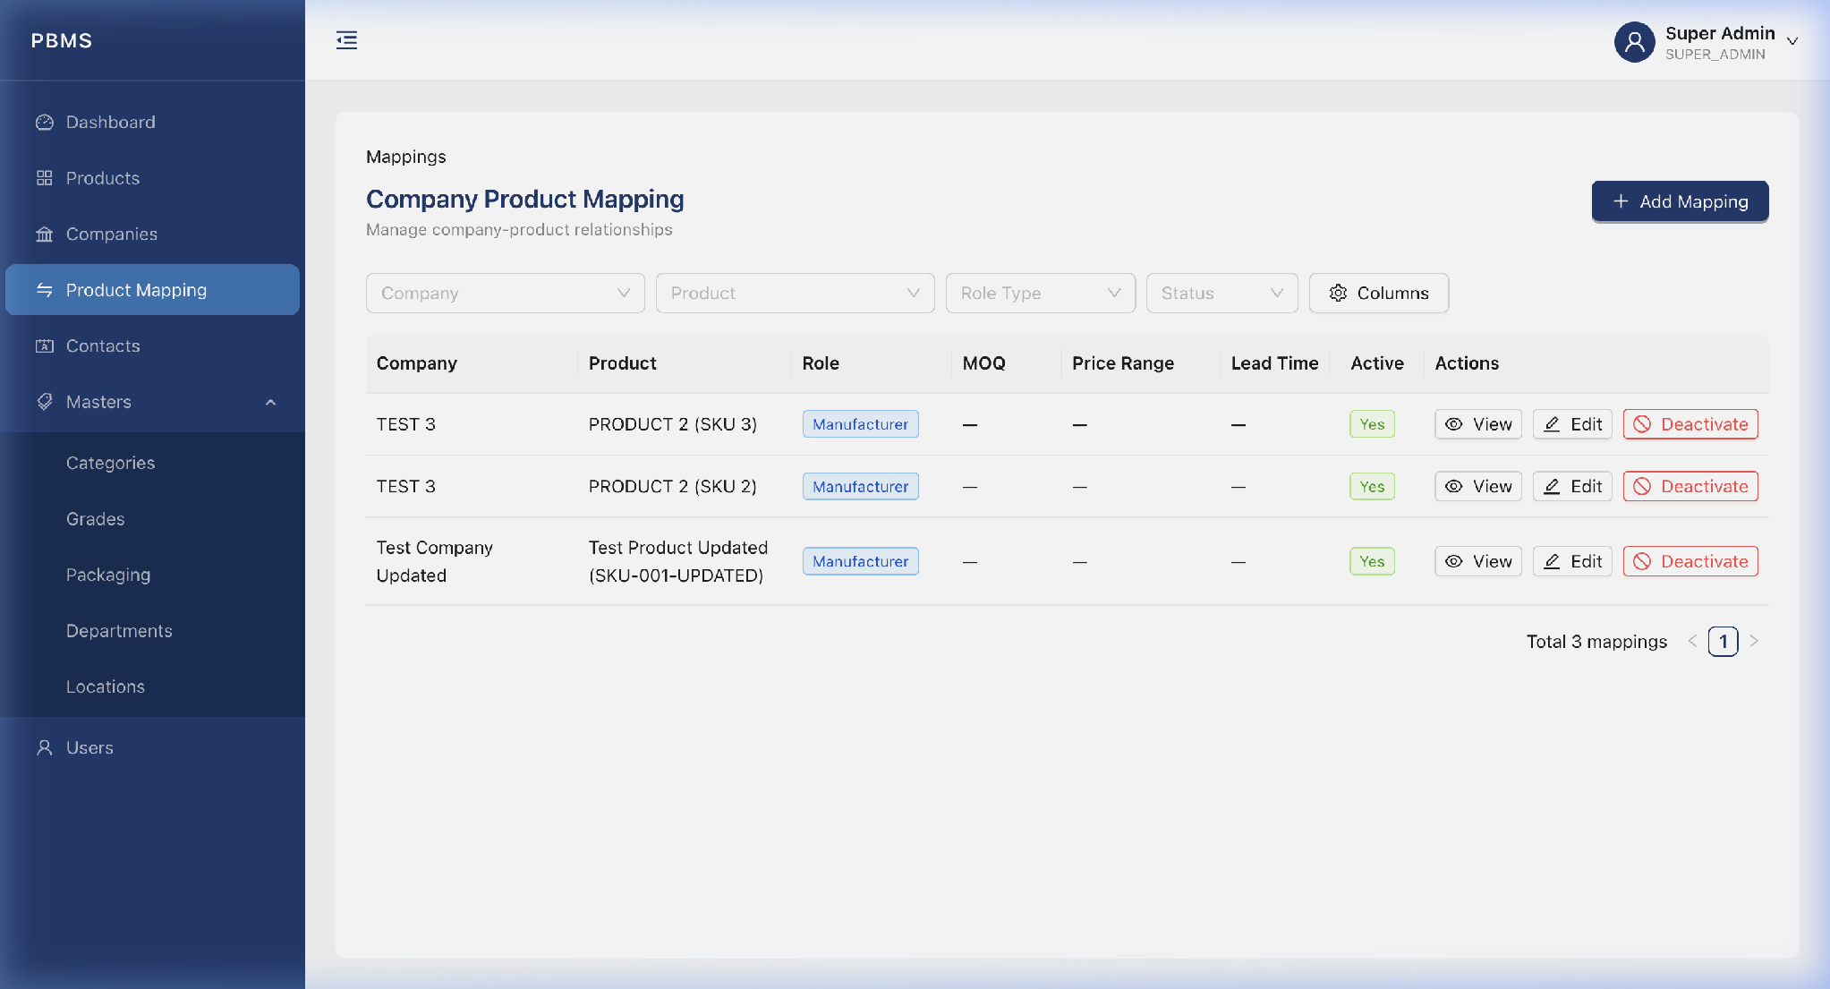
Figure 5.1 - Mapping List View

5.2 Add a New Mapping
Step 1: Click the "Add Mapping" button.
Step 2: Select a Company and Product from the dropdown menus.
Step 3: Select the Role Type (Manufacturer, Supplier, or Distributor).
Step 4: Optionally fill in: MOQ, Price Range, and Lead Time.
Step 5: Click "Submit".
📝 Note: The same company cannot be mapped to the same product with the same role twice.
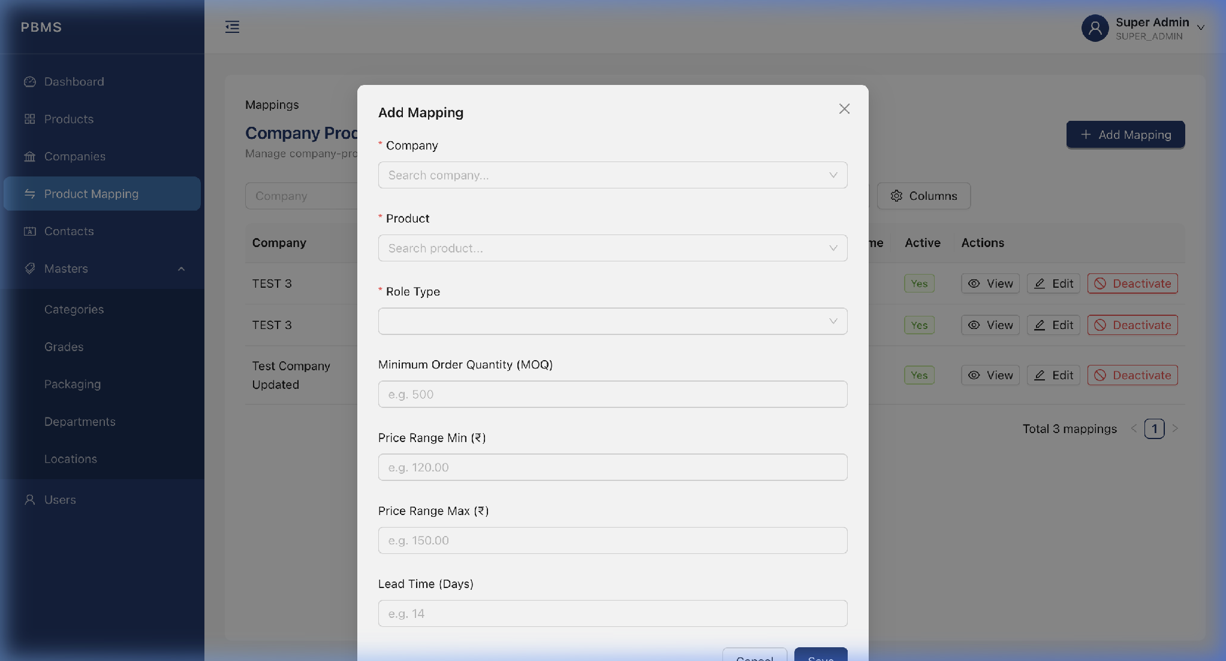
Figure 5.2 - Add Mapping Modal

6. Contacts Module
The Contacts module stores the people associated with your companies: buyers, purchase managers, sales representatives, etc.
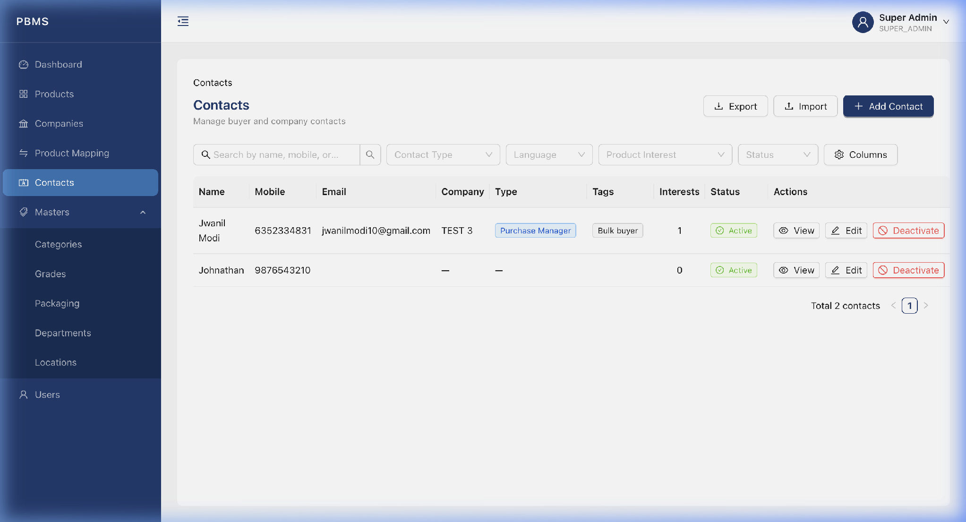
Figure 6.1 - Contacts List View

6.1 Add a New Contact
Step 1: Click the "Add Contact" button.
Step 2: Fill in: First Name, Last Name, Mobile, Email, Company, Branch, Contact Type, Designation.
Step 3: Select Product Interests, the products this contact is interested in.
Step 4: Click "Submit".
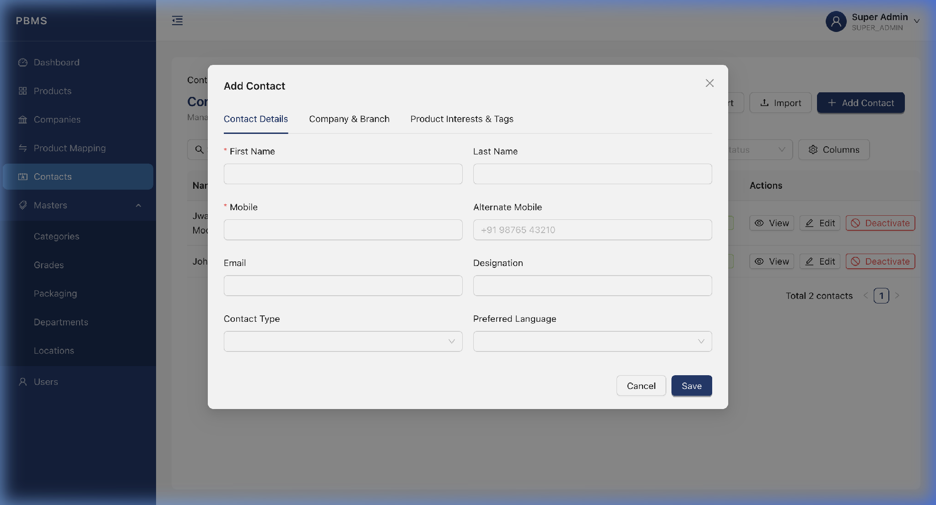
Figure 6.2 - Add Contact Modal

7. Masters - Categories
Categories classify products (e.g., Solvents, Acids, Bases).
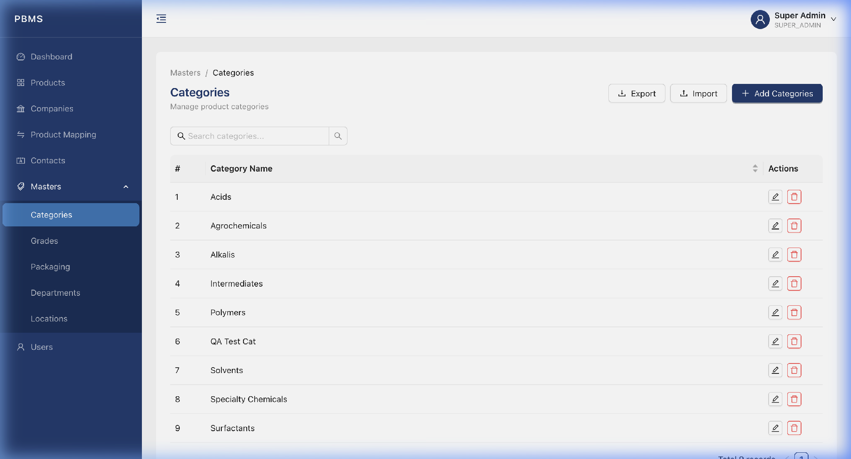
Figure 7.1 - Categories List
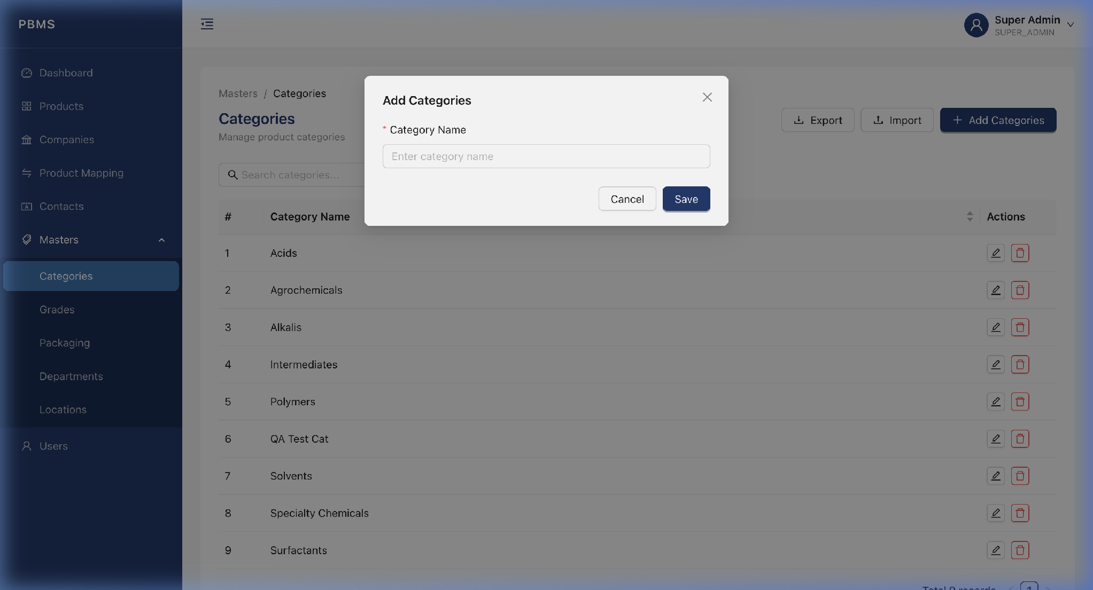
Figure 7.2 - Add Category Modal

8. Masters - Grades
Grades classify the quality level of products (e.g., Industrial, Laboratory, Pharmaceutical).
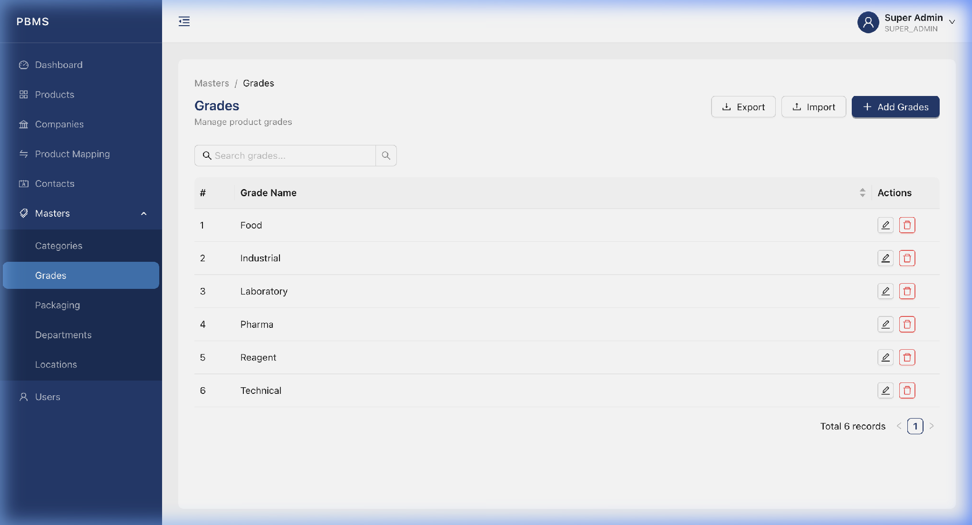
Figure 8.1 - Grades List
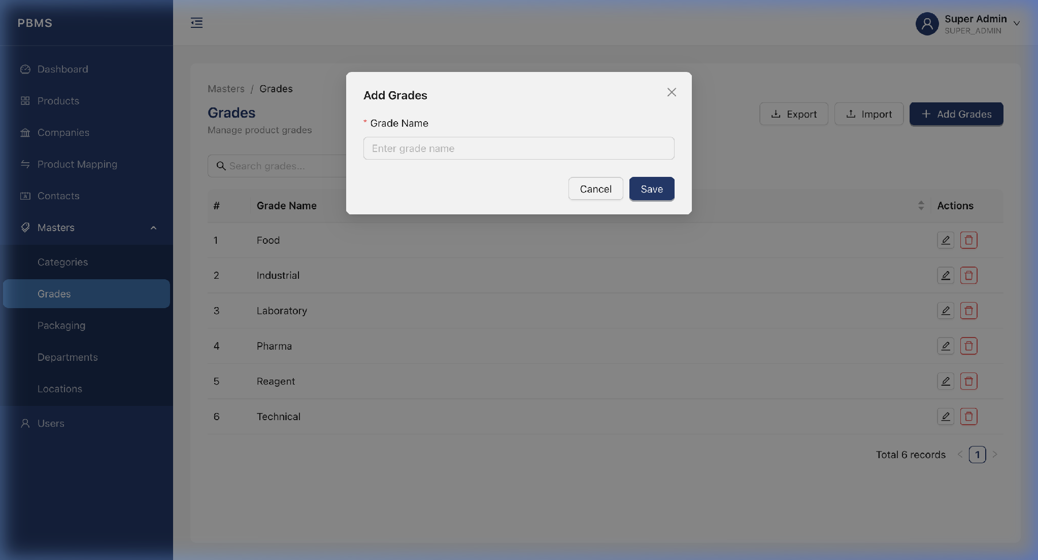
Figure 8.2 - Add Grade Modal

9. Masters - Packaging
Packaging types define how products are physically packaged (e.g., HDPE Drum 200L).
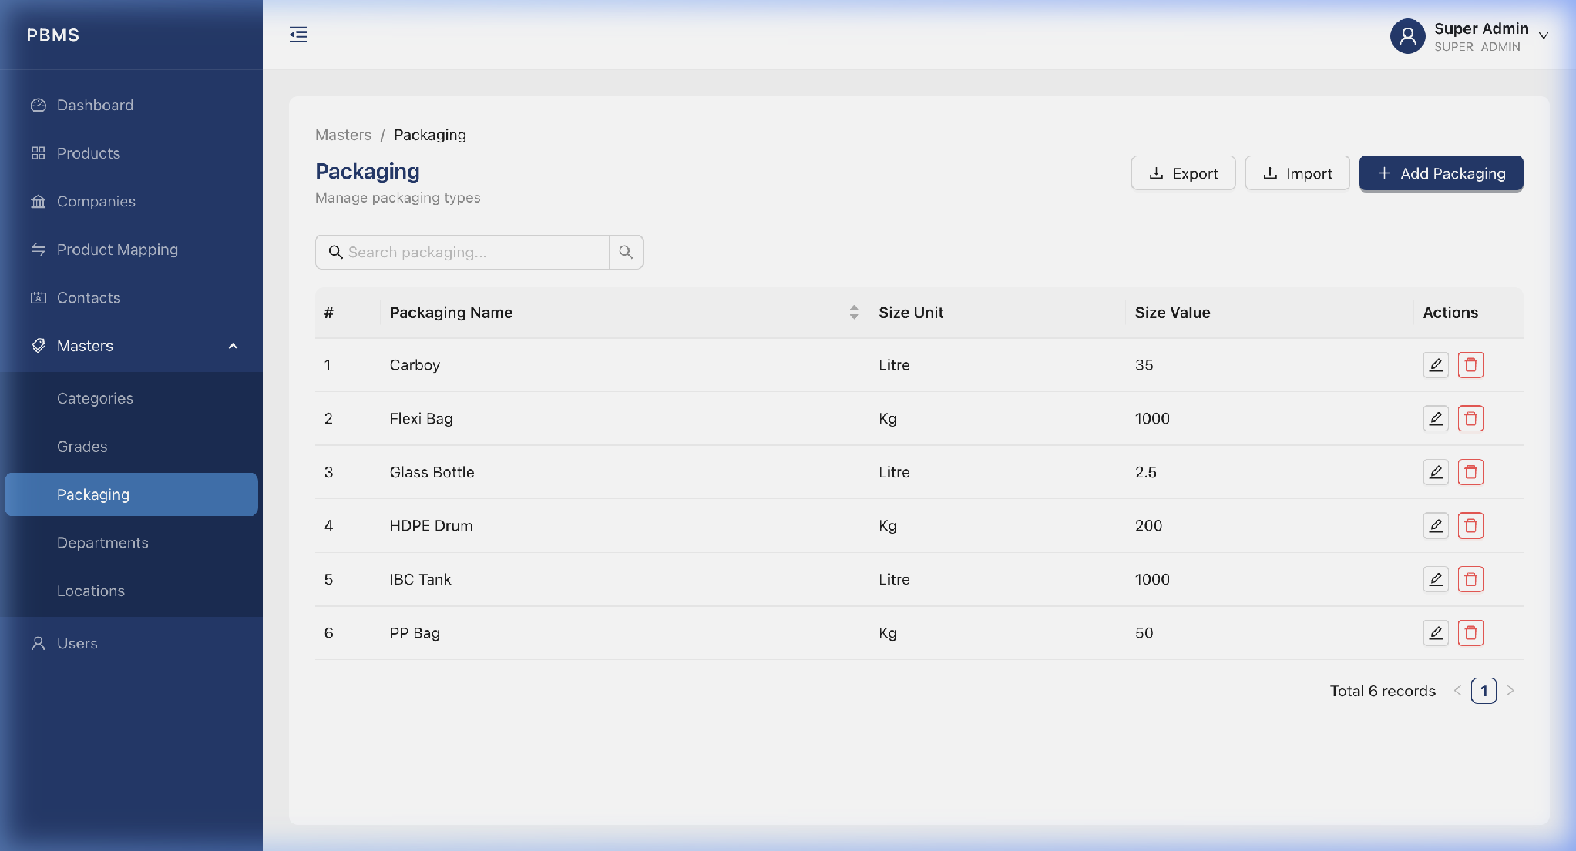
Figure 9.1 - Packaging List
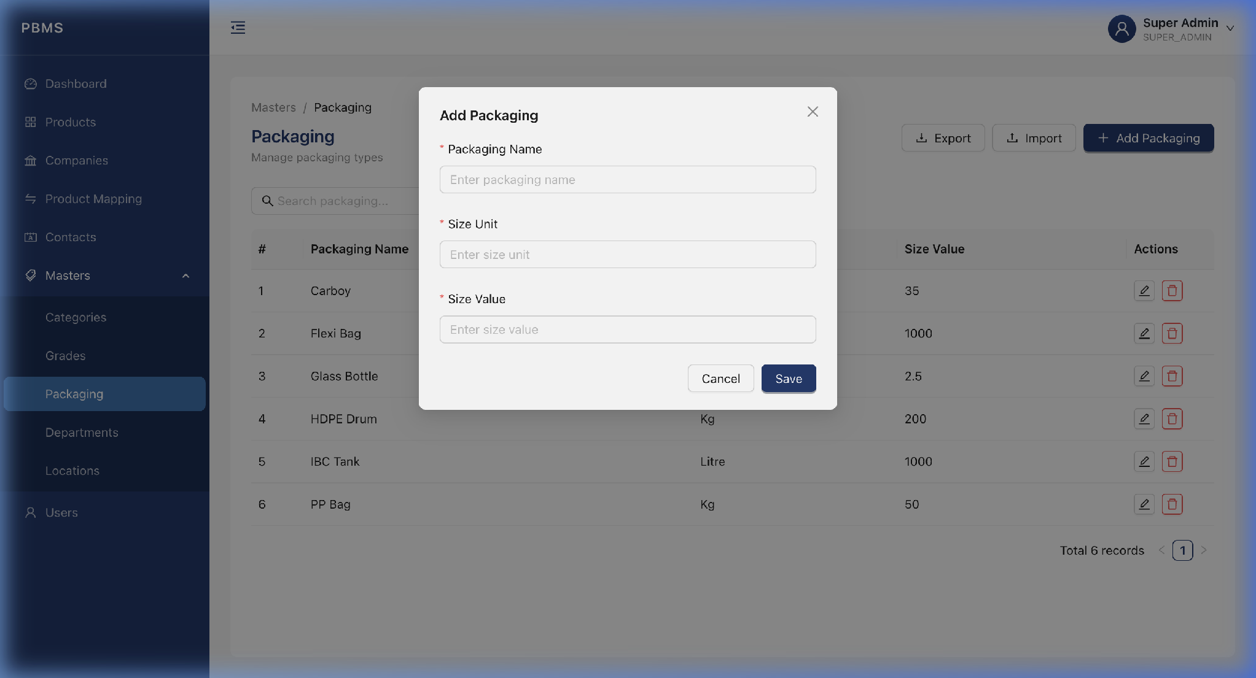
Figure 9.2 - Add Packaging Modal

10. Masters - Departments
Departments organize your internal team (e.g., Sales, Purchase, Quality Assurance).
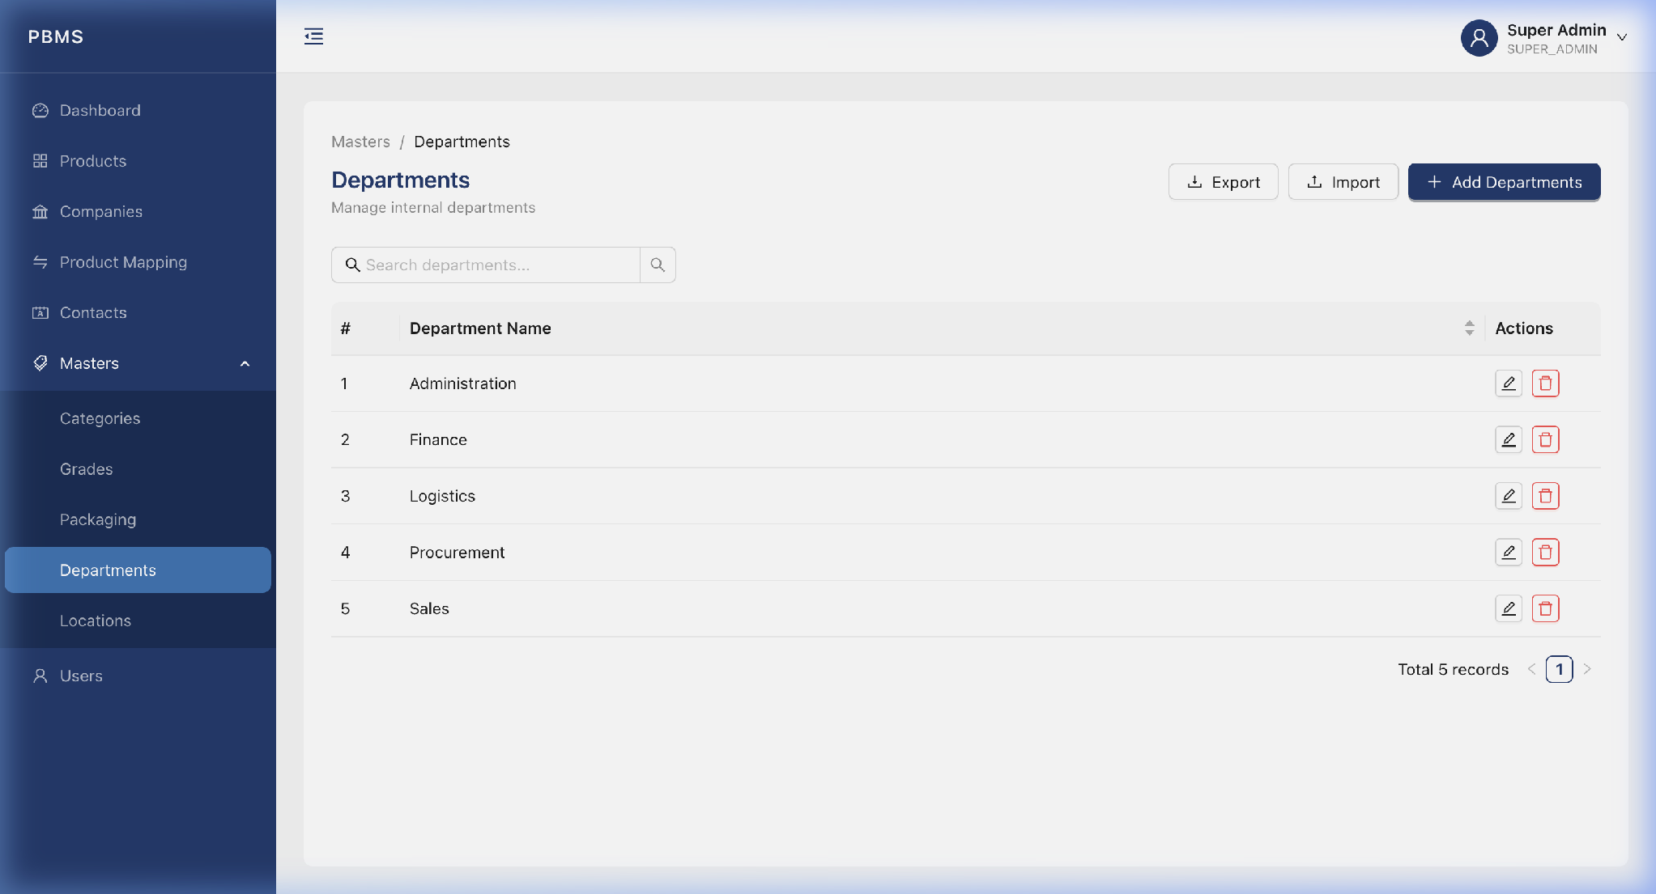
Figure 10.1 - Departments List
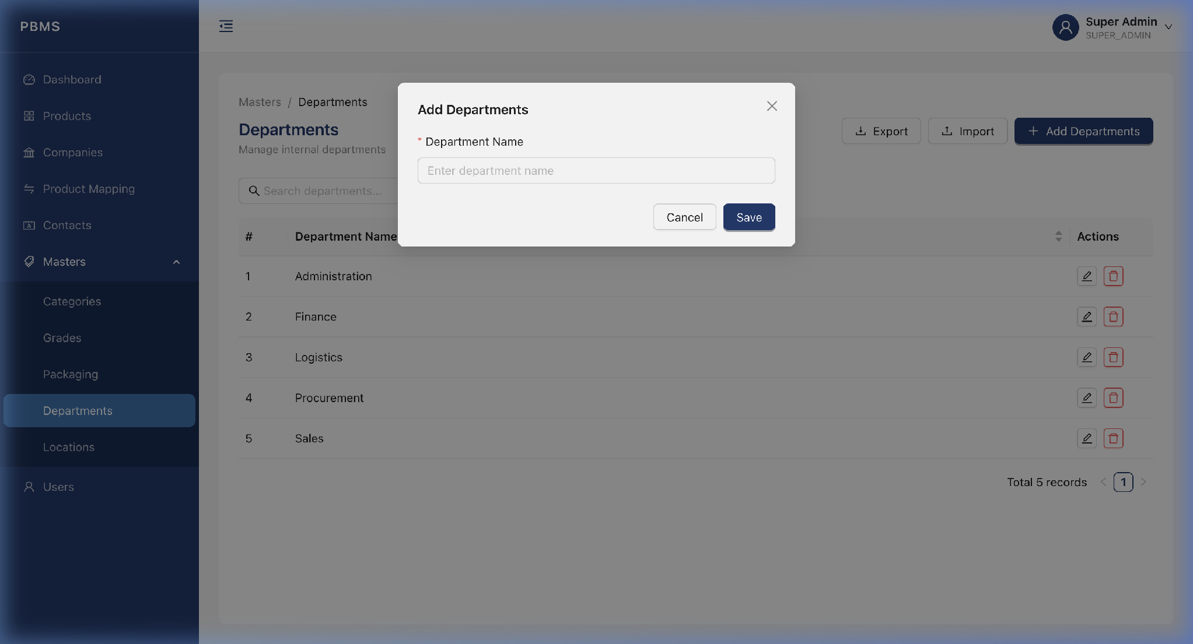
Figure 10.2 - Add Department Modal

11. Locations - Countries
The Locations module provides a cascading geography system: Countries > States > Cities.
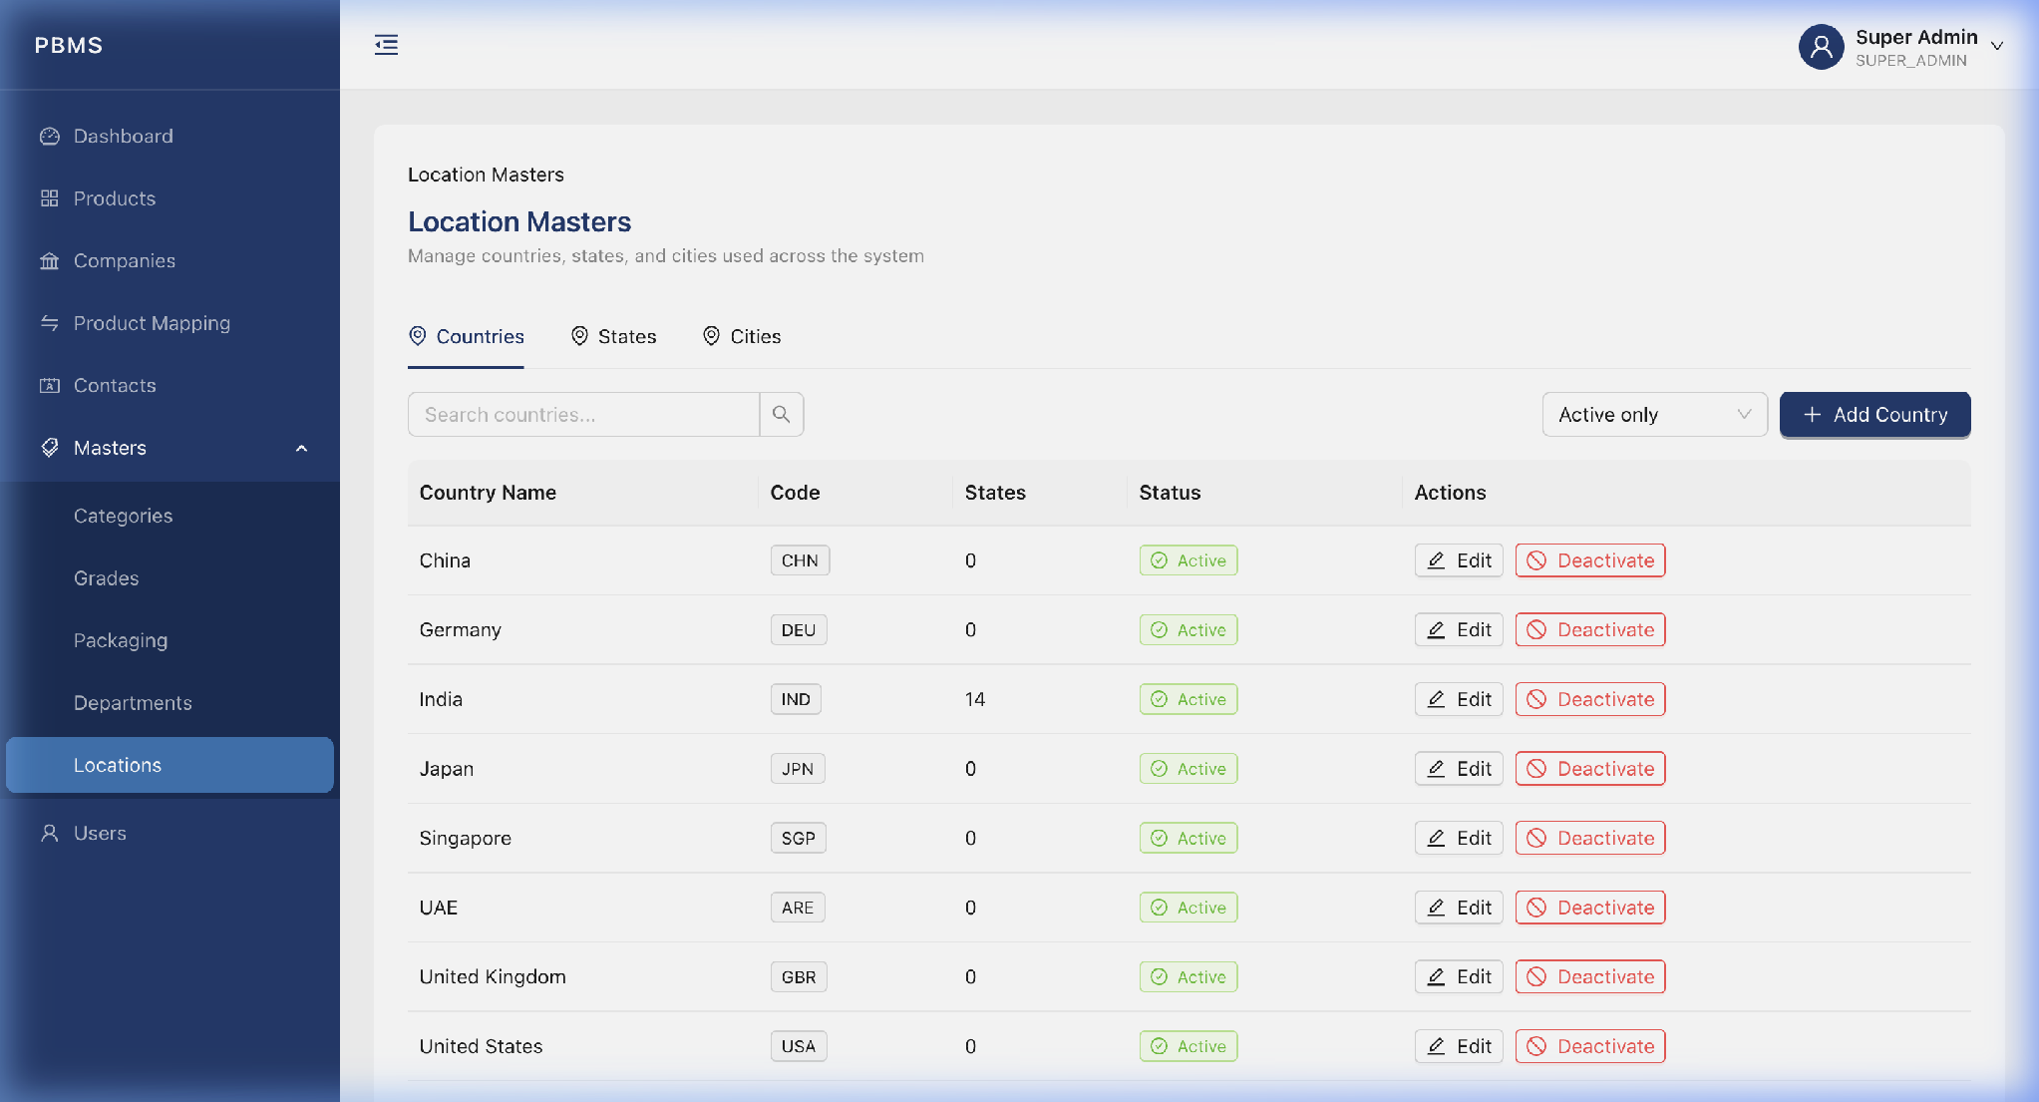
Figure 11.1 - Countries List
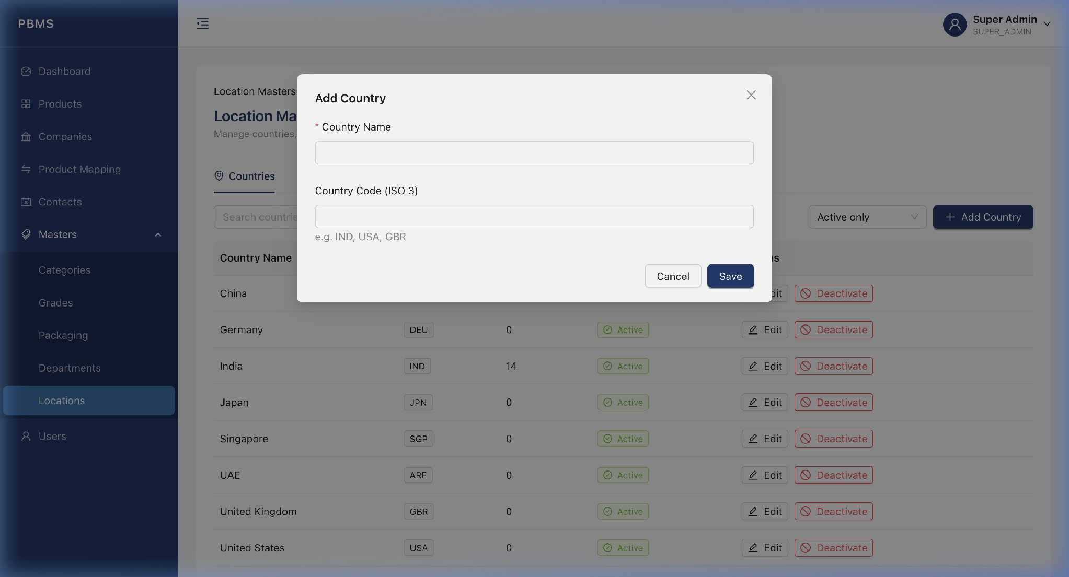
Figure 11.2 - Add Country Modal

12. Locations - States
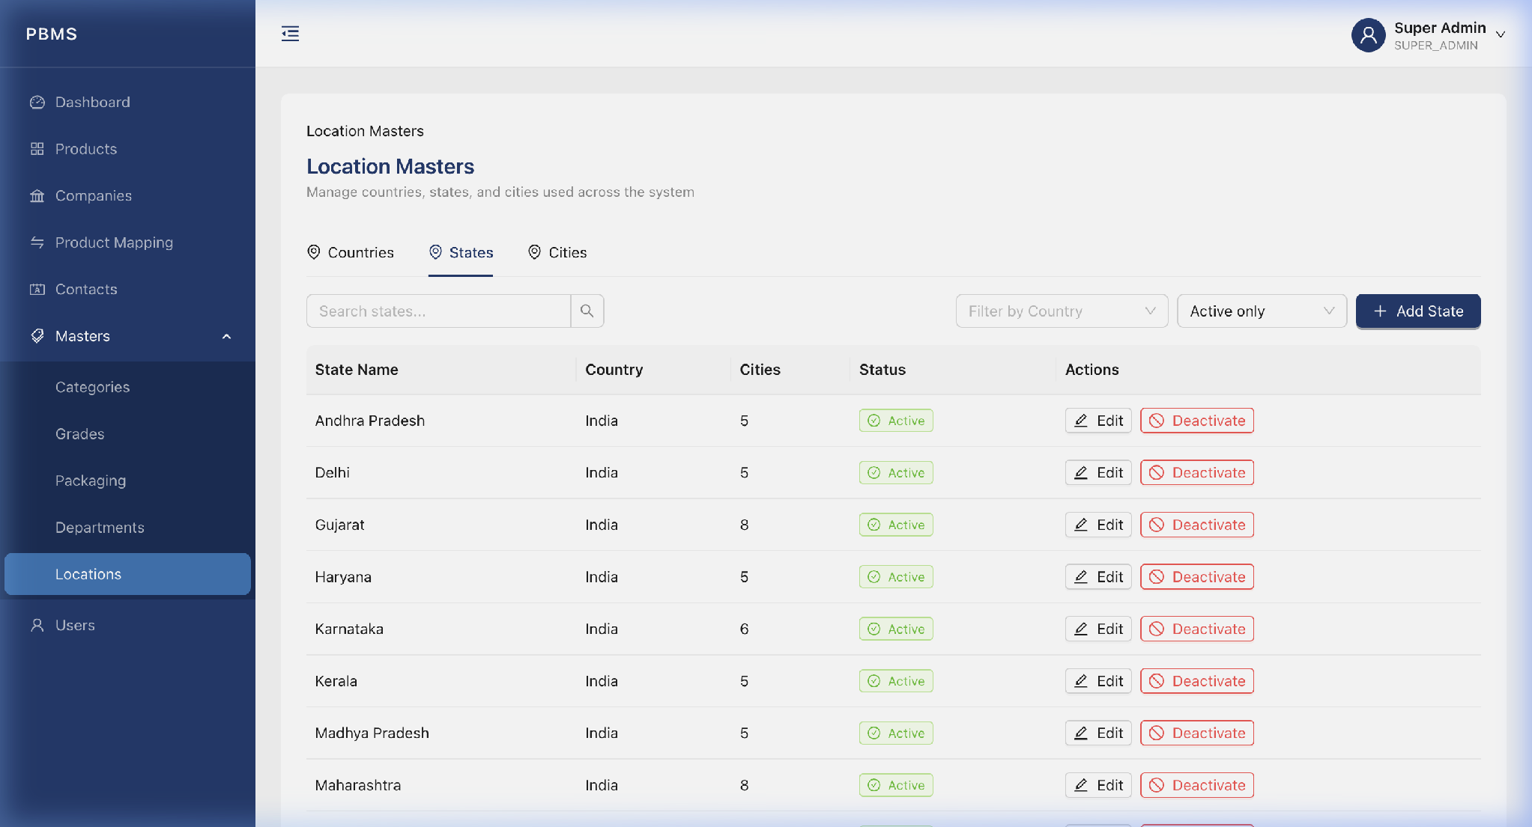
Figure 12.1 - States List
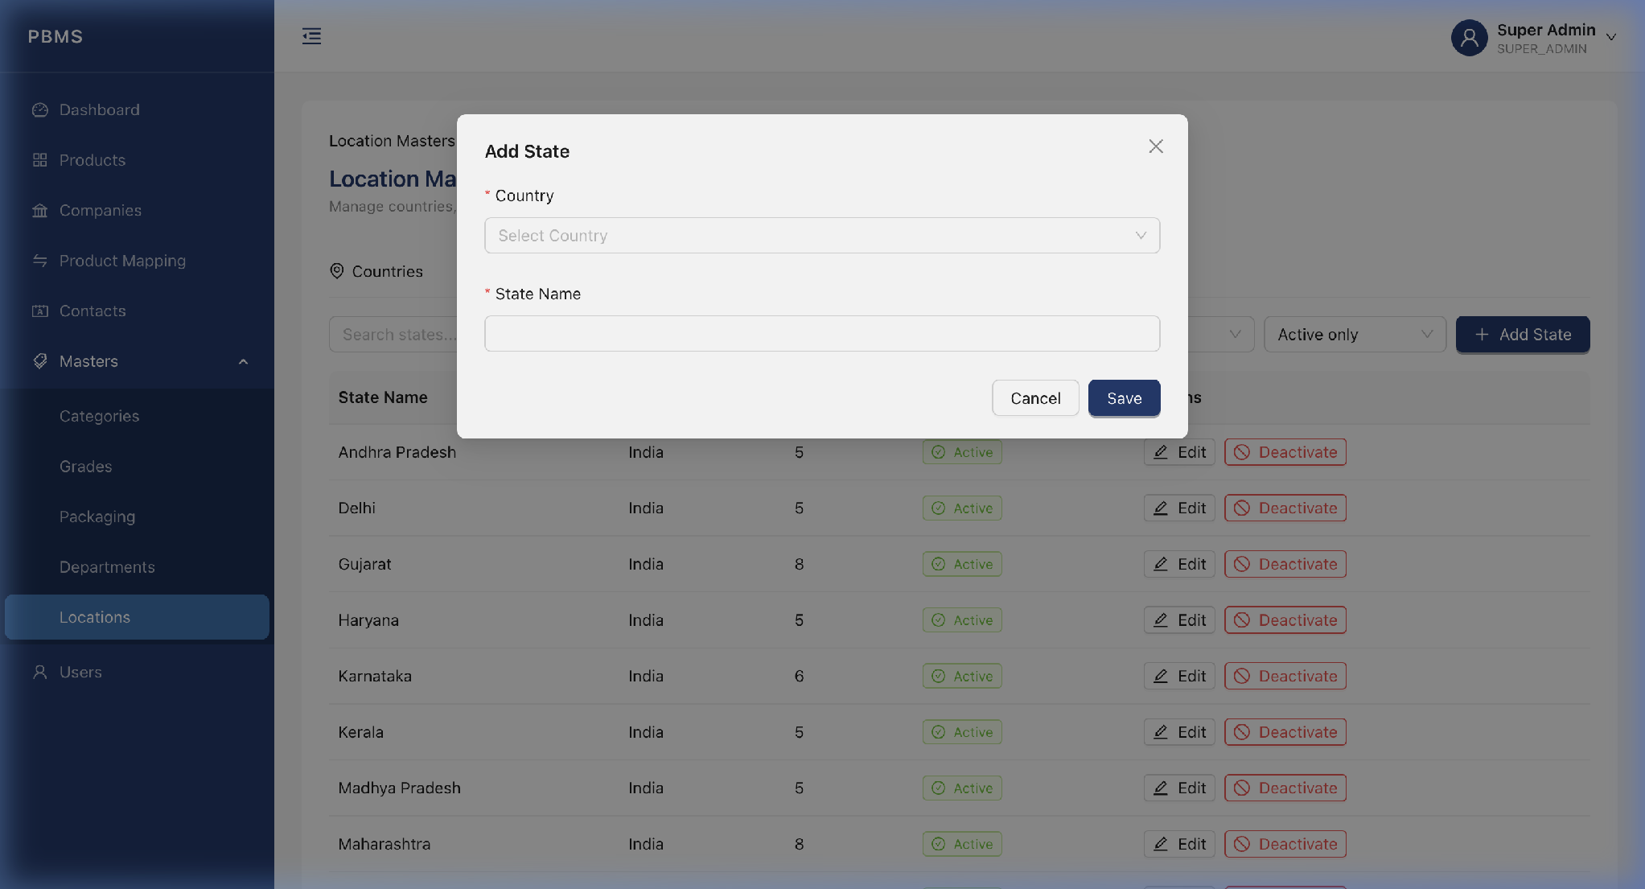
Figure 12.2 - Add State Modal

13. Locations - Cities
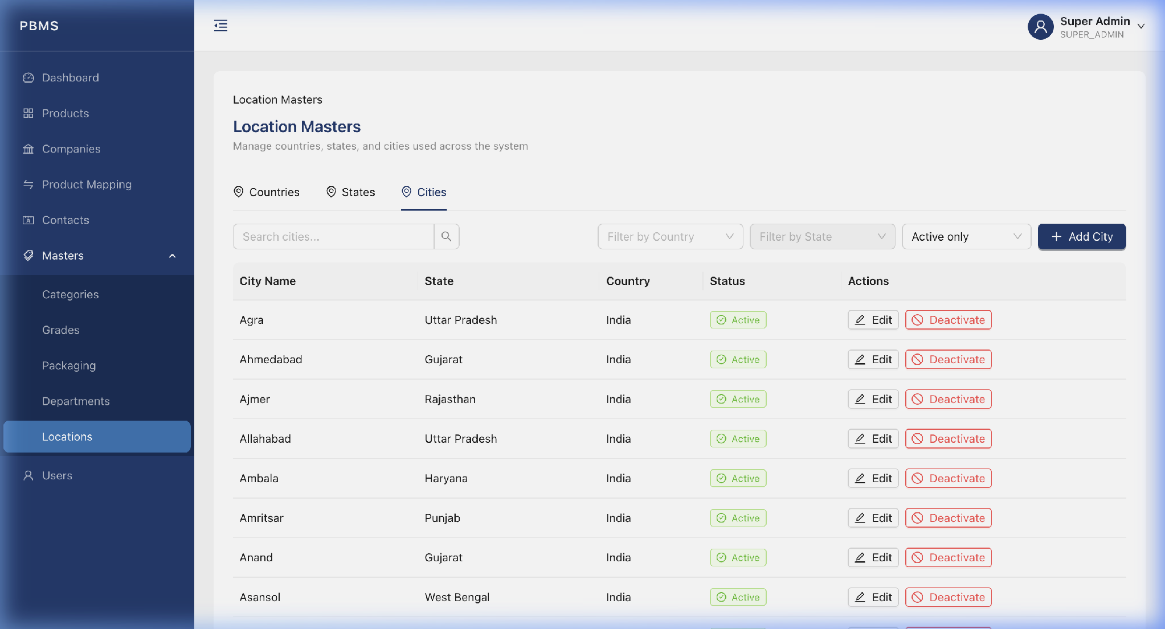
Figure 13.1 - Cities List
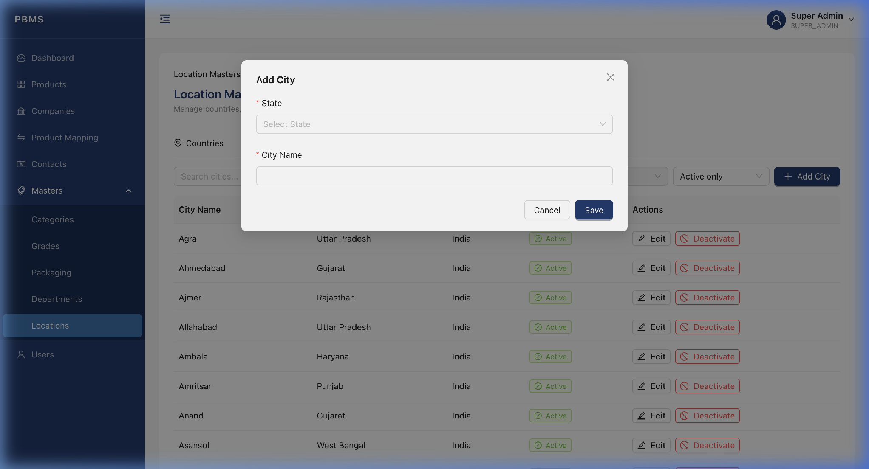
Figure 13.2 - Add City Modal

14. Users Module
The Users module allows Super Admins and Admins to manage internal team members who access the PBMS system.

14.1 Users List
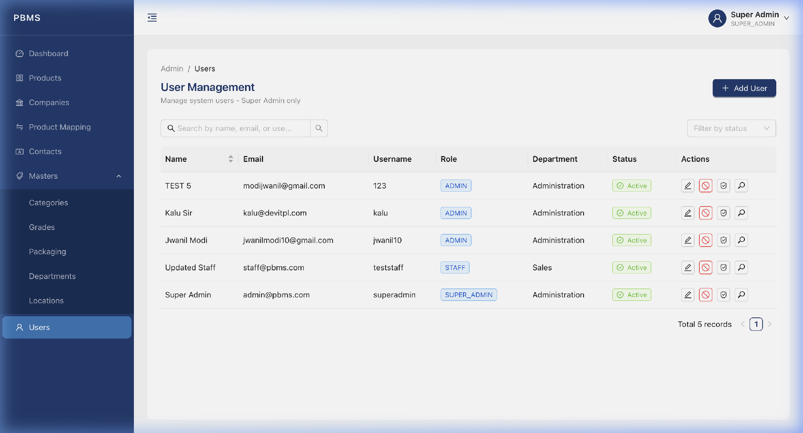
Figure 14.1 - Users List View

14.2 Add a New User
Step 1: Click the "Add User" button.
Step 2: Fill in: Full Name, Email, Mobile, Username, Password, Role, and Department.
Step 3: Click "Submit". The user will immediately be able to log in.
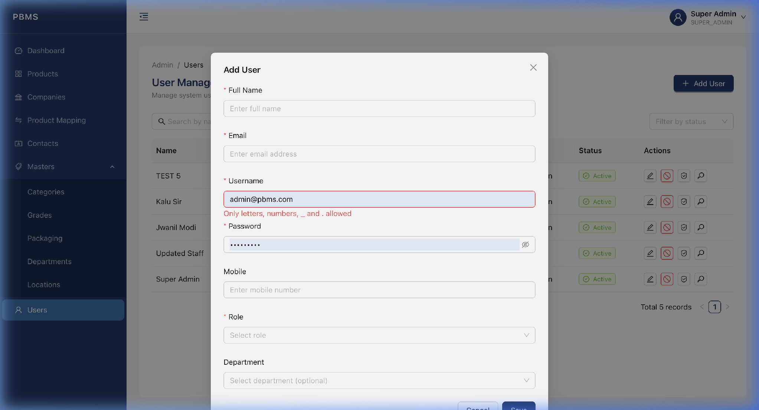
Figure 14.2 - Add User Modal

14.3 Edit a User
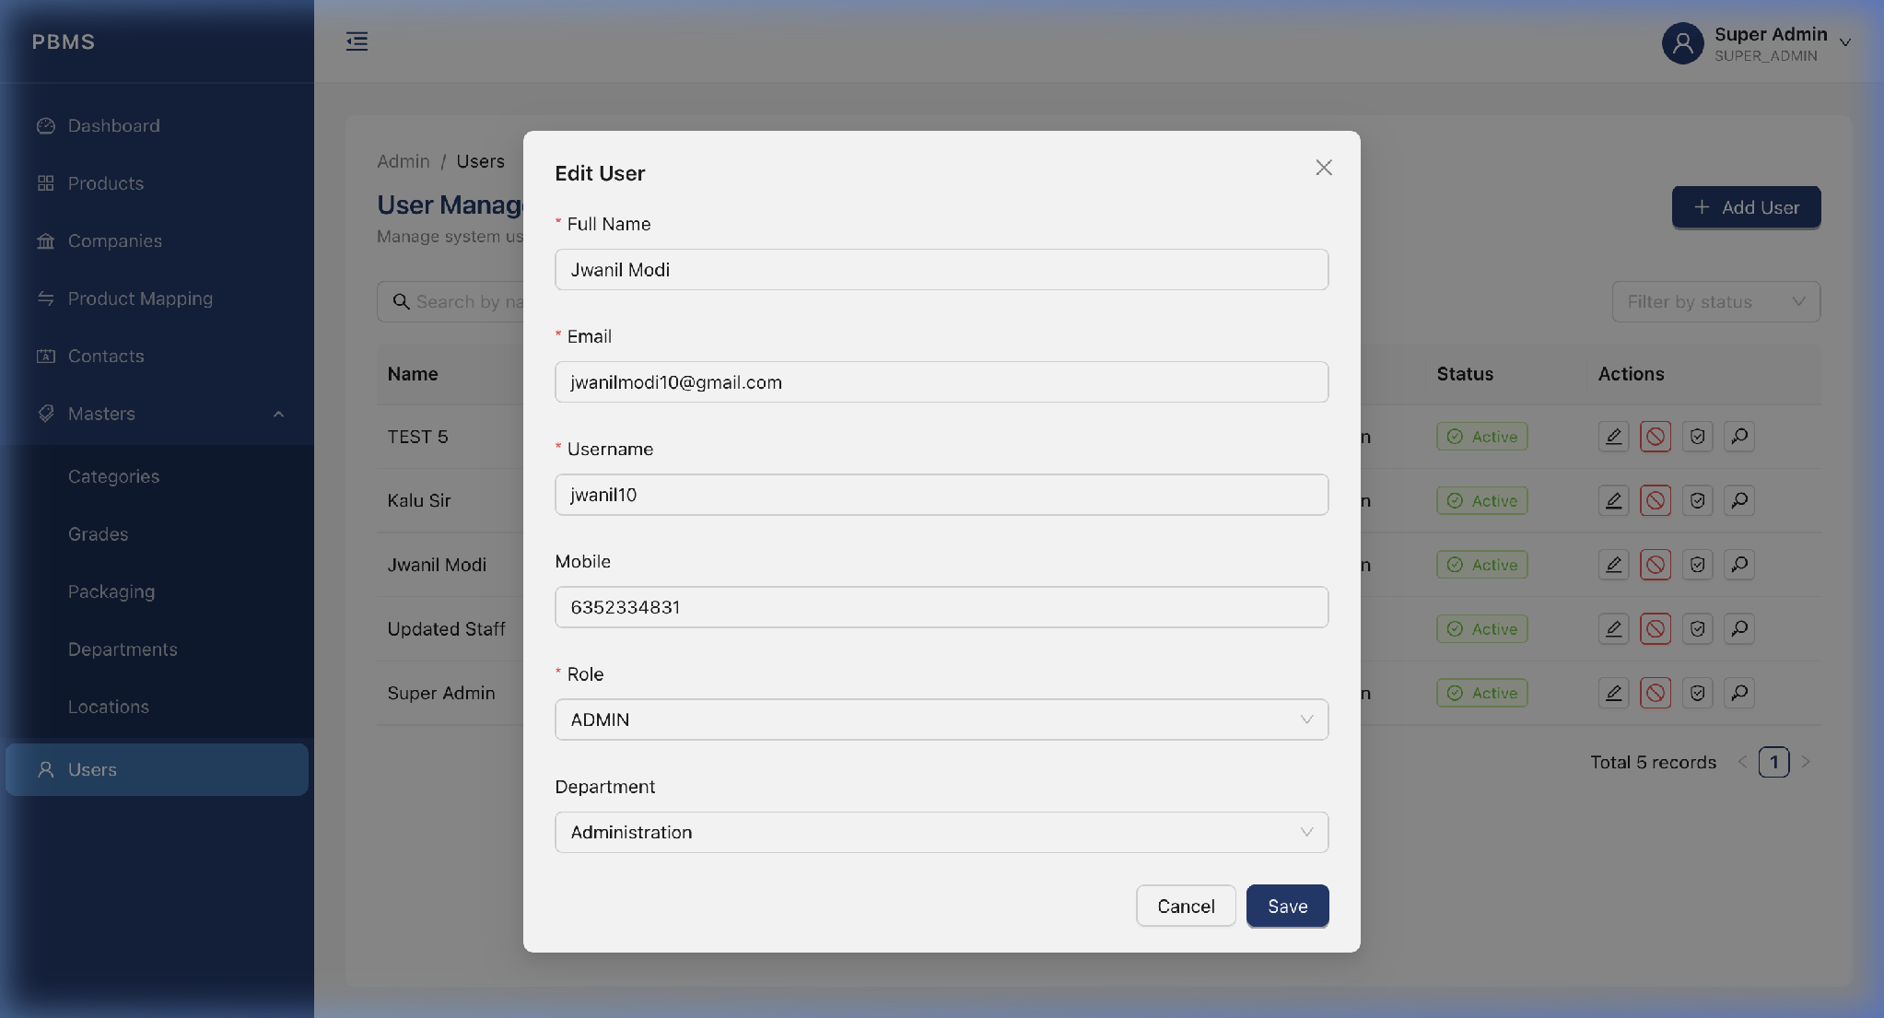
Figure 14.3 - Edit User Modal

14.4 Admin Change Password (Reset a User Password)
Admins and Super Admins can reset the password for any user directly from the Users module, without needing the user's current password. This is useful when a user forgets their password or when onboarding a new employee.
Step 1: Go to the Users page and find the user whose password needs to be reset.
Step 2: Click the "Key" button on that user's row to open the Reset User Password modal.
Step 3: Locate the "New Password" field in the edit form. Enter the new password that meets the complexity requirements (minimum 8 characters, at least one uppercase letter, one number, and one special character).
Step 4: Click "Submit" to save the changes.
Step 5: The user's password is updated immediately. Inform the user of their new password so they can log in and change it from their own Profile page.
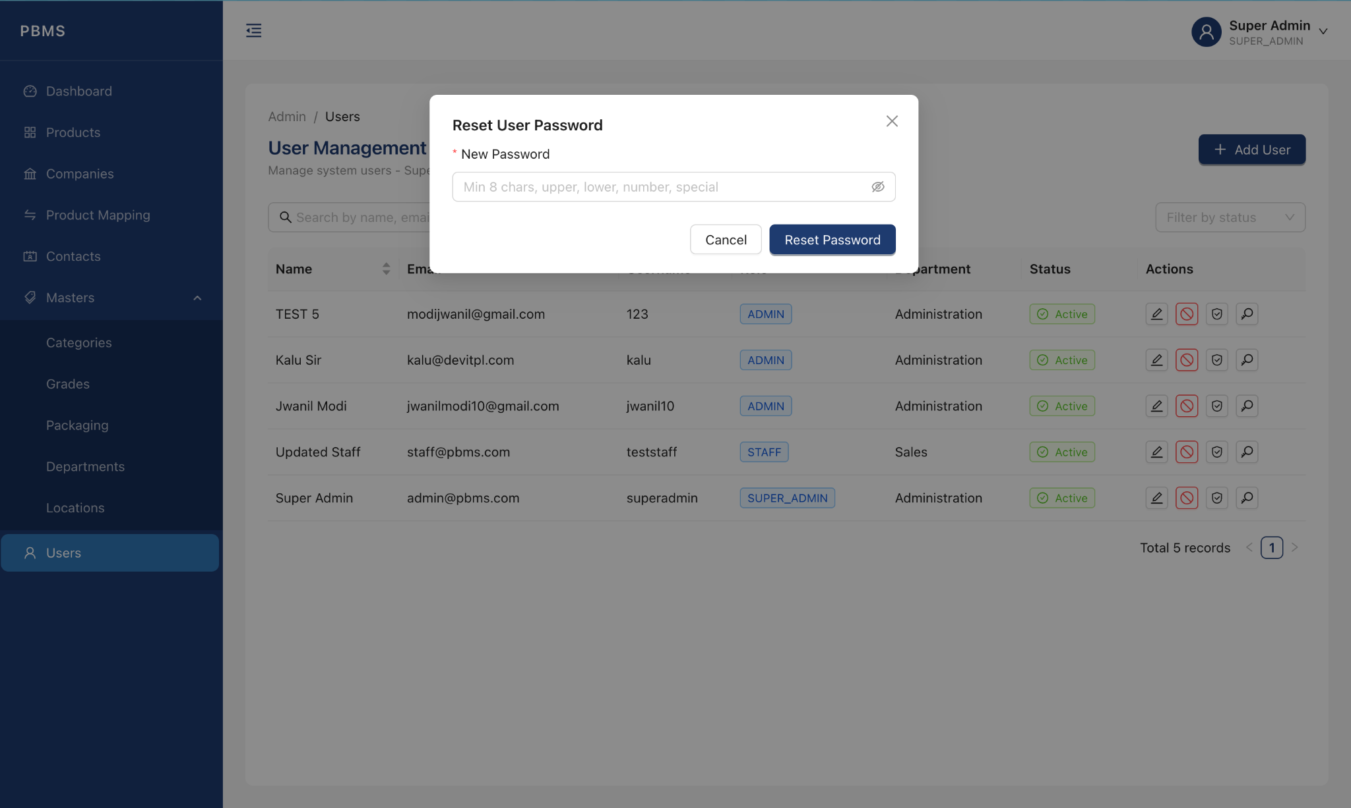
Figure 14.4 - Admin Change Password Field in Reset User Password Modal
📝 Note: This action is logged in the Audit Trail. The admin's name, timestamp, and action are recorded for accountability. The new password is never stored or visible in logs; only a hashed version is saved to the database.

15. Roles & Permissions
Each user has granular permissions that control exactly which modules they can view, create, edit, or delete.
Step 1: Go to the Users page.
Step 2: Click the Permissions icon button on a user's row.
Step 3: Toggle the checkboxes for each module: Can View, Can Create, Can Edit, Can Delete.
Step 4: Click "Save" to apply the changes immediately.
📝 Note: Permission changes take effect immediately. If you update a currently logged-in user's permissions, their UI will automatically refresh.
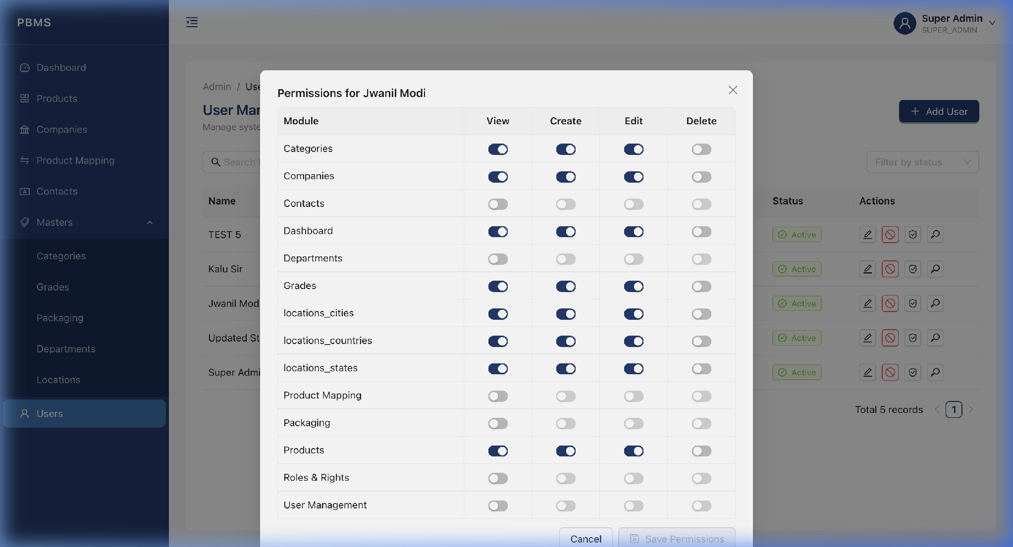
Figure 15.1 - Roles & Permissions Management

16. Profile Page
Every user can access their own profile to view personal information and change their password.

16.1 Personal Info Tab
Click your name in the top-right corner and select "Profile". The Personal Info tab displays your name, email, role, department, and last login time.
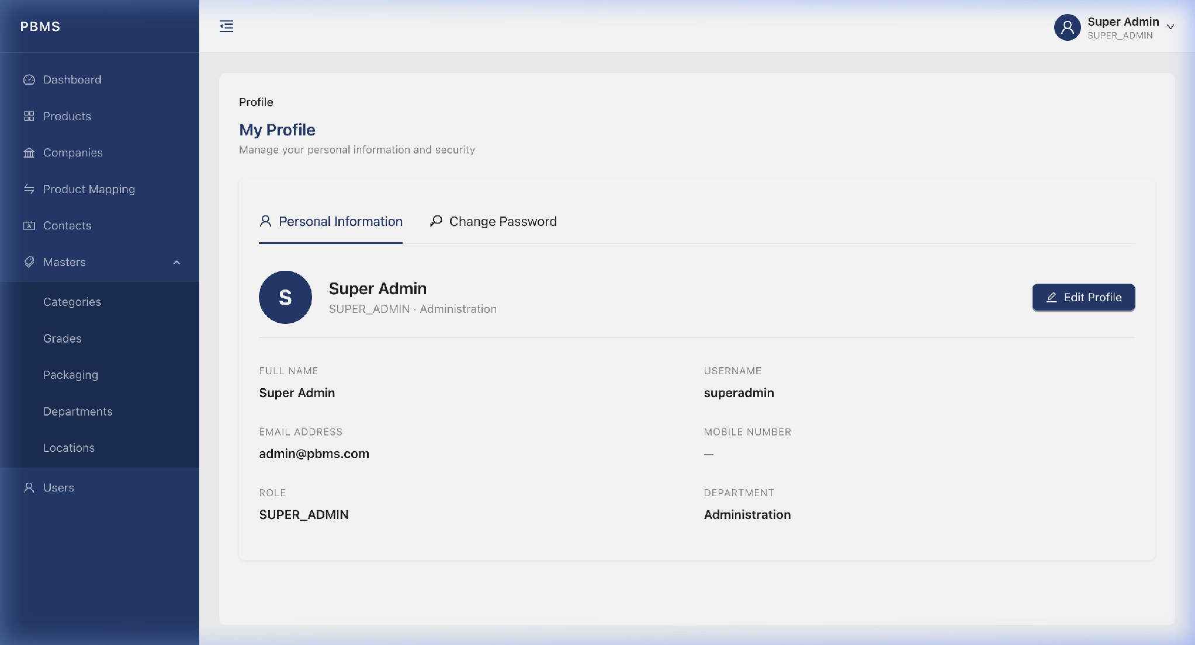
Figure 16.1 - Profile: Personal Info Tab

16.2 Change Password Tab
Step 1: Click the "Change Password" tab.
Step 2: Enter your Current Password.
Step 3: Enter your New Password (must meet complexity requirements).
Step 4: Enter Confirm New Password (must match).
Step 5: Click "Update Password".
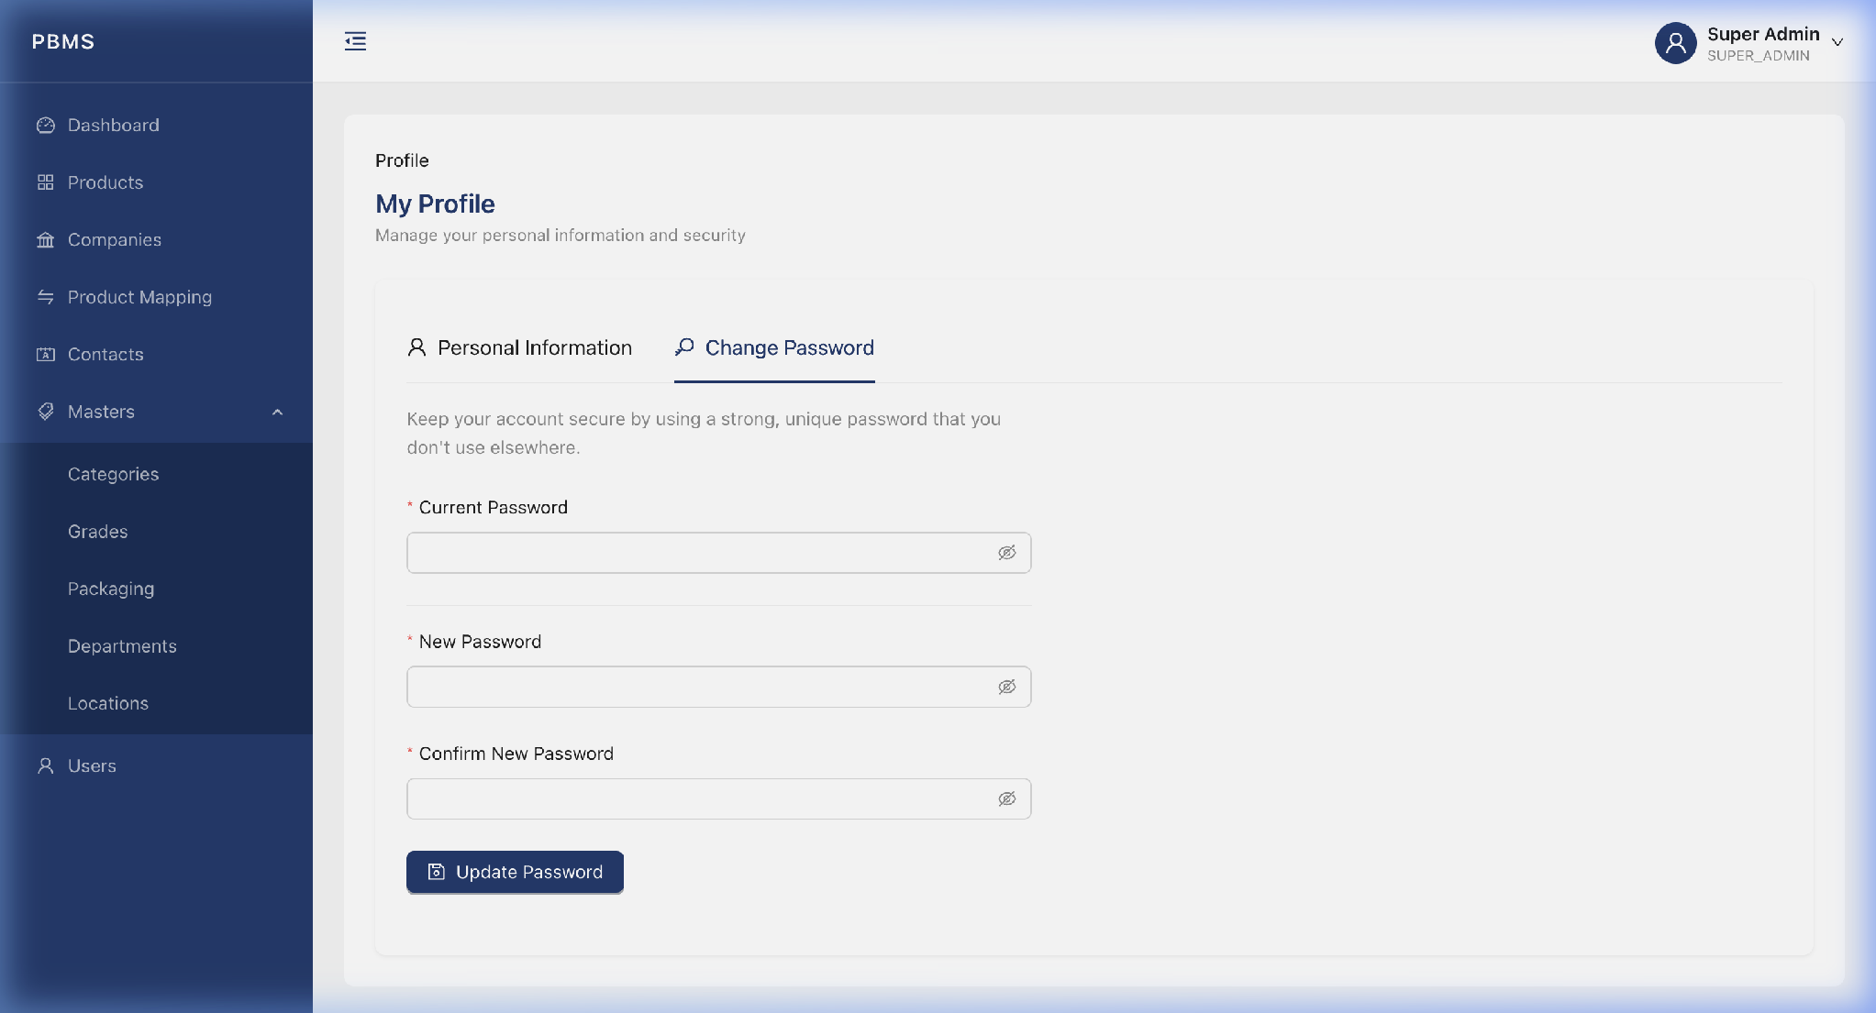
Figure 16.2 - Profile: Change Password Tab

17. Role-Based Access Control (Demonstration)
PBMS enforces strict role-based access control. Different users see different features based on their assigned permissions.

17.1 Admin View (Full Access)
When logged in as a Super Admin, the sidebar shows all modules and every action button is visible.

17.2 Limited User View (Restricted Access)
When logged in as a Staff user with limited permissions, the system automatically:
- Hides sidebar menu items for modules the user cannot access.
- Hides action buttons (Add, Edit, Delete) on pages where the user only has "View" permission.
- Redirects unauthorized URL access. Manually typing a protected URL redirects back to the Dashboard.
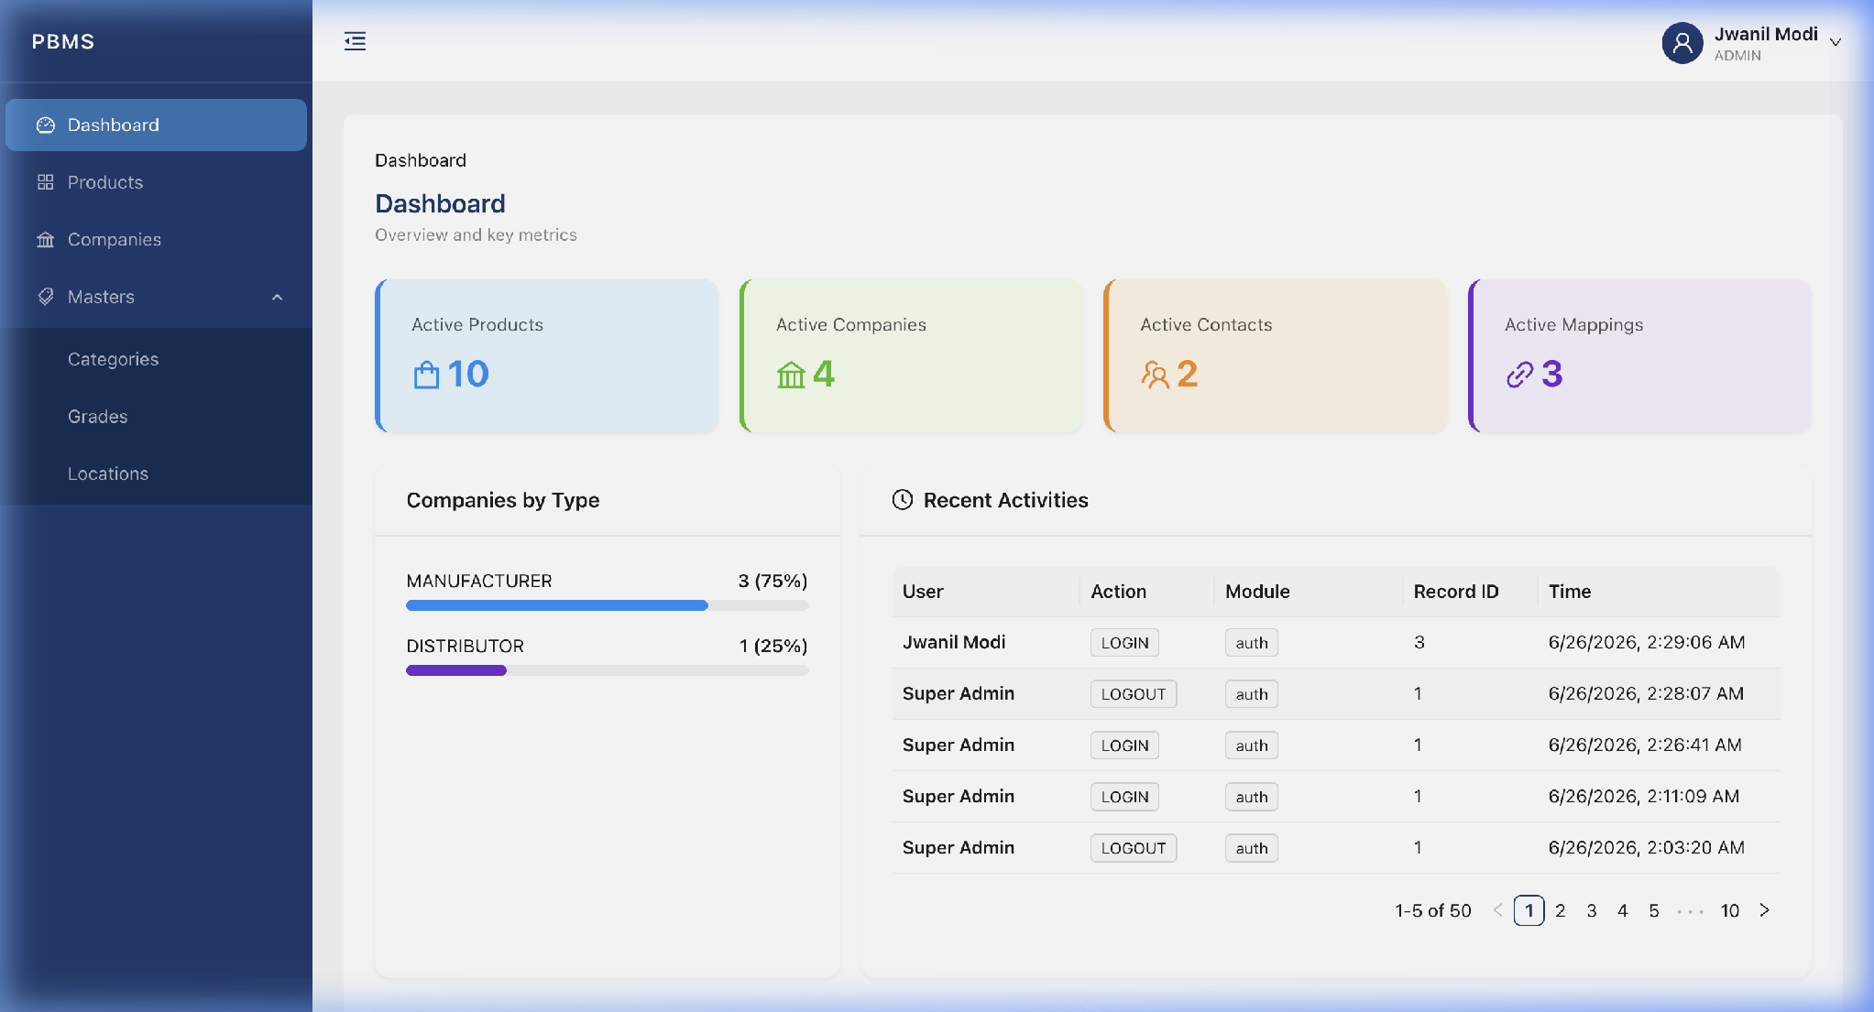
Figure 17.1 - Limited User Dashboard (Notice the reduced sidebar)
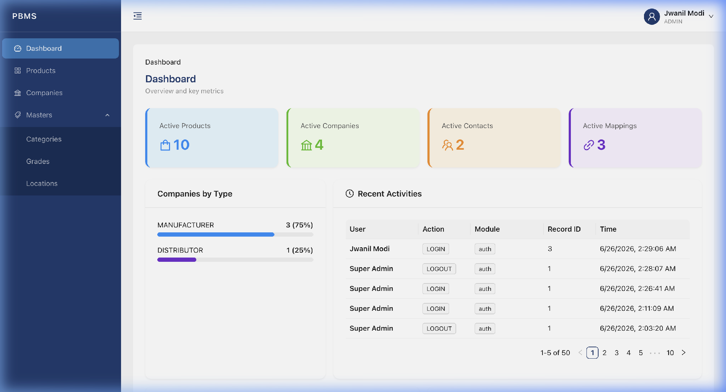
Figure 17.2 - Unauthorized Access Redirect
⚠️ Warning: Security is enforced on BOTH the frontend (hidden buttons) and the backend (API-level permission checks). Even if a user bypasses the frontend, the server will reject unauthorized calls with a 403 Forbidden error.

