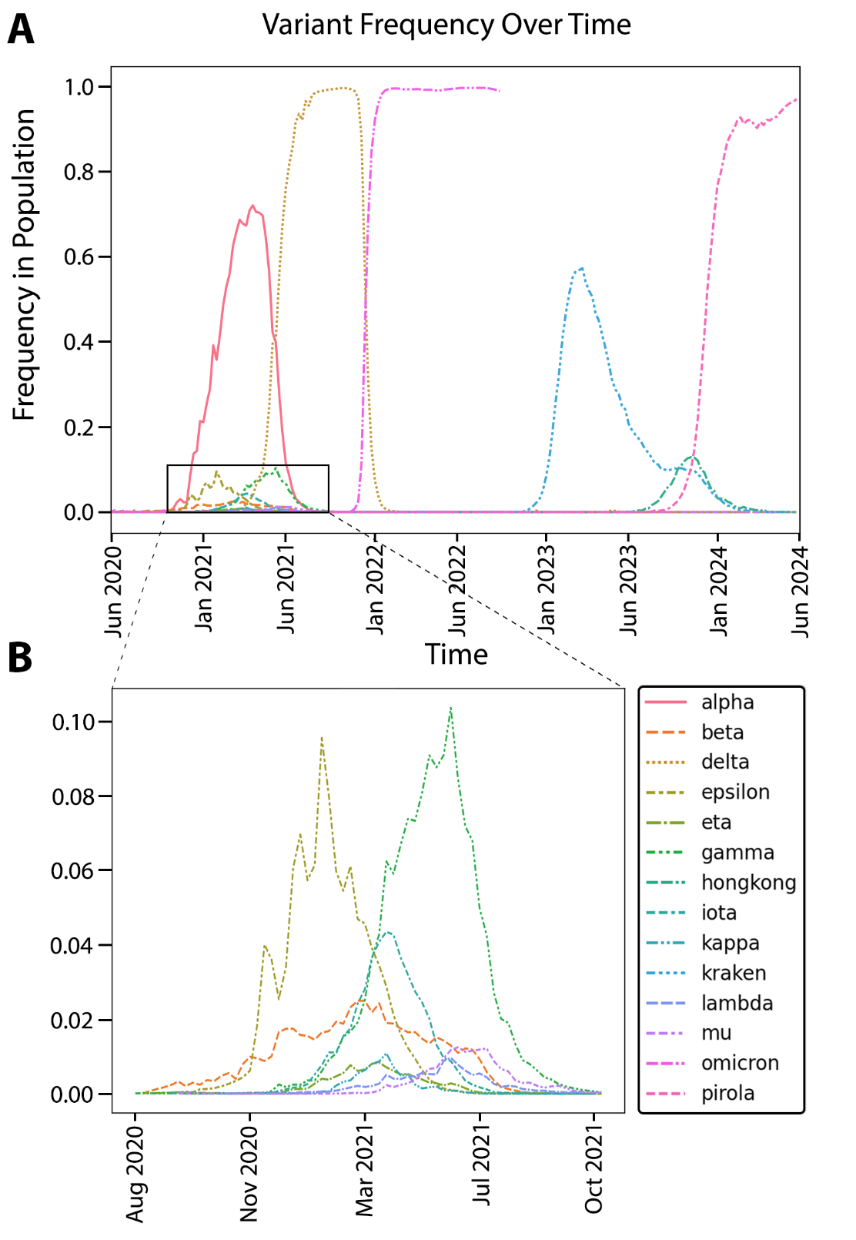
Figure S1. Distribution of Variants Over Time. A) Frequency of variants within the human population over time (Supp. Table 1). Frequency of Omicron is plotted until Omicron subspecies arise (kraken, pirola, hongkong) in Oct, 2022. B) Box shows zoom-in of August 2020 to Oct 2021 to show low frequency variants.

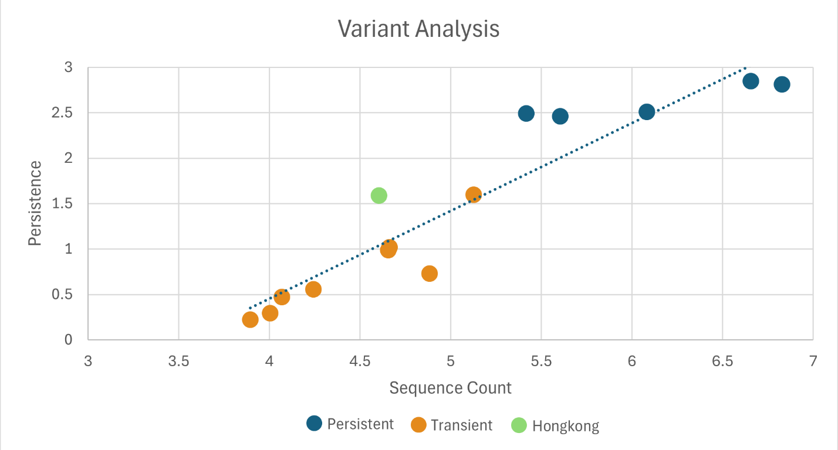
Figure S2. Persistence vs Sequence Count Regression. Persistence values plotted against sequence counts for each variant (log-log scale). Persistence is calculated by multiplying the variant duration with the maximum frequency of the variant in the human population (Table 1). Persistent, Transient, and Hongkong VoCs are shown in figure.

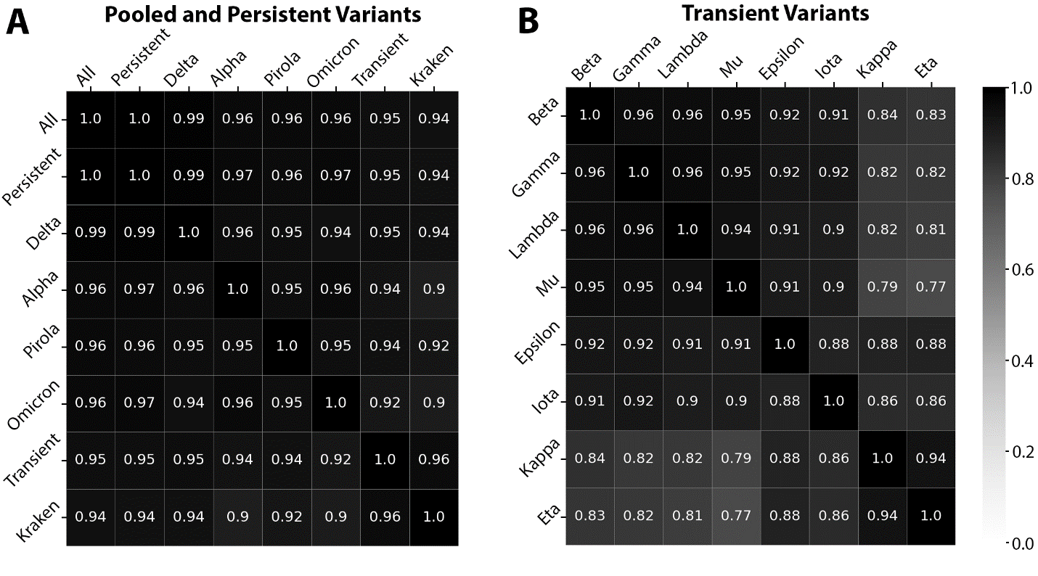Figure S3. Context-dependent Polymorphism Correlations of Population Variants. One-to-one pair-wise Pearson correlations for context-dependent polymorphisms across different population variants at minimum allele frequency 5×10⁻⁵. A) Correlation coefficients for Individual and pooled variants (All, Transient, Persistent) with sufficient sequences at the 5×10⁻⁵ threshold (>200000 sequences, see methods). B) Correlation coefficients of Individual variants that do not meet the 5×10⁻⁵ threshold (<200000 sequences). These variants are pooled downstream and designated as the “Transient” variant.

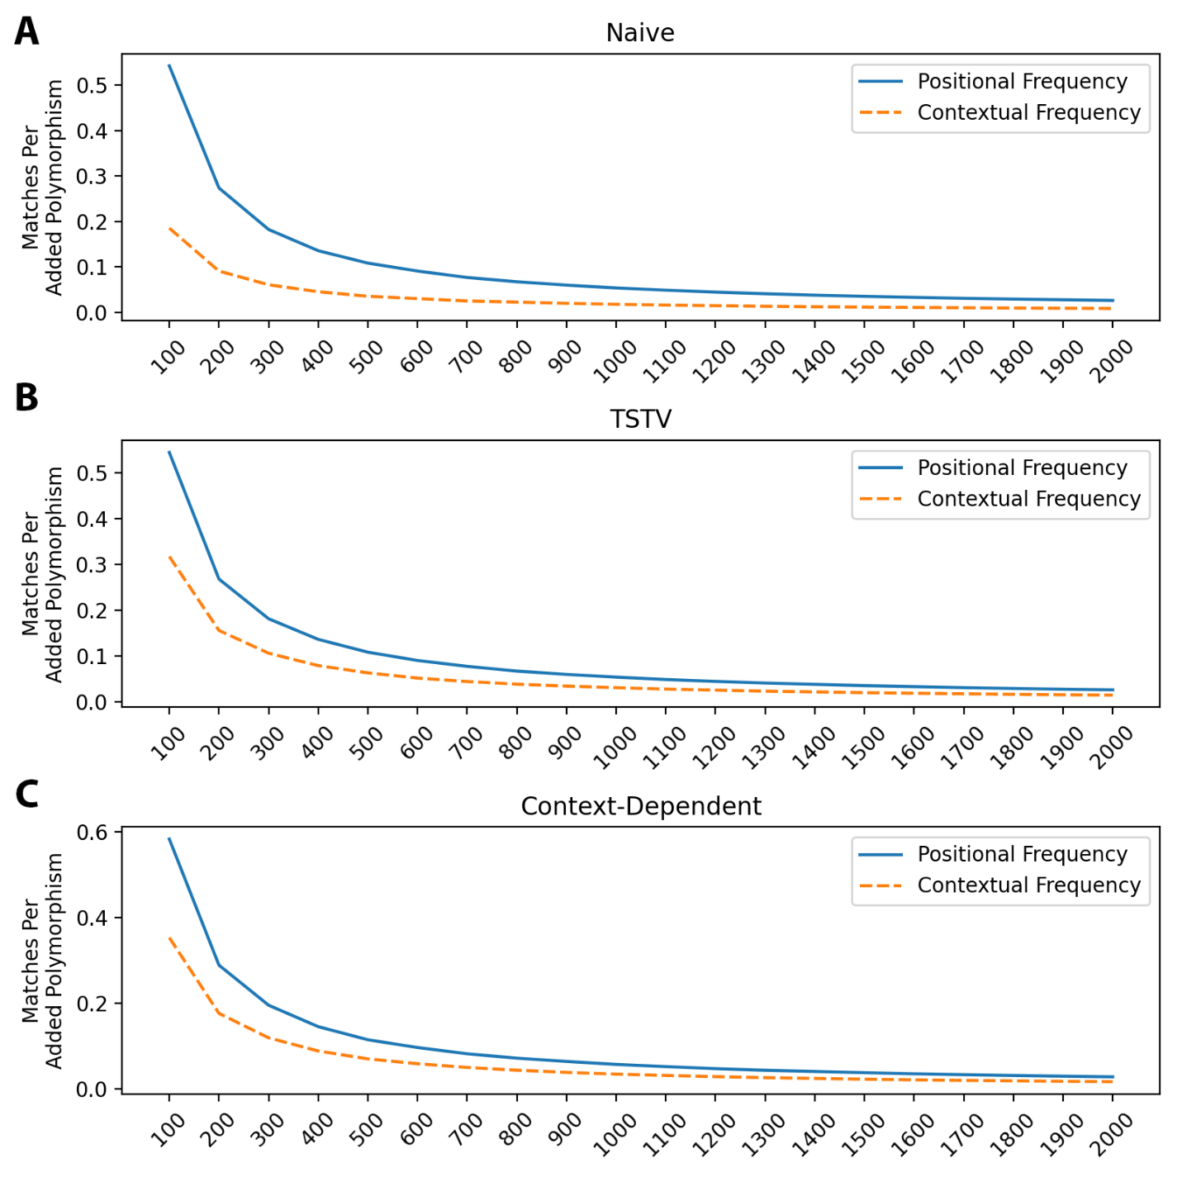 Figure S4. Match Benchmarking Across Different Simulation Types. Positional and contextual match performance for each type of simulation when placing 100 to 2000 polymorphisms. Positional matches indicate that a simulated polymorphism was placed at a position in the genome where a known polymorphism is located. Contextual matches require not only a positional match but also that the type of polymorphism is correct. There are three types of simulations: A) Naïve simulation (Naïve, 4-parameters), B) Transition/transversion simulation (TSTV, 12-parameters), C) Context-Dependent simulation (Context-dependent, 144-parameters).

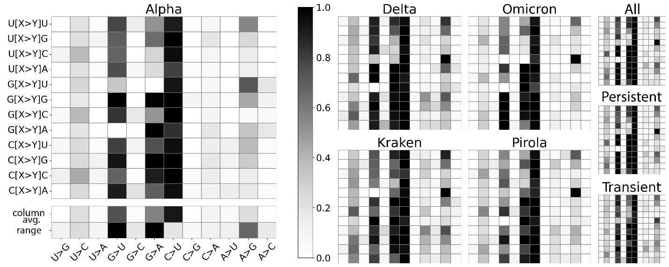
Figure S5. Context-dependent Polymorphism Matrices. Context-dependent polymorphism matrices for individual variants (Alpha, Delta, Omicron, Kraken, Pirola) and pooled variants (All, Persistent, Transient) at the 5×10⁻⁵ minimum allele frequency threshold. The column average and range for each polymorphism type is shown in Alpha only.
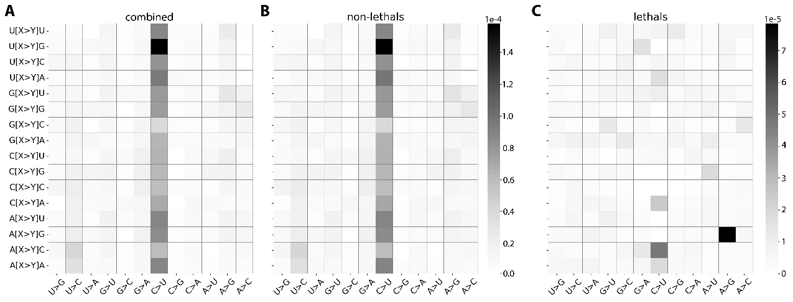
Figure S6. In Vivo Context-dependent Mutation Matrices for Total Variant. Context-dependent mutation matrices for the Total variant of the in vivo dataset the mutation rate for each context. Mutations are split into three groups: A) all mutations, B) non-lethal mutations, and C) lethal mutations. Figure A and B (1×10⁻⁴) is scaled differently Figure C (1×10⁻⁵) due to the low number of lethal mutations.
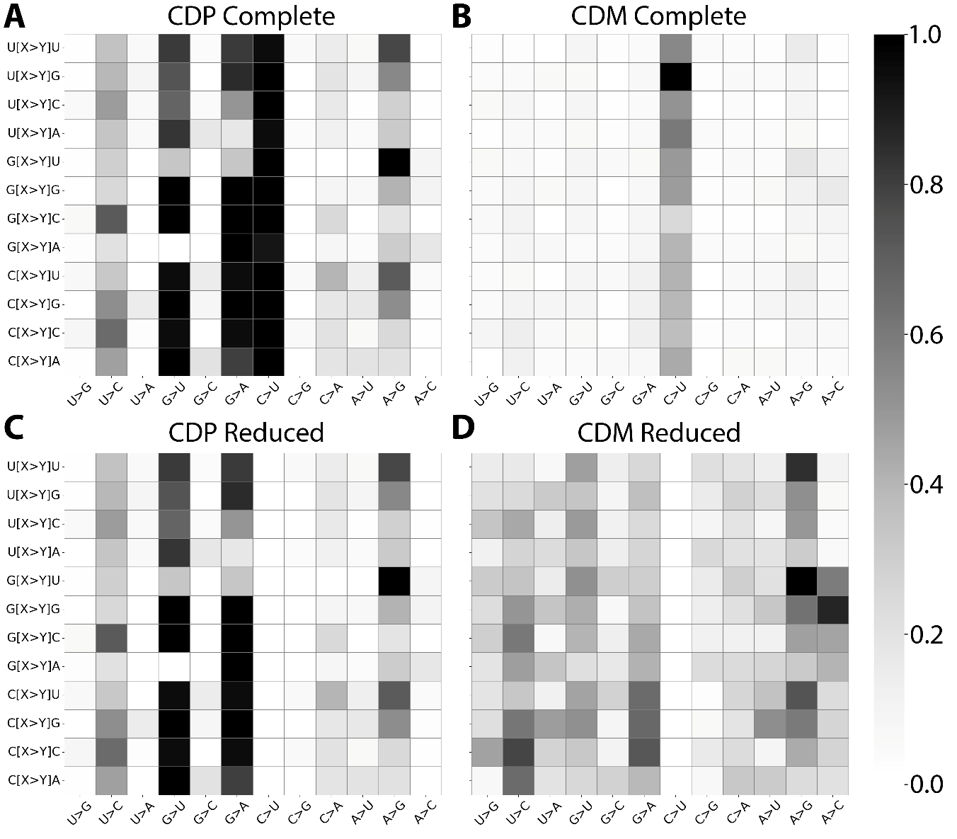
Figure S7. Context-dependent Polymorphism Matrix for All Variant vs Context-dependent Mutation Matrix for Total Variant. Comparison of the CDP matrix and CDM matrix. The All pooled population variant at threshold 5×10⁻⁵ and the CDM matrix for the Total in vivo variant. A) All CDP matrix, B) Total CDM matrix, C) All CDP matrix with the C>U column removed, D) Total CDM matrix with the C>U column removed.

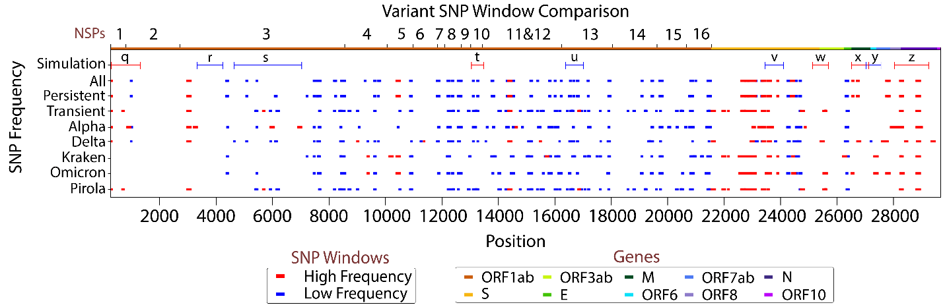
Figure S8. Polymorphism Frequencies in Simulation and Population Variants Across the Genome. Single nucleotide polymorphism (SNP) frequencies across the genome that exceed a 90% confidence interval at high (red) or low (blue) frequencies. Simulated polymorphisms are compared against the population variants (individual and pooled). Significant regions for simulated polymorphism frequencies are calculated by averaging the number of polymorphisms placed within a 250 base-pair window and for population polymorphism by averaging the frequency of known SNPs within a 100 base-pair window. Different window sizes are used due to the number of SNPs simulated being much lower than the number of known SNPs.

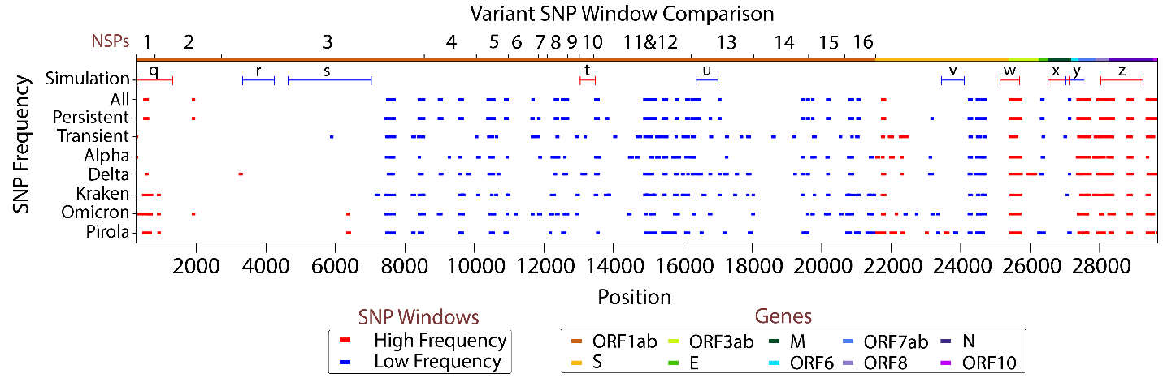
Figure S9. Polymorphism Frequencies in Simulation and Polymorphism Counts in Population Variants Across the Genome. Single nucleotide polymorphism (SNP) frequencies across the genome that exceed a 90% confidence interval at high (red) or low (blue) frequencies. Simulated polymorphisms are compared against the SNP counts of population variants (individual and pooled). Significant regions for simulated polymorphism frequencies are calculated by averaging the number of polymorphisms placed within a 250 base-pair window. Significant regions for observed SNP counts are calculated by averaging the number of SNPs within a 100 base-pair window. Different window sizes are used due to the number of SNPs simulated being much lower than the number of known SNPs.

