

SCHOOL OF ADVANCED TECHNOLOGY

ICT - Applications & Programming

Computer Engineering Technology – Computing Science



A21
Model Definitions (RE/Automaton)

Lab Professor / Lab Session:
[Paulo Souza / 302]

Team:
[Jwell Lalakiya] - Id: [041056229] / [Priya Patel] - Id: [041084491]

Language Name [DefaultX]

This template is suggested (not mandatory) to answer A11 Specification.

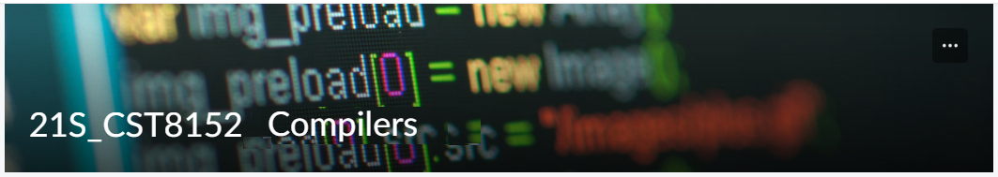

MODEL TASK FOR ASSIGNMENT 2.1 – DefaultX

- Note: This task is part of the Assignment 2 from Compilers Course. Any problem, contact your lab professor.

Task 1: Language Symbols (2.0 marks)

List examples: Define main symbols to be used:
- Special symbols (ex: “{“, “(“, “<=”, etc.)
- Comments
- Variables
- Functions
- Literals (numbers, strings)
- Keywords
- Datatypes

Answer:
Special Symbols: ‘{’, ‘}’, ‘;’, ‘<’, ‘>’, ‘>=’, ‘<=’, ‘==’, ‘!=’, ’=’, ‘+’, ‘-‘, ‘*’, ‘%’, ‘/’, ‘&&’, ‘||’, ‘!’, ‘(‘, ‘)’, ‘//’,…

Comments: (Single Line) // blah blah blah \n, (Multi Line) //* blah blah blah *//

Variable: variableName1, variableName2, variableName2, …..

Functions: func methodName (parameters datatypes) return_type {// Method implementation}

Literals:
-Integer: 32, -12, 0
-Float: 0.12, -3.14
-Boolean: True, False
-String: “Hello! Our language is DefaultX!!”

Keywords: int32, float32, string, break, default, func, case, struct, if / else, package, switch, const, type, continue, for, return.

Datatypes: int32, float32, string, bool

Task 2: RE – Regular Expression (3.0 mark)

Lexeme Classes: Define the classes to be used in your regular expression:

Answer:

L (Letters): A-Z | a-z
D (Digits): 0-9
S (Double Slash): //
J (Multi Line - Start): //*
K (Multi Line – End): *//
E (End line): \n
U (Under Score): _
P(Period): .
Q(Double Quote): “
M(Paranthesis): (
O(Other): ^[LDSJKEUPQM]

Define the RE to be used for: variables, literals and keywords:

Answer:
* Comments: (Single Line) SC= S(^S)*E, (Multi Line) MC= J(^J,K)*K
* Variables: VAR= L(L|D|U)*
* Methods: MID=L(L|D|U)*M
* Literals:
- Integers: IL= D+
- Float: FL= D+PD+ | PD+
- String: SL= Q(^Q)* Q = Q(LDSJKEUPQM)Q
* Keywords: L + € {int32 | float32 | string | break | default | func | case | struct | if | else | package | switch | const | continue | for | return}

Task 3: TD – Transition Diagram (3.0 marks)

Activity: Starting from the previous lexeme classes and obeying the RE, it is possible to define the automata for your language:

Answer (draw / copy image of the automata):

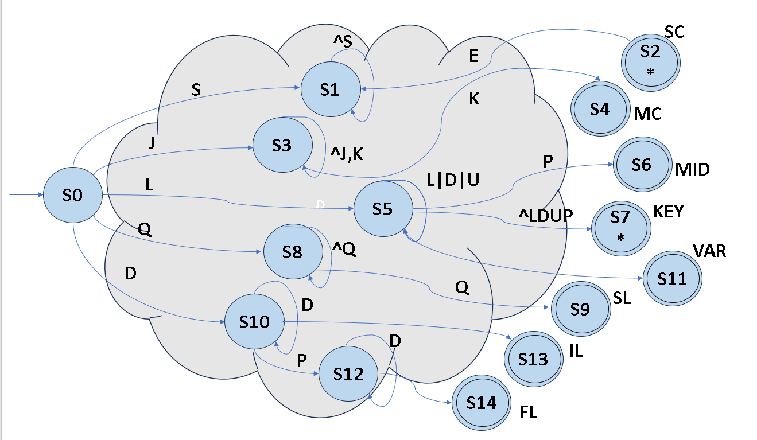

Task 4: TT – Transition Table (2.0 marks)

Activity: Now, it is possible to define the TT for these lexemes:

Answer (Transition Table):

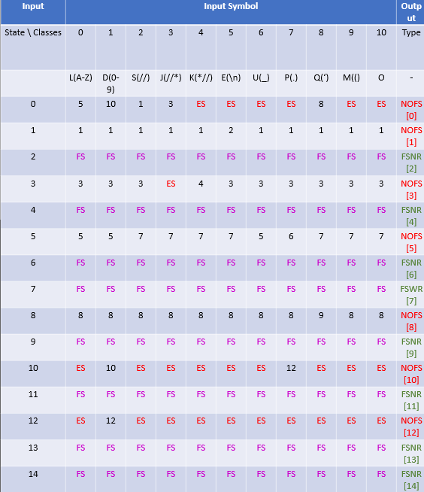

Update: Oct 10th 2023.

Adapted from resources developed by Prof. Svillen Ranev (Algonquin College, 2019)

