<https://cgi.luddy.indiana.edu/~jonawell/team34final/index.php>

Query 1: Equipment Total Damage Value

This query allows the user to select a piece of equipment that is rentable and see the total damage charges that piece of equipment has. For equipment that have very different results choose grader and then compactor when running the query.

Query 2: Equipment Availability

This query includes a lot of useful information, choose any date and the output will display all equipment that is available on that day and how many of each item is available.

Query 3: Customer Late Fees

This query allows the user to choose a Joe's customer and see how many late fees they have accumulated. After choosing, the customer and their phone number display with how many fees they've accumulated. If the customer has no late fees a special message will pop up, to see this input customer Chantelle Renad. In addition, the last digits of the customer's ssn will pop up in the header.

Query 4: Customer Damage Lawsuits

This query lets the user choose a customer and view their damage lawsuits. Damage lawsuits indicated damages to the equipment that resulted in a lawsuit. Once a customer is chosen the number of damage lawsuits they have will display.

Query 5: Employees with work phone numbers and have handled a transaction with a returned deposit

This query allows the user to select an employee to see if they have both put their work phone number into the system and have handled a transaction where the customer's deposit was returned to them. This query is special because if the selected employee satisfies this condition, it will just tell you rather than outputting a blank table. If you pick one of the 3 employees that do satisfy this condition, the table will appear with their work number.

Hint: The employees that satisfy this condition are: Malcolm Langeren, Dulcia Dursley, Tova Saunton.

Login

For the special, we constructed a database with employee logins and passwords. The logins with the username and passwords in plaintext for each employee:

Halsey Tassel: halseytass Password123

Malcolm Langeren: malcolange Secure4567

Celia Grube: celiagrube Secret987

Ardeen Rosendale: ardeenros Access321

Con Janowski: conjanowsk Private99

Bealle Wakenshaw: beallewak Hidden789

Ardys Iannelli: ardysiann Code2023

Dulcia Dursley: dulciadurs Locked908

Tova Saunton: tovasaunto Safeguard1

Elizabet Berget: elizabetbe Protect34

Rolland Caig: rollandcai Defend567

Rad Fry: radfry Firewall8

Auberta Olden: aubertaol Sentinel123

Toddie Croxley: toddiecro Guardian45

Larina Toffanelli: larinatof Protector9

Dagmar Reame: dagmarrea Watcher123

Shaylah Farreil: shaylahfa Keeper456

Catarina Buggs: cataribug Warden789

Arabella Tricker: arabellat Sentry2023

Carolina Calafato: carolical Patrol908

Rahal Edgler: rahaledgl Ranger101

Isac Rougier: isacrougi Investigate12

Arlen Baff: arlenbaff Inspector34

Charmian Frude: charmiand Detective567

Hannie Whaley: hanniewha Agent890

Joe (owner): joejoe MyBusiness

(gives special create/delete an employee login privileges, meant to be the owner)

With one of these users logged in, you can go anywhere on the site without having to login again thanks to sessions. With joejoe logged in you get to do two special things. Two buttons will appear on the homescreen, and will allow you to add an employee to the database and the second will allow you to create an employee which the system will allow you to login as, just as if the created employee was in the database from the start.

You may notice that comparing our select file with the code given, there are some slightly different queries. That is because when we moved them to the webpage, our team was told to have a dynamic dropdown or special input for each of them, rather than just clicking a button and generating the query, we were told that each one was supposed to have user input, which changed our queries a tad bit from the select file to the webpage.

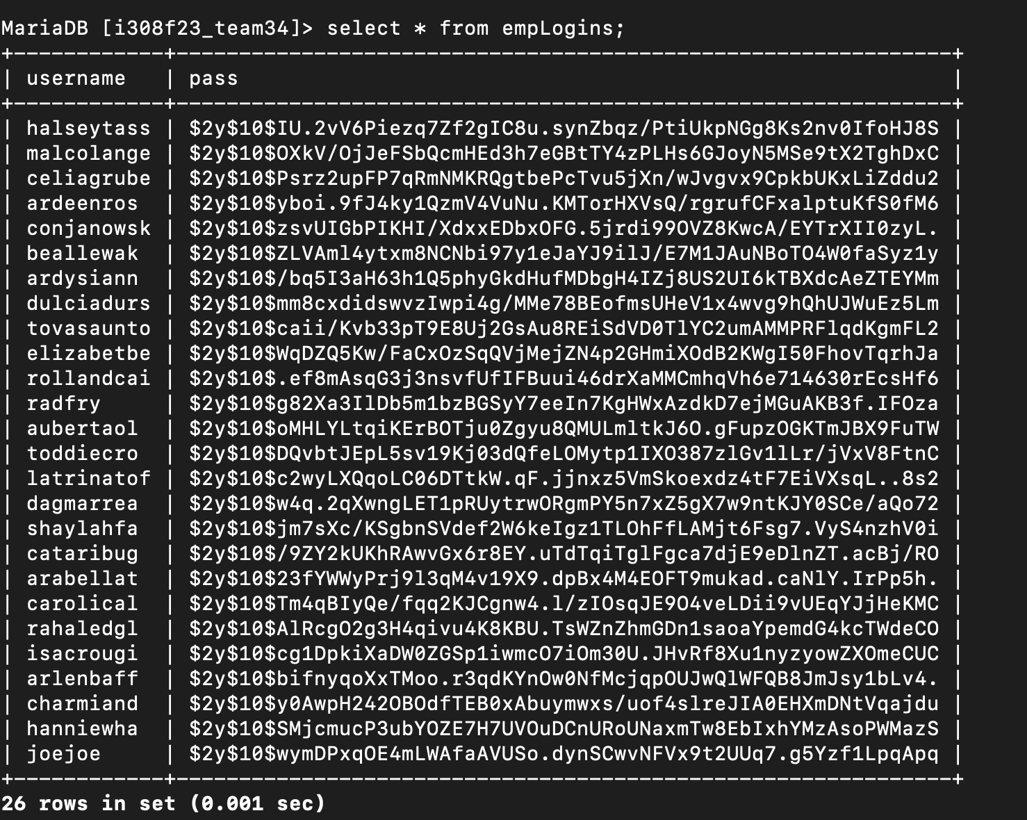

Here are the usernames and encrypted passwords in the database