Team 34: Nicole Caraballo, Jonathan Wells, Zach Dugan, Jackson Klem **Data is written as represented in our queries.**

**Strong Entities**:

customer: (SSN, nameF, nameM, nameL, phone, email, aSte, aCity, aSt, aZip, paymentInfo) inventory: (ID, price, quantity, iType, iName)

employee (emp): (ID, nameF, nameL, email, aSt, aCity, aSt, aZip, salary) rentalTransaction: (ID, rStart, rEnd, rCost, return_status, damages)

**Weak Entities:**

paymentDetails: (deposit, returnedDeposit, lateFees, damageLawsuits, lawyerFees, courtDate, assessment, ssn→, transID→)

**Relationships:**

**MultiValued:**

employeePhn: (empID→, phone, type)

**Unhandled Relationships:**

Manages: (empID→, transID→)

Handle: (empID→, itemID→)

Rent: (transID→, itemID→)

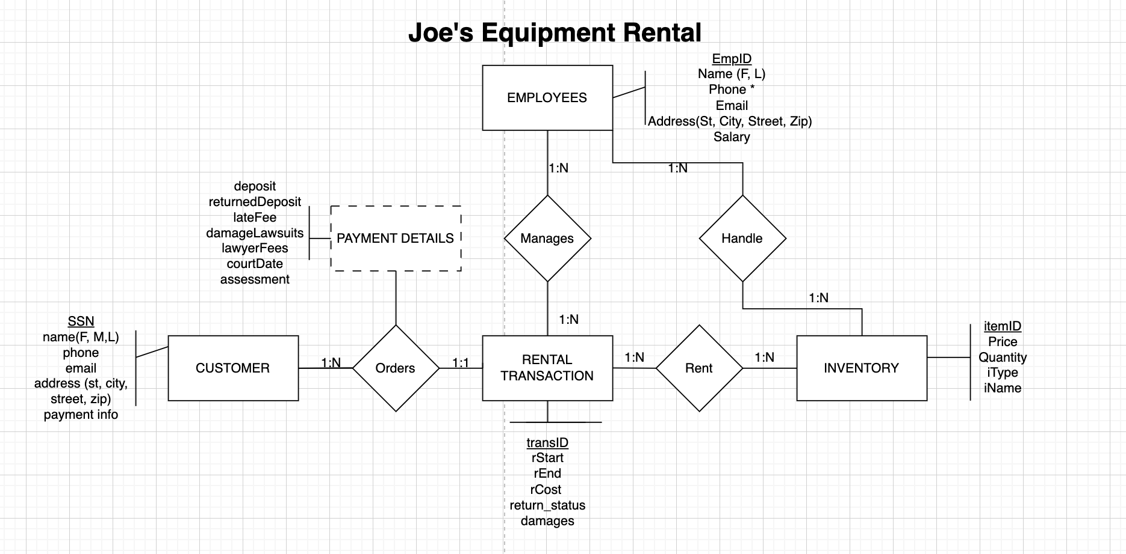

ERD Changes For Final Project:

-Changed name of Customer Experience to Customer Certification (cCert) to match the database

-Added type to cCert

-Removed Customer middle name

-Added iName, changed "Itemtype" to "Type"

-Changed Payment Details attributes to match data names

-Changed Damage Assessment to assessment (payment details)

-Changed three rental transaction names (rStart, rEnd, rCost) to match data

-Removed Customer Experience

-Changed payment details, connected to SSN and transID which is the same as our data