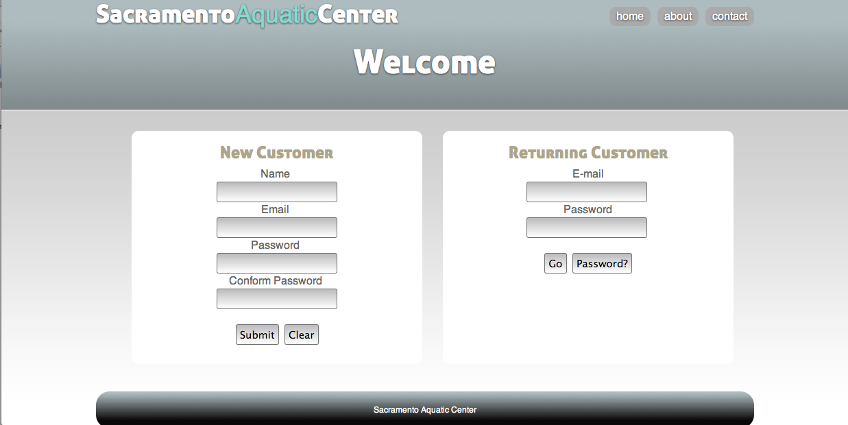
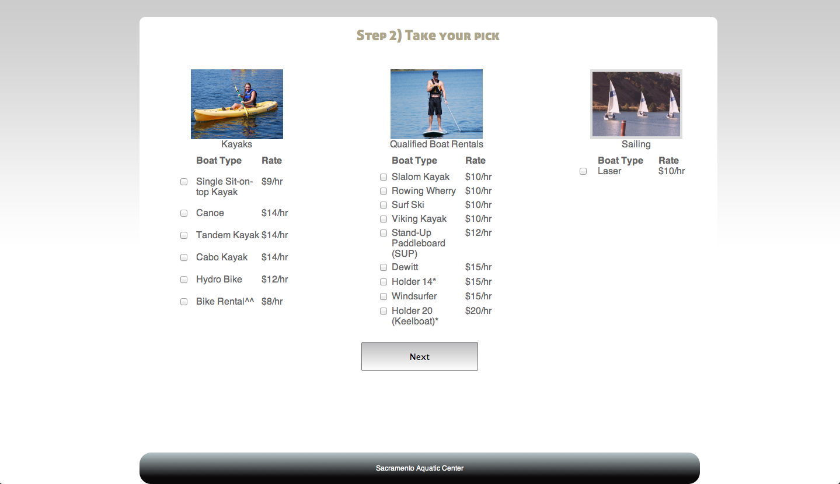
This is the Login/Register page. Designed for quick access. New customer can either become a member or login as returning customers.
Once logged in, the customer can select what equipment(s) he or she wants to rent for the day.
As the page shows, the customer will be able to select any of the equipments. This will not be the case for most people. Based on the class level, some of the items will be in red, denoting that they need to be certified before using the equipment.
some items will have a line through them, this will denote that the item is currently sold out.

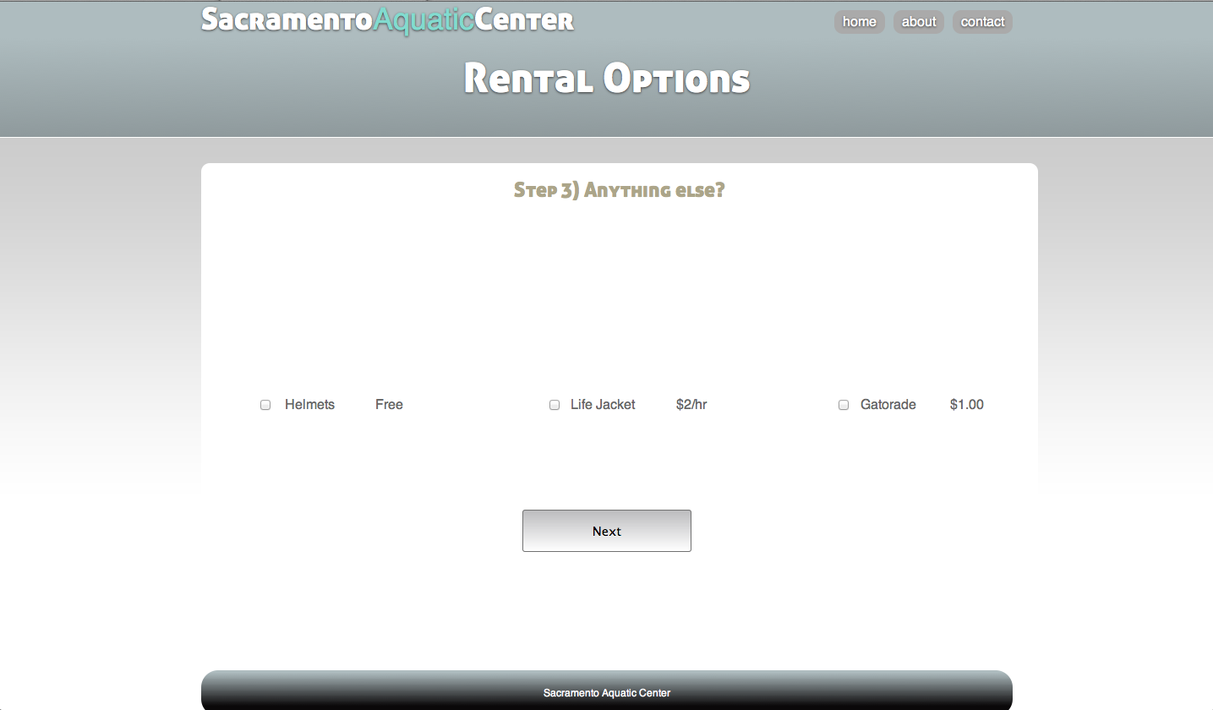
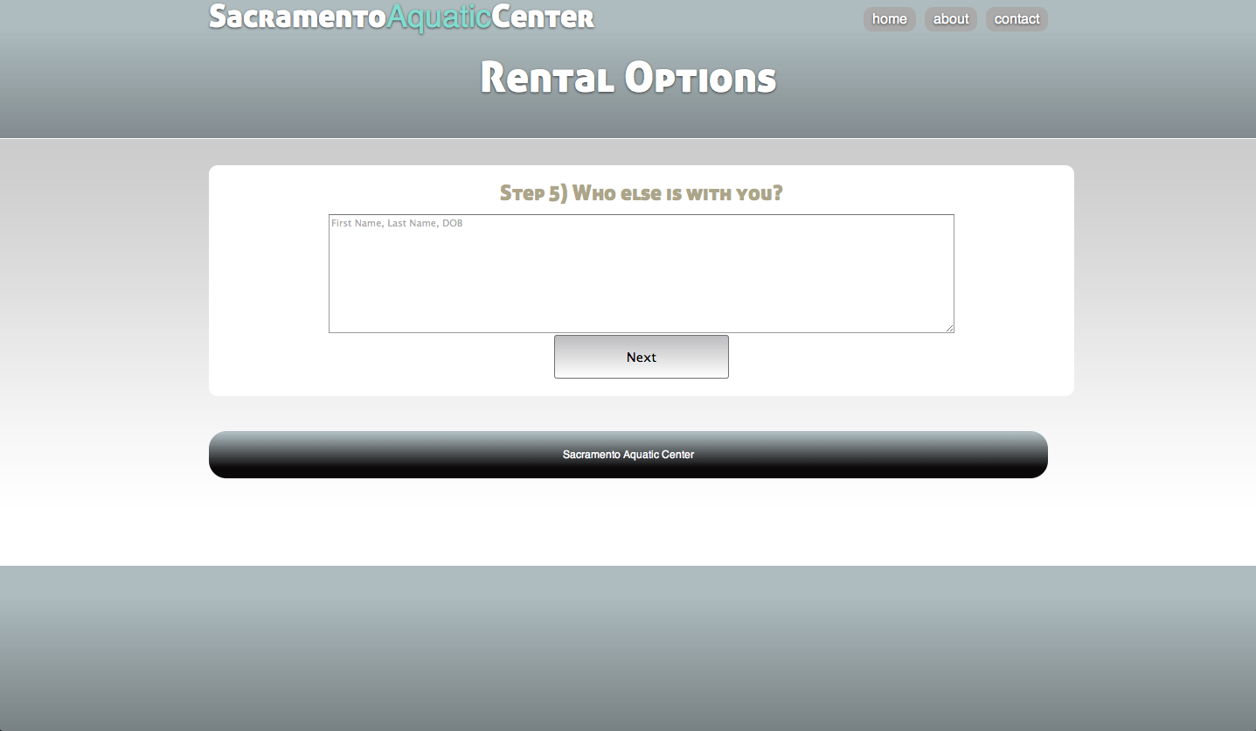
The above page looks barren now, however, it will allow for rental additional items. ie, Helmet, life jacket, or even gatorade...
Once all of the technical stuff is taken care of, we need to note who is with them. In the above field they will be able to input the persons name as well as their birth date. Note that the format is also there for them to use, however, if they fail to follow the format, our program will make up for it and use some regular expressions to determine which of the fields are birthdays and what is their name

