Wimberly Joshua
Group Project contributions
GUI

AI Prompts and some code used.
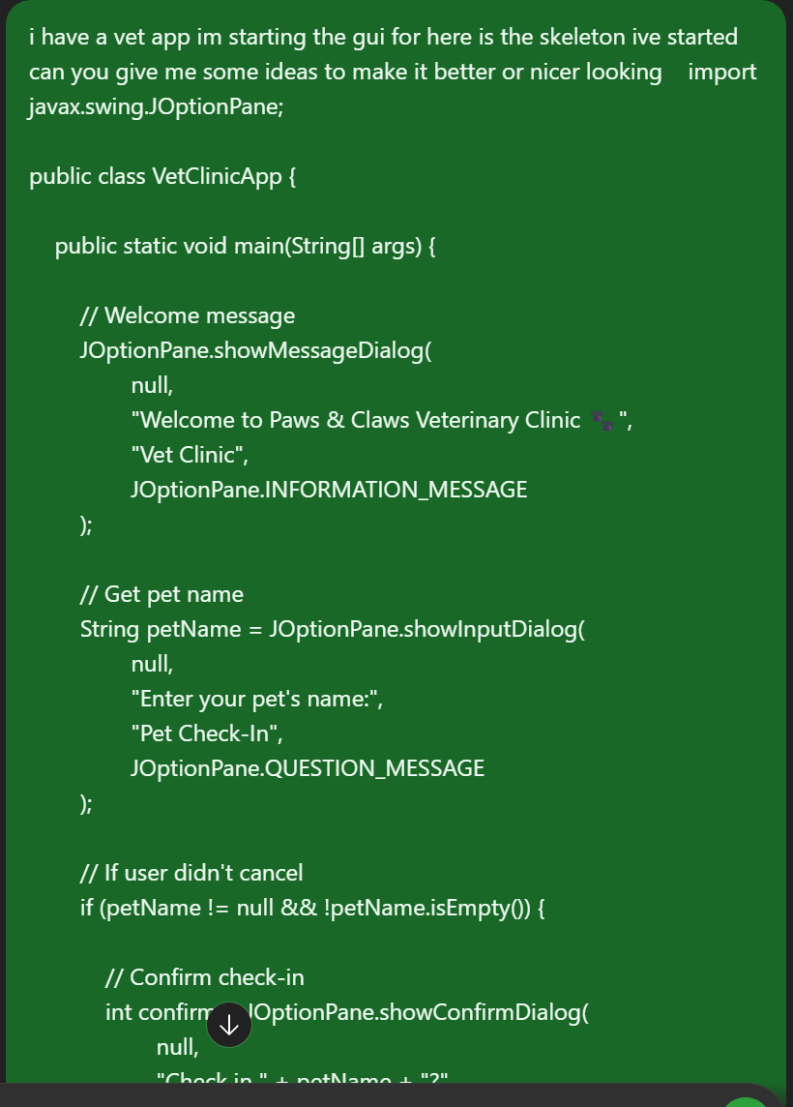

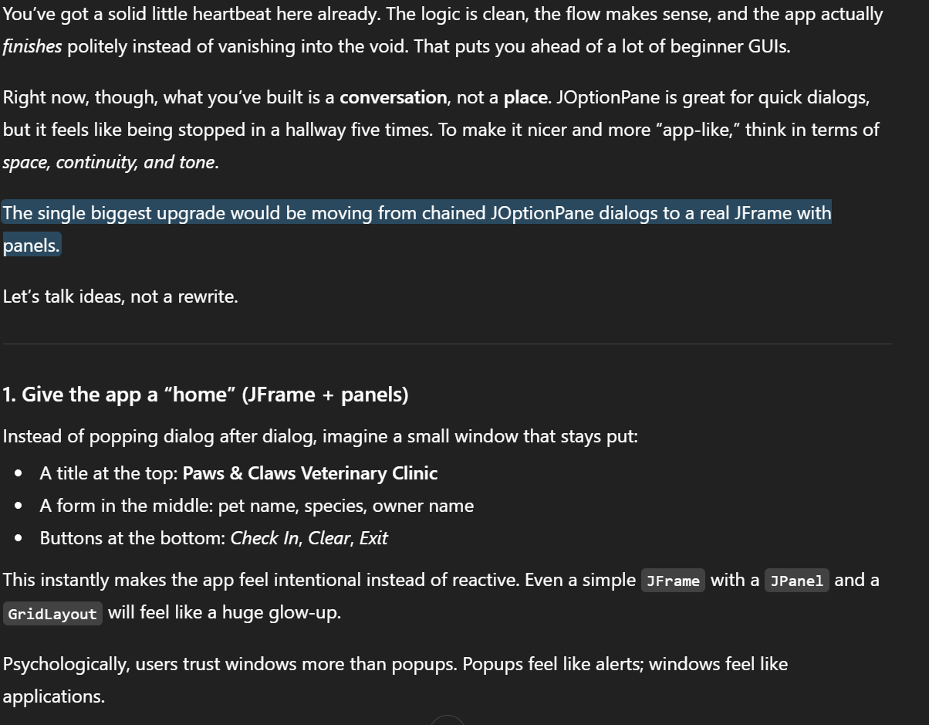

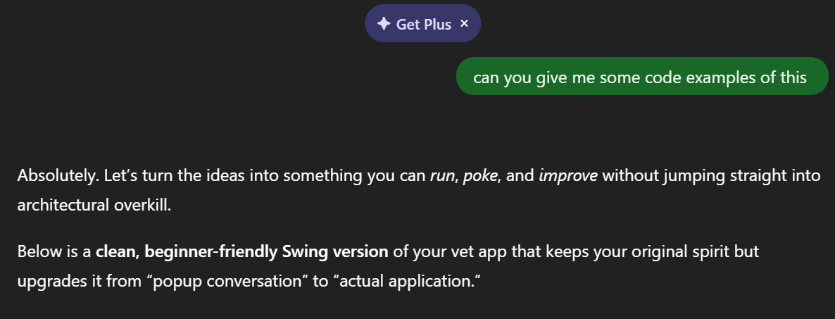

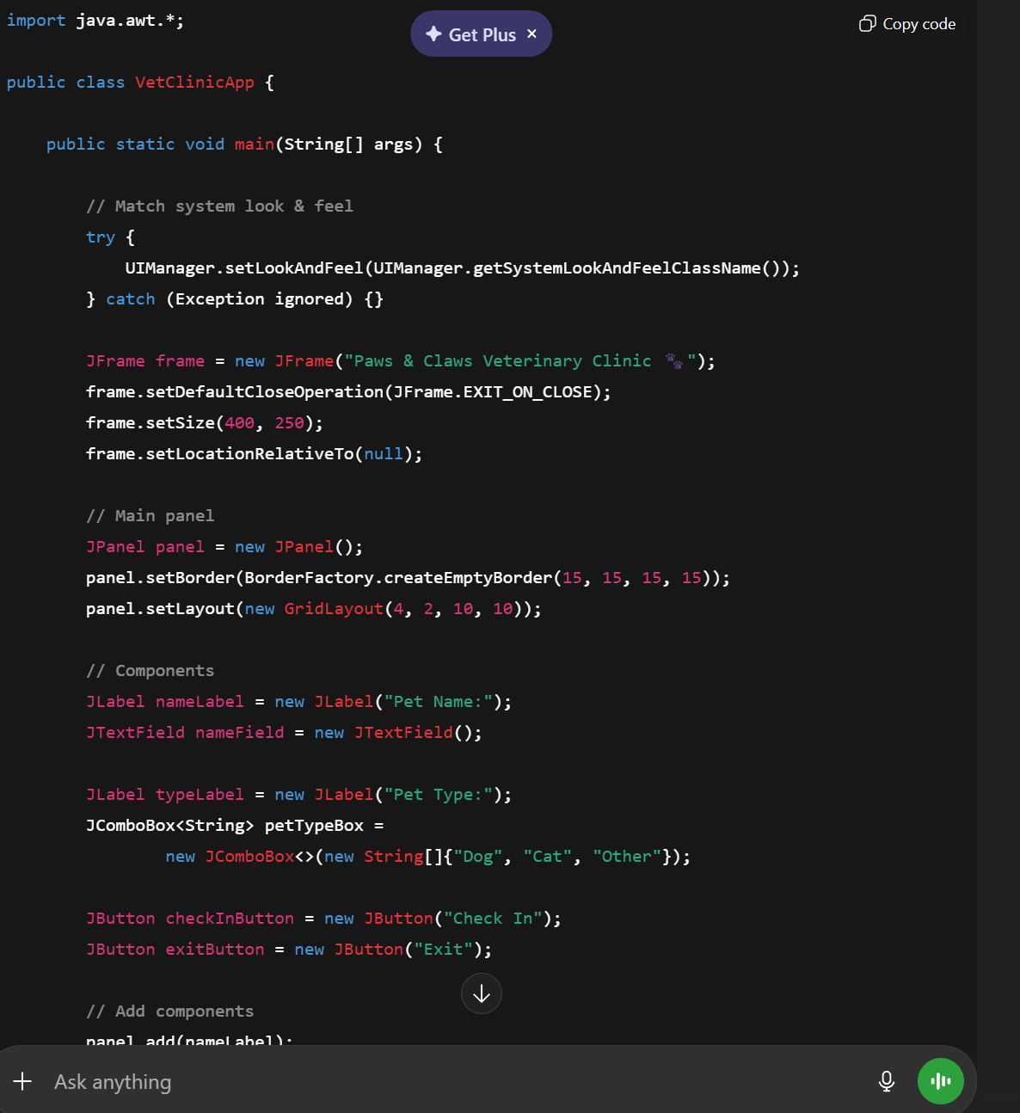

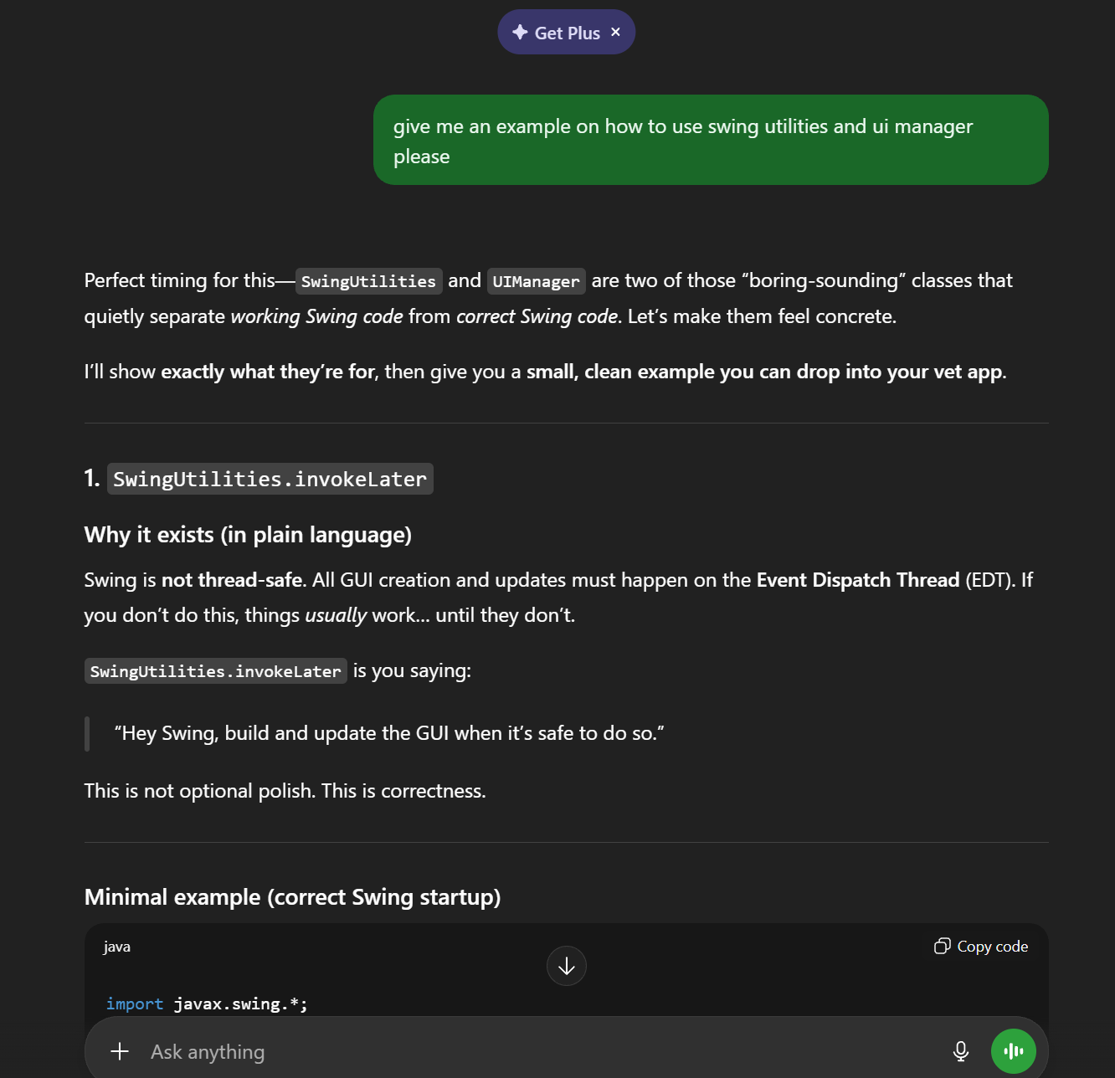

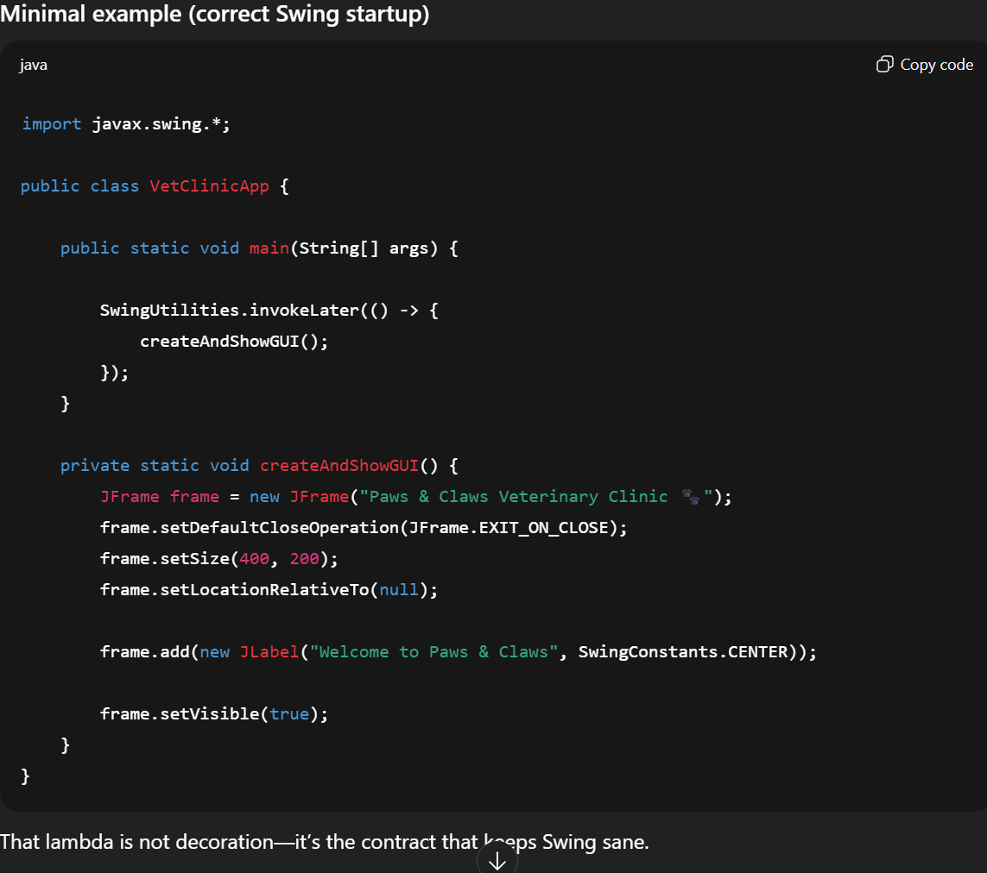

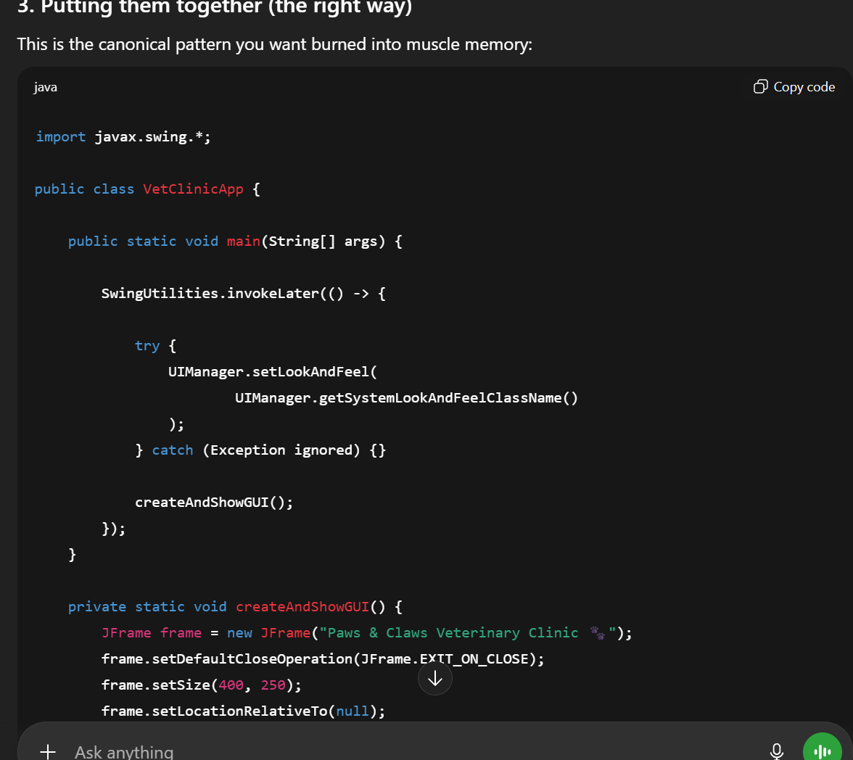

code:

import javax.swing.*;
import java.awt.*;

public class FarmManagementUI {

private final FarmManagementLogic logic;
private final JFrame frame;

private final JLabel storeSales = new JLabel("0");
private final JLabel serviceCount = new JLabel("0");
private final JLabel animalSales = new JLabel("0");
private final JLabel specialtySales = new JLabel("0");
private final JLabel revenue = new JLabel("$0.00");

public FarmManagementUI(FarmManagementLogic logic) {
this.logic = logic;

frame = new JFrame("Farm Management");
frame.setDefaultCloseOperation(JFrame.EXIT_ON_CLOSE);
frame.setLayout(new BorderLayout());

frame.add(createHeader(), BorderLayout.NORTH);
frame.add(createNav(), BorderLayout.WEST);
frame.add(createSummary(), BorderLayout.CENTER);

frame.setSize(900, 560);
frame.setLocationRelativeTo(null);
}

public void show() {
frame.setVisible(true);
refresh();
}

private JPanel createHeader() {
JPanel p = new JPanel(new BorderLayout());
p.setBorder(BorderFactory.createEmptyBorder(16, 20, 16, 20));
p.setBackground(new Color(33, 64, 54));

JLabel title = new JLabel("Red Barn Farm Management");
title.setForeground(Color.WHITE);
title.setFont(new Font("SansSerif", Font.BOLD, 20));

p.add(title, BorderLayout.WEST);
return p;
}

private JPanel createNav() {
JPanel p = new JPanel();
p.setLayout(new BoxLayout(p, BoxLayout.Y_AXIS));
p.setBorder(BorderFactory.createEmptyBorder(16, 16, 16, 16));
p.setPreferredSize(new Dimension(220, 0));

p.add(button("Record item sale", this::recordItemSale));
p.add(button("Schedule service", this::scheduleService));
p.add(button("Record animal sale", this::recordAnimalSale));
p.add(button("Record specialty resale", this::recordResale));
p.add(button("Exit", () -> frame.dispose()));

return p;
}

private JButton button(String label, Runnable action) {
JButton b = new JButton(label);
b.setMaximumSize(new Dimension(220, 36));
b.addActionListener(e -> action.run());
return b;
}

private JPanel createSummary() {
JPanel p = new JPanel(new GridLayout(3, 2, 16, 16));
p.setBorder(BorderFactory.createEmptyBorder(20, 20, 20, 20));

p.add(card("Store sales", storeSales));
p.add(card("Service appointments", serviceCount));
p.add(card("Animal sales", animalSales));
p.add(card("Specialty resales", specialtySales));
p.add(card("Total revenue", revenue));

return p;
}

private JPanel card(String title, JLabel value) {
JPanel c = new JPanel(new BorderLayout());
c.setBorder(BorderFactory.createLineBorder(Color.LIGHT_GRAY));
value.setFont(new Font("SansSerif", Font.BOLD, 18));
c.add(new JLabel(title), BorderLayout.NORTH);
c.add(value, BorderLayout.CENTER);
return c;
}

private void refresh() {
storeSales.setText(String.valueOf(logic.getStoreSalesCount()));
serviceCount.setText(String.valueOf(logic.getServiceCount()));
animalSales.setText(String.valueOf(logic.getAnimalSalesCount()));
specialtySales.setText(String.valueOf(logic.getSpecialtyResaleCount()));
revenue.setText("$" + String.format("%.2f", logic.getTotalRevenue()));
}

// ===== UI Actions =====

private void recordItemSale() {
logic.recordItemSale("Feed", 1, 10.0);
refresh();
}

private void scheduleService() {
logic.scheduleService("Client", "Vet", "2026-02-07", 50.0);
refresh();
}

private void recordAnimalSale() {
logic.recordAnimalSale("Chicken", 2, 15.0);
refresh();
}

private void recordResale() {
logic.recordSpecialtyResale("Breeder", "Duck", 1, 30.0);
refresh();
}
}

