GCAM Studio user manual
Edition 2026-10-16-1 · 2026-10-16 · English · generated from UI-automation runs of one GCAM Studio build (deployment fd235e68e4a0). The same edition as PDF and Word: MANUAL.Studio.pdf, MANUAL.Studio.docx. How each chapter was produced: generation-record.json beside this file.

Contents
- 1 Orientation
  - 1.1 Purpose, scope and prerequisites
  - 1.2 Window, workspaces and view tabs
- 2 Configure and acquire
  - 2.1 Place and edit sources
  - 2.2 Choose optics and detector settings
  - 2.4 Start, Stop, Continue and Reset
- 3 Inspect retained data
  - 3.1 Imaging measurements
  - 3.4 Spectrum
  - 3.7 Export reports and event data
- 4 Experimental readout
  - 4.4 Compare direct crystal and physical readout
- 5 Interpretation and help
  - 5.2 Interpretation and limitations

1 Orientation

1.1 Purpose, scope and prerequisites

What GCAM Studio is
GCAM Studio is the engineering viewer of Gcam, a Monte Carlo simulator of a coded-aperture gamma camera: photon transport through a tungsten MURA mask onto a scintillator array, and decoding that finds the source. Studio stays the simulator's viewer; it is not the user interface of the hand-held product concept and is not grown into one. Sources: README.md; docs/VV.Gcam.Decisions.md D-34.
Caution. GCAM Studio is the engineering viewer of a Monte Carlo simulator. Every count, image, spectrum and waveform it shows is simulated; it is not a measuring instrument, and nothing it shows is a measurement of a real source.
It runs a live list-mode acquisition — Start, Stop, Continue and Reset over a preset live time, with the physical inputs locked until a confirmed Reset — and shows the result in five workspaces: Imaging, Spectrum, Waveform, Detector and Compare. Every count is one independently transported event, so scatter inside the crystal is part of the image. Scene, optics and readout inputs sit in the left tabs; inputs changed rarely (seed, detection chain, detector and environment) are in the Options dialog. Sources: README.md (What it demonstrates); docs/VV.Studio.SRS.md SR-RUN-12, SR-RUN-16, SR-RUN-26.
Note. Studio keeps no settings. Scene, results and measurements live in memory and are lost when the window closes. To keep an export, choose a format and confirm a destination in the save dialog. Studio then writes the selected file and a same-name .scene.json sidecar; Event data (CSV) also writes a .meta.json sidecar. Studio remembers no folder; the Windows save dialog keeps its own list of recent files and folders.

Who this manual is for
Readers of this repository who want to drive the viewer. The chapters of parts 1–4 are generated from automated runs that drove one build of Studio: their steps, screen labels and figures come from that run, and a chapter whose run did not pass on that build is replaced by a notice. Each numbered figure label pairs the control's name on screen with what it is for ("Preset: choose a geometry"); those purposes are written by hand from the repository's documents, each with its sources in docs/manual/purposes.json. Chapters 1.1 and 5.2 are written by hand from the repository's documents. This edition covers the window (chapter 1.2 (Window, workspaces and view tabs)), sources (chapter 2.1 (Place and edit sources)), optics and detector settings (chapter 2.2 (Choose optics and detector settings)), the acquisition controls (chapter 2.4 (Start, Stop, Continue and Reset)), measurements on the images (chapter 3.1 (Imaging measurements)), the spectrum (chapter 3.4 (Spectrum)), export (chapter 3.7 (Export reports and event data)), comparison of the direct and physical readout (chapter 4.4 (Compare direct crystal and physical readout)) and how to read the results (chapter 5.2 (Interpretation and limitations)).

Prerequisites
- Windows: Studio is a WPF application (net9.0-windows). Source: src/Gcam.Studio/README.md.
- The .NET 9 SDK, then from the repository root dotnet build Gcam.sln -c Release and dotnet run --project src/Gcam.Studio -c Release. Source: README.md (build and run commands).
- Units on screen: positions and distances in mm, activity in µCi, energy in keV, live time in s. Source: docs/VV.Studio.SRS.md (inputs and outputs).

1.2 Window, workspaces and view tabs
Step 1. GCAM Studio opens with the top bar — the workspace switch Imaging, Spectrum, Waveform, Detector, Compare and the Start button — the left panel with the tabs Scene, Optics and Detector, the workspace in the centre and the status bar at the bottom.
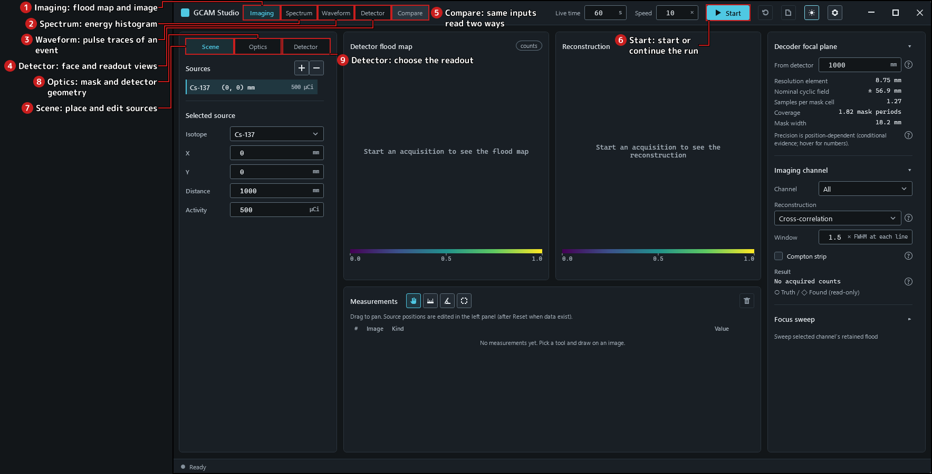
Figure 1.2-1. The window after start, Imaging workspace.
Step 2. Select the Optics tab: the engineering geometry replaces the source list in the left panel.
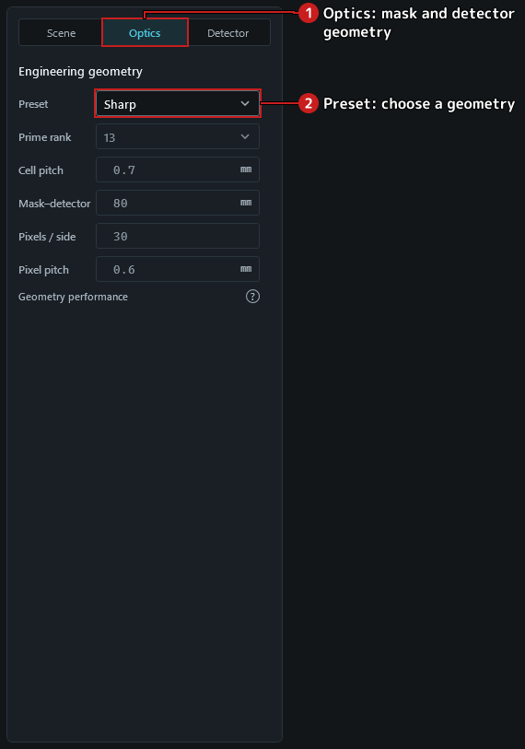
Figure 1.2-2. The Optics tab.
Step 3. Choose Spectrum in the workspace switch: the centre shows the spectrum instead of the images.
Step 4. Choose Waveform, then its view tab Four outputs (A–D). With the default direct crystal assignment there are no four outputs: the view reads Available with the experimental physical readout and offers Choose readout….
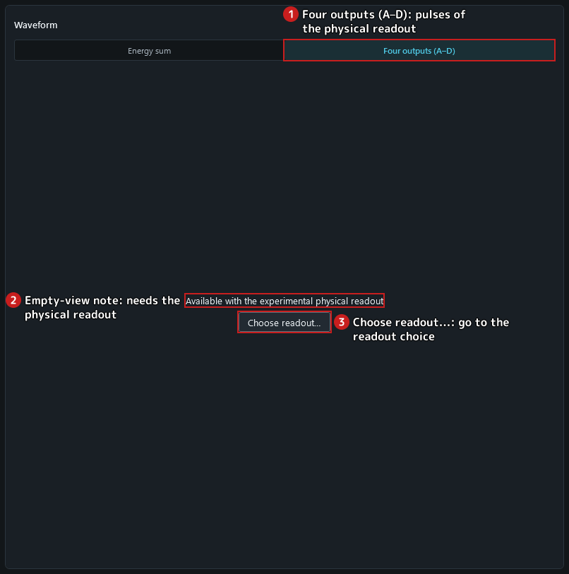
Figure 1.2-3. Four outputs under the direct crystal assignment.
Step 5. Choose Detector, then its view tab SiPM: the physical readout views are empty in the same way.
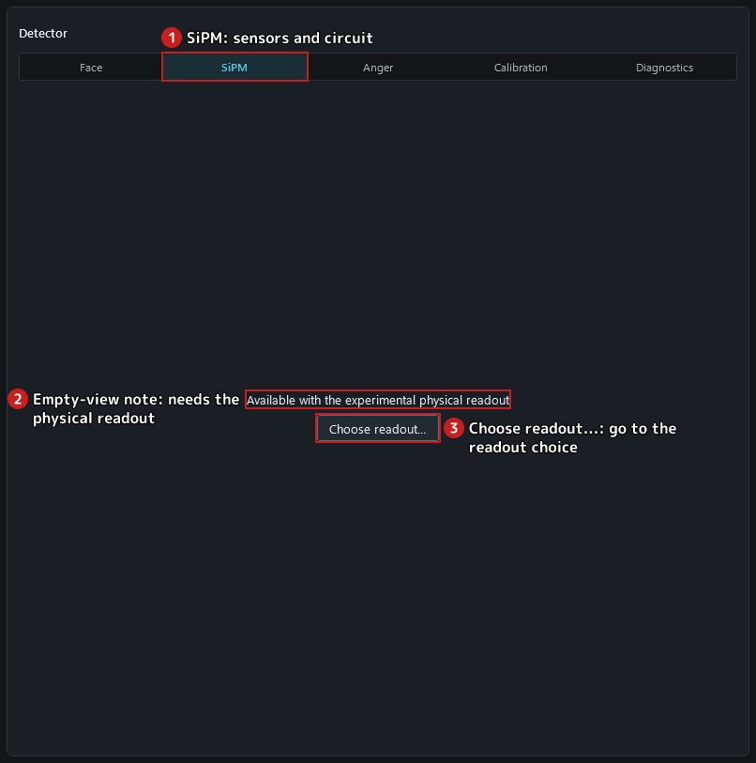
Figure 1.2-4. A Detector readout view under the direct crystal assignment.
Caution. The four-output physical readout is an experimental simulation. Its calibration lines are offered or refused from a pinned record; a module that matches no preset is calibrated locally and is unvalidated; positioning deposits at other energies with a source-line calibration is a declared approximation whose accuracy is unvalidated.
Step 6. Click Choose readout…: the left panel switches to its Detector tab with the keyboard focus on the readout choice.
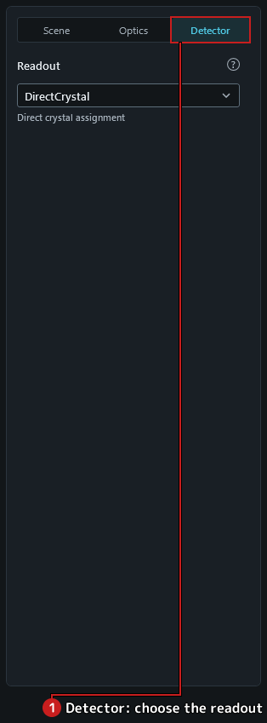
Figure 1.2-5. The readout choice in the left Detector tab.
Step 7. Choose Imaging to return to the images.
Step 8. Press Ctrl+1 through Ctrl+5 to select Imaging, Spectrum, Waveform, Detector and Compare respectively.
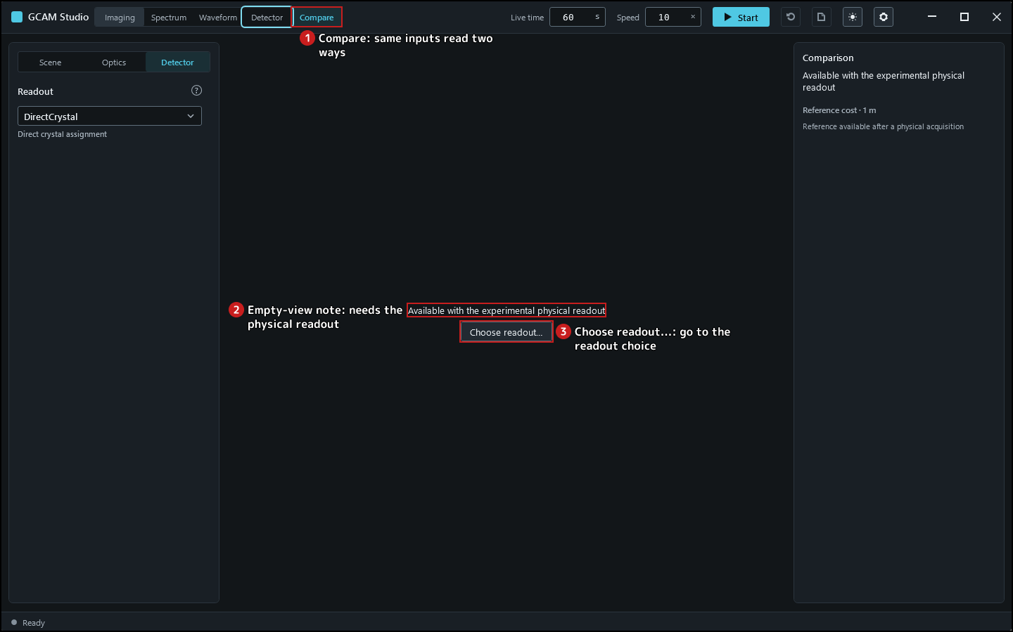
Figure 1.2-6. Compare under direct crystal assignment.

2 Configure and acquire

2.1 Place and edit sources
Step 1. Select the Scene tab. The source list holds one source; the selected source is described by Isotope, X, Y, Distance and Activity.
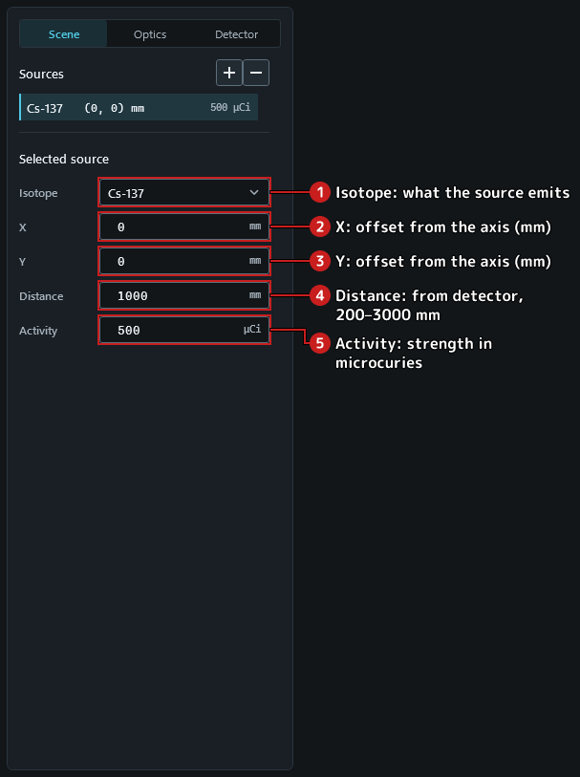
Figure 2.1-1. The Scene tab with the default source.
Step 2. Type -20 in X and leave the field (Tab or a click elsewhere): the value is taken when the field loses focus.
Step 3. Click the icon button whose tooltip reads Add source: a second source is added to the list and selected.
Step 4. For the new source choose Co-60 in Isotope, type 20 in X and 400 in Activity.
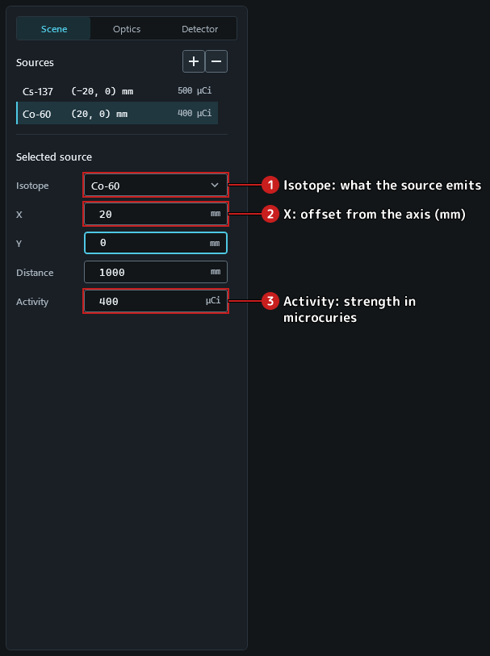
Figure 2.1-2. Two sources; the selected one is edited below the list.
Step 5. Click the icon button whose tooltip reads Remove selected source: the selected source is removed.
Step 6. Click Continue and wait until the acquisition completes. While acquired data exist the source fields and the add and remove buttons are locked, so the images always belong to the scene shown.
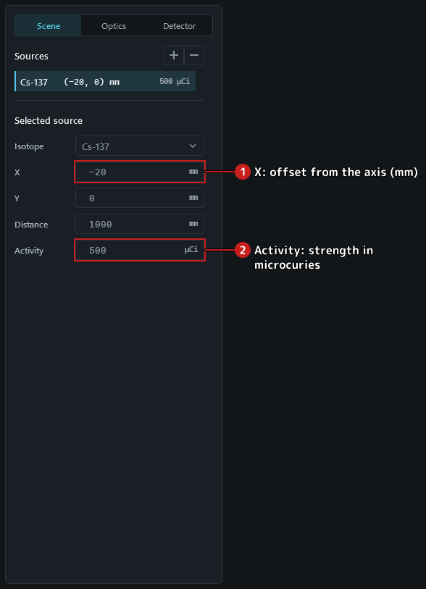
Figure 2.1-3. Source fields locked while data exist.
Step 7. Click the icon button whose tooltip reads Reset acquisition: a confirmation asks before the data are discarded.
Step 8. Confirm with Discard: the acquisition is discarded and the source fields unlock for the next acquisition.

2.2 Choose optics and detector settings
Step 1. Select the Optics tab. Preset shows Sharp, the default engineering geometry. A preset writes its five values — Prime rank, Cell pitch, Mask–detector, Pixels / side and Pixel pitch — into the fields and keeps them read-only.
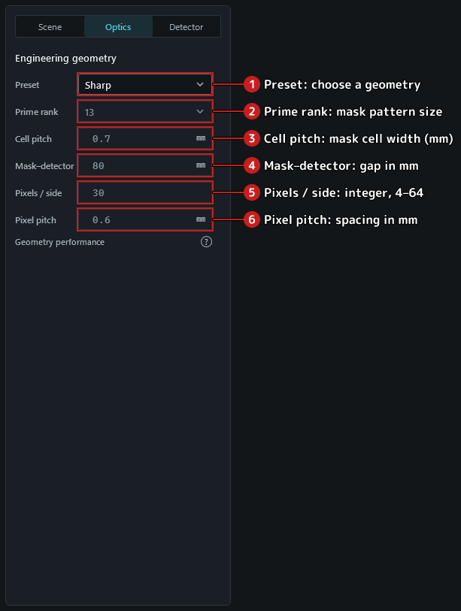
Figure 2.2-1. The Optics tab with the default preset.
Step 2. Choose Baseline in Preset: the fields now hold the 12 × 12 pixel, rank-7 reference geometry, still read-only.
Step 3. Choose Detector: its Face view draws the detector face for these settings, captioned Settings for the next acquisition.
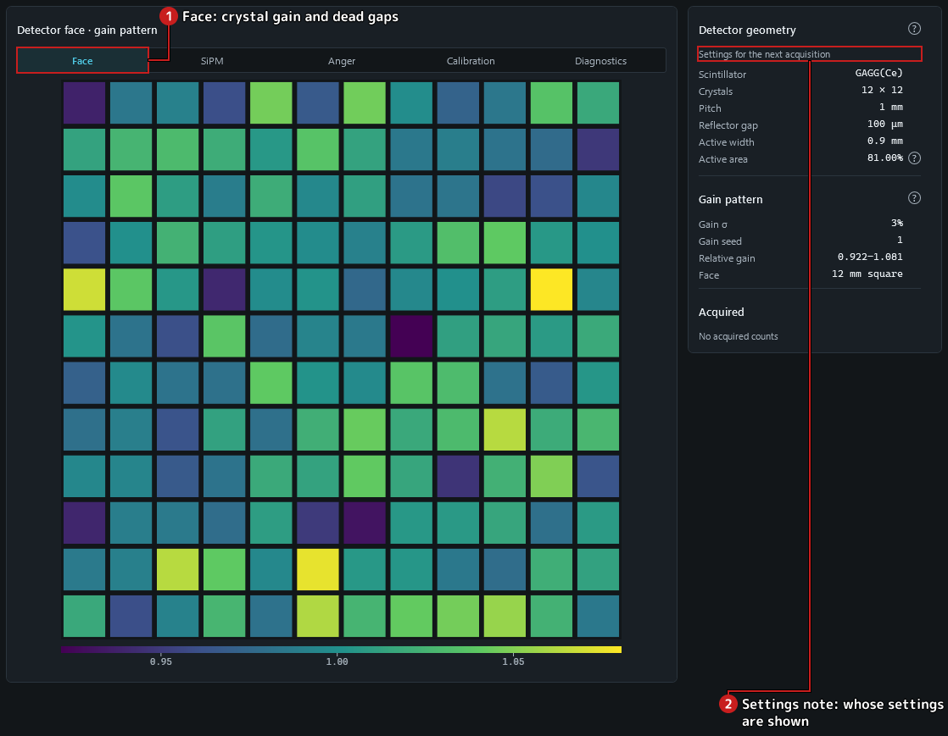
Figure 2.2-2. The detector face of the Baseline geometry before an acquisition.
Step 4. Back on the Optics tab, choose Custom in Preset: the fields keep the Baseline values and become editable.
Step 5. Type 3 in Pixels / side. The geometry is refused — the tab reads Detector pixels must be an integer from 4 to 64. — and Start does not start: the status bar gives the reason.
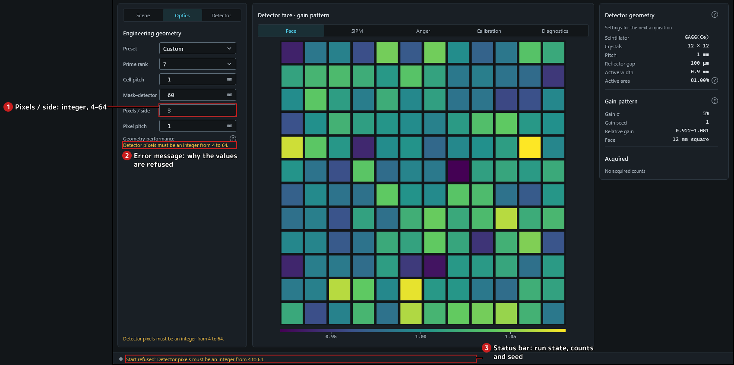
Figure 2.2-3. A refused geometry: the message under the fields and the refusal in the status bar.
Step 6. Type 12 in Pixels / side again: the message clears.

2.4 Start, Stop, Continue and Reset
Step 1. Set Live time to 600 (seconds) and Speed to 1 (live seconds per wall second) in the top bar.
Step 2. Open the Options dialog with the cog button (accessible name Options); on its Acquisition tab type 12345 in the seed field and apply with OK. A fixed seed makes the acquisition reproducible; the status bar lists it.
Caution. GCAM Studio is the engineering viewer of a Monte Carlo simulator. Every count, image, spectrum and waveform it shows is simulated; it is not a measuring instrument, and nothing it shows is a measurement of a real source.
Step 3. Click Start. The acquisition runs: counts grow in the status bar, the scene and the live time are locked, and the button becomes Stop.
Figure 2.4-1. Acquiring.
Note. Live time advances at the chosen speed (live seconds per wall second) and Stop acts when it is clicked, so the counts kept at a Stop differ from run to run even with a fixed seed. A fixed seed reproduces the acquisition itself.
Step 4. Click Stop: the acquisition stops and keeps its data; the counts no longer change, the inputs stay locked and the button reads Continue.
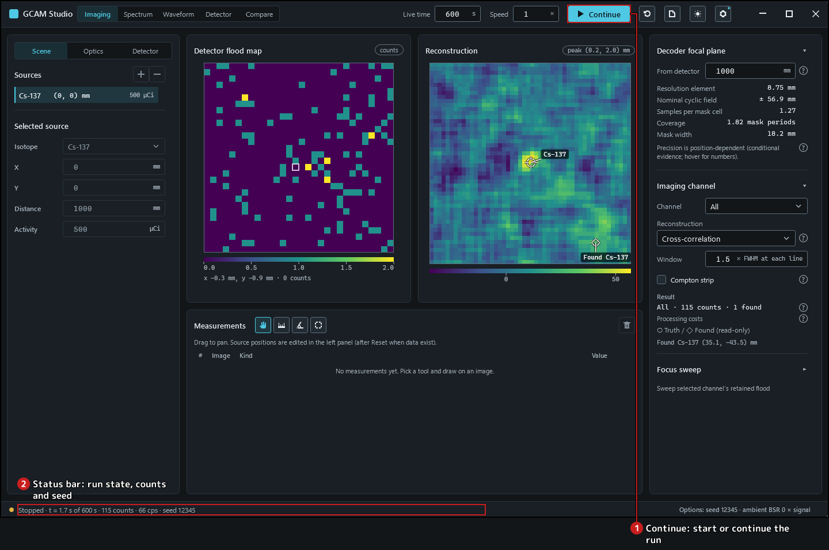
Figure 2.4-2. Stopped: the data are kept and Continue is offered.
Step 5. Click Continue again: the same acquisition continues and its counts keep growing; stop it again with Stop.
Step 6. Click the icon button whose tooltip reads Reset acquisition. A confirmation names the acquired live time and counts; Cancel keeps the acquisition.
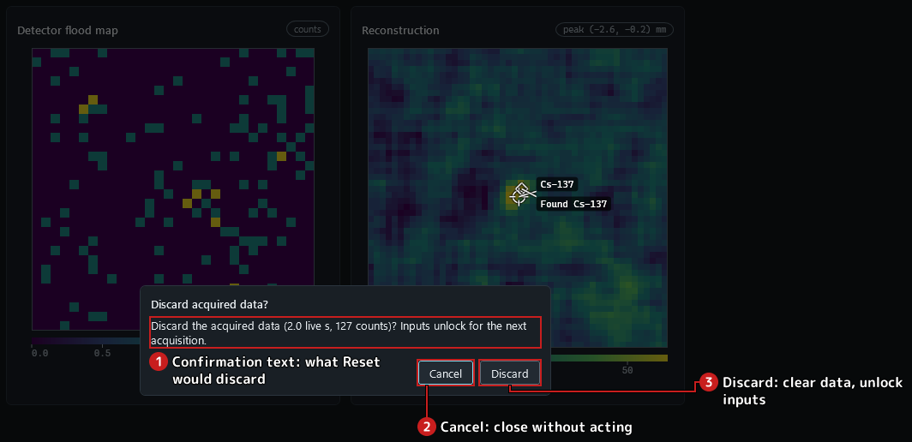
Figure 2.4-3. The reset confirmation.
Step 7. Click Reset acquisition again and confirm with Discard: the data are discarded, the status reads Ready and the inputs unlock; the button reads Start again.
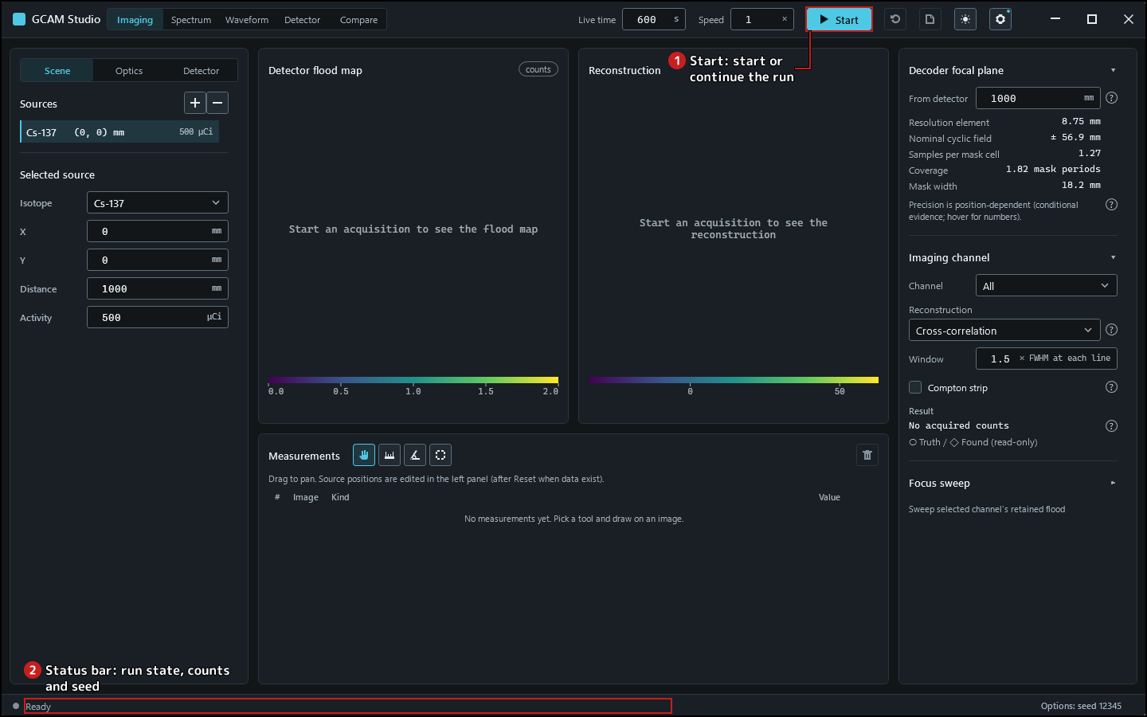
Figure 2.4-4. Ready for the next acquisition.

3 Inspect retained data

3.1 Imaging measurements
Caution. GCAM Studio is the engineering viewer of a Monte Carlo simulator. Every count, image, spectrum and waveform it shows is simulated; it is not a measuring instrument, and nothing it shows is a measurement of a real source.
Step 1. Click Continue and wait until the acquisition completes: the flood map and the reconstruction fill in.
Step 2. Hold the pointer over a cell of the flood map: the line under the image reads x 6.3 mm, y -4.5 mm · 12 counts — the cell's centre in millimetres (x to the right, y up, 0 on the axis) and its counts.
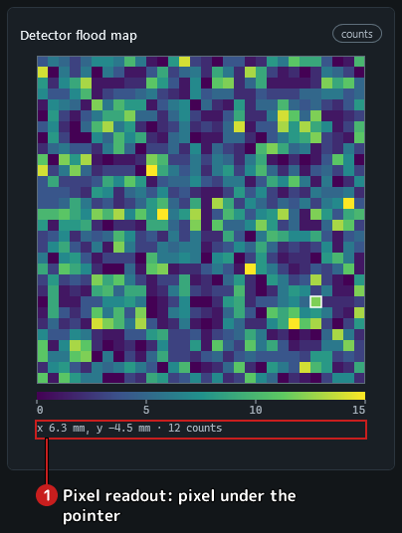
Figure 3.1-1. The readout under the flood map.
Step 3. Choose the distance tool (accessible name Distance tool) above the measurement table and drag across the flood map: the table gains a row with the length in millimetres.
Step 4. Choose the angle tool (Angle tool) and click three points on the reconstruction — the end of the first arm, the vertex, the end of the second arm: the table gains the angle in degrees.
Step 5. Choose the ROI tool (ROI tool (region of interest)) and drag a rectangle on the flood map: the table gains the sum over the whole pixels whose centres lie inside, and the line under the table gives its size and pixel count.
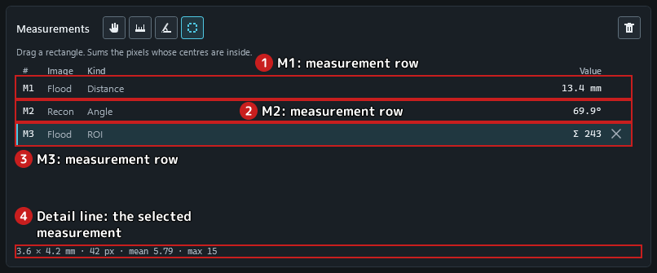
Figure 3.1-2. Three measurements in the table; the selected one is described under it.
Step 6. Press Delete with the flood map focused: the selected measurement (the ROI) is removed.
Step 7. Click the icon button whose tooltip reads Clear all measurements: the table is emptied.

3.4 Spectrum
Caution. GCAM Studio is the engineering viewer of a Monte Carlo simulator. Every count, image, spectrum and waveform it shows is simulated; it is not a measuring instrument, and nothing it shows is a measurement of a real source.
Step 1. Click Continue and wait until the acquisition completes.
Step 2. Choose Spectrum: the histogram of measured energies with a band at each emission line, and the line table with the counts inside each band.
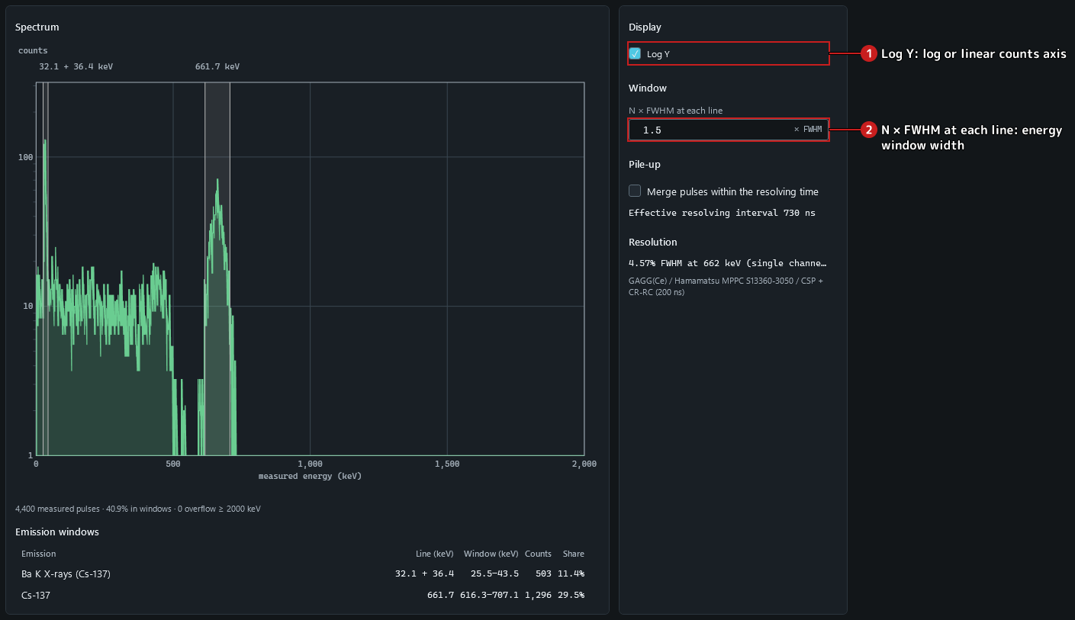
Figure 3.4-1. The spectrum after an acquisition of the default Cs-137 source.
Step 3. Type 2 in N × FWHM at each line and leave the field: each band widens to twice the FWHM at its line and the table recounts; the histogram itself does not change.
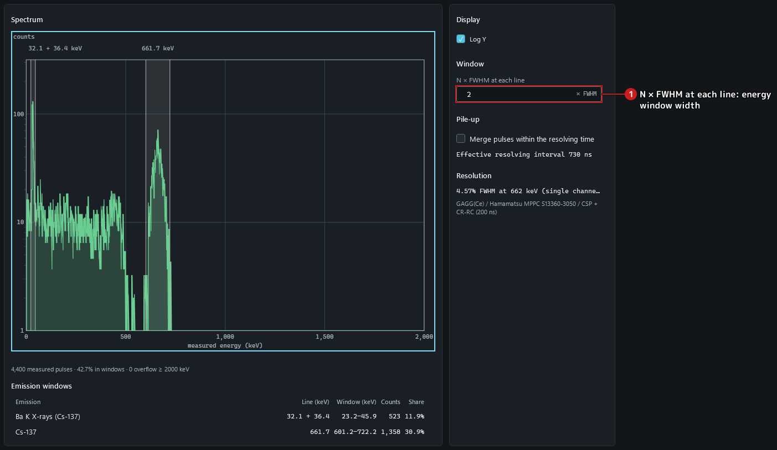
Figure 3.4-2. The wider window at 2 × FWHM.
Step 4. Log Y is checked initially. Untick it to show a linear counts axis; the histogram data are unchanged.
Step 5. Tick Log Y again: the counts axis becomes logarithmic, so small and large bins can be read together; the data are unchanged.
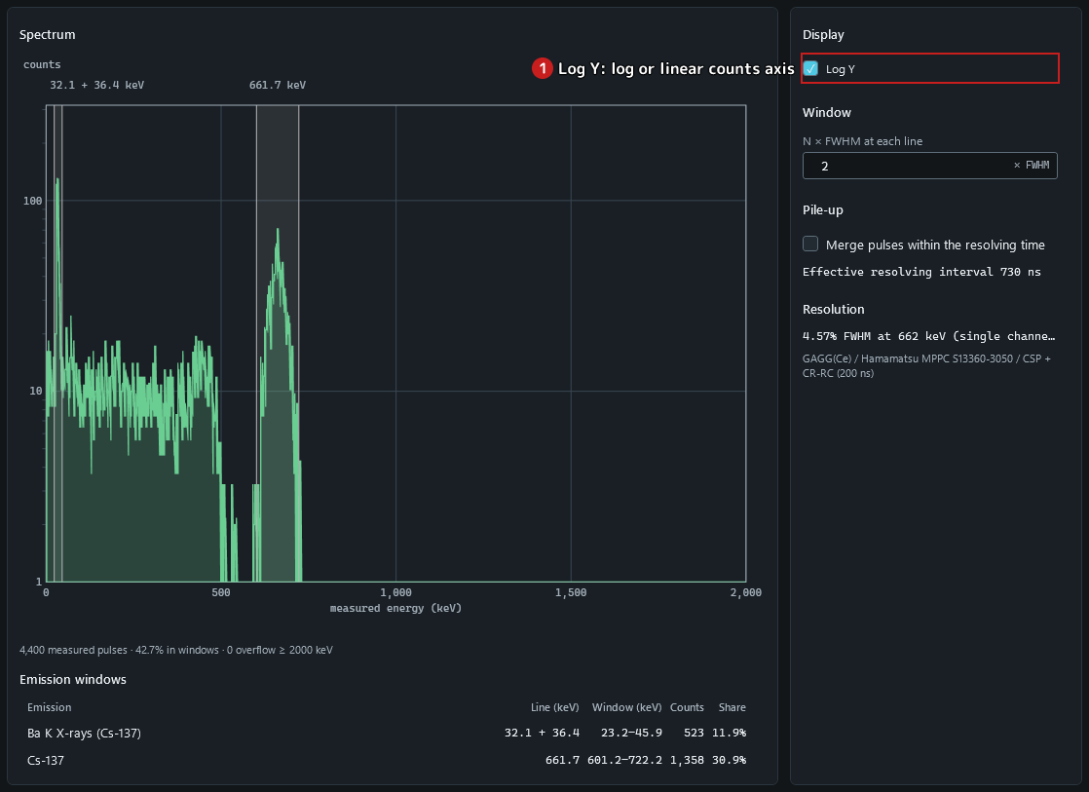
Figure 3.4-3. The spectrum with a logarithmic counts axis.

3.7 Export reports and event data
Caution. GCAM Studio is the engineering viewer of a Monte Carlo simulator. Every count, image, spectrum and waveform it shows is simulated; it is not a measuring instrument, and nothing it shows is a measurement of a real source.
Note. Studio keeps no settings. Scene, results and measurements live in memory and are lost when the window closes. To keep an export, choose a format and confirm a destination in the save dialog. Studio then writes the selected file and a same-name .scene.json sidecar; Event data (CSV) also writes a .meta.json sidecar. Studio remembers no folder; the Windows save dialog keeps its own list of recent files and folders.
Step 1. Set a short live time and click Start; wait until the acquisition completes.
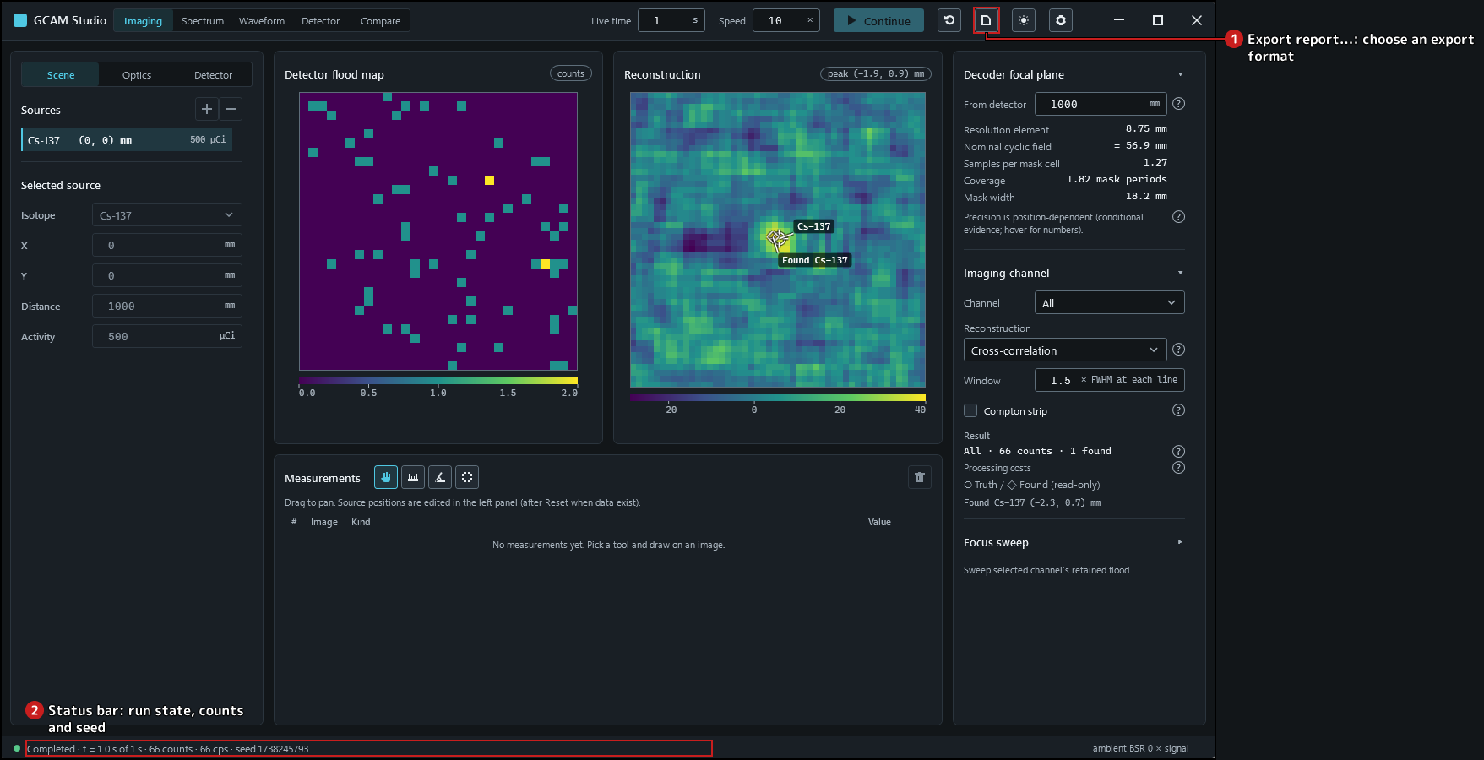
Figure 3.7-1. An acquired snapshot can be exported.
Note. An export records the snapshot captured when Export report is opened. The scene sidecar records acquisition inputs; it does not promise to reproduce the run. A physical readout's calibration bank and the Compare workspace are not included. HTML, PDF and Word contain the report; CSV contains retained event data with its metadata.
Step 2. Open Export report…. Choose HTML, PDF, Word or Event data. Cancel closes the format popup without writing.
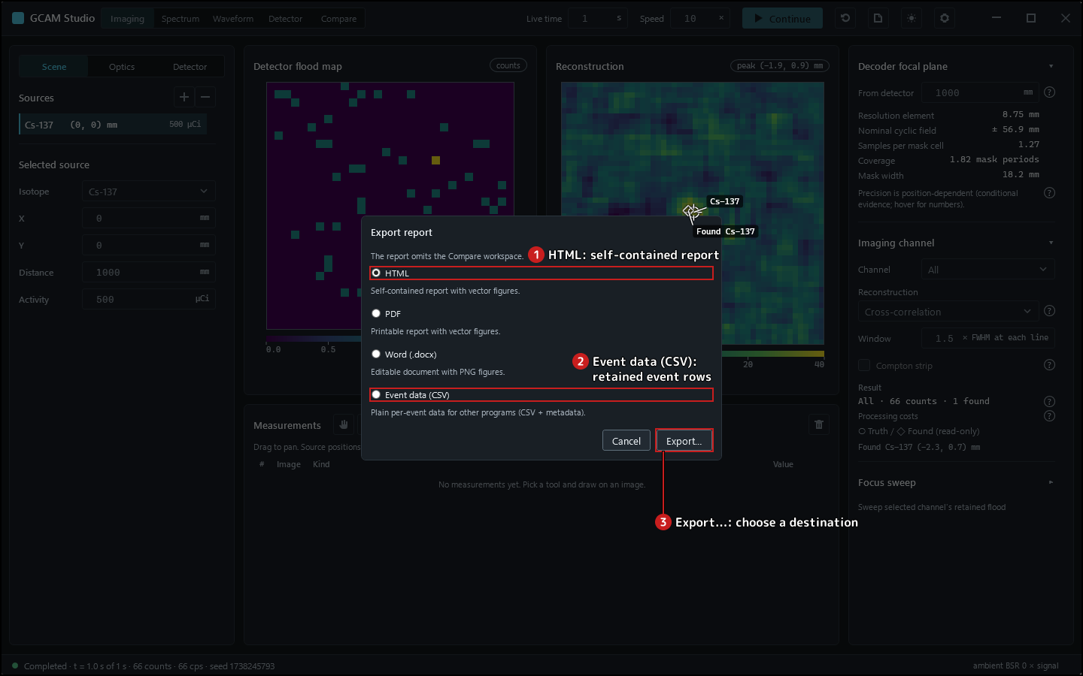
Figure 3.7-2. Report and event-data formats.
Step 3. Open Export report…, choose Html and click Export…. In the save dialog enter a destination, check the filename and Save. Keep the same-name scene sidecar.
Step 4. Open Export report…, choose Pdf and click Export…. In the save dialog enter a destination, check the filename and Save. Keep the same-name scene sidecar.
Step 5. Open Export report…, choose Word and click Export…. In the save dialog enter a destination, check the filename and Save. Keep the same-name scene sidecar.
Step 6. Open Export report…, choose Csv and click Export…. In the save dialog enter a destination, check the filename and Save. Keep the same-name scene sidecar and metadata sidecar.
Figure 3.7-3. Studio after the exports; the acquisition is retained.

4 Experimental readout

4.4 Compare direct crystal and physical readout
Caution. GCAM Studio is the engineering viewer of a Monte Carlo simulator. Every count, image, spectrum and waveform it shows is simulated; it is not a measuring instrument, and nothing it shows is a measurement of a real source.
Caution. The four-output physical readout is an experimental simulation. Its calibration lines are offered or refused from a pinned record; a module that matches no preset is calibrated locally and is unvalidated; positioning deposits at other energies with a source-line calibration is a declared approximation whose accuracy is unvalidated.
Step 1. Choose Compare. With direct crystal assignment the physical comparison is unavailable; follow Choose readout….
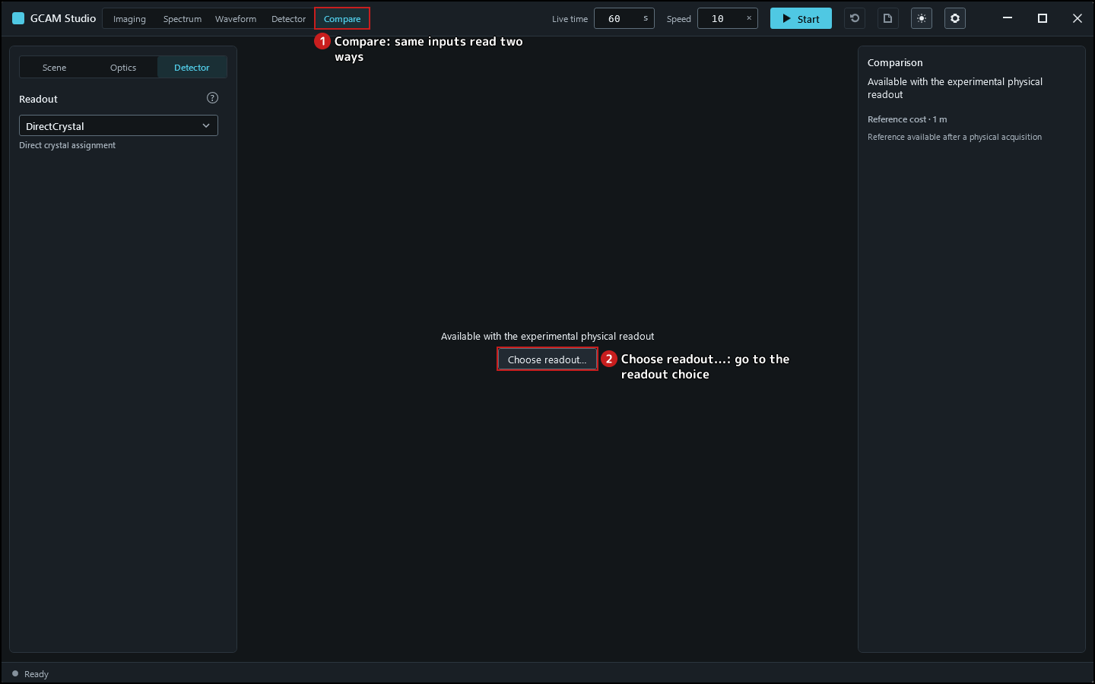
Figure 4.4-1. Compare requires the experimental physical readout.
Step 2. Choose Baseline in Preset, then FourOutputAnger in Readout model assumptions. Set seed 47001, ambient dose 0 and live time 10 s. Click Prepare and wait for Ready.
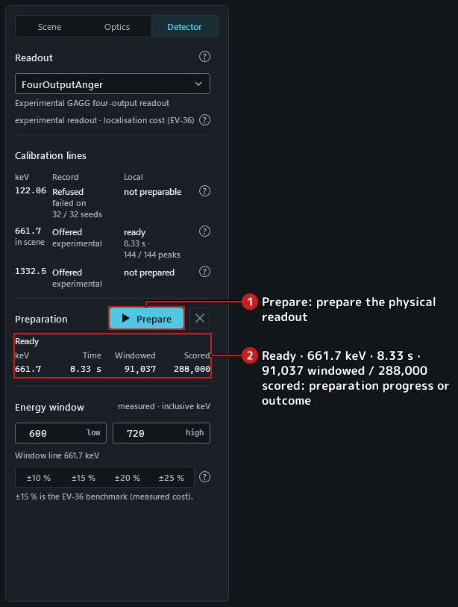
Figure 4.4-2. Baseline physical readout prepared.
Step 3. Click Continue; after completion choose Compare. Both paths show the same retained prefix, with direct ideal deposit energy beside the acquired Anger path.
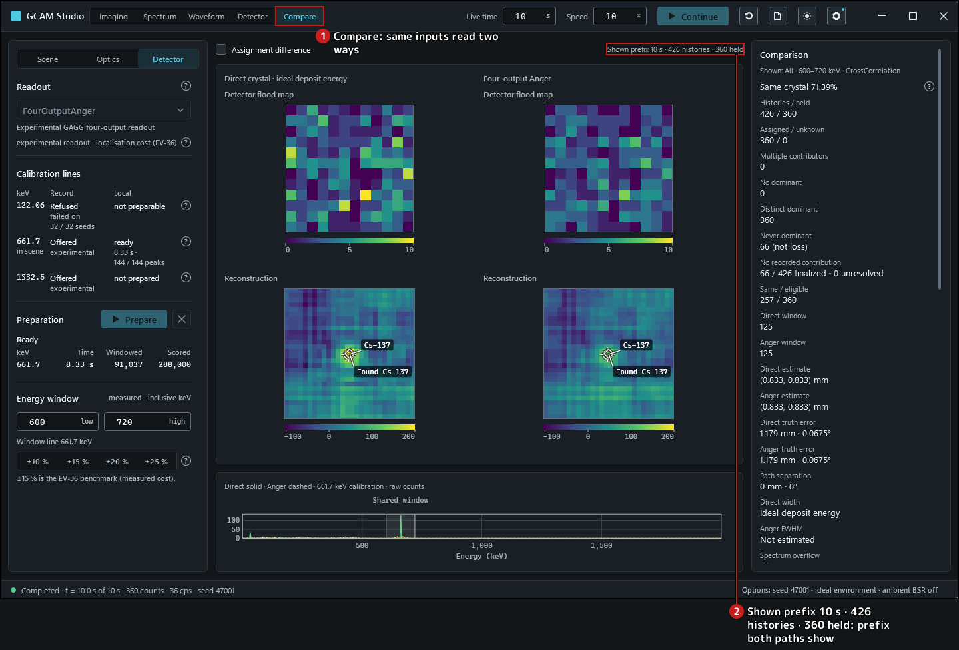
Figure 4.4-3. Direct crystal and physical readout, same acquired prefix.
Step 4. Read the population rows and the same-crystal share beneath them. Histories and held conversions are different populations. Further down the panel (scroll), Reference cost · 1 m is a benchmark, not a prediction for this scene.
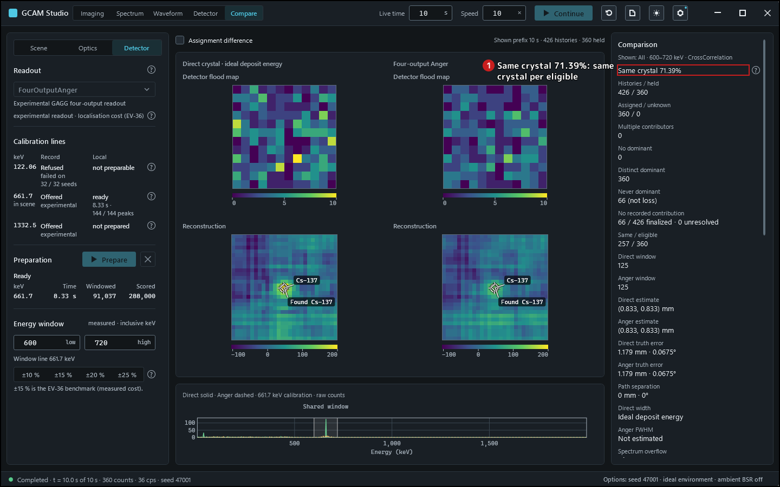
Figure 4.4-4. Population share and the rows beneath it.
Step 5. Turn on Assignment difference: the flood row becomes different / eligible per direct crystal. Reconstructions remain below it.
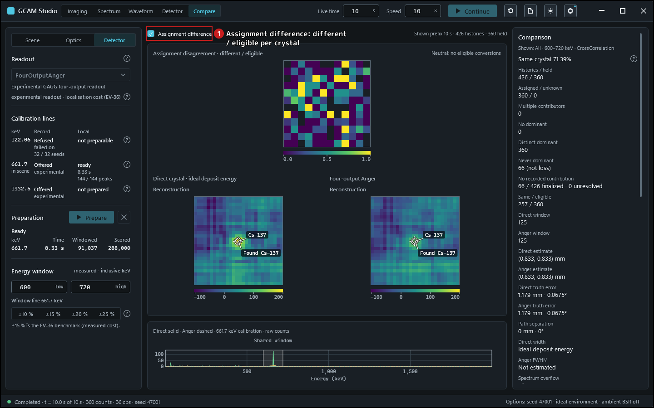
Figure 4.4-5. Assignment disagreement with the reconstructions retained.
Step 6. Click Reset acquisition and confirm with Discard. Compare returns to its start state.

5 Interpretation and help

5.2 Interpretation and limitations
Caution. GCAM Studio is the engineering viewer of a Monte Carlo simulator. Every count, image, spectrum and waveform it shows is simulated; it is not a measuring instrument, and nothing it shows is a measurement of a real source.

Images at the default optics
With the default optics and the 1 m focal plane the detector samples the mask-cell shadow at 1.27 pixels per cell (0.761 mm shadow on 0.6 mm pixels), below two samples per cell. The decoded peak then shifts with the source position: over y = −10 … 10 mm the error is 0.95 mm RMS and 1.91 mm at most. Finer pixels reduce it (0.24 mm RMS at 3.8 samples per cell); the default optics reach two samples per cell only near a 160 mm focal plane. Read a peak position at the default optics with that spread in mind. Sources: docs/VV.Studio.Imaging.md (Localisation bias); docs/VV.Studio.md AN-11.

What the locks and measurements guarantee
- The images always belong to the inputs shown: physical inputs are locked while data exist, and Reset discards the data before an edit. Source: docs/VV.Studio.md §6 (risk table; AN-06).
- Positions read off an image use one screen-to-millimetre mapping with the decoder's pixel-centre convention. An ROI counts whole pixels by their centres; values are shown at 0.1 resolution, not to a sub-pixel precision. Source: docs/VV.Studio.md §6 (risk table).

Isotope stripping
With the Compton strip view the displayed flood is clamped at zero, while cross-correlation decodes the signed difference; both reconstruction methods report the signed net count as N ± σ (one standard deviation, counting and calibration). A negative net is shown as it is and implies no detection verdict, and the scalar model removes no ambient background. Stripping removes the higher isotope's downscatter in the mean, not its noise: the smallest detectable Cs-137 source under 10 µSv/h of Co-60 at 1 m is 1.6 MBq in 60 s. Sources: docs/VV.Studio.SRS.md SR-IMG-05; docs/VV.Studio.Imaging.md (Strip count and signed decoding); README.md (headline results).

Experimental physical readout
Caution. The four-output physical readout is an experimental simulation. Its calibration lines are offered or refused from a pinned record; a module that matches no preset is calibrated locally and is unvalidated; positioning deposits at other energies with a source-line calibration is a declared approximation whose accuracy is unvalidated.

Known gaps of the viewer
- Measurements can only be created with the pointer; keyboard users can review, select and delete them. Source: docs/VV.Studio.md AN-01.
- Windows high-contrast themes are not honoured. Source: docs/VV.Studio.md AN-03.
- No screen-reader session has been run, and keyboard-only flows and other display scaling remain unverified. Source: docs/VV.Studio.md §6 and AN-02.
- End-to-end responsiveness during a window resize is not established. Source: docs/VV.Studio.md AN-13.
- On one machine a render test found a truncated table value in the Spectrum line table; the cause is not established. Source: docs/VV.Studio.md AN-15.

Comparing and exporting retained data
Compare reads the same retained physical acquisition two ways: direct crystal assignment with ideal deposit energy, and the acquired four-output Anger path. Its populations distinguish histories from held conversions; the same-crystal share uses eligible single-contributor conversions. The disagreement map divides different by eligible per direct crystal; an empty denominator is unavailable. The cost table is a benchmark reference, not a time prediction for this scene. Source: docs/VV.Studio.SRS.md SR-CMP-01 through SR-CMP-05.
Note. An export records the snapshot captured when Export report is opened. The scene sidecar records acquisition inputs; it does not promise to reproduce the run. A physical readout's calibration bank and the Compare workspace are not included. HTML, PDF and Word contain the report; CSV contains retained event data with its metadata.

