**Screenshot of the function of application are shown below:**

1. Give the input text and shift value (only for Caesar Cipher).And then select which algorithm to use from the option of Caesar Cipher, Playfair Cipher and DES algorithm.

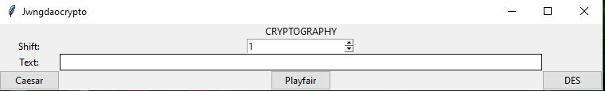

2.Caesar Cipher: Select one from the option ‘Encrypt’ and ‘Decrypt’.

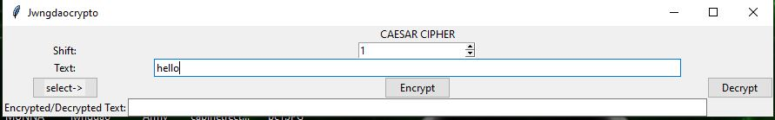

2.1: Encryption Result.

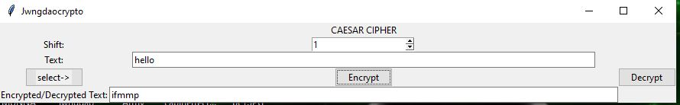

2.2: Decryption Result.

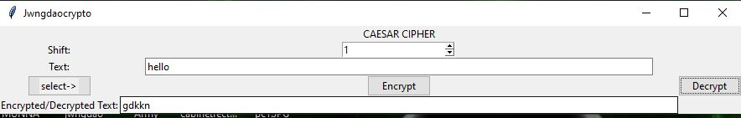

3.Playfair Cipher: Select one from the option ‘Encrypt’ and ‘Decrypt’.

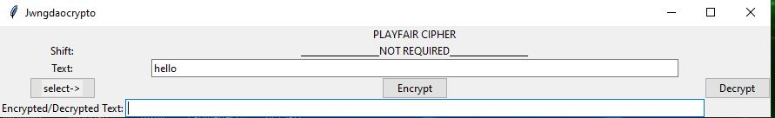

3.1: Encryption Result.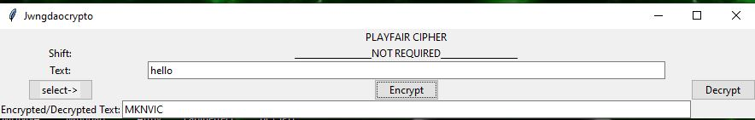

3.2: Decryption Result.

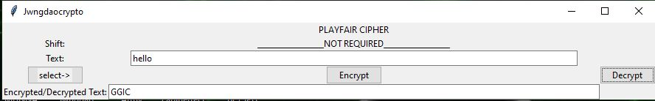

4.DES (Data Encryption Standard): Select one from the option ‘Encrypt’ and ‘Decrypt’.

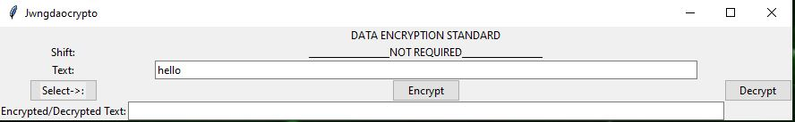

4.1: Encryption Result.

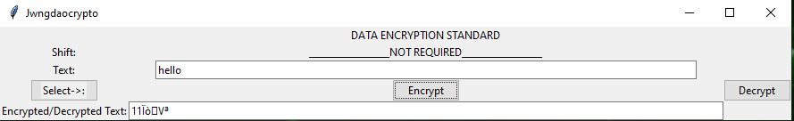

4.2: Decryption Result.

