Immediately you are given three files. Two are .exe and one is a .txt. The txt contains only the letter X. Upon running RunGame.exe windows defender is immediately triggered and detects malware within HighScore.txt
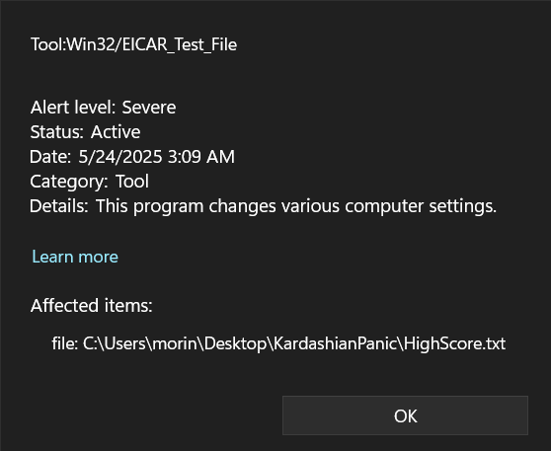
The EICAR Test File is a harmless string that is used to test malware, so we know this can’t really harm our computer. It is odd that it didn’t immediately catch this or notice that it was part of the .exe. Upon decompiling we see that the string is base64 encoded then dropped into the txt file after decoding.
We also see that the decoded version is missing the first character, that explains the X in the file earlier.
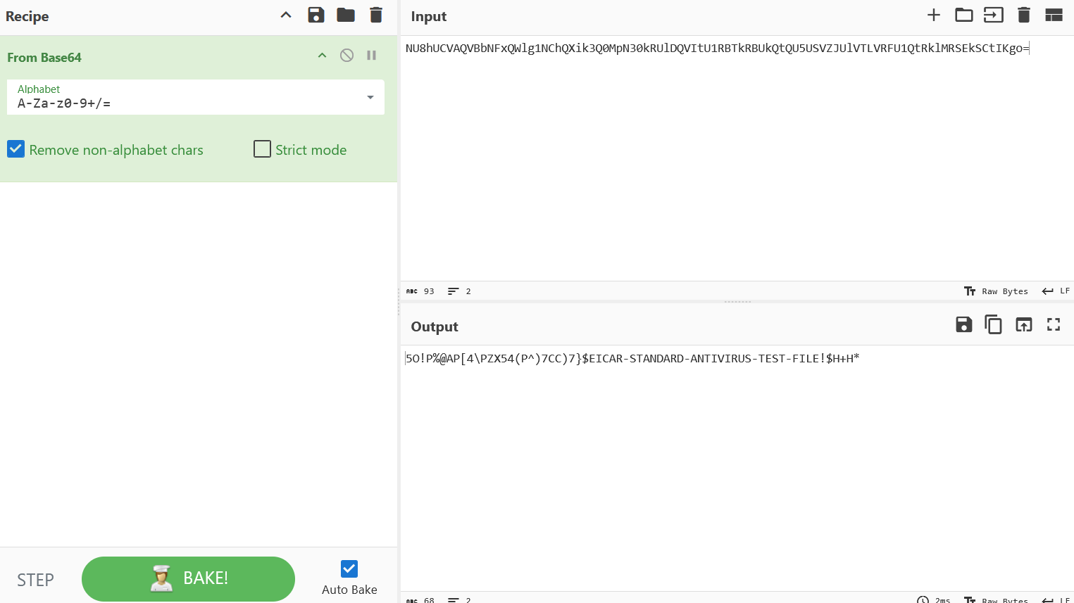
We also see that all RunGame.exe does is drop the eicar string and open hl2.exe, meaning that must be the real game. Furthermore, playing the game creates a file called HighScores.txt, but still references HighScore.txt in the code.
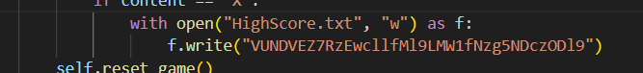
This string appears in HighScore.txt if you aren’t fooled by the RunGame.exe trojan and leave the X in the file.
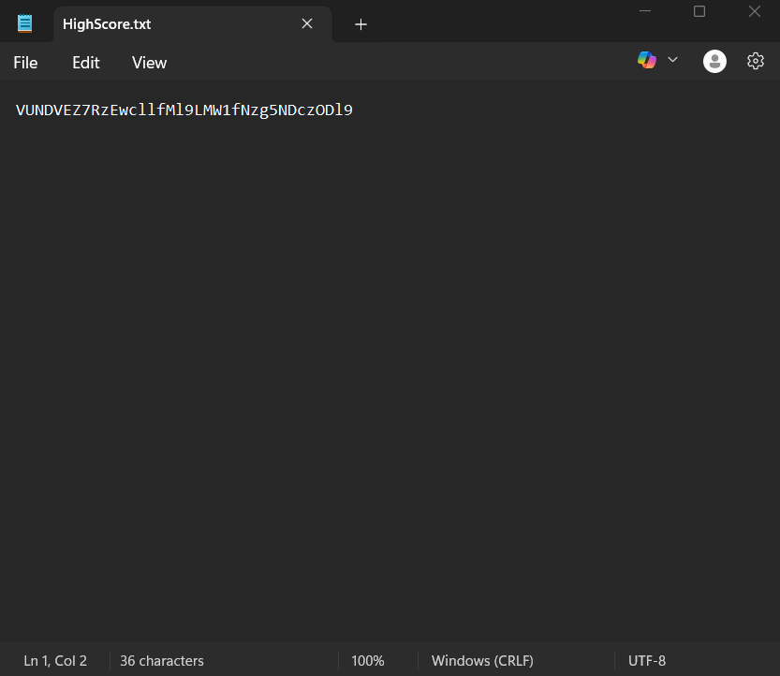
Decode the string from base64 and we have our flag.
