Given the description, this person probably doesn’t understand technology. He says he converted the file, but he probably did it wrong. Step one is learning what file format it started as. Converting to docx didn’t work, so it can’t be word. 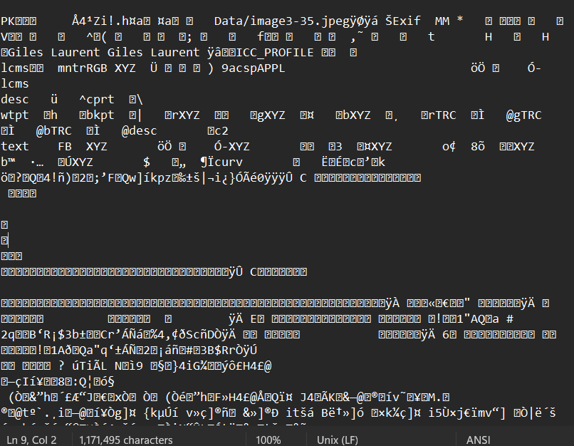
Looking at this code, it looks like word, and the file unzips like a work document, but it isn’t doc or docx.
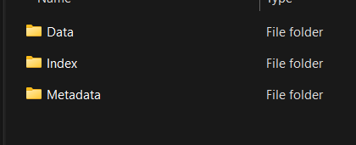
He said he’s a mac user. Macs use PAGES. It is a pages file. Change the file extension to .pages. Convert from PAGES to docx and note the base64 text in the header.
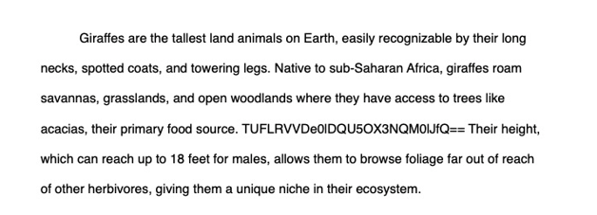
Decode from base64 and you have your flag.
