**Assignment 3**

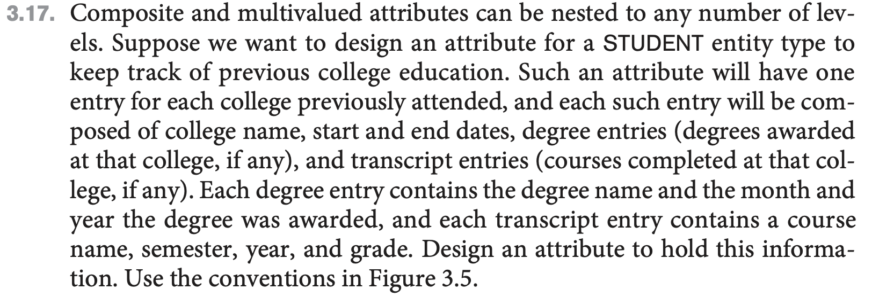

{Colleges_attended(Col_name, Start_date, End_date, {Degree(D_name, D_Month D_Year)}, Comp_course(CcName, CcSemester, CcYear, CcGrade)}}

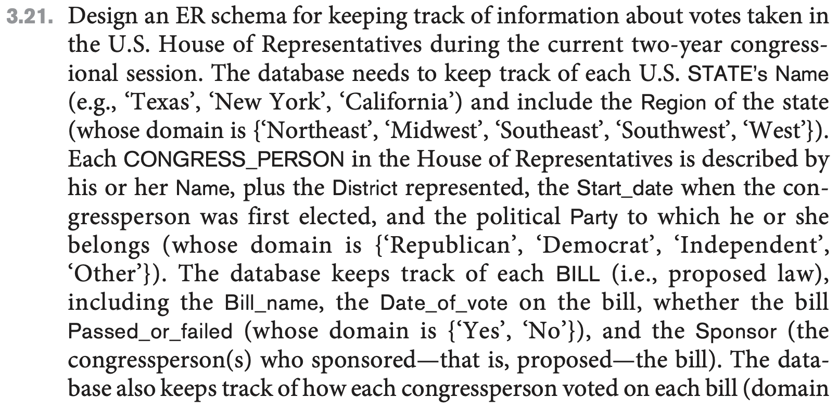

**ENTITY TYPES:**

* **STATE**
  + Represents a unique state in the United States. Its name ***SName*** is the unique attribute since every state’s name is unique. There is one other attribute, ***Region***, which represents one of the five regions in the USA; *“Northeast”, “Midwest”, “Southeast”, “Southwest”, or “West”*. It can have one of these regions as its value.

* **CONGRESS_PERSON**
  + This entity type represents the state representatives in the House of Representatives. The unique attribute if this entity type is ***RName*** which represents the representative’s name. Other attributes of this entity type are ***District***, ***Start_date***, and ***Party***. ***District*** refers to the district which the congress person represents. ***Start_date*** reflects the date when they were elected, and ***Party*** tells us what political party they belong to. The political party options include *Republican, Democrat, Independent or Other*.
* **BILL**
  + This entity type represents a proposed legislation and it has 3 attributes. Its unique attribute is its name, ***Bill_name***. Its other two attributes are ***Date_of_vote*** and ***Pass_or_fail.*** They represent the date that the bill was voted on and whether or not the bill passed, respectively. The attribute ***Pass_or_fail*** is of Boolean type represent as ***“****Yes”* if it passed and *“No”* if it failed.

**RELATIONSHIP TYPES**

* **SPONSORS**
  + Relates the entity types ***CONGRESS_PERSON*** and ***BILL***.
  + Cardinality of this relationship type is as follows:
    - A lone congressman can sponsor many bills and a collection of sponsors can sponsor a single bill
    - Therefore, the cardinality of this relationship type is ***many to many***.
  + Bill’s participation is total in this relationship since is must be sponsored by a state representative.
* **VOTES**
  + Also relates to the entity types ***CONGRESS_PERSON*** and ***BILL***.
  + This relationship stores how the congress representative voted on a particular bill which is stored in its attribute ***Vote*** which has the domain *{‘Yes’, ‘No’, ‘Abstain’, ‘Absent’}*.
  + Since a state representative can vote for many different bills and single bill can get votes from many different congressman, this relationship type’s cardinality is ***many to many***.
  + Every congressman must vote and every bill must be voted on, therefore, both the bill’s and the congressmen’s participation are total.
* **REPRESENTS**
  + This relationship type relates ***CONGRESS_PERSON*** and **STATE** entity types.
  + Since it is possible that each state can be represented by multiple representatives but a representative can only represent one state, the cardinality of this relationship type is ***many to one***.
  + Participation is total for both the congressman and the state since each state must be represented and each congressman must represent a state.