**Author**: Jeremy Vuong

**Course**: CSC 138-03

**Professor**: Jun Dai

**Date**: 03/05/2023

**Wireshark Lab 2-HTTP**

1. My browser is running HTTP version 1.1.

The server is running HTTP version 1.1.

1. My browser indicates that it can accept the language en-US.
2. The IP address of my computer is 10.0.0.96 and the IP address of the gaia.cs.umass.edu server is 128.119.245.12.
3. The status code returned from the server to my browser is Status Code: 200.
4. The HTML file was last modified Sun, 05 Mar 2023 03:59:01 GMT.
5. 128 bytes of content are being returned to my browser.
6. I do not see any headers within the data that are not displayed in the packet-listing window

1. No, I do not see an “IF-MODIFIED-SINCE” line in the HTTP GET.

1. Yes, the server explicitly returned the contents of the file. The section named “Line-based text data” shows exactly what is displayed in my browser when I opened the webpage ([gaia.cs.umass.edu/wireshark-labs/HTTP-wireshark-file2.html](http://gaia.cs.umass.edu/wireshark-labs/HTTP-wireshark-file2.html)) into my browser.

1. Yes, I see an “IF-MODIFIED-SINCE:” line in the HTTP GET. The information that follows the “IF-MODIFIED-SINCE:” header is the date and time that I last accessed the link/webpage.

1. The HTTP status code is 304. No, the server did not explicitly return the contents of the file. Because the file had not been modified since it was last accessed, the browser retrieved the old file from its cached memory.

1. My browser sent 1 HTTP GET requests. The packet that contains the GET message for the Bill of Rights is packet number 951.



1. The packet that contains the status code and phrase associated with the response to the HTTP GET request is packet number 970.

1. The status code is 200 and the phrase is OK in the response.

1. There were 4 data-containing TCP segments needed to carry the single HTTP response and the text of the Bill of Rights.

1. My browser sent 3 HTTP GET request messages.
   * 128.119.245.12 (wireshark-labs/HTTP-wireshark-file4.html)
   * 128.119.245.12 (pearson.png)
   * 178.79.137.164 (/8E_cover_small.jpg)

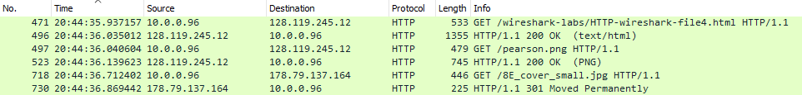

1. Yes, the two images were downloaded serially. The first image’s HTTP GET request was completed before the second image’s HTTP GET request was sent.



1. The server’s response code is 401 Unauthorized.

1. The new field that is included is the authorization field.

