CYBERSECURITY HOME LAB
Attack, Detection and Incident Investigation using DVWA and Wazuh
Final Project Report
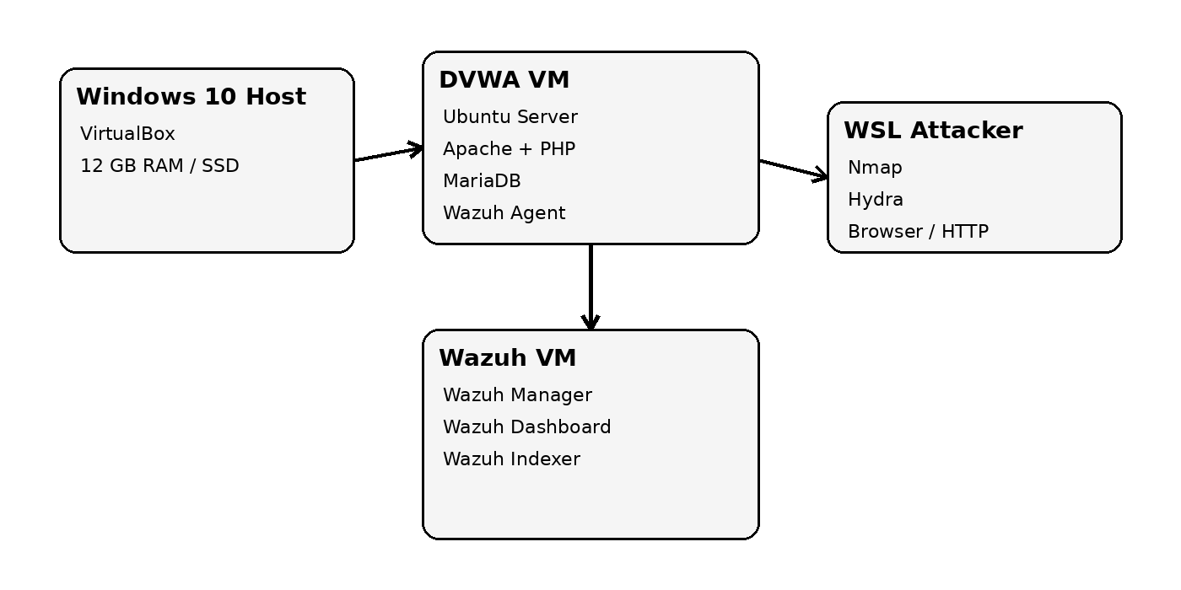
Prepared as an isolated academic home-lab exercise. All attack telemetry, alert records, and dashboard observations in the simulation sections are explicitly marked as simulated and are not claimed to be captured from a live Wazuh deployment.

Table of Contents
- 1. Abstract
- 2. Objectives and Scope
- 3. Lab Architecture
- 4. Technologies and Their Roles
- 5. Implementation Status
- 6. Security Threat Scenarios
- 7. Simulated Attack Results
- 8. Simulated Wazuh Detection and Investigation
- 9. Risk Assessment
- 10. Security Recommendations
- 11. Incident Response Workflow
- 12. Conclusion and Future Scope
- Appendix A. Example Commands
- Appendix B. Evidence and Integrity Note

1. Abstract
This project demonstrates an end-to-end defensive security workflow in a controlled home lab. A deliberately vulnerable Damn Vulnerable Web Application (DVWA) is hosted on an Ubuntu virtual machine, while Wazuh is intended to operate as an external security monitoring platform. An attacker toolkit hosted in Windows Subsystem for Linux (WSL) is used to model reconnaissance and common web-application attacks. The resulting workflow is designed to show how security teams move from asset discovery and risk assessment to attack simulation, log collection, alert investigation, containment recommendations, and executive reporting.
Because the available implementation window was limited, the report separates the real lab setup already completed from simulated evidence used to demonstrate the expected attack and detection workflow. Any simulated evidence is labelled as such so that the document does not misrepresent hypothetical results as genuine Wazuh captures.

2. Objectives and Scope
- Build an isolated two-VM security monitoring environment.
- Deploy DVWA as an intentionally vulnerable web target.
- Use WSL tools such as Nmap and Hydra for controlled attack simulation.
- Use Wazuh as the SIEM/monitoring layer and investigate endpoint telemetry.
- Map attack activity to relevant logs, alerts, severity, and defensive controls.
- Produce an executive-level risk summary and practical remediation plan.
Scope boundary: all testing is intended to occur only against the user-owned lab systems. No external or production system is part of the exercise.

3. Lab Architecture

The preferred architecture keeps the vulnerable application and the monitoring stack on separate virtual machines. The DVWA VM hosts the target application and Wazuh Agent, while the Wazuh VM hosts the Manager, Dashboard, and Indexer. WSL provides the attacker-side command-line toolkit on the Windows host.
Component | Purpose | Planned / Actual
Windows 10 desktop | Physical host for virtualization and WSL | Actual
VirtualBox | Hypervisor for isolated VMs | Actual
DVWA VM | Ubuntu server hosting Apache, PHP, MariaDB, DVWA, Wazuh Agent | Partially implemented
Wazuh VM | Central Manager, Dashboard and Indexer | Planned in this submission
WSL Ubuntu | Attacker tooling: Nmap, Hydra, HTTP testing | Planned / partially prepared

4. Technologies and Their Roles
Technology | Meaning | Role in the project
DVWA | Damn Vulnerable Web Application | Intentionally vulnerable target for safe training
Wazuh | Open-source security monitoring platform | Collects endpoint telemetry, generates alerts and supports investigation
SIEM | Security Information and Event Management | Centralizes and analyzes security events
Wazuh Agent | Endpoint monitoring component | Runs on the DVWA VM and forwards telemetry
Nmap | Network Mapper | Reconnaissance and service discovery
Hydra | Network login brute-force tool | Controlled credential-attack simulation
SQL Injection | Injection of SQL syntax through user input | Tests input validation and database query safety
XSS | Cross-Site Scripting | Tests browser-side script injection defenses
Command Injection | Injection of operating-system commands | Tests unsafe handling of system-level input
PCAP | Packet Capture | Network-level evidence source; optional in this assignment

5. Implementation Status
Task | Status | Evidence / Note
Windows 10 host selected | Complete | Desktop used as primary lab host
VirtualBox installed | Complete | VM creation environment established
Ubuntu DVWA VM created | Complete | 2 GB RAM, 2 CPUs, 25 GB virtual disk
Ubuntu network verified | Complete | Internet/DNS connectivity tested
Apache installed | Complete | Service confirmed active
PHP packages | Complete / verification needed | PHP stack installed; final web rendering verification remained pending
MariaDB installed | Complete / config verified during setup | Database service prepared
DVWA source cloned | Complete | Repository cloned successfully
DVWA database initialization | Pending at snapshot point | Setup page still required final PHP rendering/config check
Wazuh OVA | Pending | Not captured as a completed live deployment in this report
Wazuh Agent registration | Pending | No live agent status claimed
Live attack execution | Pending | Simulated evidence used below
Live Wazuh alert investigation | Pending | Simulated evidence used below

6. Security Threat Scenarios

Brute Force
Repeated authentication attempts target a login endpoint. Primary impact is account compromise risk.

SQL Injection
Malicious input alters backend SQL logic. Potential impact includes unauthorized data access or authentication bypass.

XSS
Script content is injected into a web page and executed in a victim browser context. Impact may include session or UI manipulation.

Command Injection
User-controlled input is passed to an operating-system command. Impact can include arbitrary command execution on the server.

7. Simulated Attack Results
The following section is a controlled academic simulation. Values are representative examples created to demonstrate the expected reporting format; they must not be interpreted as actual Wazuh event IDs, timestamps, IP addresses, or captured alerts.
Scenario | Illustrative action | Expected evidence | Risk
Brute Force | Multiple invalid login attempts against DVWA | Repeated authentication failures from the attacker IP | High
SQL Injection | Malicious input submitted to a vulnerable query parameter | Web access entry containing suspicious SQL metacharacters and abnormal response | High
XSS | Script payload submitted to a vulnerable input field | Web request containing script-like content and corresponding application response | Medium-High
Command Injection | Shell metacharacters appended to a vulnerable parameter | Web request plus server-side command execution evidence | Critical

8. Simulated Wazuh Detection and Investigation
The next tables model what a defender would expect to investigate after the attacks. These are simulated records for report completion, not exported Wazuh alerts.
Attack | Illustrative alert title | Severity | Likely evidence source | Investigation focus
Brute Force | Multiple authentication failures | High | Linux/authentication + Apache access logs | Source IP, username targeted, attempt frequency, lockout status
SQL Injection | Suspicious web request / injection pattern | High | Apache access log + application logs | Parameter value, endpoint, response code, repeated source behavior
XSS | Suspicious script payload in HTTP request | Medium-High | Apache access log + application logs | Payload location, stored/reflected behavior, affected page
Command Injection | Web request followed by shell execution indicators | Critical | Apache/access + system/audit telemetry | Exact command evidence, parent process, user context, persistence risk
BRUTE FORCE
Illustrative alert ID: SIM-001 | Agent: dvwa-server | Source: 10.0.2.20 | Result: authentication failure burst
SQL INJECTION
Illustrative alert ID: SIM-002 | Agent: dvwa-server | Endpoint: /DVWA/vulnerabilities/sqli/ | Pattern: SQL metacharacter sequence
XSS
Illustrative alert ID: SIM-003 | Agent: dvwa-server | Endpoint: /DVWA/vulnerabilities/xss_r/ | Pattern: script payload
COMMAND INJECTION
Illustrative alert ID: SIM-004 | Agent: dvwa-server | Endpoint: /DVWA/vulnerabilities/exec/ | Pattern: shell metacharacters + process activity

8.1 Analyst Investigation Workflow
- Establish the alert timestamp and affected endpoint.
- Identify the originating IP and correlate repeated requests.
- Review the raw Apache/application logs surrounding the event.
- Determine whether the activity caused authentication failure, data access, script execution, or command execution.
- Assess persistence or lateral-movement indicators.
- Assign severity and document containment/remediation actions.

9. Risk Assessment
Finding | Likelihood | Impact | Risk rating | Primary control
Weak authentication / brute force exposure | High | High | High | Strong passwords, MFA, rate limiting, lockout
SQL Injection | High | Critical | Critical | Prepared statements, server-side validation, least-privilege DB account
Reflected/Stored XSS | Medium-High | High | High | Context-aware output encoding, input validation, CSP
Command Injection | Medium | Critical | Critical | Avoid shell calls, strict allowlists, process isolation, least privilege
Insufficient centralized monitoring | Medium | High | High | Wazuh agent, log retention, alerting and analyst runbooks

10. Security Recommendations

Application security
Use prepared statements, strict input validation, output encoding and secure session handling. Do not pass user-controlled data to shell commands.

Identity security
Use strong unique passwords, MFA, login rate limiting, account lockout or adaptive throttling, and alerting for credential abuse.

Least privilege
Run database and web services with the minimum privileges necessary. Keep separate service accounts and restrict filesystem permissions.

Monitoring
Deploy Wazuh Agent on endpoints, forward web/authentication logs, retain sufficient history, and build detection rules around anomalous request patterns.

Network segmentation
Keep the vulnerable lab isolated from personal or production networks. Separate target and SIEM infrastructure.

Patch management
Keep the operating system, Apache, PHP, MariaDB and supporting libraries updated outside intentionally vulnerable training scenarios.

11. Incident Response Workflow
A practical SOC workflow for the simulated events is:
- Preparation: maintain isolated lab assets, logging, account controls and documentation.
- Detection and analysis: review Wazuh alerts and correlate endpoint/web events.
- Containment: block or isolate the source, disable compromised credentials, and restrict the vulnerable endpoint.
- Eradication: remove malicious changes, correct application flaws, rotate secrets and patch systems.
- Recovery: restore service, validate controls, and monitor for recurrence.
- Lessons learned: update detection rules, architecture, training and secure-development practices.

12. Conclusion and Future Scope
The project establishes the design for a compact SOC-style training environment in which a deliberately vulnerable web application is attacked under controlled conditions and monitored by an external SIEM. The implemented portion of the lab demonstrates that the Ubuntu target, virtualization layer, web stack, database stack and DVWA source were successfully prepared. The remaining live Wazuh deployment and attack execution were not completed within the available window, so this report uses clearly labelled simulated evidence to demonstrate the intended defensive workflow.
Future improvements include completing Wazuh Agent registration, building custom detection rules for the four attack classes, capturing real event timelines, adding packet-level PCAP correlation, forwarding richer application logs, and measuring mean time to detect (MTTD) and mean time to respond (MTTR).

Appendix A. Example Commands
sudo apt update
sudo apt upgrade -y
sudo apt install apache2 php php-mysql php-gd php-mbstring php-xml php-curl php-zip unzip git mariadb-server -y
sudo systemctl status apache2
sudo systemctl status mariadb
cd /var/www/html
sudo git clone https://github.com/digininja/DVWA.git
nmap <DVWA-IP>
hydra -h
Note: attack commands should only be executed against the isolated lab target. Do not reuse them against public or third-party systems.

Appendix B. Evidence and Integrity Note
This report deliberately distinguishes three evidence classes: (1) observed lab setup items that were actually completed during the build; (2) pending implementation items; and (3) simulated attack/alert content used to demonstrate the expected final-state report format. The simulated sections use identifiers prefixed with SIM- to prevent confusion with genuine Wazuh alert IDs.
For an academic demonstration, the recommended practice is to disclose the simulation clearly and, where required by an evaluator, replace the simulated tables with genuine screenshots or exported event data after the lab is completed.

