# NIRVANA - 2022

## CERTIFICATE OF ACHIEVEMENT

This Certificate is awarded to Crescendo team from VNRVJIET for participating in Battle of Bands

conducted by Symphony Music Club of MGIT on 1st

July,2022 and won first prize.

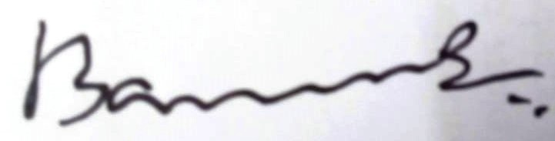

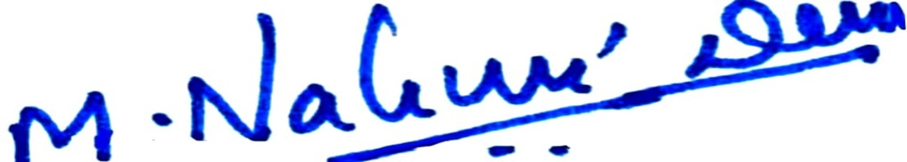

Dr.M Nalini Devi

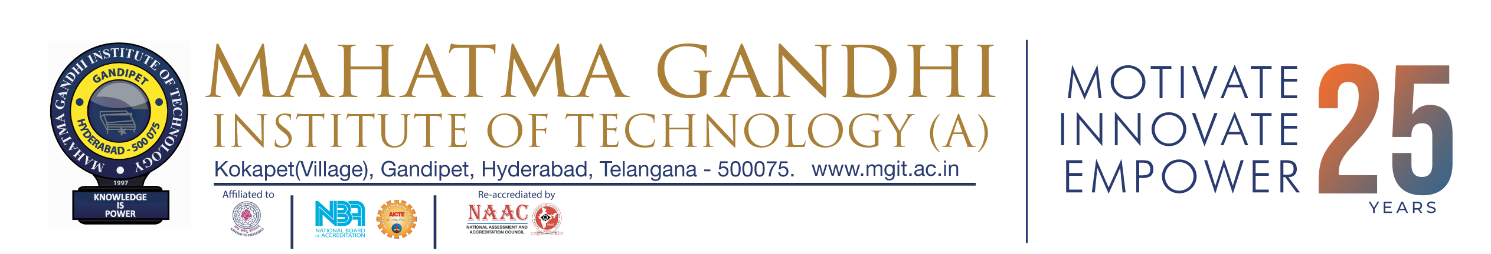

Music Club- Coordinator

Prof K. Jaya Sankar Principal