# PPT

## START

**START**, the world's first Web-based question answering system. <https://groups.csail.mit.edu/infolab/publications.html>

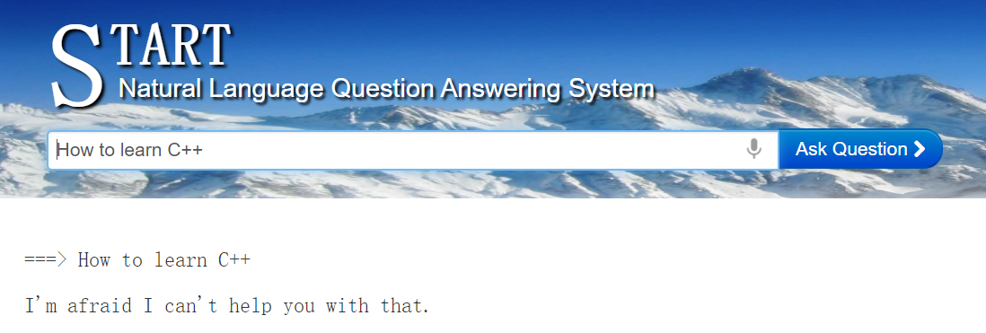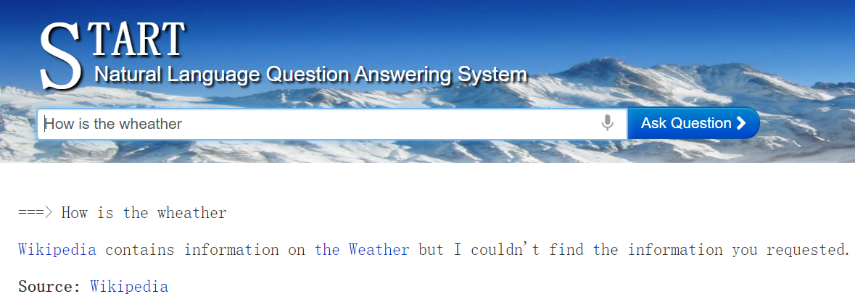

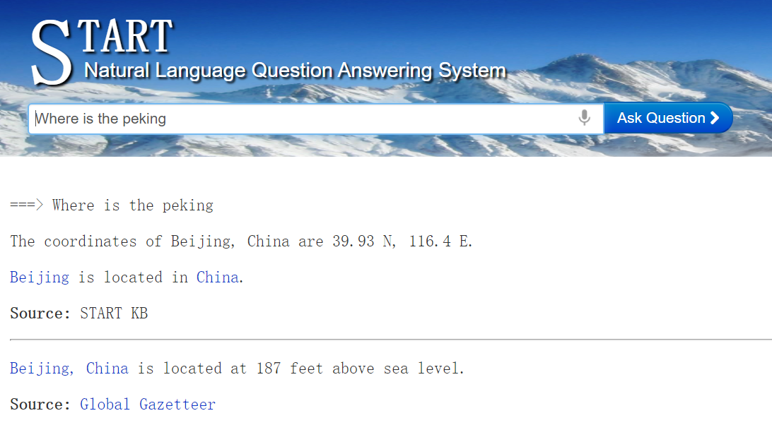

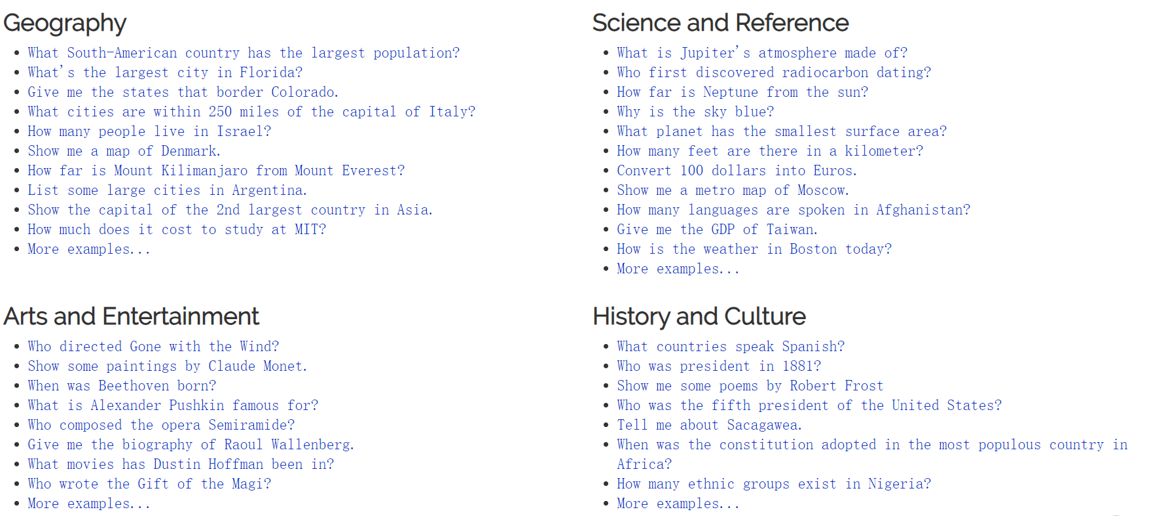

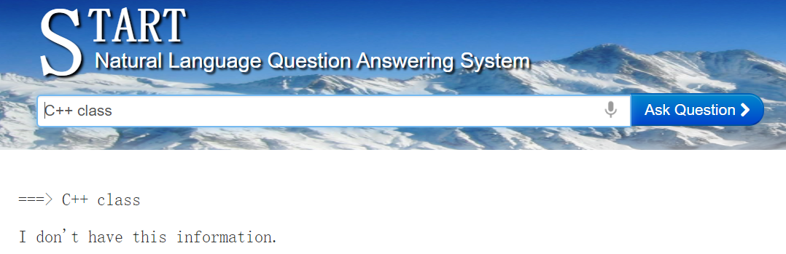

<http://start.csail.mit.edu/index.php>

## DeepQA

<https://researcher.watson.ibm.com/researcher/view_group_pubs.php?grp=2099>