Credit where credits due:
Research references:
Insight Into the x86-64 Bare PC Application Boot/Load/Run Methodology
StackOverflow (Many users helped answer my questions)
Google Fu

SAXTON HALE OS
Property DAAMAAAAAGGEE!!
-Justin Yang

Build Instructions:

- Install NASM
- Run $ make
- Load “Disk.img” onto VirtualBox, Qemu, or Bosch

Boot Methodology and Process:

When a PC is booted, it starts in real mode. This limits it to 1MB of memory (address) and allows it access to all BIOS interrupts. The interrupts can be used to accomplish simple tasks that are needed during the boot and load process. This includes setting up and preparing for transition to 32 bit protected mode and finding/loading the kernel from elsewhere on the disk.

Files added by the custom Image Maker are added right after each other. This saves us from having to implement a search function to find our kernel. We just load the sector after our boot sector to the location we specify.

HaleOS loads sectors containing the OS image (11 sectors in total) to/from 0x1000:0x0000 (Physical Address: 0x10000). This is the 1MB address. Sectors loaded from here can now be accessed in protected and 64 bit modes.

At the end of the bootloader sequence, execution jumps to 0x10000:0x0
Where entry.s begins.

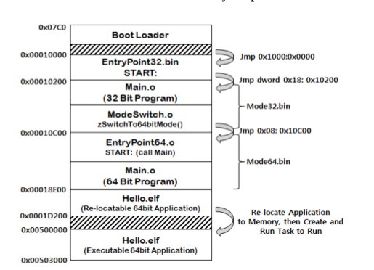

Printing to Screen w/ direct memory manipulation

Bootloader manipulates VGA memory to output characters on screen.

(SP: 0xffff)
Push MSG (+2)
Push 0 (+4)
Push 0 (+6)
call PRINTMESSAGE

NOTE: Calling function pushes return address onto stack
Called function pops return address from stack

PRINT MESSAGE: (SP: 0xfff7)
push bp
mov bp, sp
