

CAPSTONE PROJECT 1
Proposal

Hybrid Computer Vision Based Smart Parking Occupancy Detection

by

Ng Ji Yeung
23026479

Bachelor of Software Engineering

Supervisor: Assoc. Prof. Ir. Dr Ranjit Singh Sarban Singh
Semester: April 2026
Date: 15 May 2026
School of Computing and Artificial Intelligence
Faculty of Engineering and Technology
Sunway University

Abstract
Parking congestion in university facilities causes drivers to spend time locating vacant bays, increasing internal traffic and delaying journeys. Entry-exit counters provide only aggregate, error-prone availability, while per-space sensors impose installation and maintenance costs. Camera-based classical vision can reuse existing surveillance infrastructure but is sensitive to lighting, shadows, viewpoint changes, and occlusion; continuous deep-learning inference can be impractical on a CPU-only server. This project proposes a hybrid computer vision-based smart parking occupancy detection system for a selected university parking zone. Its objective is to deliver accurate, timely zone- and slot-level availability through a mobile application while evaluating whether selective deep-learning verification balances detection reliability with computational cost. Periodic JPEG snapshots will be obtained from permitted ONVIF-compatible fixed cameras and mapped to predefined parking-space polygons. Two OpenCV branches - vacant-reference comparison and MOG2 foreground analysis - will produce features that are fused into a calibrated occupancy probability. Only uncertain or incomplete cases will enter a bounded YOLOv8s verification queue, after which vehicle detections will be associated with slot polygons. Candidate states will be confirmed across three consecutive snapshots, stored transactionally in PostgreSQL, and published through FastAPI REST and WebSocket interfaces to a Flutter client with timestamp, stale-state, and service-health indicators. OpenCV-only, YOLOv8s-only, and selective hybrid configurations will be compared on session-separated held-out data using slot-level detection metrics, false-vacant and false-occupied rates, latency, CPU and memory use, queue depth, recovery, and end-to-end mobile-update consistency. The study will provide locally valid evidence on the reliability, resource cost, and deployment practicality of the complete architecture rather than assume universal superiority.

Introduction
Background and problem statement. Parking congestion is a persistent problem in university and other high-demand parking facilities, particularly during peak periods. Drivers may spend considerable time circulating for a vacant bay, which increases internal traffic, fuel use, emissions, and delays. Traditional entry-exit counting systems report only aggregate availability and can become inaccurate after missed or duplicated vehicle movements; they also cannot identify the vacant zone or individual bay. These limitations can cause drivers to continue searching even when spaces are available elsewhere and can contribute to illegal or inefficient parking.
Proposed response. To address this problem, the project proposes a hybrid computer vision-based smart parking occupancy detection system that uses permitted ONVIF-compatible fixed cameras. The backend will retrieve periodic JPEG snapshots, analyse predefined parking-space polygons through two OpenCV evidence branches, and invoke YOLOv8s only when the lightweight result is uncertain or incomplete. Confirmed availability will be delivered to users through a Flutter mobile application.

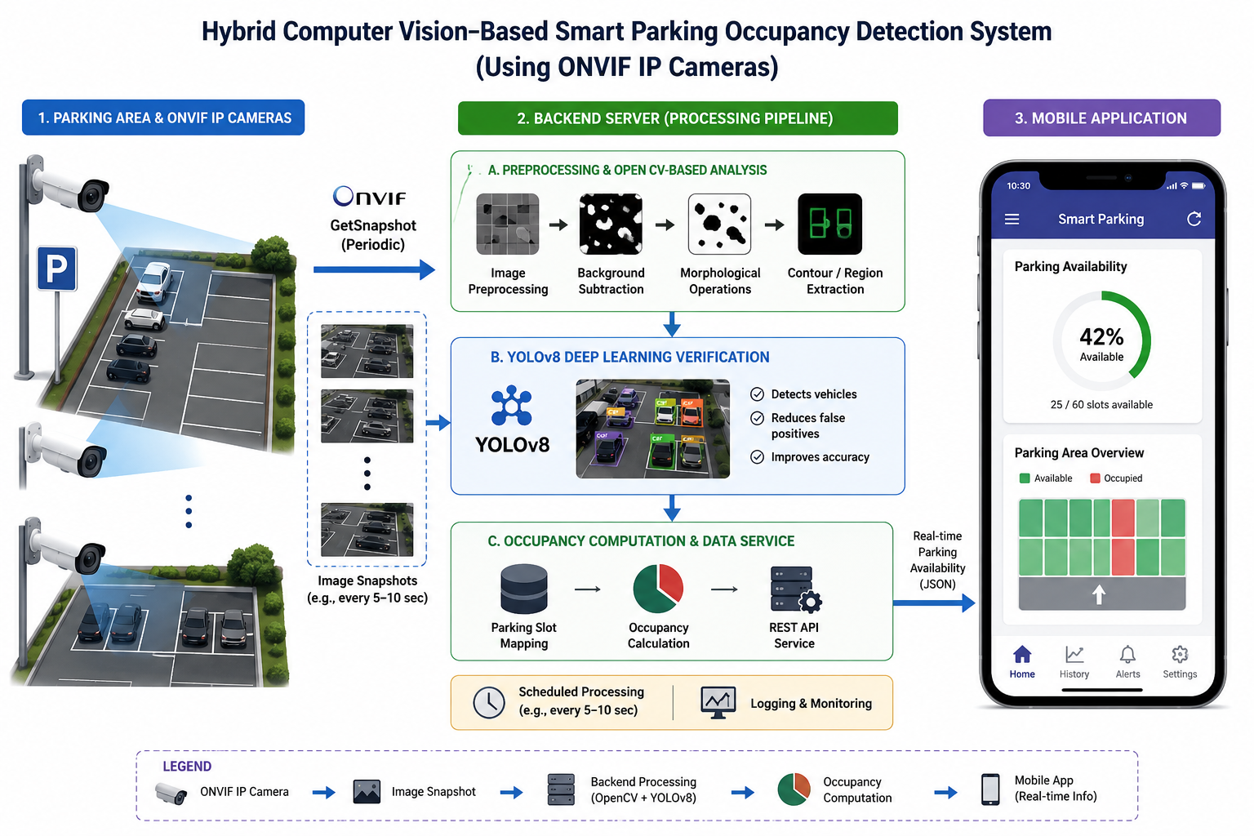
Figure 1.1. Architecture of the proposed AI-based smart parking occupancy monitoring system for university parking facilities.

Objective, scope and limitations. The primary objective is to provide accurate, timely zone- and slot-level parking availability through a mobile application while evaluating whether selective deep-learning verification balances decision reliability with computational cost. The initial deployment is limited to a selected university parking zone with approximately 20 to 40 visible bays across up to four fixed camera views, using the available CPU-only virtual private server. The study will not claim full-campus scalability or universal accuracy. Reservation, payment, facial recognition, licence-plate recognition, and driver profiling are outside the project scope.

Research significance. The project evaluates whether existing permitted camera infrastructure can support practical parking guidance without installing a dedicated sensor at every bay. Reliable and timely availability information may reduce unnecessary circulation and improve parking-space utilisation, while the privacy controls restrict the system to occupancy state rather than identity. The evaluation will also provide locally valid evidence about accuracy, resource use, latency, and failure recovery for the complete acquisition-to-mobile workflow.
Technology roles and deployment scope
- ONVIF (selected): standardizes device discovery and media-service interfaces. The backend obtains a snapshot URI through GetSnapshotUri and then retrieves the JPEG through HTTP (ONVIF, 2025; ONVIF, n.d.).
- OpenCV (selected): the open-source computer vision library used for polygon masking, vacant-reference comparison, MOG2 foreground extraction, morphology, and probability features (OpenCV, n.d.).
- YOLOv8s (selected): the secondary vehicle detector invoked only for uncertain or incomplete OpenCV results. Its accuracy will be measured on held-out project data rather than assumed (Jocher et al., 2023; Redmon et al., 2016).
- PostgreSQL (selected): persists cameras, parking-slot definitions, processing results, confirmed occupancy states, and audit timestamps.
- FastAPI with REST and WebSocket (selected): REST supplies initial and current state, while WebSocket pushes confirmed occupancy updates to the client.
- Flutter (selected): provides the mobile interface for zone and slot availability, status age, and service health.
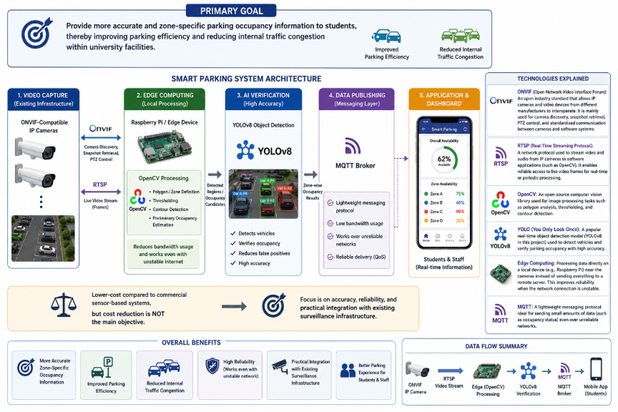
Figure 1.2. Integration of ONVIF, RTSP, OpenCV, YOLOv8, edge computing, and MQTT technologies in the proposed smart parking occupancy detection system.

Figure 1.2 separates the assessed baseline from alternatives reviewed during design. RTSP controls continuous media sessions but is unnecessary for the selected periodic-HTTP-snapshot workflow (Schulzrinne et al., 2016). Edge computing and MQTT remain future deployment options if processing is moved near the cameras or publish–subscribe messaging becomes necessary; they are not components of the current centralized VPS, REST, and WebSocket architecture (OASIS Open, 2019; Satyanarayanan, 2017).

Literature Review

This chapter reviews the research papers literature related to parking occupancy detection technologies and smart parking systems. The review begins by examining the challenges associated with parking congestion and the limitations of traditional parking monitoring methods. Subsequently, sensor-based, computer vision-based, and deep learning-based parking occupancy detection methodology or approaches are reviewed discussed. Hybrid computer vision and deep learning techniques are then reviewed to highlight recent advancements in balancing detection accuracy and computational efficiency. Finally, a comparative analysis of existing studies is presented to identify research gaps and justify the development of the proposed Hybrid Computer Vision-Based Smart Parking Occupancy Detection System.

Parking Congestion Problem
Parking congestion has become a significant challenge in urban areas, educational institutions, shopping complexes, hospitals, and commercial facilities due to the rapid increase in vehicle ownership and limited parking capacity. Drivers often spend a considerable amount of time searching for available parking spaces, leading to traffic congestion within parking facilities, increased fuel consumption, higher carbon emissions, and reduced user satisfaction. The inefficiency of parking space utilization not only affects drivers but also contributes to broader transportation and environmental issues.
Traditional parking management systems commonly rely on manual monitoring or vehicle or parking space counting mechanisms at entry and exit points. While these approaches provide an estimate of parking occupancy, existing systems are unable to identify the availability of individual parking spaces or specific parking zones. As a result, drivers may continue searching for vacant spaces despite the existence of available parking elsewhere within the facility. According to Idris et al. (2009), conventional parking systems often face limitations in accuracy, scalability, and real-time occupancy monitoring in dynamic parking environments.
Early smart parking surveys conducted by Revathi and Dhulipala (2012) highlighted the growing need for intelligent parking management systems capable of reducing congestion, improving parking space utilization, and providing real-time parking information to users. The study emphasized the importance of integrating sensing and information technologies to address the shortcomings of conventional parking management approaches.
To address these challenges, smart parking systems have emerged as an effective solution by providing real-time parking occupancy information to users. By leveraging sensing technologies, computer vision, and intelligent data processing, smart parking systems can improve parking utilization, reduce vehicle searching time, and enhance the overall parking experience. Consequently, the development of accurate and efficient parking occupancy detection systems has become an important research area in intelligent transportation and smart city applications.

2.2 Traditional Parking Monitoring Systems

Traditional parking monitoring systems are commonly used to manage vehicle flow and estimate parking occupancy in parking facilities. These systems typically rely on manual observation, ticketing systems, boom gate counters, or vehicle counting mechanisms installed at entry and exit points. The primary objective of these systems is to determine the number of vehicles entering and leaving a parking area, thereby providing an estimate of the available parking spaces.
Figure 2.1 models the operating logic of entry–exit monitoring and shows why an apparently simple total can diverge from physical parking occupancy.
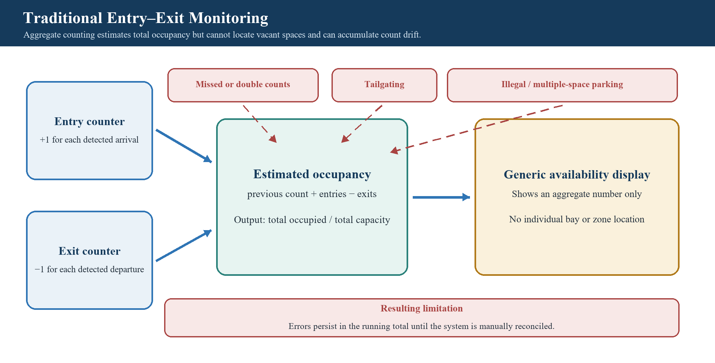
Figure 2.1. Operation and limitations of traditional entry–exit parking monitoring.
The illustration demonstrates that the limitation is structural: even a correct aggregate count cannot identify which bay or zone is vacant, while missed or duplicated events remain in the running total until reconciliation (Idris et al., 2009; Lin et al., 2017).
Although entry-exit counting systems are relatively simple to implement and cost-effective, entry-exit counting systems have several limitations. The occupancy estimation is based solely on the difference between incoming and outgoing vehicles and does not provide information about the occupancy status of individual parking spaces or specific parking zones. Consequently, visitors may still spend significant time searching for vacant spaces even when parking availability information is displayed.
Furthermore, the accuracy of traditional parking monitoring systems can be affected by various operational factors, such as counting errors, vehicle tailgating, illegal parking, and vehicles occupying multiple parking spaces. In large and dynamic parking environments, these issues may result in inaccurate occupancy estimates and reduced system reliability. According to Idris et al. (2009), traditional parking systems often face challenges related to scalability, accuracy, and real-time monitoring capabilities.
Due to these limitations, there is an increasing demand for more intelligent parking monitoring solutions capable of providing real-time and location-specific occupancy information. This has led to the development of smart parking systems that utilize sensors, computer vision, and artificial intelligence technologies to improve parking management efficiency and user experience.

2.3 Sensor-Based Smart Parking Systems

Sensor-based smart parking systems were introduced to overcome the limitations of traditional parking monitoring methods by providing real-time parking occupancy information at the individual parking space level. These systems typically employ sensors such as ultrasonic sensors, infrared sensors, magnetic sensors, and wireless sensor networks (WSNs) to detect the presence or absence of vehicles in parking spaces. The occupancy information is then transmitted to a central management system, allowing drivers to identify available parking spaces more efficiently.
Figure 2.2 illustrates how sensor-based systems obtain direct per-space occupancy and why deployment and maintenance effort increases with the number of bays.
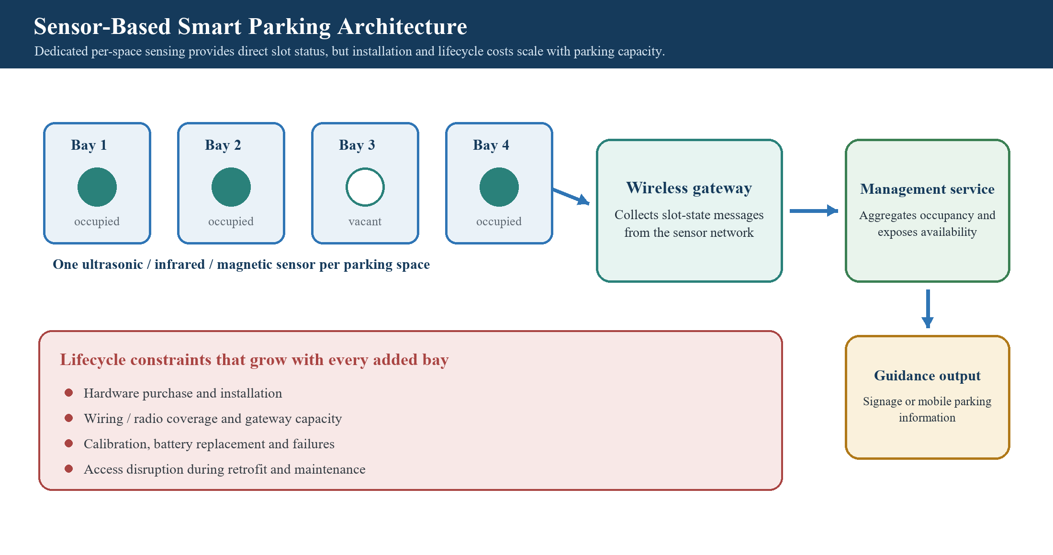
Figure 2.2. Sensor-based smart parking occupancy monitoring architecture.
This architecture provides direct slot-level observations and timely guidance, but each added bay also adds hardware, communications, calibration, power, and maintenance obligations; those lifecycle costs constrain large retrofit deployments (Barone et al., 2014; Lin et al., 2017).
Several studies have demonstrated the effectiveness of sensor-based parking systems in improving parking management and reducing vehicle searching time. According to Lin et al. (2017), sensor-based smart parking solutions can enhance parking guidance services and optimize parking space utilization through real-time occupancy monitoring. The ability to monitor individual parking spaces also provides higher accuracy compared to traditional entry-exit counting systems.
Despite these advantages, sensor-based parking systems have several practical limitations. The installation of dedicated sensors at each parking space increases deployment costs, particularly in large parking facilities. In addition, maintenance requirements, sensor calibration, battery replacement, and communication infrastructure can further increase operational expenses. Barone et al. (2014) highlighted that large-scale sensor deployment may present significant challenges in terms of scalability and long-term maintenance, especially when retrofitting existing parking infrastructures.
Due to these challenges, researchers have increasingly explored camera-based parking occupancy detection systems that leverage existing surveillance infrastructure. By utilizing computer vision techniques, a single camera can monitor multiple parking spaces simultaneously, reducing hardware requirements while providing a more scalable and cost-effective solution for smart parking applications.

2.4 Computer Vision-Based Parking Detection

Computer vision-based parking detection systems have emerged as a cost-effective alternative to sensor-based parking solutions by utilizing existing surveillance cameras to monitor parking occupancy. Instead of installing dedicated sensors at individual parking spaces, computer vision-based parking detection systems analyze images or video streams captured by cameras to determine whether parking spaces are occupied or vacant. This approach reduces hardware deployment costs while enabling a single camera to monitor multiple parking spaces simultaneously.
Figure 2.3 synthesizes the traditional computer-vision pipeline from camera acquisition and polygon masking to feature extraction and an occupied-or-vacant decision.
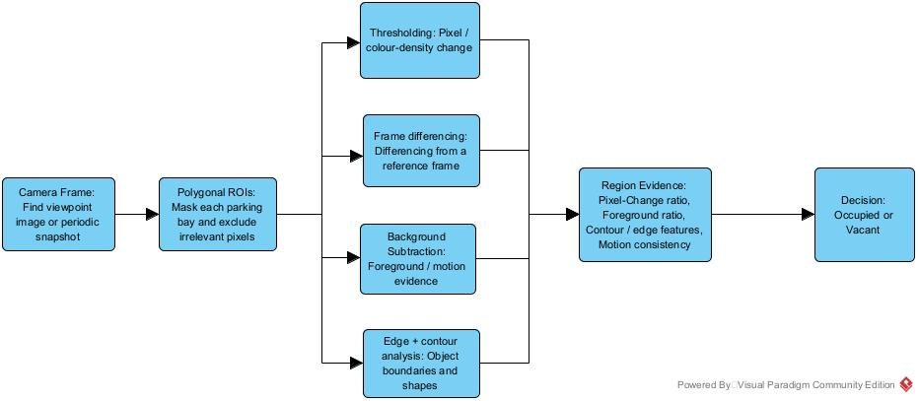
Figure 2.3. Traditional computer-vision workflow for parking-space occupancy detection.
Traditional computer vision techniques commonly employed in parking occupancy detection include image thresholding, contour analysis, edge detection, frame differencing, background subtraction, and Region of Interest (ROI) analysis. In many implementations, parking spaces are manually defined using polygonal ROIs, and occupancy is estimated by analyzing pixel density, object contours, or motion changes within the designated regions. These methods are attractive because they are computationally efficient and can be implemented using open-source libraries such as OpenCV.
Camera-based parking studies demonstrate that a single view can support multi-space occupancy analysis without installing one physical sensor per bay. Amato et al. (2016) implemented parking occupancy detection in a smart-camera network, while de Almeida et al. (2022) found that region-based classification is a common structure across public-dataset studies. Reusing a permitted fixed camera can therefore reduce additional field hardware, although performance still depends on the camera view, data, and environmental conditions.
de Almeida et al. (2022) conducted a systematic review of computer vision-based parking management systems and highlighted the growing adoption of camera-based occupancy detection due to its scalability and lower deployment cost compared to sensor-based approaches. Similarly, Hadi et al. (2024) reported that computer vision techniques have become one of the dominant approaches in smart parking research due to their ability to utilize existing surveillance infrastructure.
Grbić and Koch (2023) further demonstrated the effectiveness of vision-based parking slot detection and occupancy classification, highlighting the potential of camera-based systems for large-scale parking monitoring applications.
Wang et al. (2023) proposed a polygon-based parking slot representation approach that improved parking slot localization accuracy and demonstrated the potential of advanced computer vision techniques for parking occupancy monitoring.
ONVIF defines standardized interfaces intended to support interoperability between IP-based physical-security devices and client software. Its Core Specification covers device discovery and configuration, while the Media Service operation GetSnapshotUri returns a stable URI from which the client obtains a JPEG through HTTP (ONVIF, 2025; ONVIF, n.d.). In this project, these interfaces provide a vendor-neutral method for integrating permitted existing cameras; no unsupported claim is made that ONVIF adoption is increasing across smart parking implementations.
Despite having advantages, traditional computer vision methods are highly sensitive to environmental factors such as lighting variations, shadows, weather conditions, occlusions, and changes in camera viewpoints. These challenges can lead to inaccurate occupancy estimation and reduced system reliability in real-world deployments. Consequently, researchers have increasingly adopted deep learning-based object detection techniques to improve robustness and detection accuracy under complex operating conditions.

2.5 Deep Learning-Based Parking Detection

Deep learning has significantly advanced the field of computer vision by enabling automated feature extraction and robust object recognition in complex environments. Unlike traditional computer vision techniques that rely on manually designed features and threshold-based rules, deep learning models can learn discriminative features directly from large datasets, resulting in improved detection accuracy and adaptability. As a result, deep learning-based approaches have become increasingly popular for parking occupancy detection applications.
Convolutional Neural Networks (CNNs) are among the most widely used deep learning architectures for image analysis and object detection. In parking management systems, CNN-based models can identify and classify vehicles within parking areas, allowing occupancy status to be determined automatically. Research shows, object detection frameworks such as You Only Look Once (YOLO) have gained significant attention due to their ability to perform real-time object detection with high accuracy. YOLO simultaneously predicts object locations and classifications in a single processing stage, making it suitable for real-time parking monitoring applications.
Parking-specific results show that YOLO-family performance and inference cost are deployment-dependent rather than universal. da Luz et al. (2026) evaluated YOLOv8 through YOLOv11 with pixel-wise parking-space ROIs and reported strong results on a 3,484-image custom dataset, while also finding substantial inference differences across model and hardware choices. The study supports evaluating a YOLO-family detector for parking, but its reported accuracy cannot be assumed to transfer to the cameras and CPU-only server used in this project.
Pokhrel and Dao (2025) also examined a customized YOLOv8 parking detector, but their preprint provides supporting rather than conclusive evidence. Together, these studies motivate YOLOv8s as a candidate vehicle detector whose accuracy, latency, and failure modes must be measured on a frozen held-out partition from the target deployment.
YOLOv8 is used here as a software implementation of the one-stage YOLO family (Jocher et al., 2023; Redmon et al., 2016). It will serve as a secondary source of vehicle evidence rather than being described as automatically verifying parking occupancy with high accuracy; vehicle detection, slot association, and final occupancy decisions will be evaluated separately.
A one-stage detector is a practical candidate for timely vehicle localization, whereas two-stage architectures such as Faster R-CNN prioritize a different speed–accuracy trade-off (Redmon et al., 2016; Ren et al., 2015). For this project, the relevant question is not whether YOLOv8s is universally faster or more accurate, but whether its selective use improves held-out occupancy decisions without making update latency impractical on the available server.
However, the improved detection performance of YOLOv8 is achieved at the expense of higher computational requirements, highlighting the need for hybrid frameworks that selectively utilize deep learning only when additional verification is required.
Despite these advantages, deep learning inference generally requires more computation than simple image-processing rules. Running an object detector for every image and parking space can increase latency, energy use, and queue pressure in a CPU-only or otherwise resource-constrained deployment. This motivates a controlled comparison of lightweight screening, continuous YOLOv8s inference, and selective hybrid verification rather than assuming that any one configuration is operationally superior.

2.6 Hybrid Computer Vision and Deep Learning Approaches

Hybrid computer vision and deep learning approaches have emerged as an effective solution for balancing detection accuracy and computational efficiency in parking occupancy monitoring systems. Traditional computer vision techniques offer fast processing speeds and low computational requirements but are often sensitive to environmental factors such as lighting variations, shadows, and occlusions. In contrast, deep learning models provide superior detection accuracy and robustness but require significantly higher computational resources. Hybrid approaches aim to combine the advantages of both methods while minimizing their individual limitations.
In a typical hybrid framework, lightweight computer vision techniques are employed as the primary detection mechanism to estimate parking occupancy. Methods such as background subtraction, contour analysis, pixel density analysis, and Region of Interest (ROI) evaluation can rapidly identify potential occupancy changes with minimal processing overhead. When the confidence level of the primary detection becomes uncertain, a deep learning model such as YOLO can be activated to perform secondary verification. This selective activation strategy reduces unnecessary deep learning inference while maintaining reliable occupancy detection performance.
Fusion-oriented parking studies provide evidence that complementary detection and spatial or temporal rules can strengthen occupancy decisions. Chen et al. (2020) combined vehicle detection, parking-space overlap logic, and temporal voting, while Adi et al. (2024) evaluated fusion of YOLO-based segmentation with edge, intersection-over-region, and intersection-over-union algorithms. These studies support evidence fusion, but they do not establish that uncertainty-triggered YOLOv8s will meet the present CPU and latency constraints.
Consequently, a hybrid design should not be treated as automatically efficient. Its actual cost depends on threshold calibration, fallback frequency, camera view, detector choice, and hardware. The project must therefore measure both decision quality and operational performance, including false-vacant errors, update latency, processor use, memory use, and queue growth.
Hybrid systems can also use intersection over union (IoU) to associate detected vehicles with parking polygons and temporal confirmation to prevent a single noisy frame from changing the published state. Spatial overlap and voting mechanisms have been used in prior parking systems (Adi et al., 2024; Chen et al., 2020). Their thresholds and confirmation windows nevertheless require calibration and held-out testing under the target conditions.
These characteristics make hybrid approaches particularly attractive for smart parking applications where high detection accuracy, computational efficiency, and cost-effective deployment must be achieved simultaneously.

2.7 Comparative Analysis of Existing Studies
The literature indicates that various approaches have been proposed to address parking occupancy detection, each offering distinct advantages and limitations. Traditional parking monitoring systems provide basic occupancy estimation through vehicle counting mechanisms but lack the capability to identify individual parking space availability. Sensor-based systems improve occupancy detection accuracy by monitoring individual parking spaces; however, they require substantial hardware installation and maintenance costs.
Computer vision-based approaches have gained popularity due to their ability to utilize existing surveillance infrastructure while reducing deployment costs. Traditional computer vision techniques such as background subtraction, contour analysis, and ROI-based detection offer computational efficiency but remain sensitive to environmental factors including lighting variations, shadows, and occlusions. To overcome these limitations, deep learning-based approaches, particularly YOLO-based object detection models, have been widely adopted because of their superior detection accuracy and robustness. Nevertheless, continuous deep learning inference introduces higher computational requirements, making large-scale deployment challenging, especially in resource-constrained environments.
More recently, fusion and hybrid approaches have combined complementary image evidence, vehicle detection, spatial overlap, and temporal rules. These designs may balance decision quality and processing cost in resource-aware deployments, but the balance is configuration- and hardware-dependent. Table 2.1 summarizes the major approaches identified in the reviewed literature and makes the remaining evaluation requirements explicit.
While deep learning approaches generally provide superior robustness, hybrid approaches offer a more balanced solution by leveraging the strengths of both traditional computer vision and deep learning techniques.
The comparative analysis suggests that no single approach can fully satisfy the requirements of accuracy, scalability, computational efficiency, and deployment cost simultaneously. Therefore, the proposed system adopts a hybrid computer vision-based architecture that combines OpenCV-based occupancy estimation with YOLOv8 verification, IoU-based parking space validation, and temporal smoothing to achieve reliable real-time parking occupancy detection.
Table 2.1. Comparative Analysis of Parking Occupancy Detection Approaches
Approach | Technology Used | Strengths | Limitations | References
Traditional Parking Monitoring | Entry–exit vehicle counting and ticketing | Simple implementation and low initial cost | No individual-space location; accumulated counting error | Idris et al. (2009)
Sensor-Based Systems | Ultrasonic, infrared, magnetic sensors and WSN | Direct per-space status and timely monitoring | Per-bay installation, maintenance, power and scalability costs | Barone et al. (2014); Lin et al. (2017)
Computer Vision-Based Systems | Polygonal ROIs, thresholding, contours, background subtraction and OpenCV | Reuses cameras; one view can monitor multiple spaces | Sensitive to lighting, shadows, weather, viewpoint change and occlusion | Amato et al. (2016); de Almeida et al. (2022); Hadi et al. (2024)
Deep Learning-Based Systems | CNN and YOLO-family object detection | Semantic vehicle detection and learned features | Dataset and hardware dependence; higher computation | da Luz et al. (2026); Pokhrel and Dao (2025); Redmon et al. (2016)
Hybrid / Fusion Systems | Detector plus spatial overlap, IoU, temporal voting or evidence fusion | Combines complementary evidence; reduces transient decisions | Requires calibration; end-to-end gains are deployment-specific | Adi et al. (2024); Chen et al. (2020)

The comparison reveals a trade-off between deployment cost, detection accuracy, scalability, and computational complexity.
Table 2.1 shows that no single approach simultaneously guarantees slot-level accuracy, environmental robustness, low computation, low deployment effort, and timely user delivery. The proposed system therefore uses permitted existing cameras, obtains snapshot URIs through ONVIF and retrieves JPEGs through HTTP, screens every slot with two OpenCV evidence branches, and invokes YOLOv8s only for uncertain or incomplete cases. IoU-based association, three-snapshot confirmation, persistent state, and mobile delivery address later stages of the workflow. These design choices are hypotheses to be evaluated, not assumed advantages.

2.8 Research Gap
The comparative evidence reveals a transferability gap rather than an absence of parking-detection techniques. de Almeida et al. (2022) found that much of the reviewed literature evaluates classifiers on pre-segmented spaces from a small number of public datasets, often using non-standard or biased protocols, and identified camera-view changes and limited environmental diversity as persistent issues. In the original PKLot experiments, recognition exceeded 99% when training and testing used the same view but fell to approximately 89% for parking lots excluded from training (de Almeida et al., 2015). Benchmark accuracy is therefore insufficient evidence of reliable operation in the selected university parking zone.
A second gap concerns end-to-end integration. The studies reviewed in Sections 2.4–2.7 primarily evaluate individual components such as parking-slot localization, occupancy classification, detector accuracy, spatial overlap, or temporal voting (Adi et al., 2024; Chen et al., 2020; Grbić & Koch, 2023; Wang et al., 2023; da Luz et al., 2026). Within this reviewed body of work, no single study evaluates the exact proposed combination of standardized ONVIF snapshot acquisition, two lightweight OpenCV evidence branches, probability-based selective YOLOv8s verification, confirmed persistent slot state, and real-time mobile delivery on the available CPU-only server. This bounded observation replaces the unsupported general claim that ONVIF is globally underexplored in smart parking.
The resulting operational gap is whether selective verification can reduce false-vacant and false-occupied decisions without causing impractical processing delay, queue growth, resource use, or stale mobile updates when lighting, occlusion, camera access, or simultaneous slot changes occur. A defensible evaluation must compare OpenCV-only, YOLOv8s-only, and selective hybrid configurations on the same session-separated held-out data. It must report accuracy, precision, recall, F1-score, false-vacant rate, latency, fallback frequency, CPU and memory use, queue depth, acquisition recovery, and state consistency, with detection results stratified by relevant environmental conditions.
To address these gaps, this project will implement and evaluate a Hybrid Computer Vision-Based Smart Parking Occupancy Detection System for a selected university parking zone. It will obtain periodic JPEG snapshots from permitted ONVIF-compatible cameras, combine two OpenCV evidence branches, invoke YOLOv8s only for uncertain or failed cases, confirm changes across successive snapshots, persist confirmed state in PostgreSQL, and publish current availability through FastAPI to a Flutter application. The intended contribution is not a new object-detection model or a claim of universal superiority; it is locally valid evidence about the reliability, resource cost, deployment practicality, and user-facing timeliness of the complete architecture.
Table 2.2 converts the synthesized evidence into a traceable research question, project response, and required evaluation evidence.
Table 2.2. Research Gap Synthesis and Project Response
Evidence-based limitation | Unresolved gap | Project response | Required evaluation evidence
Dataset, camera-view and environmental dependence; public-dataset scores may not transfer. | Performance for the target camera views and university conditions is unknown. | Frozen session-separated partitions; target-zone data stratified by lighting, occlusion and viewpoint. | Accuracy, precision, recall, F1, false-vacant and false-occupied rates by condition.
Classical vision is efficient but environmentally sensitive; detector cost varies by model and hardware. | Whether selective fallback is better than OpenCV-only or YOLOv8s-only on the CPU-only VPS. | Dual OpenCV evidence, calibrated probability, and uncertainty-triggered YOLOv8s. | Three-way comparison of error, fallback rate, latency, CPU, memory and queue depth.
Reviewed studies commonly assess individual detection or decision components. | Reliability of the complete acquisition-to-mobile workflow under failures and concurrent updates. | ONVIF URI acquisition, HTTP JPEG retrieval, identifiers, retries, three-snapshot confirmation, PostgreSQL, FastAPI and Flutter. | Acquisition recovery, stale-state behavior, boundary/concurrency tests, state consistency and mobile-update delay.
Offline technical results do not establish deployment or privacy suitability for a campus service. | Operational feasibility within approved camera access, data minimization and user-facing status requirements. | Authorized fixed views; temporary-frame deletion; slot status rather than identity; visible state age and service health. | Retention/access audit, peak and off-peak operational sessions, availability and usability evidence.
Figure 2.4 then shows how the project components connect to operationalize the response in Table 2.2.
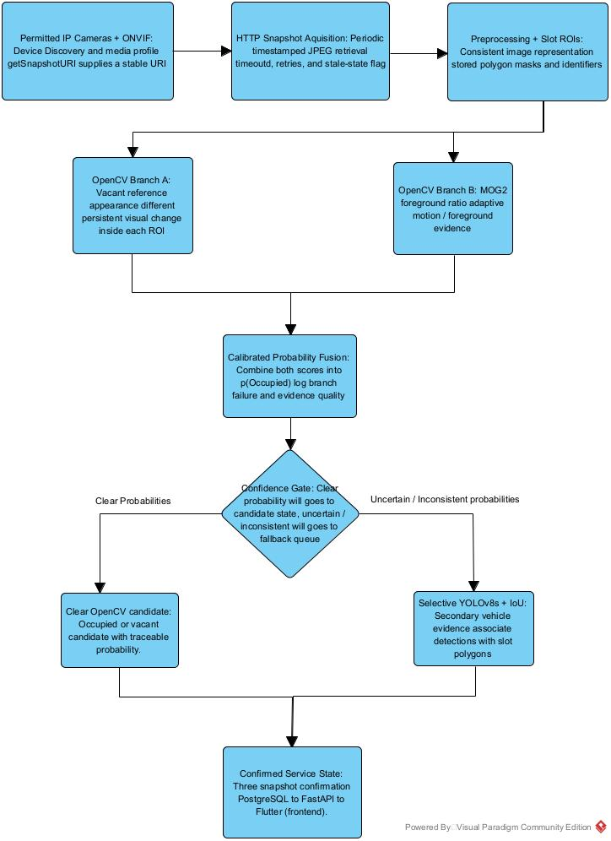
Figure 2.4. Conceptual framework of the proposed hybrid computer vision-based smart parking occupancy detection system.

Figure 2.4 illustrates the conceptual framework of the proposed system: ONVIF-assisted camera integration and HTTP snapshot retrieval feed the two OpenCV evidence branches; uncertain cases receive YOLOv8s verification and IoU-based slot association; temporal confirmation produces persistent state that the backend publishes to the mobile client. Chapter 3 specifies the implementation and evaluation procedure for each component.
The framework is synthesized from the evidence and bounded research gaps in Sections 2.4–2.8, while the acceptance evidence in Table 2.2 prevents the proposed architecture from being treated as effective before testing.

2.9 Summary
This chapter reviewed the progression from aggregate monitoring and per-space sensors to camera-based, deep-learning, and fusion approaches. The comparative analysis identified trade-offs in deployment effort, environmental sensitivity, computation, transferability, and end-to-end service integration. The research gap is therefore framed as a bounded integration-and-evaluation problem: the proposed architecture must demonstrate held-out detection quality and operational feasibility in the target university context. Chapter 3 translates that evidence into a project-specific implementation and evaluation methodology.

Methodology
This chapter defines an applied system-development methodology organized into five operational phases, followed by quantitative experimental evaluation. The procedure is derived from the evidence, limitations, and bounded research gap synthesized in Chapter 2 and is presented here as project-specific design, implementation, calibration, and validation steps rather than as a second literature review. The computing artefact will acquire periodic camera snapshots, obtain two OpenCV evidence scores, selectively verify uncertain cases with YOLOv8s, confirm and persist stable slot states, and publish current availability to a Flutter client. Evaluation will determine both detection quality and operational feasibility on the available CPU-only virtual private server. Figure 3.1 presents the complete workflow, while Figures 3.2 to 3.6 explain the mechanism and controls within each phase.

3.1 Research Design and Overall System Workflow

The methodology addresses the project objectives through five connected phases. Phase 1 obtains a snapshot URI through the ONVIF Media Service, retrieves a JPEG through HTTP, attaches traceable identifiers, and prepares the configured parking-slot polygons. Phase 2 processes every prepared slot through vacant-reference comparison and MOG2 foreground analysis in parallel, synchronizes their results, and converts the evidence into a calibrated probability of occupancy. Phase 3 sends only uncertain or incomplete cases to a bounded YOLOv8s verification queue and associates qualifying vehicle detections with parking polygons. Phase 4 requires consistent candidate evidence across three consecutive snapshots before committing a confirmed state to PostgreSQL. Phase 5 publishes confirmed and time-stamped availability through FastAPI REST and WebSocket interfaces to the Flutter application.
Each phase has an explicit input, output, failure response, and acceptance evidence so that implementation decisions remain traceable to the project objectives. Common snapshot_id, camera_id, and slot_id values will be retained across the pipeline; thresholds and model versions will be frozen before final testing; and only confirmed states will be presented as current availability. The selective design is intended to reserve CPU-intensive inference for cases that need semantic verification, but its benefit will be established by controlled comparison rather than assumed. Table 3.1 summarizes the phase boundaries and the evidence required to accept each phase.
- Table 3.1. Phase Traceability and Acceptance Overview
Phase | Main input | Primary output | Acceptance evidence
1 | Approved camera profile, snapshot URI, ROI configuration | Validated timestamped JPEG and slot masks | Acquisition success and recovery; identifier traceability; ROI and reference validation
2 | Prepared frame, vacant references and MOG2 state | Calibrated p(occupied), clear candidate, or fallback record | Branch completeness; probability calibration; boundary and branch-failure tests
3 | Uncertain or failed frame and affected slot list | Verified occupied candidate or retain-prior instruction | Fallback rate; queue depth; YOLO latency; confidence and polygon-association tests
4 | Candidate state and previous confirmed slot state | Transactionally confirmed occupied, vacant, or unknown-stale state | Three-snapshot rule; ordering; idempotency; state-consistency and recovery tests
5 | Confirmed PostgreSQL state and service health | Authenticated API/WebSocket payload and mobile availability view | API and mobile delay; payload consistency; stale-state, access-control, and accessibility tests

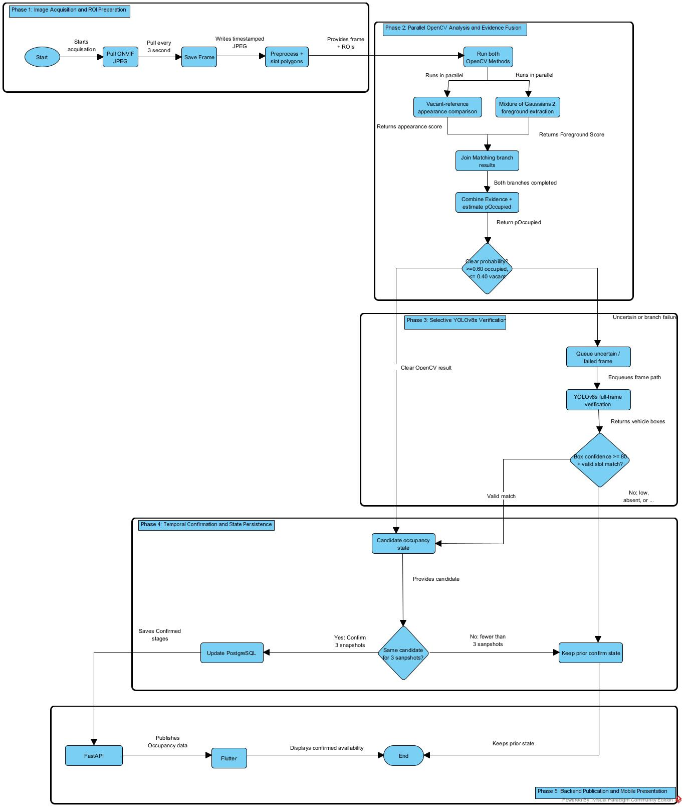
Figure 3.1. Smart Parking Hybrid Occupancy Detection Methodology.

3.2 Phase 1: Image Acquisition and ROI Preparation
Phase 1 converts an approved fixed-camera view into a traceable, analysis-ready image and its predefined parking-slot masks. The phase starts with camera configuration and ends only when the JPEG, capture metadata, and ROI definitions have passed validation. Figure 3.2 shows the acquisition, identification, preprocessing, and recovery controls.
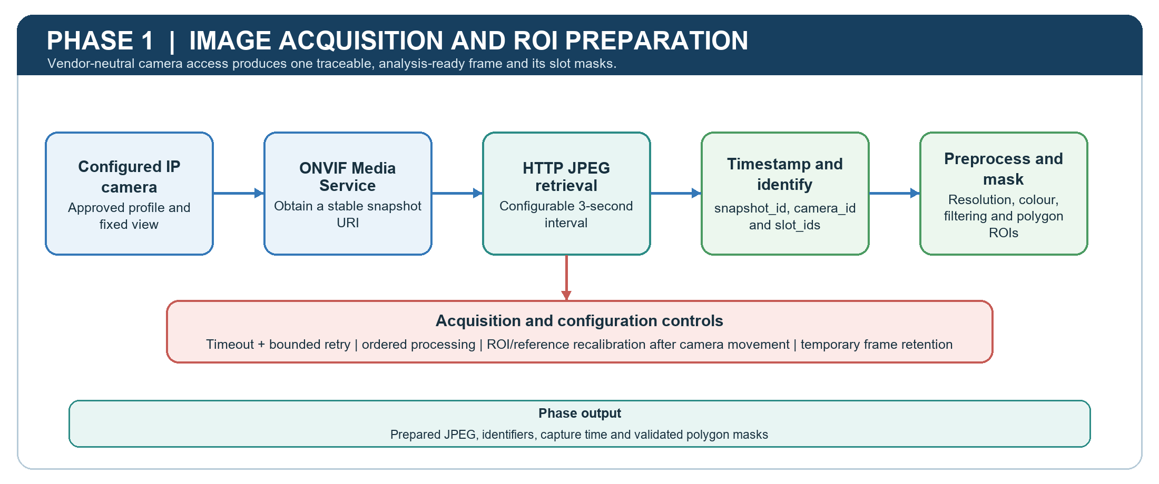
Figure 3.2. Phase 1 image acquisition and ROI preparation.
Camera acquisition. The backend will execute from /opt/smart-parking/backend/ on the server named perfect-Jy-Debian. During configuration, it will use the ONVIF Media Service to obtain the snapshot URI for the selected camera profile. At an initially configured interval of three seconds, the acquisition scheduler will issue an HTTP GET request to that URI and retrieve one JPEG per camera. The interval will remain configurable so that later load testing can identify a sustainable value. Every successful retrieval will receive a unique snapshot_id, camera_id, capture timestamp, and the slot_ids visible in that view. The frame will be stored temporarily in the incoming-frame directory using the name {camera_id}/{timestamp}_{snapshot_id}.jpg, and the same identifiers will accompany all downstream records.
Parking-slot configuration and preprocessing. During initial setup, the visible corners of each parking space will be marked in order on a representative frame and stored as a polygon linked to one camera and slot_id. Polygons will accommodate the trapezoidal appearance caused by camera perspective more accurately than fixed rectangles. A confirmed-vacant reference will be collected for each slot while camera position, zoom, resolution, and orientation are fixed. Before analysis, every JPEG will be decoded, checked for corruption and minimum dimensions, converted to the selected colour representation and resolution, lightly filtered for sensor noise, and masked using the versioned polygons. One stateful MOG2 model will be maintained per camera and supplied with frames in chronological order.
Failure handling and output. Connection and read timeouts will prevent one unavailable camera from blocking the scheduler. A failed retrieval will receive bounded exponential-back-off retries; if all attempts fail, no occupancy candidate will be created, the last confirmed state will be retained, and the affected camera will be marked stale. Camera movement, resolution change, or reference drift will suspend affected slots until their polygons and vacant references are recalibrated. Ordinary incoming frames will be deleted after Phase 2 unless queued for Phase 3 or selected for the approved evaluation dataset. The accepted output of Phase 1 is therefore a validated JPEG with complete identifiers, capture time, current configuration version, and usable slot masks.
Phase acceptance. Tests will verify successful acquisition from each configured camera, unique and traceable identifiers, retry and stale-state behaviour, polygon containment within the image, correct processing order, and bounded temporary storage. A frame that fails any validation will not proceed as if it were valid evidence.

3.3 Phase 2: Parallel OpenCV Analysis and Evidence Fusion
Phase 2 obtains complementary appearance and foreground evidence for every visible parking slot before deciding whether the result is sufficiently clear or requires secondary verification. Both branches analyse the same prepared frame and are joined only when their identifiers match. Figure 3.3 illustrates the parallel branches, calibrated fusion, and confidence gate.
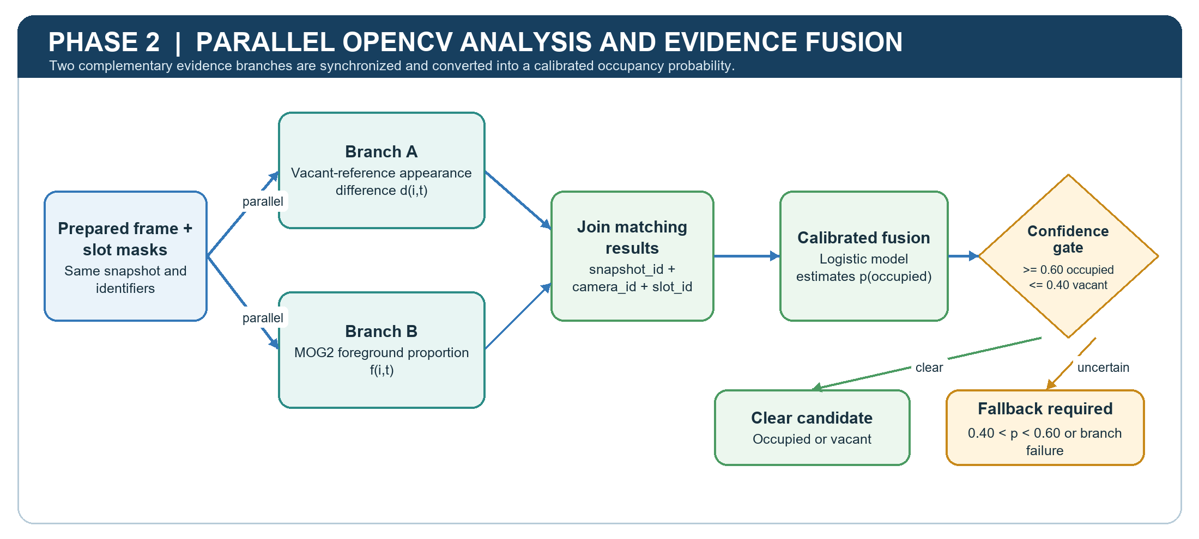
Figure 3.3. Phase 2 parallel OpenCV analysis and probability fusion.
Parallel evidence extraction. The vacant-reference branch will compare the greyscale pixels inside each current slot polygon with its confirmed-vacant reference. The MOG2 branch will update the camera background model once per chronological frame, produce a full-frame foreground mask, exclude shadow labels, apply calibrated morphological opening and closing, and then measure foreground pixels inside every slot. For slot i at time t, the two evidence values will be computed as follows:
dᵢ,ₜ = (1 / 255|Pᵢ|) Σ₍ₓ,ᵧ₎∈Pᵢ |Iₜ(x,y) - Iᵛᵃᶜᵢ(x,y)|
fᵢ,ₜ = (1 / |Pᵢ|) Σ₍ₓ,ᵧ₎∈Pᵢ 𝟙[Mₜ(x,y) = foreground]
Here, Pᵢ denotes the valid pixels of slot i, Iₜ is the current image, Iᵛᵃᶜᵢ is the vacant reference, and Mₜ is the cleaned MOG2 mask. Larger values indicate stronger deviation from the vacant appearance or a larger foreground proportion. Neither value will be described as a native confidence score: the first is a normalized distance and the second is a mask proportion.
Calibrated evidence fusion. After both branches return the same snapshot_id, camera_id, and slot_id, their values will form one evidence vector. Labelled fitting data will estimate a logistic-regression model that converts this vector into pᵢ,ₜ, an estimated probability of occupancy:
pᵢ,ₜ = 1 / {1 + exp[-(β₀ + β₁dᵢ,ₜ + β₂fᵢ,ₜ)]}
The coefficients and decision boundaries will be fixed using the fitting and calibration partitions. The initial operating rule will treat pᵢ,ₜ >= 0.60 as an occupied candidate and pᵢ,ₜ <= 0.40 as a vacant candidate; values strictly between 0.40 and 0.60 will be uncertain. Exactly 0.60 and 0.40 will follow the occupied and vacant branches respectively. These values are experimental starting points rather than assumed universal thresholds.
Synchronization, failure handling, and acceptance. The probability will not be calculated when a branch times out, fails, or returns mismatched identifiers. Instead, the full frame and affected slot records will be moved to the verification area with the two available values, error information, and configuration version. Phase 2 is accepted when branch outputs remain traceable, calibration quality is reported, boundary cases behave exactly as specified, and every uncertain or failed observation produces one complete fallback record without creating a premature confirmed status.

3.4 Phase 3: Selective YOLOv8s Verification and Slot Association
Phase 3 adds semantic vehicle evidence only when Phase 2 is uncertain or incomplete. A single full-frame inference can address all affected slots from the same snapshot, avoiding repeated inference per polygon. Figure 3.4 shows the verification queue, detector, slot association, and conservative decision paths.
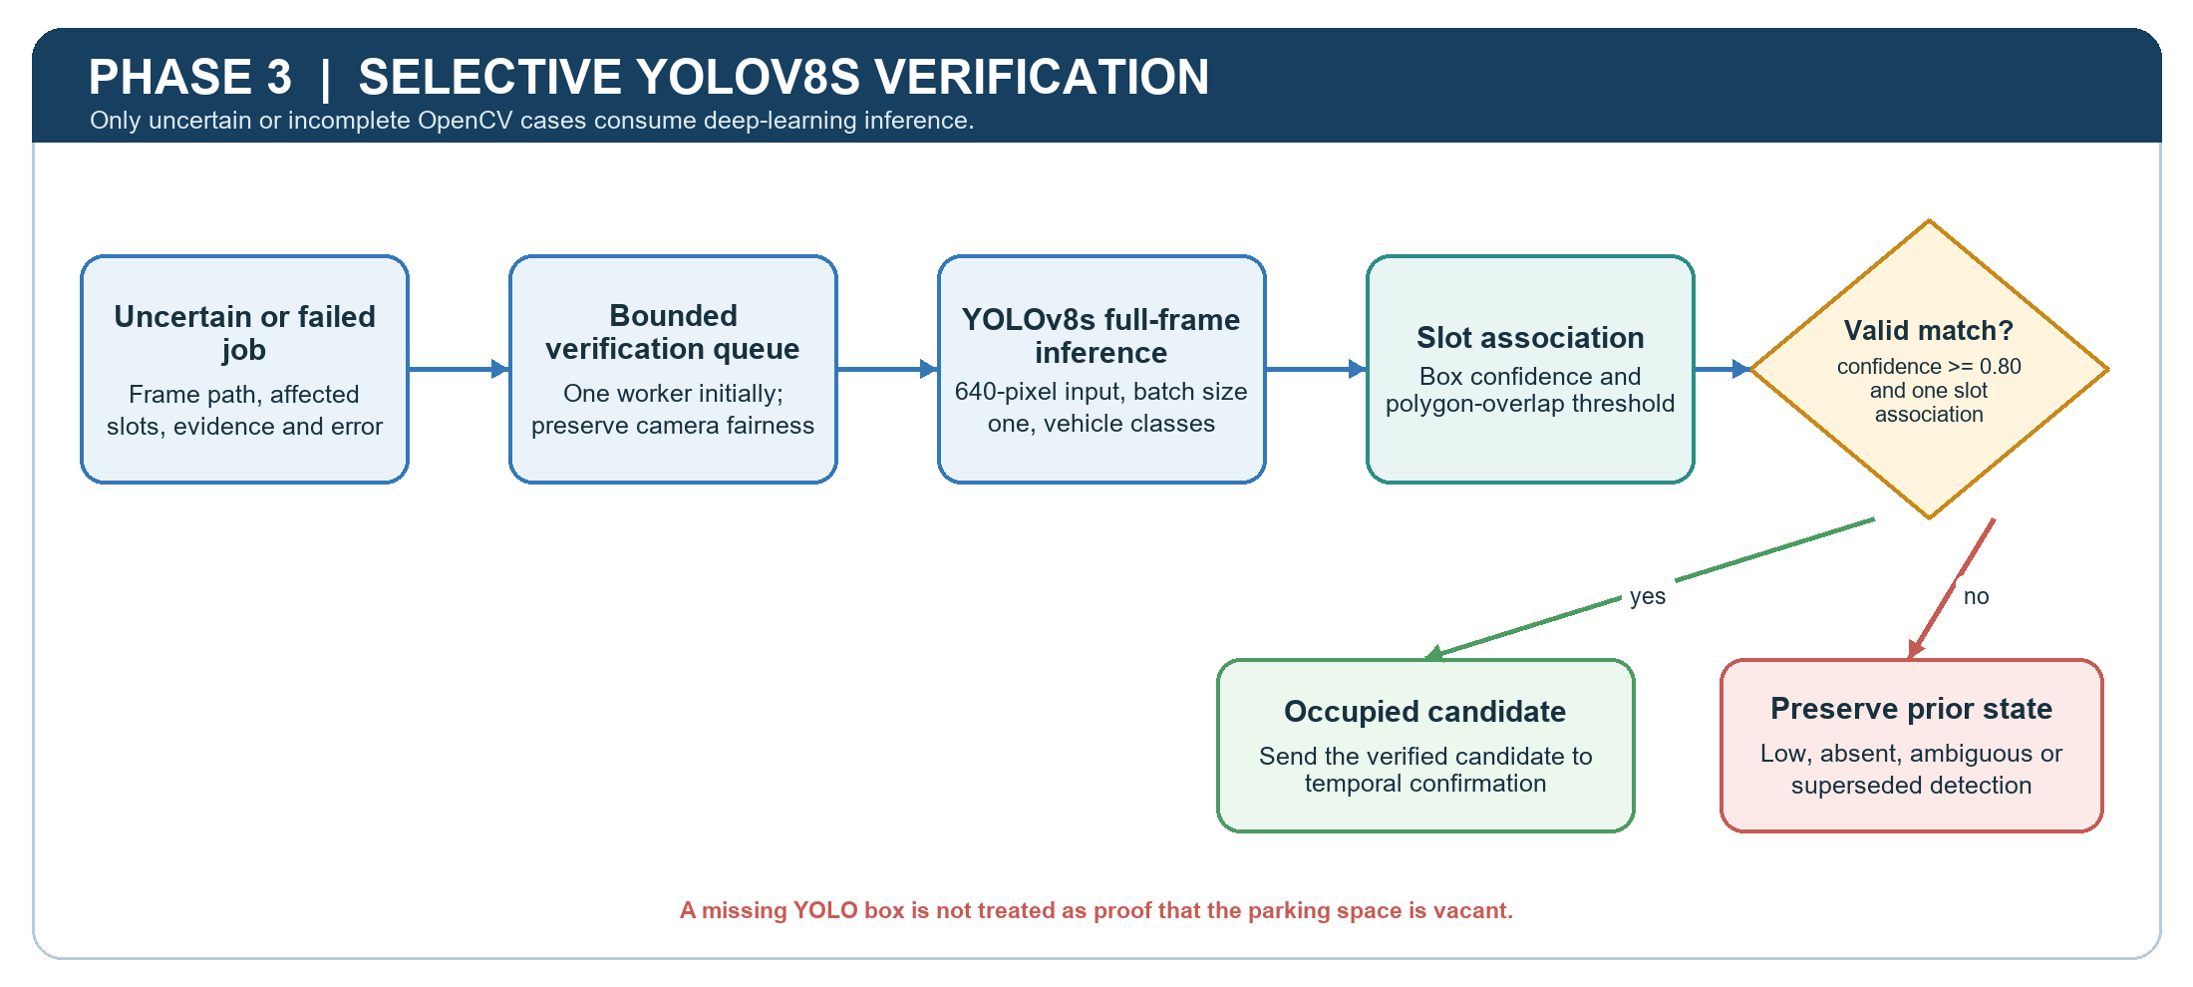
Figure 3.4. Phase 3 selective YOLOv8s verification and slot association.
Verification queue and inference. Each job will contain the frame path, snapshot_id, camera_id, affected slot_ids, Phase 2 evidence, error details, and enqueue time. The queue will be bounded and initially served by one worker so that memory demand and ordering are observable. YOLOv8s will be loaded once, use a 640-pixel input and batch size one, and run once on the relevant full frame. Only configured vehicle-related classes will be retained. Box confidence will be treated as confidence in a detected object, not as a calibrated probability that a particular parking slot is occupied.
Vehicle-to-slot association. Each retained box will be compared with the stored slot polygons using polygon-overlap proportion, with the minimum overlap selected on calibration images. The initial rule will require box confidence of at least 0.80 and exactly one valid slot association to create an occupied candidate; exactly 0.80 will be accepted. When a vehicle spans neighbouring slots, association will use the calibrated overlap rule and unresolved ties will remain ambiguous rather than being forced into a slot.
Conservative failure handling. A low-confidence, absent, or ambiguous YOLO detection will not be interpreted as proof that a slot is vacant because a missed detection remains possible. The previous confirmed state will therefore be retained until a later clear OpenCV vacant candidate passes Phase 4. A verification result will also be discarded if a newer accepted snapshot for the same camera and slot has superseded it. Completed verification frames will be deleted unless selected for the approved research dataset.
Phase acceptance. Tests will cover confidence exactly at and immediately around 0.80, no qualifying box, ambiguous polygon overlap, multiple uncertain slots in one frame, queue saturation, worker failure, and superseded results. Reported evidence will include fallback frequency, queue depth, verification latency, processor and memory use, box-level performance when annotations exist, and the proportion of verification jobs that produce a valid occupied candidate.

3.5 Phase 4: Temporal Confirmation and State Persistence
Phase 4 converts a momentary occupied or vacant candidate into a durable service state. It prevents temporary motion, glare, occlusion, duplicated jobs, and late results from immediately changing published availability. Figure 3.5 illustrates the per-slot candidate history, three-snapshot decision, and transactional persistence controls.
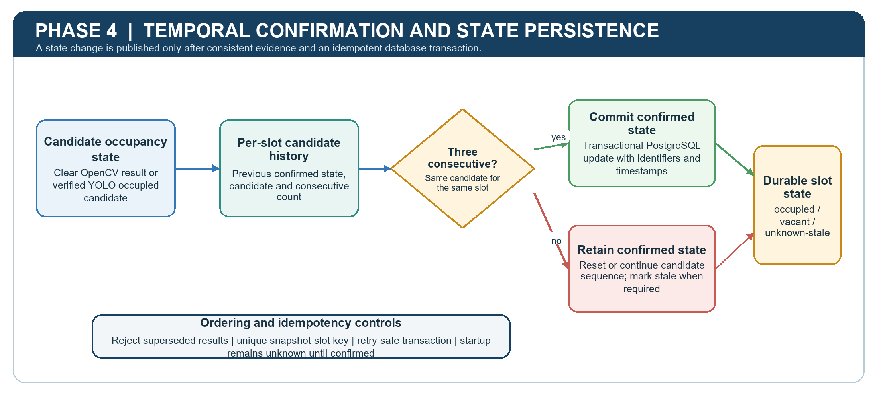
Figure 3.5. Phase 4 temporal confirmation and persistent-state control.
Temporal state machine. Each slot will store its confirmed state, pending candidate, consecutive-candidate count, most recent observation time, and configuration version. At startup the slot will remain unknown until one candidate is observed in three consecutive accepted snapshots. A candidate matching the pending candidate will increment the count; a conflicting clear candidate will replace it and restart the count; an uncertain or failed observation will interrupt the sequence without changing the confirmed state. A candidate matching the already confirmed state will refresh the observation time without creating a redundant state-change event.
Transactional persistence. The verification_queue table will record job identifiers, frame path, affected slots, Phase 2 evidence, job status, errors, and creation and completion times. The parking_status table will hold confirmed occupancy, result source, decision value, pending candidate, consecutive count, observation time, update time, and stale flag. A unique snapshot-slot key, chronological acceptance check, and database transaction will ensure that retries cannot create duplicated, partially written, or out-of-order state changes.
Reliability and recovery. If persistence fails, the job will remain retryable and the in-memory result will not be published as confirmed. Superseded results will be recorded or discarded according to the retention policy but will not overwrite a newer state. Camera or processing interruption will preserve the last confirmed value while its freshness expires into a visible stale condition. MOG2 will be allowed to re-stabilize after a prolonged interruption before its evidence is again accepted as clear.
Phase acceptance. Boundary, concurrency, restart, and fault-injection tests will verify the three-snapshot rule, startup unknown state, duplicate-job idempotency, rejection of late results, atomic updates, stale transitions, and recovery after database or camera interruption. Phase 4 succeeds only when every published state can be traced to an accepted snapshot sequence and the stored record remains internally consistent.

3.6 Phase 5: Backend Publication and Mobile Presentation
Phase 5 exposes confirmed occupancy through a controlled service boundary and converts it into understandable parking availability. Raw camera images and database credentials do not pass to the mobile client. Figure 3.6 shows the PostgreSQL, FastAPI, REST/WebSocket, Flutter, and user-facing sequence.
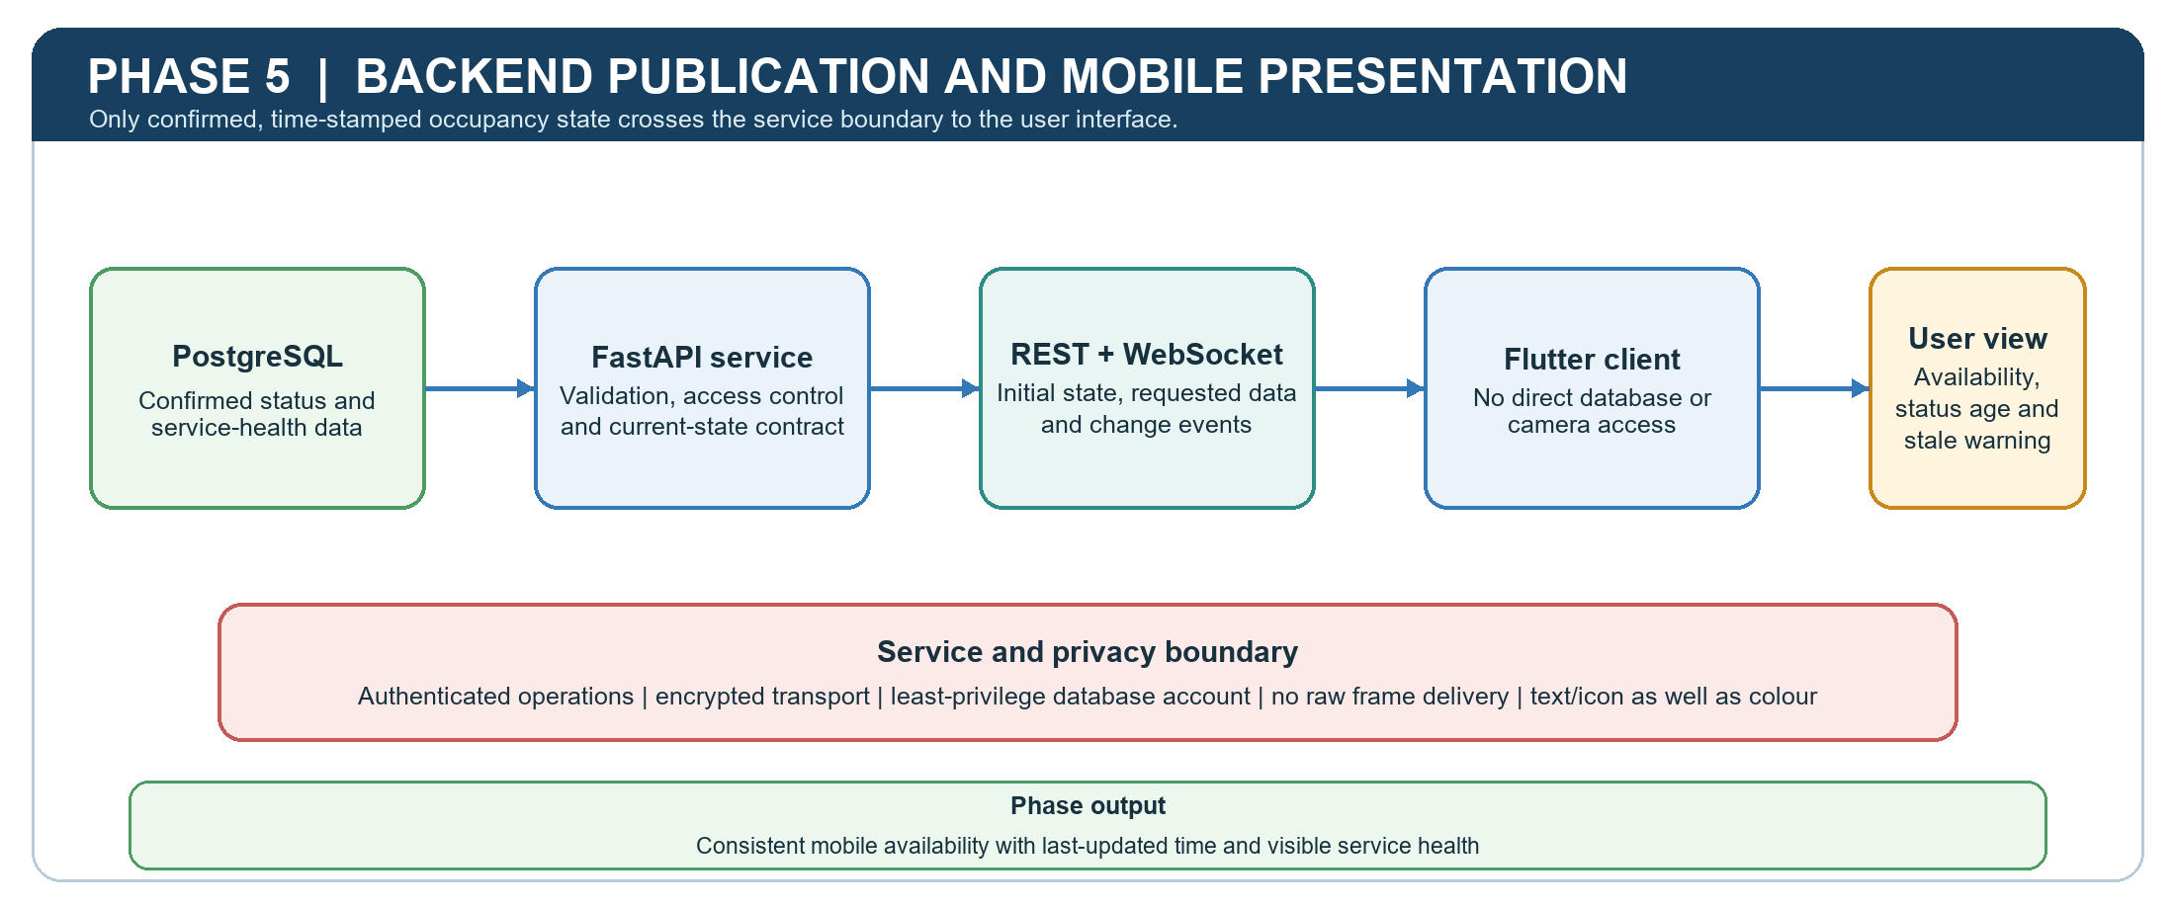
Figure 3.6. Phase 5 backend publication and mobile presentation.
Backend service contract. FastAPI REST endpoints will provide the initial current-state view and authorized historical or configuration data, while a WebSocket channel will publish confirmed occupancy changes without continuous mobile polling. Each slot payload will contain slot_id, camera or zone context, confirmed state, result source, observation time, update time, state age, and stale or service-health indicators. The API will validate output against the committed PostgreSQL state before delivery.
Mobile presentation and usability. The Flutter application will display occupied, vacant, unknown, and stale states; available-space counts; last-updated time; and camera or service health. Status will be communicated through text or icons as well as colour so that the display does not depend on colour perception alone. The application will not access PostgreSQL or camera credentials directly, and it will preserve the last confirmed value with a stale warning when new data are delayed rather than presenting old information as current.
Security, privacy, and failure handling. Camera and database secrets will be stored outside source code, database accounts will follow least privilege, privileged API operations will require authentication, and network communication will use encryption in deployment. Only occupancy state and operational metadata will be sent to Flutter; facial recognition, licence-plate recognition, driver profiling, and raw-frame delivery are outside scope. Reconnection logic will restore the current REST state before resuming WebSocket events so that missed messages cannot leave the client inconsistent.
Phase acceptance. End-to-end tests will confirm that only committed state changes reach the client, unauthorized requests are rejected, reconnecting clients converge to the database state, stale indicators appear after the defined age, and text or icons accompany colour. Measurements will include FastAPI response time, WebSocket and Flutter update delay, payload consistency, reconnection recovery, and completion of predefined availability-check tasks.

3.7 Data Collection, Ground Truth, and Calibration
Dataset scope and provenance. Evaluation images will be obtained from institution-authorized cameras or publicly available or pre-recorded indoor parking footage whose use is permitted for academic testing. The intended scope is approximately 20 to 40 visible parking spaces across up to four fixed camera views. Recording sessions will seek vacant and occupied examples and, where observable, daytime, nighttime, rain or wet reflections, shadows, glare, occlusion, different vehicle sizes, and unusual parking. Coverage will be documented; no environmental condition will be claimed as evaluated when it lacks adequate examples.
Ground truth. Each sampled slot observation will be labelled occupied, vacant, or ambiguous. Ambiguous observations, including severe occlusion or uncertain boundary overlap, and a sample of ordinary observations will undergo a second review pass before the dataset is frozen. Disagreements will be resolved and logged. Ambiguous cases will be excluded from the primary binary metrics and reported separately as failure-mode evidence. No facial, licence-plate, or driver-identity labels will be created.
Partitioning and leakage control. Data will be divided by recording session or day into 60% fitting or training, 20% calibration and validation, and 20% final testing. Adjacent three-second snapshots from one parking event will remain in the same partition so that nearly identical observations cannot appear in model development and final testing. The fitting partition will support vacant references, logistic fusion, and optional YOLOv8s fine-tuning. The calibration partition will determine OpenCV probability boundaries, MOG2 and morphology settings, polygon-overlap threshold, YOLO confidence threshold, stale interval, and temporal confirmation. The final test partition will remain untouched until these choices and software versions are frozen.
Model and threshold control. The values 0.40, 0.60, and 0.80 and the three-snapshot window are initial experimental settings, not guaranteed final values. Pretrained YOLOv8s will be the baseline; if held-out calibration recall is inadequate, it may be fine-tuned using representative fitting data in a GPU-equipped environment, while the VPS remains inference-only. YOLOv8 Medium will be considered only if it produces a meaningful held-out improvement without unacceptable memory use, latency, or queue growth. Every dataset, polygon, reference, model, and parameter set will receive a version so that the final experiment can be reproduced.

3.8 Evaluation and Validation
Comparative design. Three configurations will process the same final-test observations, polygons, and ground truth: calibrated OpenCV without YOLO, YOLOv8s on every test frame, and the selective hybrid pipeline. Unresolved OpenCV-only observations will be counted as abstentions and decision coverage will be reported. The comparison will determine whether selective verification improves the balance of decision quality, coverage, latency, and resource use instead of testing only the proposed configuration in isolation.
Detection and calibration measures. Slot-level results will include accuracy, precision, recall, F1-score, confusion matrix, false-vacant rate, false-occupied rate, and decision coverage. False-vacant errors will receive particular attention because they can direct a user toward an unavailable space. Reliability plots and Brier score will assess calibration of the fused OpenCV probability. Where vehicle boxes are annotated, YOLOv8s precision, recall, and mean Average Precision will also be reported. Session-level bootstrap confidence intervals will represent uncertainty without treating adjacent frames as independent; paired significance testing will be used only when its assumptions and sample size are satisfied, otherwise the comparison will remain descriptive.
Environmental and failure-mode analysis. Results will be separated by camera and by adequately represented conditions such as daytime, nighttime, rain or wet surfaces, glare, and occlusion. This stratification will reveal whether a strong overall result hides weak performance in one view or condition. Conditions with insufficient held-out observations will be reported as limitations rather than assigned unsupported accuracy claims. Ambiguous ground truth and representative false-vacant, false-occupied, queue, acquisition, and association failures will be analysed qualitatively.
Operational evaluation. Measurements will include snapshot-retrieval success, Phase 3 fallback rate, p50 and p95 end-to-end latency, FastAPI response time, Flutter update delay, CPU utilization, peak RAM, disk use, queue depth, and stale-state duration. A one-worker load test will emulate up to four cameras at the initial three-second interval, equivalent to a worst-case arrival rate of approximately 1.33 verification frames per second if every frame falls back. Sustained queue growth, an out-of-memory event, or delay extending beyond later acquisition cycles will identify an unsustainable configuration.
Functional, boundary, and concurrency validation. Tests will cover probabilities below, exactly on, inside, and above the OpenCV boundaries; branch failure or timeout; YOLO confidence immediately below, exactly at, and above 0.80; absent or ambiguous detection; three consecutive and interrupted candidate sequences; duplicate jobs; camera reconnect; database failure; client reconnect; and stale-state expiry. Concurrency tests will verify that results cannot mix snapshot_id, camera_id, or slot_id. The final end-to-end test will require one validated image sequence to produce the expected PostgreSQL transaction, API payload, WebSocket event, and Flutter state while an invalid or superseded sequence produces no false publication.
Usability and acceptance decision. The mobile interface will be checked with predefined tasks covering identification of current availability, interpretation of occupied, vacant, unknown, and stale states, and recognition of the last-updated time. Participant-based usability testing will be conducted only if the required institutional approval and consent are available; otherwise the report will limit its claims to functional and accessibility inspection. The proposed system will be accepted only if detection, operational, reliability, security, privacy, and user-delivery evidence is reported together and any unmet target is stated as a limitation rather than hidden by an overall accuracy value.

3.9 Computing Factors and Constraints
Deployment platform. The confirmed target is the perfect-Jy-Debian KVM virtual machine running Debian GNU/Linux 13 on x86-64 architecture, with four virtual CPUs, 3.8 GiB RAM, no swap, and a 30 GB virtual disk with approximately 27 GB initially free. These values are treated as measured constraints rather than evidence that the server is sufficient. The selected runtime and acquisition interval must demonstrate sustainable operation on this platform while OpenCV, PostgreSQL, and FastAPI are active.
Performance and scalability. YOLOv8s will be loaded once, use batch size one, and initially run through one verification worker. PyTorch, ONNX Runtime, and OpenVINO execution will be benchmarked on the actual VPS, and the selected runtime must preserve validation accuracy while avoiding sustained queue growth. YOLOv8 Medium will be an accuracy-contingency alternative and will not be invoked as a timeout fallback. Cameras or workers will be added only after measured service time, memory use, queue depth, and database contention show adequate capacity.
Storage, reliability, and maintainability. Ordinary incoming frames will be deleted after processing and verification frames after job completion, except for explicitly approved evaluation samples. Disk alerts and bounded directories will prevent accumulation. Chronological camera queues, unique identifiers, structured error records, timeouts, last-confirmed-state fallback, MOG2 re-stabilization, idempotent database updates, and the three-snapshot rule will support reliability. Acquisition, OpenCV analysis, YOLO verification, persistence, API, and mobile components will remain separate, with versioned polygons, references, models, schemas, and calibration settings to support reproducibility and later maintenance.
Security, privacy, and ethics. Camera and database secrets will be environment-based, PostgreSQL accounts will use least privilege, sensitive API operations will be authenticated, and deployed network communication will be encrypted. Camera views and frame retention will be limited to the parking purpose; research images will have restricted access; and the application will publish slot state rather than identity. Facial recognition, licence-plate recognition, driver profiling, payment, reservation, and unrestricted camera access remain outside scope. Any participant-based usability activity will require approval, informed consent, and data minimization.
Usability and practical limitations. The interface will use text or icons as well as colour, show availability counts, state age, and service-health warnings, and avoid presenting stale data as current. The evaluation will acknowledge limits created by camera permission, available environmental coverage, fixed viewpoints, manual polygon configuration, VPS resources, class imbalance, and the selected study duration. These controls provide a method tailored to the project while preventing the proposal from claiming full-campus scalability or universal accuracy before evidence is available.

Work Plan & Timeline
This chapter presents the work plan for the complete capstone project, covering the proposal and design activities in Capstone 1 and the implementation, integration, evaluation, and final reporting activities in Capstone 2. The schedule is dependency-based: each work package has a defined predecessor, output, duration rationale, milestone where applicable, and schedule-risk response. Completed Capstone 1 activities are distinguished from current and planned work so that the timeline reflects both actual progress and the remaining delivery commitments.

4.1 Planning Basis and Phase Relationships
Capstone 1 establishes the evidence and design baseline. Problem selection and feasibility lead to scope definition, which enables the literature review and initial methodology to proceed with partial overlap. The methodology then passes through supervisor review and application-focused restructuring before the evaluation design, computing constraints, work plan, and complete proposal are consolidated. This sequence prevents implementation from beginning against an unstable scope while still allowing literature synthesis and method design to progress in parallel.
Capstone 2 follows a staged build-and-validate sequence. Requirements re-baselining enables camera integration and the backend foundation to begin in parallel. Camera access enables polygon configuration and labelled-data collection; these outputs support the two OpenCV evidence branches, probability fusion, and selective YOLO verification. The database and API foundation is developed concurrently because it can use controlled test data before the detector is complete. Detector, persistence, and frontend outputs converge at the end-to-end integration milestone, after which the system configuration and data partitions are frozen before final held-out evaluation. Reported conclusions will therefore be based only on results collected after the system freeze.
Completed Capstone 1 dates are based on the weekly project logbooks. Semester boundaries, mid-semester breaks, and assessment windows follow the Sunway University Academic Calendar 2026 (Sunway University, 2026). The official breaks from 22 to 28 June 2026 and 16 to 22 November 2026 are shown explicitly; the first contains documented review work, while the second is reserved mainly as contingency and supervisor-review capacity. Exact Capstone submission and presentation deadlines remain governed by the module brief and should replace the end-of-window targets if formally announced.

4.2 Work Activities, Duration Rationale and Dependencies
Table 4.1. Work activities, schedule, dependencies, outputs, and duration rationale.
ID | Work activity | Dates and duration | Predecessor(s) | Output and risk-adjusted duration rationale
P1 | Problem selection, supervision and feasibility | 4-15 May 2026  2 weeks | None | Feasible topic and supervisor commitment. Two weeks allowed problem framing, resource checks, and supervision confirmation.
P2 | Scope, objectives and system framework | 18-22 May  1 week | P1 | Scope and framework baseline. One focused week was sufficient once feasibility and supervision were confirmed.
P3 | Literature synthesis and research-gap analysis | 25 May-5 Jun  2 weeks | P2 | Thematic review and defensible research gap. Two weeks allowed comparison of sensor, vision, deep-learning, and hybrid approaches.
P4 | Initial methodology and evaluation design | 1-12 Jun  2 weeks | P2; early P3 | First end-to-end method draft. It overlaps P3 because emerging evidence can inform design while the review is consolidated.
P5 | Supervisor review and methodology restructuring | 15 Jun-10 Jul  4 weeks | P4 | Application-focused methodology revision. Four weeks reflect repeated feedback, comparable-paper review, and consistency checks; the June break acts as review capacity.
P6 | Consolidate methodology, constraints and tests | 13-24 Jul  2 weeks | P5 | Reproducible Chapter 3 baseline. Time covers detailed thresholds, data partitions, VPS constraints, metrics, boundary tests, and end-to-end validation logic.
P7 | Chapter 4 and complete proposal integration | 27 Jul-6 Aug  2 weeks | P3, P6 | Rubric-aligned work plan and integrated proposal. Two weeks provide time for dependency mapping, risk analysis, Gantt preparation, and cross-chapter consistency.
P8 | Final QA, submission and presentation preparation | 7 Aug-14 Aug  1 week | P7 | Submission-ready proposal and presentation. The teaching-end and assessment window provides formatting, reference, supervisor-correction, and presentation contingency.
D1 | Re-baseline requirements and development environment | 28 Sep-9 Oct  2 weeks | P8 | Confirmed MVP backlog and reproducible environment. Two weeks allow package, repository, secret, database, and server checks after the semester transition.
D2 | Camera acquisition and polygon/ROI configuration | 5-23 Oct  3 weeks | D1 | Timestamped snapshot path and versioned polygons. Extra time covers ONVIF/RTSP access, viewpoint stability, permissions, and fallback test feeds.
D3 | Data collection, labelling and frozen partitions | 12 Oct-13 Nov  5 weeks | D1, D2 | Reviewed occupied, vacant, and ambiguous labels with session-level 60/20/20 partitions. Five weeks improves environmental coverage and avoids leakage.
D4 | PostgreSQL and FastAPI foundation | 12 Oct-6 Nov  4 weeks | D1 | Database schema plus REST/WebSocket skeleton. Parallel work is possible with fixtures before detector output is available; time includes migrations and access control.
D5 | OpenCV branches and probability fusion | 19 Oct-13 Nov  4 weeks | D2, D3 | Reference-difference and MOG2 evidence with calibrated fusion. Four weeks covers masking, chronology, shadow/noise handling, coefficient fitting, and unit tests.
Buffer | Supervisor review and recovery allowance | 16-22 Nov  1 week | D3-D5 | Protected contingency. Used only for review, data-access recovery, performance rework, or defects that threaten the critical chain.
D6 | YOLO verification, slot association and queue | 23 Nov-4 Dec  2 weeks | D3, D5 | Selective full-frame verifier for uncertain slots. Two weeks covers model loading, box-polygon association, ambiguity handling, stale-result rejection, and queue tests.
D7 | State confirmation, persistence and reliability | 30 Nov-11 Dec  2 weeks | D4-D6 | Transactional confirmed-state pipeline. Time covers three-observation confirmation, retries, timeouts, error logs, storage cleanup, and stale-data behaviour.
D8 | Flutter, REST and WebSocket integration | 7-18 Dec  2 weeks | D4; D7 final | Mobile prototype showing status, counts, stale warnings, and timestamps. Mock APIs support early work; final acceptance depends on D7 outputs.
D9 | End-to-end, boundary and concurrency testing | 14-25 Dec  2 weeks | D7, D8 | Release candidate and frozen configuration. Tests cover probability boundaries, failure paths, identifier isolation, duplicate prevention, and validated publication to Flutter.
D10 | Held-out accuracy, environmental and operational evaluation | 21 Dec-8 Jan 2027  3 weeks | D3, D6, D9 | Final metrics and load-test evidence. Three weeks supports three configurations, environmental stratification, latency/resource monitoring, and failure analysis.
D11 | Analysis, final report, poster, demonstration and corrections | 28 Dec-20 Jan  3.5 weeks | D10 | Submission-ready evidence and demonstration. Writing overlaps late evaluation, but final claims wait for D10; the assessment window absorbs feedback and presentation fixes.

4.3 Milestones and Acceptance Criteria
A milestone is achieved only when its acceptance criterion is met; elapsed time alone does not constitute completion. These gates prevent unfinished work from being passed to dependent activities.
Table 4.2. Project milestones and measurable acceptance criteria.
ID | Target | Milestone | Acceptance criterion
M1 | 15 May 2026 | Feasibility and supervision confirmed | Problem, intended solution, main resource assumptions, and supervisor interest are documented.
M2 | 22 May | Scope and framework baseline | System boundary, major components, data flow, objectives, and key exclusions are explicit.
M3 | 12 Jun | Evidence and initial method baseline | The literature gap and first end-to-end methodology are sufficiently complete for supervisor review.
M4 | 10 Jul | Application-focused methodology revision | Methods specify project inputs, steps, outputs, assumptions, limitations, and justification instead of repeating theory.
M5 | 24 Jul | Complete evaluation design | Data split, metrics, test cases, constraints, thresholds, and end-to-end validation route are internally consistent.
M6 | 28 Aug | Capstone 1 stage complete | Proposal, work plan, references, presentation material, and required submission items are checked against the module brief.
M7 | 23 Oct | Acquisition and ROI proof | At least one permitted camera or test feed produces timestamped snapshots with stable identifiers and saved polygon configuration.
M8 | 13 Nov | Data, OpenCV, and API foundation | Reviewed labels and partitions exist; both OpenCV evidence branches run; PostgreSQL/FastAPI basics operate with test records.
M9 | 4 Dec | Selective hybrid verifier | Uncertain slots reach YOLO once per frame, vehicle boxes map to polygons, and verification jobs are traceable.
M10 | 18 Dec | Integrated mobile prototype | Confirmed and stale states, available counts, and timestamps reach Flutter through REST/WebSocket without direct database access.
M11 | 25 Dec | System and configuration freeze | Critical functional, boundary, and concurrency tests pass; code, settings, polygons, and data partitions are versioned and frozen.
M12 | 8 Jan 2027 | Evaluation complete | Held-out accuracy, error, environmental, latency, resource, queue, and API/mobile timing results are collected for all feasible configurations.
M13 | 20 Jan | Final delivery and demonstration | Results are analysed without unsupported claims; report, poster, demonstration, corrections, and module submissions are complete.

4.4 Schedule Risks and Contingencies
Schedule risk is controlled through early trigger checks, protected buffers, and scope rules. A risk response is activated when its trigger is observed rather than waiting for the related milestone to fail. The mid-semester contingency week and final assessment windows are not used to add optional features.
Table 4.3. Schedule risks, triggers, mitigation, and contingency responses.
Risk ID / tasks | Risk | Likelihood / impact | Preventive mitigation | Trigger, contingency and allocated buffer
R1  D2, D3, D10 | Camera or parking-data access is delayed or withdrawn | High / High | Seek permission early; validate ONVIF/RTSP using one camera; retain permitted public or prerecorded footage and a test feed. | Trigger: no stable feed by 16 Oct. Switch D2/D3 to fallback footage and document the deployment limitation. Allocated buffer: the pooled 16-22 Nov recovery week for later access recovery.
R2  D3, D5, D10 | Insufficient night, rain, glare, occlusion, or unusual-parking coverage | Medium / High | Track coverage by camera, session, condition, and label; review gaps weekly; keep adjacent frames within one partition. | Trigger: a required condition remains unrepresented by 6 Nov. Prioritise targeted collection; otherwise report the gap and avoid a separate accuracy claim. Allocated buffer: up to the pooled 16-22 Nov week for targeted collection.
R3  D5-D7, D10 | The 4-vCPU, 3.8-GiB VPS cannot sustain verification load | High / High | Benchmark YOLOv8s early with one worker and batch size one; compare approved CPU runtimes; monitor p95 latency, RAM, disk, and queue growth. | Trigger: sustained queue growth, an out-of-memory event, or processing beyond later capture cycles. Reduce verification demand or runtime cost. Allocated buffer: the pooled 16-22 Nov week for performance rework.
R4  D5, D6, D10 | Fusion or YOLO thresholds do not achieve reliable occupancy decisions | Medium / High | Fit and calibrate only on fitting/calibration partitions; retain abstention handling; analyse false-vacant and false-occupied errors separately. | Trigger: unacceptable calibration or recall at M9. Tune within the calibration set or fine-tune YOLOv8s in a GPU environment; never tune on the final test set. Allocated buffer: the pooled 16-22 Nov week for recalibration before M9.
R5  D4, D7-D9 | Integration, stale results, duplicates, or identifier mixing delay the prototype | Medium / High | Define payload and database contracts early; use unique snapshot-slot keys, transactions, mocks, boundary tests, and incremental end-to-end checks. | Trigger: M10 data differs across detector, database, API, and Flutter. Freeze feature work and correct contracts and concurrency. Allocated buffer: 21-25 Dec, the second D9 week.
R6  D1-D11 | Optional features or broad deployment create scope creep | Medium / Medium | Protect the MVP: one selected area, 20-40 slots, 2-4 camera views, occupancy display, and no reservation, payment, face, or licence-plate functions. | Trigger: optional work threatens M10 or M11. Defer it to recommendations. Allocated buffer: zero additional time; immediate scope reduction protects the November and final-delivery buffers.
R7  D2-D4, D10 | Privacy, security, or retention concerns interrupt data use | Low / High | Limit views and retention; exclude identity labels; restrict image access; store secrets outside code; use least-privilege database/API access. | Trigger: an access concern or unauthorised data exposure. Stop collection, quarantine affected material, use approved alternatives, and document the impact. Allocated buffer: the pooled 16-22 Nov week only after approved access resumes.
R8  P1-P8, Buffer, D9-D11 | Supervisor rework or an earlier module deadline compresses final activities | Medium / High | Submit staged outputs, maintain weekly logs, keep references and report sections current, and compare work against the rubric before the final window. | Trigger: a formal deadline or major feedback shortens the schedule. Re-baseline in the same dependency order and remove non-MVP work first. Allocated buffer: unused P8 capacity (10-28 Aug), the pooled 16-22 Nov week, and non-MVP deferral.

4.5 Gantt Charts
Figures 4.1 and 4.2 depict weekly activity bars, predecessor IDs, official break periods, and milestone gates. Overlapping bars show intentional parallel work rather than missing dependencies. Completed, in-progress, and planned states are visually separated, while the milestone labels correspond to the acceptance criteria in Table 4.2.

 |  | Completed |  | In progress |  |  | Planned |  |  |  |  | Official break / contingency; B = review or buffer work
ID | Activity |  |  |  |  | Pred. |  | 04  May | 11  May |  | 18  May |  | 25  May | 01  Jun | 08  Jun | 15  Jun |  | 22  Jun | 29  Jun | 06  Jul | 13  Jul | 20  Jul | 27  Jul | 03  Aug | 14  Aug
P1 | Problem, supervision, feasibility |  |  |  |  | - |  |  | M1
P2 | Scope, objectives, framework |  |  |  |  | P1 |  |  |  |  | M2
P3 | Literature and research gap |  |  |  |  | P2
P4 | Initial methodology and evaluation |  |  |  |  | P2/P3 |  |  |  |  |  |  |  |  | M3
P5 | Review and methodology restructure |  |  |  |  | P4 |  |  |  |  |  |  |  |  |  |  |  | B |  | M4
P6 | Detailed method, constraints, tests |  |  |  |  | P5 |  |  |  |  |  |  |  |  |  |  |  |  |  |  |  | M5
P7 | Chapter 4 and proposal integration |  |  |  |  | P3/P6
P8 | QA, submission, presentation |  |  |  |  | P7 |  |  |  |  |  |  |  |  |  |  |  |  |  |  |  |  |  |  | M6
Figure 4.1. Capstone 1 work plan from 4 May to 14 August 2026.

ID | Activity | Pred. | 28  Sep | 05  Oct | 12  Oct | 19  Oct | 26  Oct | 02  Nov | 09  Nov | 16  Nov | 23  Nov | 30  Nov | 07  Dec | 14  Dec | 21  Dec | 28  Dec | 04  Jan | 11  Jan | 18  Jan
D1 | Requirements and environment baseline | P8
D2 | Camera acquisition and ROI config | D1 |  |  |  | M7
D3 | Data collection and frozen splits | D1/D2
D4 | PostgreSQL and FastAPI foundation | D1
D5 | OpenCV branches and fusion | D2/D3 |  |  |  |  |  |  | M8
Buffer | Review and recovery allowance | D3-D5 |  |  |  |  |  |  |  | B
D6 | YOLO verifier and queue | D3/D5 |  |  |  |  |  |  |  |  |  | M9
D7 | State, persistence, reliability | D4-D6
D8 | Flutter, REST, WebSocket | D4/D7 |  |  |  |  |  |  |  |  |  |  |  | M10
D9 | End-to-end and concurrency tests | D7/D8 |  |  |  |  |  |  |  |  |  |  |  |  | M11
D10 | Held-out and operational evaluation | D3/D6/D9 |  |  |  |  |  |  |  |  |  |  |  |  |  |  | M12
D11 | Analysis, report, demo, corrections | D10 |  |  |  |  |  |  |  |  |  |  |  |  |  |  |  |  | M13
Figure 4.2. Capstone 2 work plan from 28 September 2026 to 20 January 2027.
Note. The Gantt charts use weekly columns and official semester windows. M1-M13 are completion gates rather than decorative dates. If the module brief specifies an earlier submission or presentation deadline, affected tasks will be compressed within their existing dependency order and optional work will be deferred before any acceptance criterion is reduced.

References

Adi, G. S., Nugroho, H., Rahmatullah, G. M., Fadhlan, M. Y., & Mutamaddin, D. (2024). Fusion algorithms on identifying vacant parking spots using vision-based approach. Indonesian Journal of Electrical Engineering and Computer Science, 36(3), 1640–1654. https://doi.org/10.11591/ijeecs.v36.i3.pp1640-1654
Amato, G., Carrara, F., Falchi, F., Gennaro, C., & Vairo, C. (2016). Car parking occupancy detection using smart camera networks and deep learning. In 2016 IEEE Symposium on Computers and Communication (ISCC) (pp. 1212–1217). IEEE. https://doi.org/10.1109/ISCC.2016.7543901
Barone, R. E., Giuffrè, T., Siniscalchi, S. M., Morgano, M. A., & Tesoriere, G. (2014). Architecture for parking management in smart cities. IET Intelligent Transport Systems, 8(5), 445–452. https://doi.org/10.1049/iet-its.2013.0045
Chen, L.-C., Sheu, R.-K., Peng, W.-Y., Wu, J.-H., & Tseng, C.-H. (2020). Video-based parking occupancy detection for smart control system. Applied Sciences, 10(3), 1079. https://doi.org/10.3390/app10031079
da Luz, G. P. C. P., Sato, G. M., Gonzalez, L. F. G., & Borin, J. F. (2026). Smart parking with pixel-wise ROI selection for vehicle detection using YOLOv8, YOLOv9, YOLOv10, and YOLOv11. Internet of Things, 36, 101858. https://doi.org/10.1016/j.iot.2025.101858
de Almeida, P. R. L., Oliveira, L. S., Britto, A. S., Jr., Silva, E. J., Jr., & Koerich, A. L. (2015). PKLot—A robust dataset for parking lot classification. Expert Systems with Applications, 42(11), 4937–4949. https://doi.org/10.1016/j.eswa.2015.02.009
de Almeida, P. R. L., Alves, J. H., Parpinelli, R. S., & Barddal, J. P. (2022). A systematic review on computer vision-based parking lot management applied on public datasets. Expert Systems with Applications, 198, 116731. https://doi.org/10.1016/j.eswa.2022.116731
Grbić, R., & Koch, B. (2023). Automatic vision-based parking slot detection and occupancy classification. Expert Systems with Applications, 225, 120147. https://doi.org/10.1016/j.eswa.2023.120147
Hadi, R. A., George, L. E., & Ahmed, Z. J. (2024). Computer vision-based approaches, datasets, and applications of smart parking systems: A review. Iraqi Journal of Science, 65(2), 979–1000. https://doi.org/10.24996/ijs.2024.65.2.32
Idris, M. Y. I., Leng, Y. Y., Tamil, E. M., Noor, N. M., & Razak, Z. (2009). Car park system: A review of smart parking system and its technology. Information Technology Journal, 8(2), 101–113. https://doi.org/10.3923/itj.2009.101.113
Jocher, G., Chaurasia, A., & Qiu, J. (2023). Ultralytics YOLOv8 (Version 8.0.0) [Computer software]. GitHub. https://github.com/ultralytics/ultralytics
Lin, T., Rivano, H., & Le Mouël, F. (2017). A survey of smart parking solutions. IEEE Transactions on Intelligent Transportation Systems, 18(12), 3229–3253. https://doi.org/10.1109/TITS.2017.2685143
OASIS Open. (2019, March 7). MQTT Version 5.0 (A. Banks, E. Briggs, K. Borgendale, & R. Gupta, Eds.). https://docs.oasis-open.org/mqtt/mqtt/v5.0/os/mqtt-v5.0-os.html
ONVIF. (2025, December). ONVIF core specification (Version 25.12). https://www.onvif.org/onvif/specs/core/ONVIF-Core-Specification.pdf
ONVIF. (n.d.). Media service: GetSnapshotUri. Retrieved August 4, 2026, from https://www.onvif.org/yaml/wsdl-viewer.php?file=%2Fver10%2Fmedia%2Fwsdl%2Fmedia.wsdl
OpenCV. (n.d.). About OpenCV. Retrieved August 4, 2026, from https://opencv.org/about/
Pokhrel, A., & Dao, G. (2025). Optimizing YOLOv8 for parking space detection: Comparative analysis of custom YOLOv8 architecture [Preprint]. arXiv (arXiv:2505.17364). https://doi.org/10.48550/arXiv.2505.17364
Redmon, J., Divvala, S., Girshick, R., & Farhadi, A. (2016). You only look once: Unified, real-time object detection. In 2016 IEEE Conference on Computer Vision and Pattern Recognition (CVPR) (pp. 779–788). IEEE. https://doi.org/10.1109/CVPR.2016.91
Ren, S., He, K., Girshick, R., & Sun, J. (2015). Faster R-CNN: Towards real-time object detection with region proposal networks. Advances in Neural Information Processing Systems, 28, 91–99. https://dl.acm.org/doi/10.5555/2969239.2969250
Revathi, G., & Dhulipala, V. R. S. (2012). Smart parking systems and sensors: A survey. In 2012 International Conference on Computing, Communication and Applications (ICCCA) (pp. 1–5). IEEE. https://doi.org/10.1109/ICCCA.2012.6179195
Satyanarayanan, M. (2017). The emergence of edge computing. Computer, 50(1), 30–39. https://doi.org/10.1109/MC.2017.9
Schulzrinne, H., Rao, A., Lanphier, R., Westerlund, M., & Stiemerling, M. (Eds.). (2016). Real-Time Streaming Protocol Version 2.0 (RFC 7826). RFC Editor. https://doi.org/10.17487/RFC7826
Wang, L., Musabini, A., Leonet, C., Benmokhtar, R., Breheret, A., Yedes, C., Burger, F., Boulay, T., & Perrotton, X. (2023). Holistic parking slot detection with polygon-shaped representations. In 2023 IEEE/RSJ International Conference on Intelligent Robots and Systems (IROS) (pp. 5797–5803). IEEE. https://doi.org/10.1109/IROS55552.2023.10342486

