CSS 422 Final Project Documentation
  - By Jasper Yeung
  - Last Updated: Mar 15, 2025

Overview
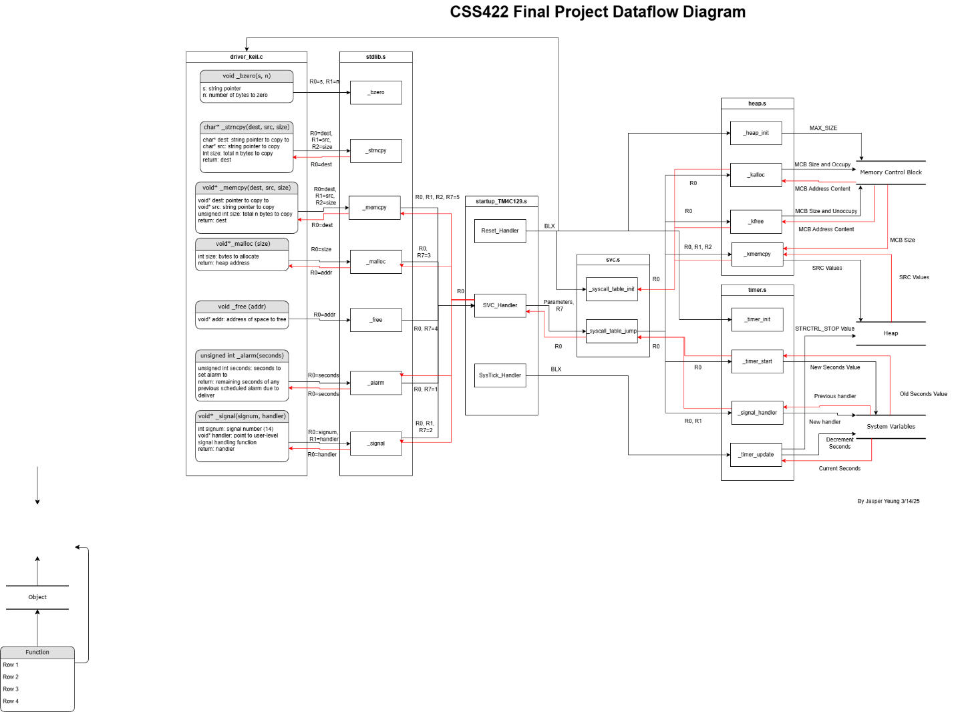
Figure 1 Dataflow Diagram
The Final Project is composed of 6 files of which 1 is based in C language and 5 in Arm Assembly. Depending on the operation in question the order in which files are run can vary. The implementation starts from Reset_Handler, _sycall_table_init, _heap_init, _timer_init, and then main() and subsequently runs according to the data flow in figure 1. The main functions implemented are _bzero(), _strncpy(), _malloc(), _free(), _alarm(), and _signal() whose implementation will be discussed later in this document.
All functions stated in the CSS422 Final Project: Table 14, have been implemented and should not have any missing functions. Furthermore, an additional function _memcpy() has been implemented in heap.s and will be elaborated later in this document.

stdlib.s
This file contains functions _bzero(), _strncpy(), _malloc(), _free(), _alarm(), and _signal(). These functions follow ARM Procedure Call Standards where function parameters are passed in R0-R3 and further parameters are passed into the stack.
_bzero() and _strncpy() are entirely implemented in stdlib.s and require no subroutine calls. _bzero() takes in a pointer to a string and an int number of bytes to zero-initialize in the string. _strncpy() takes a destination string pointer, a source string pointer, and int size of bytes to copy from source string to destination string while returning the destination pointer.
The rest of the functions _malloc, _free, _alarm, _signal, and _memcpy follow a similar structure of setting R7 to 3, 4, 1, 2, and 5 respectively and calling SVC_Handler for a subroutine call and returning the resulting R0 if needed.

startup_TM4C129.s
This file is a modified version of the startup assembly file running on the device TM4C129XNCZAD. Significant modifications are made to Reset_Handler, SVC_Handler, and SysTick_Handler. Reset_Handler runs upon starting the run-time environment and performs initialization for _syscall_table_init, _heap_init, and _timer_init for the respective data structures and calls __main() in driver_keil.c. SVC_Handler is invoked by some stdlib.s functions and invokes _syscall_table_jump which returns the appropriate return value in R0 for stdlib.s. SysTick_Handler catches any SysTick interrupts and invokes _timer_update.

svc.s
This file is used by SVC_Handler to run appropriate subroutines according to the passed R7 value. _syscall_table_init is run by Reset_Handler to initialize the system call table which stores function locations of _timer_start, _signal_handler, _kalloc, and _kfree which are associated with R7 values 1 to 4 respectively. _syscall_table_jump gets the appropriate function location based on the passed R7 and calls the function and then goes back to SVC_Handler.

heap.s
This file contains heap related functions for memory allocation and deallocation. _heap_init is called by Reset_Handler and initializes the heap by setting the max size of the heap at the top of memory control block and zeroing all values in the heap. The following functions are all called by _sycall_table_jump.
_kalloc allocates a memory space based on R0 parameter. _kalloc is a recursive function that uses the buddy system which goes throughout memory and divides free memory into two smaller sizes and setting buddies when able and assigns a 1 to the occupying bit in an appropriate sized MCB space while calculating and returning the heap address.
_kfree frees memory at a heap address specified in R0. _kfree is a recursive function that clears the occupying bit of the R0 address and then recursively joins other unoccupied buddy memory spaces into larger spaces until no more can be merged together which then returns the original heap address if successful or 0 if unsuccessful.
_memcpy copies the a specified size of bytes values of the source pointer in heap to the destination pointer in heap. The function compares the size of bytes to be copied to the MCB space allocation of the source and destination pointers. The function prevents overflow into other heap memory allocations if the bytes to copy is more than the destination’s space. The function also makes sure to zero any other values in destination if the entire space is not copied to.

timer.s
This file contains timer related functions for starting and updating. _timer_init is called by Reset_Handler and initializes the timer by stopping SysTick and loading the max value into SysTick Reload Value Register.
_timer_start is called by _syscall_table_jump and sets a timer by first retrieving the value at SECOND_LEFT in system variables and writing the SECOND_LEFT value to be the new seconds value of the R0 parameter. Then SysTick is enabled.
_timer_update is called by SysTick_Handler when it catches a SysTick interrupt. The function decrements the SECOND_LEFT by one. If the value is not 0 then the function is finished, otherwise the timer is stopped user function is invoked.
_signalhandler is called by _syscall_table_jump and chooses how to handle an interrupt signal from the parameter. The specific interrupt signal is specified by parameter in R0 and the new function pointer is written to USR_HANDLER if R0 is equal to 14. Then the old handler function pointer is returned in R0.

