Individual Weekly Report for Jasper Yeung

A Virtual Tabletop for Game Masters to Create Immersive Experience

July 19, 2025

# Accomplishments

* Met with the librarian and received possible sources, tools, and search methods to use for the project.
* Completed an expert meeting showing the design artifacts including the design specification document, SRS document, class diagram, domain diagram, flowchart, and component diagram while getting feedback.
* Implemented some Batte Map functionality including dragging objects, unchangeable map image, panning, zooming, and deleting objects.
* Implemented some Token functionality including a being movable, circle shape image, moveable, get methods, and set methods.

# Weekly Activities

| Activity / Task / Work | Hours | Status |
| --- | --- | --- |
| Expert Meeting | 1.15 | Complete |
| Battle Map Implementation | 18 | In progress |
| Status Report | 2 | Complete |
| Librarian Meeting | 0.25 | Complete |
| Research Azure DevOps | 0.6 | In progress |
| Capstone Contract Draft | 1 | Complete |
| **Weekly Total** | **23** |  |
| Previous Weekly Cumulative Total (Carry Over) | 60 |
| **Current Cumulative Total** | **83** |

# Plans for Next Week

| Activity / Task / Work | Est Hours |
| --- | --- |
| 1st Career Activity | 1 |
| Status Report Week 5 | 1.5 |
| Meeting | 2.5 |
| Implement Battle Maps and Tokens | 11 |
| Learn New Tools from Expert Meeting | 2 |

# Response to Feedback

**Librarian Je: Have you used any web design libraries or sources?**

That’s a good point Je. As of now, I have simply had a cursory look at possible libraries such as Chakra that may be useful for me to make intuitive user interface. However, I am very willing to look at the web design sources and libraries that you have provided.

**Expert John: What are the devices your web application will run on? What possible resolutions will they have?**

That’s a good point that I didn’t specify in the design specifications document. The web application will run on laptops and computers. However, devices like a large TV or tablet may run the web application. The main reason for these devices to run the application is that they must or can connect to a keyboard and mouse which are required for this application to be intuitive and functional. I don’t know the exact resolutions but I have implemented some functionality to adjust the application’s features to the window size.

**Expert John: GitHub is not only version control and a repository but also a release management and source control tool. You should learn more about creating build versions like WAR files.**

Thanks for the feedback and that is a good point. I have some experience with GitHub but not a lot, so this feedback is helpful for me to learn how to better utilize GitHub. I did not know what WAR files were before so I will investigate what they are.

**Expert John: You should use DevOps tools like Azure DevOps which will provide analytics for certain metrics, a repository for the source code, backlogs for work items, and testing plans. You have many of the structures and artifacts already in place to use DevOps.**

Thanks, that is a very helpful suggestion! I did not have any knowledge of DevOps tools before but now that I know what they are, I think it will significantly help me track my metrics, schedule, and testing plans.

**Expert John: On the class diagram, you should not use abbreviations for classes like TTRPG and RPScene since from the user’s perspective they won’t see it but developers should be able to understand what the class is at a glance.**

That is a good idea John. I thought the names were too long and cumbersome but I understand that a developer should create understandable class names. Modern IDE’s also autocomplete class names anyway so an abbreviated class name is not necessary and should be changed.

**Expert John: For your testing plans, what you are describing for system testing is more like functional testing. System testing has more to do with performance and resources.**

Thank you for the feedback. I definitely do not have a deep understanding of testing plans so having your input on this was very helpful and I will change system testing to functional testing.

# Other Reflections

This week has been extremely important for the progress of the project. The expert and librarian meetings were held which both yielded helpful tools and information needed to aid the functional implementation of the project. The expert meeting in particular highlighted issues regarding my testing plans, revisions needed in the design and specification document, and DevOps tools I should use.

This week was also the first week that coding was performed. Already some functional requirements have been included including the draggable objects, panning, zooming, and deleting objects. However, this week highlighted how extremely optimistic the original schedule was in regard to the functional development of the project. I do not believe the Battle Map and Tokens will be completed at minimum in two more weeks. This also means the schedule will have to be vastly adjusted, especially with new considerations for testing using new tools recommended by the expert.

# Comments, Issues, Notes, Anything Else?

N/A

# Evidence of Work

**Librarian Research Consultation Document**

<https://docs.google.com/document/d/1X-BkAc4kf96CUbSyE94KTqZY5NIhvTFGNBEH_1jNLYI/edit?usp=sharing>

The librarian research consultation document includes my explanation of my project and sources already visited as well as the various sources and databases Je provided during the meeting. Some sources are recommended databases, web design sources, usability testing sources, and player experience sources.

**Expert Feedback Notes**

The expert feedback notes are some quick and short notes taken to record the feedback given by John while reviewing my artifacts. The document notes include design specification revisions needed, tools to look into, testing plans to change, and artifacts to create.

**Battle Map and Token Implementation**

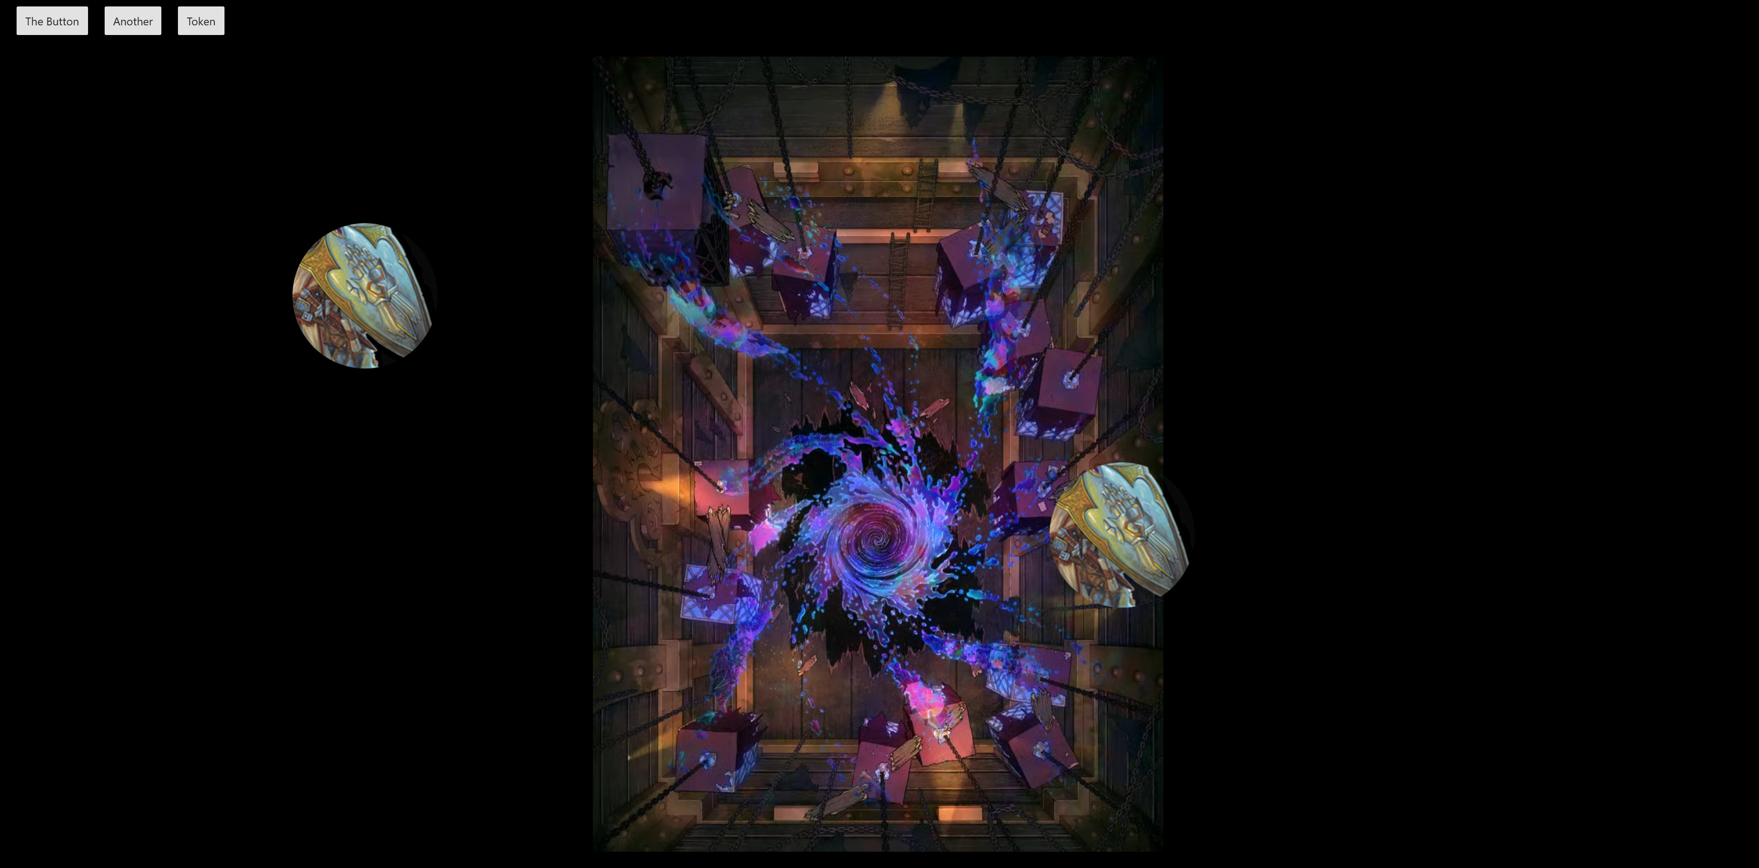

The image above is a screenshot of the web application at this point in development. The application has implemented panning and zooming functionality, movable objects, resizing the canvas based on window size, deleting selectable objects, and a simple toolbar with buttons that add a battle map image that cannot be manipulated, a button to create a default shape like a circle, and a button that creates a Token that is the child of the FabricImage class in the fabric.js library. However, the functionality of the battle map and token features are not complete enough for unit testing.

# Interaction Report

Interaction Type: Librarian

Interaction Date: 7/15/25

Attendees: Jasper Yeung

## Summary of Interaction

During the meeting, the project was discussed with Je in regards to the overall project goals and the current progress. I listed the resources I already found for TTRPG domain sources, search methods used, and tool documentation found. Je recommended sources and databases such public APIs from GitHub and O’Reilly. Because the project is a web application, many sources for web design were given and usability testing. Finally, since this project’s domain is related to games, some game related sources were provided such as player experience benchmarks.

## Action Items

* Look at the web design sources after the project functionality is mostly complete.
* Look at possible public APIs that may be useful for the project.

## Reflection on the Interaction

The information gained from this meeting is likely not be immediately used until it is required. Unfortunately, the player benchmarks provided would have been useful for the stakeholder interview, but the interview was already conducted. Furthermore, my prior research into tools and sources has already yielded the core sources and tools that I need to complete my project. However, the new sources and databases will be useful when new issues arise or once developments needs change to require new tools and information. Especially useful will be the web design sources which will absolutely need to be used to make an intuitive web application.

Interaction Type: Expert

Interaction Date: 7/17/25

Attendees: Jasper Yeung

## Summary of Interaction

During the meeting, the various design artifacts were shown to an expert John Yeung who has had experience with web application development. He gave feedback on clarifications needed for the design document including devices the software will run on, language and localization considerations, and using GitHub as release management and source control. John also recommended further tools to use including DevOps services like Azure DevOps and Jira, device simulations for browser applications, and Visio for professional prototype mockups. Additionally, lots of feedback was given regarding testing such as clarifying that system testing should be functional testing instead, having integration tests including connecting to API calls like OneDrive, and build verification testing.

## Action Items

* Learn how to use Azure DevOps.
* Learn to use testing frameworks and test environments.
* Add project goals with device and localization considerations.
* Create a mockup prototype of what the project will look like.

## Reflection on the Interaction

This meeting was extremely valuable to gain professional feedback about what the design specification document lacked, what tools should be used, and especially about my testing plans. The design specification feedback was generally able to get the idea of the project across but had some sections that needed improvements and clarifications. The testing especially needs a lot of more planning and time needed to learn how to create better test plans. The tools including the testing tools are especially valuable for me to take the time to learn which will not only help with the project’s development but is also useful for future jobs.