Individual Weekly Report for Jasper Yeung

A Virtual Tabletop for Game Masters to Create Immersive Experience

August 2, 2025

# Accomplishments

* Completed implementing the grid functionality that allows for custom grid layouts, shape and token snapping, and resizing all current elements on the Battle Map.
* Implemented the basic context menu interface that only triggers when Tokens are selected.
* Implemented context menu display options including offsetting the Token image and displaying the Token’s name.
* Implemented the display options of the context menu to reflect the current values of the Token being selected.
* Implemented the display options to function when selecting a single Token or multiple Tokens.
* Implemented the function of allowing user to delete selected Tokens from the context menu.

# Weekly Activities

| Activity / Task / Work | Hours | Status |
| --- | --- | --- |
| Battle Map and Token Implementation | 19.8 | In progress |
| Instructor Meeting | 0.2 | Complete |
| Status Report | 1.5 | Complete |
| **Weekly Total** | **21.5** |  |
| Previous Weekly Cumulative Total (Carry Over) | 104 |
| **Current Cumulative Total** | **125.5** |

# Plans for Next Week

| Activity / Task / Work | Est Hours |
| --- | --- |
| Battle Map and Token Implementation | 14.5 |
| Showcase Slides | 1.5 |
| Meeting | 2.5 |
| Weekly Status Report | 1.5 |

# Response to Feedback

**Professor Dawn-Marie Oliver:** You are missing a signature on the capstone contract.

Thank you for pointing that out. I didn’t notice that I should have signed it even if that section was not applicable for me. I also noticed that I missed writing my phone number and date at the bottom of the contract so I will make these changes.

# Other Reflections

Yes, this week’s work has been extremely helpful for the project’s progress. This week was almost entirely implemented. The implementation is starting to require more UI with the current feature being worked on being the context menu. That is why I have begun using Chakra UI for easy to use and style UI components. I have only been using Chakra UI since this week, but I believe I have enough knowledge to simply pick and choose from the documentation what I need instead of looking at starting tutorials. The competency of learning by doing is clearly being shown which is a useful skill for my future career.

In terms of revelations, I believe a significant one is that my original class and component diagram have been followed loosely since the implementation of the project. I did not know Fabric.js, TypeScript, and React very in depth during the creation of those diagrams and because of that, some of the classes could not be implemented as originally designed. Instead, I have new classes such as ContextMenuManager and function components like Board. However, that is not to say that my original design was not helpful. The basic hierarchy of the diagram is still being preserved and is simply being modified or added onto in order to better adapt to the development context.

# Comments, Issues, Notes, Anything Else?

N/A

# Evidence of Work

**Token Context Menu**

New functionality has been added to the Token feature primarily through a unique context menu that controls offsetting the Token image and displaying names. This context menu is able to function with multiple or a single Token selected.

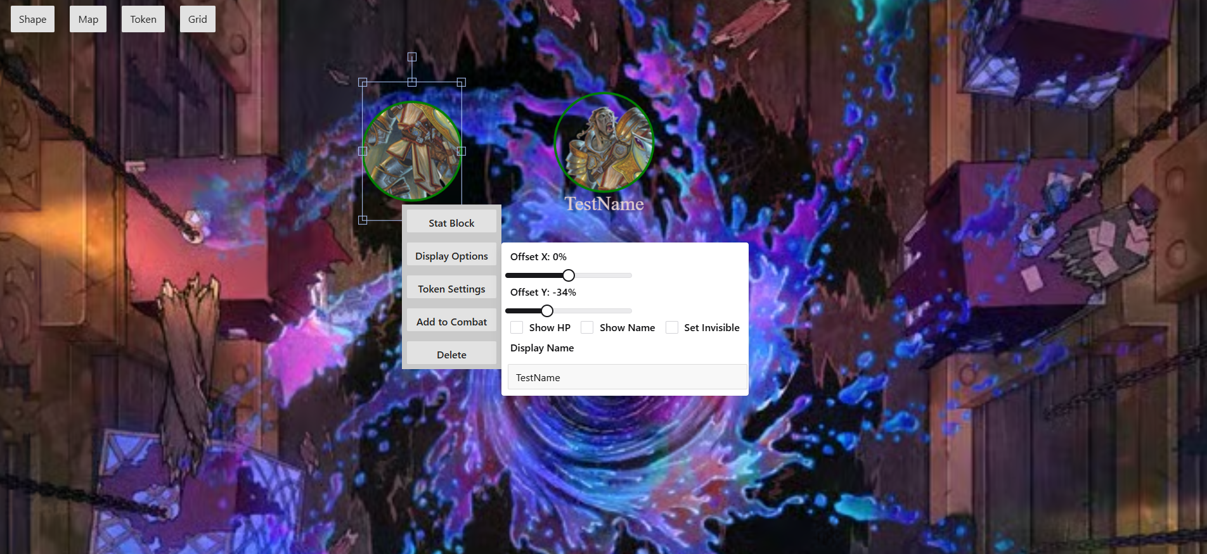

**Grid Functionality**

Grid functionality has been completed for the Battle Map and Tokens. Tokens and shapes snap to grid rectangles appropriately given their size multipliers. They can center onto the intersection of four rectangles or the center of a rectangle depending on their size multiplier. Tokens and shapes also resize automatically if the grid is also resized.

# Interaction Report

Interaction Type: Instructor

Interaction Date: 7/30/25

Attendees: Jasper Yeung

## Summary of Interaction

During the meeting, the current progress of the project was discussed and the work being done since the previous week. The previous week had less overall time for the project’s implementation and focused more on the required class assignments and documentation. The current week’s progress was discussed with the grid, snapping, and resizing functionality discussed. In terms of questions asked to Professor Dawn-Marie Oliver, one was when the feedback for the Capstone Contract draft would be given. The professor reviewed the draft during the meeting and noticed missing signatures but otherwise there were no other problems. The second question was what the latest code review could be conducted to which the professor answered before the Friday of week nine.

## Action Items

* Provide signatures for the capstone contract and submit the final draft.
* Conduct a code review before the given deadline.
* Continue with the implementation of the project.

## Reflection on the Interaction

The main change made after the meeting was planned for the end of the quarter. So far, I have not made in-depth testing plans, and the current development speed is not as fast as my initial schedule indicated. On week nine of the quarter, I will need to perform a code review which will likely be on the weekend between week 8 and 9 due to the expert’s schedule. This will provide enough time for the code review for the expert, myself for additional development time with testing and code organization, and the professor for checking off the completion of the code review.