Thread Message Queue Project

Answer Document

Design

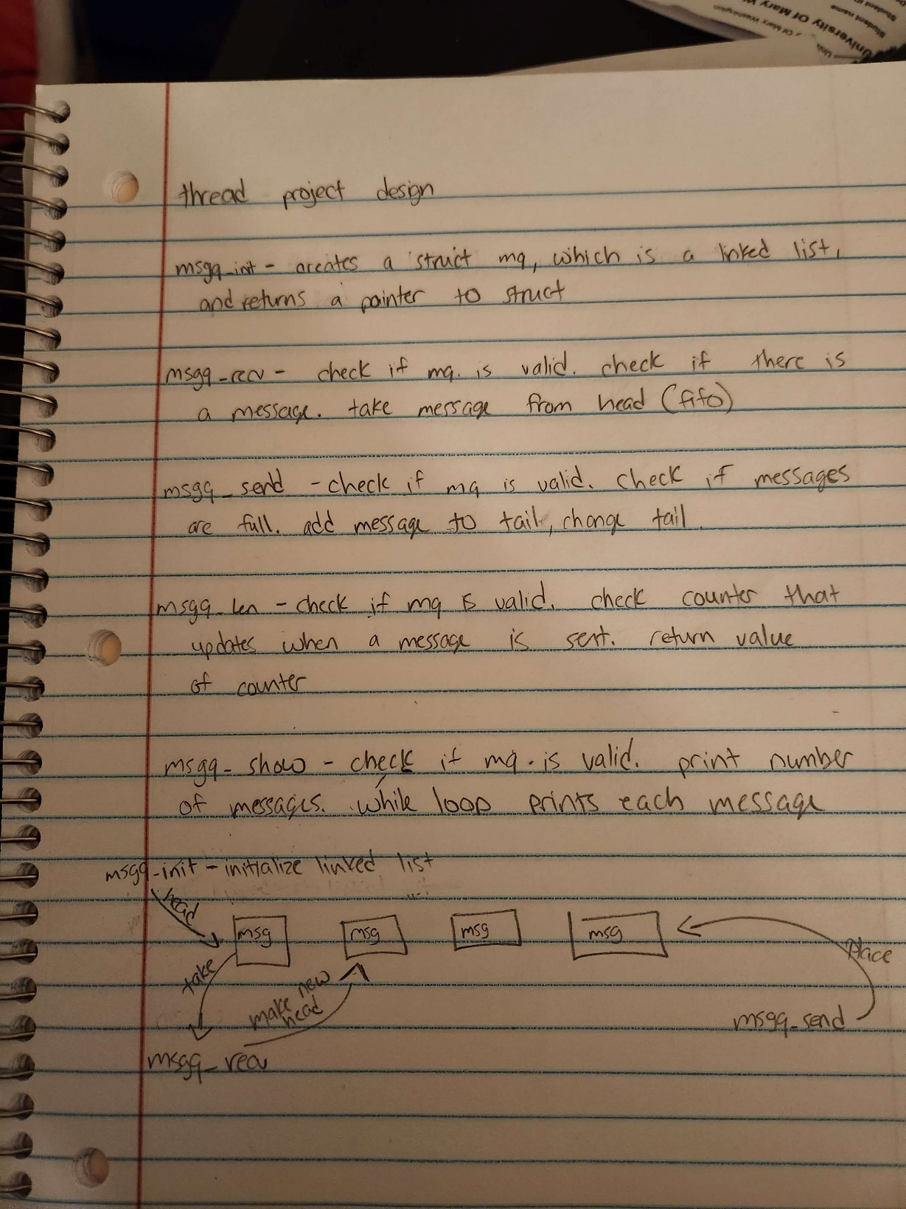.

Testing

* Place screenshots of your testing here.

Message array with 50 messages and 2 producers 3 consumers.

#define MSGQLEN 100

#define ARRAYLEN 100

#define DEFMESSAGES 50

#define DEFPRODUCERS 2

#define DEFCONSUMERS 3

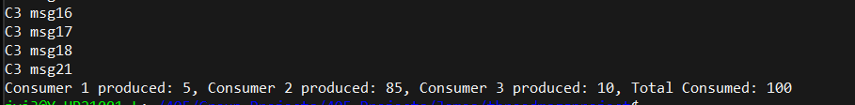

Message array with 75 messages and 2 producers 3 consumers.

#define MSGQLEN 150

#define ARRAYLEN 150

#define DEFMESSAGES 75

#define DEFPRODUCERS 2

#define DEFCONSUMERS 3

Message array with 100 messages and 2 producers 3 consumers.

#define MSGQLEN 200

#define ARRAYLEN 200

#define DEFMESSAGES 100

#define DEFPRODUCERS 2

#define DEFCONSUMERS 3

