ECONOCAUSAL

Dynamic Pricing with
Double Machine Learning
Implementation Report: Promotion Treatment Effects,
Uplift Curves, and Qini-Style Comparison

1. Executive Summary
This report documents the work completed to generate and compare estimated treatment effects for two promotional treatments—display exposure and mailer exposure—within the EconoCausal project. The notebook uses saved individual treatment-effect (ITE) estimates and observed sales outcomes to create cumulative Qini-style gain curves.
The display and mailer curves were both generated and saved as CSV data and PNG plots. A combined comparison plot was also created. In the displayed comparison, the mailer curve rises substantially higher than the display curve, while the display curve peaks early and later becomes negative. These are exploratory patterns, not conclusive evidence that mailer promotion is causally superior.

2. Project Objective
The objective of this implementation stage was to use the estimated treatment effects from the promotion models to assess how effectively observations can be ranked by predicted response to a promotion. The immediate deliverable was a set of uplift/Qini-style curves for display and mailer exposure, plus a visual comparison of the two.
The analysis is related to causal treatment-effect modeling rather than ordinary prediction alone: the aim is to estimate how an outcome may differ under treatment versus control, and then rank observations by their estimated treatment effect.

3. Data and Existing Model Outputs
The workflow used cleaned transaction and promotion data and pre-existing notebook model outputs. The two treatment-effect result structures used in the notebook were:
- Display ITE results: display_exposed, SALES_VALUE, and estimated_display_effect, with product/store/week identifiers also present in the saved output.
- Mailer ITE results: PRODUCT_ID, STORE_ID, WEEK_NO, mailer_exposed, and estimated_mailer_ite.
- Transaction outcomes were matched to mailer predictions using PRODUCT_ID, STORE_ID, and WEEK_NO to recover SALES_VALUE for the mailer curve.
The original model used EconML's CausalForestDML. During Kaggle execution, the package was initially unavailable and installation failed because the notebook environment could not resolve pypi.org. The workflow was then continued using existing saved ITE outputs, avoiding the need to retrain the model in that session.

4. Implementation Steps Completed
- Notebook and data setup: Configured dataset paths and loaded the cleaned transaction and promotion datasets in the notebook environment.
- Existing ITE outputs: Used saved model estimates for display and mailer treatments rather than rerunning the causal forest model during the network issue.
- Display Qini-style curve: Ranked records by estimated_display_effect in descending order and computed cumulative adjusted outcome gain using observed SALES_VALUE and display_exposed.
- Mailer outcome recovery: The mailer prediction table initially did not include SALES_VALUE. The transaction outcome was joined back to mailer predictions using PRODUCT_ID, STORE_ID, and WEEK_NO.
- Mailer Qini-style curve: Applied the same general cumulative gain procedure to mailer_exposed, SALES_VALUE, and estimated_mailer_ite.
- Combined comparison: Loaded the saved display and mailer curve CSVs and plotted both curves on the same axes.
- Output saving: Saved curve point data as CSV and figures as PNG files under outputs/model_training.

5. Method Used for the Qini-Style Curves
For each promotion, observations were sorted from the highest to lowest estimated treatment effect. At each position in this ranking, cumulative sales among treated observations and cumulative sales among control observations were calculated. The control cumulative outcome was scaled by the ratio of treated to control observations, and the difference was plotted against the fraction of observations targeted.
The implemented gain calculation can be summarized as:
Gain(k) = Cumulative treated outcome(k) − Cumulative control outcome(k) × (Nₜ / N꜀)
This implementation is best described as a Qini-style cumulative gain curve. It should not be treated as a validated standard Qini score without confirming the chosen Qini definition, evaluation design, and any required normalization. The code also calculated an exploratory area summary, but that value is not a formally validated Qini coefficient.

6. Generated Output Files
Output | Format | Purpose
display_qini_curve.csv | CSV | Fraction targeted and cumulative Qini-style gain for display.
display_qini_curve.png | PNG | Individual display curve visualization.
mailer_qini_curve.csv | CSV | Fraction targeted and cumulative Qini-style gain for mailer.
mailer_qini_curve.png | PNG | Individual mailer curve visualization.
display_vs_mailer_qini.png | PNG | Combined comparison of display and mailer curves.
The notebook output listing confirmed the presence of all four individual curve files. The combined comparison plot was also displayed and saved to the Kaggle working output directory.

7. Results and Visual Interpretation
In the combined plot, the mailer curve rises rapidly and reaches a peak of approximately 31,000 cumulative adjusted sales gain around one-third of the observations targeted. It remains positive throughout the plotted range, then declines toward the end.
The display curve rises to approximately 2,500 early in the ranking, fluctuates near zero, and then declines below zero after around half of the observations are targeted. It ends at approximately −15,000 on the displayed y-axis.
These values are visual approximations read from the supplied chart, not exact statistics computed from the CSVs. The plot suggests that, under the current ranking and gain calculation, mailer has a larger cumulative gain than display. However, differences in sample composition, treatment/control ratios, outcome matching, model specification, or evaluation data can produce differences in curve scale. The graph alone does not establish that mailer causes higher sales.
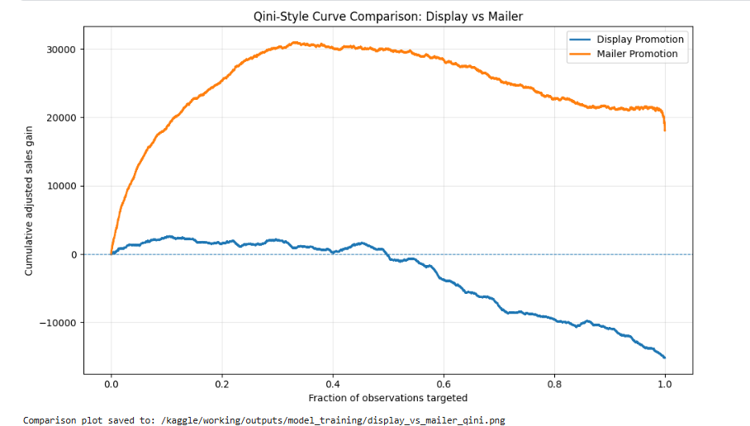
Figure 1. Combined Qini-style curve comparison generated in the notebook.

8. Interpretation and Limitations
- Training-sample evaluation: the available ITE estimates were generated by models trained on the same sample or workflow. Curves evaluated on training observations can overstate ranking performance.
- Not a definitive promotion ranking: display and mailer estimates may differ in their evaluation populations, treatment definitions, treatment/control proportions, and outcome construction.
- Outcome matching: mailer SALES_VALUE was attached using product/store/week keys. The join must reflect the same aggregation level and target definition used by the model; duplicate or mismatched keys can distort results.
- Qini terminology: the implemented method is a Qini-style cumulative gain calculation. A formal Qini evaluation should use a clearly specified standard definition and evaluation protocol.
- No uncertainty estimates: the plotted curves do not provide confidence intervals or statistical significance tests.
- No causal guarantee: causal interpretation depends on appropriate confounder adjustment, treatment assignment assumptions, model specification, and data quality.

9. Recommended Next Steps
- Create a held-out evaluation dataset and generate predictions for observations not used to train the causal models.
- Evaluate both promotions on a consistent and clearly defined population, with comparable outcome units and documented treatment indicators.
- Confirm the mailer outcome merge is one-to-one or many-to-one as expected, and report the number of unmatched rows.
- Select and document a standard Qini/uplift evaluation formula, including how ties, treatment/control imbalance, and baseline/reference curves are handled.
- Calculate a formal Qini score or area metric from the validated evaluation curve, and consider bootstrap confidence intervals.
- Preserve the individual CSVs, PNG plots, notebook, data preparation details, and environment/package information for reproducibility.

10. Conclusion
The implementation successfully produced individual Qini-style curves for display and mailer exposure and a combined comparison visualization. The observed plot shows a much larger positive cumulative gain for mailer than for display under the current calculation. This is a useful exploratory result for the EconoCausal project, but it should be presented as preliminary until the evaluation is repeated on held-out data using a consistent and formally defined Qini methodology.

