**Generative Adversarial Network (GAN) Architecture**

**Adversarial Process in GAN Training**

A GAN consists of two neural networks—the **Generator (G)** and the **Discriminator (D)**—that compete in a **minimax game** (a two-player zero-sum game). The process is adversarial because:

1. **Generator (G):**
   * **Goal:** Generates fake data (e.g., images) that resembles real training data.
   * **Improvement:** Learns to produce increasingly realistic samples by fooling the discriminator.
   * **Input:** Random noise (latent vector *z*).
   * **Output:** Fake data (*G(z)*).
2. **Discriminator (D):**
   * **Goal:** Distinguishes between real data (from training set) and fake data (from generator).
   * **Improvement:** Gets better at detecting fake samples, forcing the generator to improve.
   * **Input:** Real data (*x*) or fake data (*G(z)*).
   * **Output:** Probability (0 to 1) indicating whether the input is real or fake.

**Competition Dynamics**

* The **generator** tries to **minimize** the discriminator’s ability to detect fakes.
* The **discriminator** tries to **maximize** its accuracy in classifying real vs. fake.
* This leads to an **equilibrium** where the generator produces highly realistic data, and the discriminator can no longer distinguish real from fake (outputs 0.5 probability, meaning it is guessing randomly).

**GAN Training Objective**

The adversarial process is formalized as a **minimax game** with the following value function *V(G,D)*:

min⁡Gmax⁡DV(D,G)=Ex∼pdata(x)[log⁡D(x)]+Ez∼pz(z)[log⁡(1−D(G(z)))]*G*min​*D*max​*V*(*D*,*G*)=E*x*∼*pdata*​(*x*)​[log*D*(*x*)]+E*z*∼*pz*​(*z*)​[log(1−*D*(*G*(*z*)))]

* **Discriminator (D)** maximizes:
  + log⁡D(x)log*D*(*x*) (correctly classify real data as real).
  + log⁡(1−D(G(z)))log(1−*D*(*G*(*z*))) (correctly classify fake data as fake).
* **Generator (G)** minimizes:
  + log⁡(1−D(G(z)))log(1−*D*(*G*(*z*))) (fool D into classifying fakes as real).
* **GAN Architecture Diagram**
* Here’s a simplified representation of GAN data flow:

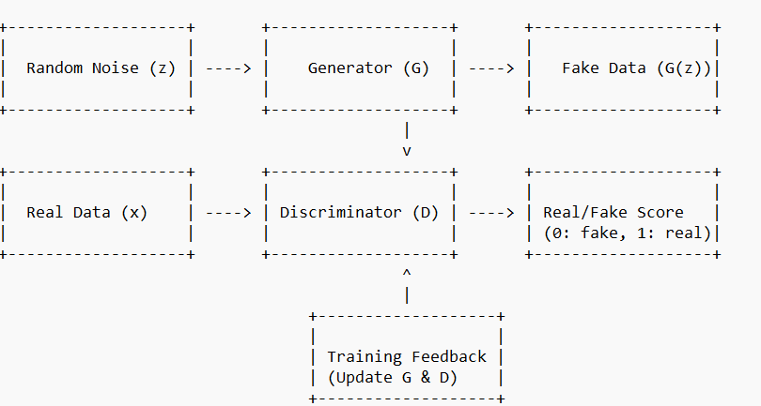

**Key Components:**

1. **Generator (G):**
   * Takes random noise *z* as input.
   * Outputs synthetic data *G(z)*.
   * Trained to maximize *D(G(z))* (fool D).
2. **Discriminator (D):**
   * Takes either real data (*x*) or fake data (*G(z)*).
   * Outputs a probability (0 = fake, 1 = real).
   * Trained to maximize classification accuracy.
3. **Training Loop:**
   * Alternates between updating **D** (to improve detection) and **G** (to improve generation).
   * Ideally, G becomes so good that D cannot distinguish real from fake (D outputs 0.5).

**Conclusion**

GANs rely on **adversarial training**, where the generator and discriminator improve iteratively through competition. The generator learns to produce realistic data, while the discriminator becomes a better critic, leading to high-quality synthetic samples.