Padlet in the Classroom: An Open Teacher's Toolkit
Oct 15, 2026 · Jyoshna Reddy Annapureddy · Licensed CC BY 4.0
This toolkit gives any teacher six ready-to-run Padlet activities, a setup guide and a safety checklist. It is free to use, adapt and share under a Creative Commons licence.

About this resource
Who it is for: school teachers (Grades 6–12), teacher educators and student teachers who want to use Padlet for more than collecting feedback.
What it grew from: a peer presentation on Padlet in the MA Education and Technology programme at TISS. The activities answer what 11 peers asked for in their feedback: exit tickets, student work examples, other formats and features, uses for teacher trainers, McLuhan's Tetrad and limitations.
Licence: Creative Commons Attribution 4.0 International (CC BY 4.0). You may copy, adapt and share it, including commercially, as long as you credit the author.
Suggested credit: "Padlet in the Classroom: An Open Teacher's Toolkit" by Jyoshna Reddy Annapureddy, licensed under CC BY 4.0.

How it meets the renewable assessment criteria
Criterion | How this toolkit meets it
Useful after the class | Teachers can run any activity tomorrow; each one has a prompt, steps, an assessment idea and accessibility notes
Publicly available | Published openly online (see Reuse, remix and contribute) so anyone can find it without a login
Openly licensed | CC BY 4.0, so others can adapt it for their subject, grade or language and republish it

Padlet quick start
A Padlet is a shared online board; learners add posts to it and the teacher controls who can post and what appears.
Term | What it means
Padlet (board) | A shared online board where a group posts and organizes ideas
Post | One contribution: text, link, image, video, audio, drawing, file or poll
Format | The board's layout: Wall, Grid, Stream, Columns, Timeline, Map or Canvas
Section / column | A heading that groups related posts, e.g. one column per topic or group
Reactions | Like, vote, star or grade a post
Comments | Threaded replies under a post, used for peer feedback
Moderation | The owner approves posts before they appear

Set up a board in five steps
- Create a board and choose the format that fits the activity (see the activity cards below).
- Write the prompt as the board title and add a pinned post with instructions and an example.
- Set permissions: who can post, whether names show, whether comments and reactions are on, and whether posts need approval.
- Share the link or QR code; test it from a student device first.
- Close the loop: discuss themes in class, then export the board (PDF, image or CSV) as a record.
Padlet's features and free-plan limits change often; check the Padlet Help Centre before planning a large rollout.

Six ready-to-use activities
Each card works in any subject; swap the example prompt for your own topic.
# | Activity | Best for | Format | Time
1 | Three-column exit ticket | Formative check at the end of a lesson | Columns | 5 min
2 | I see, I think, I wonder | Reflection on an artefact or experiment | Columns | 15 min
3 | KWL launch board | Prior knowledge before a unit | Columns | 10 min
4 | Student work gallery | Peer review and improvement | Grid | 1–2 lessons
5 | Debug wall (Computer Science) | Learning from errors in code | Wall | 20 min
6 | Share-a-practice wall | Teacher training and PD | Grid or Map | 30 min

1. Three-column exit ticket
- Prompt: "One thing I learned · One thing I'm unsure about · A question for next class"
- Steps: students add one post per column in the last 5 minutes; posts can be anonymous to the class but visible to the teacher.
- Assessment: scan the "unsure" column to plan a 5-minute recap; use the Grade reaction or a short comment to acknowledge strong answers.
- Accessibility: allow audio posts and sentence starters ("Today I learned that…").

2. I see, I think, I wonder
- Prompt: pin a video, image or experiment; students respond in three columns: I see (observations), I think (explanations), I wonder (new questions).
- Steps: keep one board per unit and add a column each month so students build a record of learning over time.
- Assessment: look for movement from description (see) to explanation (think); use the wonder column to plan inquiry.
- Accessibility: audio reflections suit language learners; allow home languages and offer a script to scaffold.

3. KWL launch board
- Prompt: "What I Know · What I Want to know · What I Learned"
- Steps: fill K and W at the start of a unit; return to L at the end and connect it to a W post with a comment.
- Assessment: compare K and L posts to show growth; W posts reveal misconceptions to address.
- Accessibility: let students react (vote) to a peer's post if writing is a barrier.

4. Student work gallery
- Prompt: "Post your draft with one line on what you want feedback on."
- Steps:
  - Each student posts work (image, short screen recording or file).
  - Peers comment on at least two posts using two stars and a wish.
  - Students reply to comments and post an improved version.
  - The teacher picks examples to discuss in class.
- Assessment: grade the improved version and the quality of feedback given.
- Accessibility: turn on moderation; agree feedback norms before posting.

5. Debug wall (Computer Science)
- Prompt: "Post a screenshot of an error you met this week, what caused it and how you fixed it."
- Steps: students post a screenshot plus three lines: error, cause, fix; peers star posts that helped them.
- Assessment: check whether the cause is explained, not just the fix; recurring errors become a class mini-lesson.
- Accessibility: accept a typed error message where screenshots are hard; a class glossary post defines key terms.

6. Share-a-practice wall (teacher training)
- Prompt: "Share one strategy that worked in your classroom this month: what, for whom, and evidence it worked."
- Steps: participants post before the workshop; the facilitator groups posts into sections and uses them to open the session. Map format works for teachers across schools or regions.
- Assessment: participants comment on one strategy they will try and report back next session.
- Accessibility: allow a 1-minute video or audio post instead of writing.

From posting to meaningful collaboration
A board full of posts is not yet learning; five design moves turn posting into collaboration.
- Purposeful prompt — ask for reasoning or evidence, not just an answer.
- Build on a peer — each learner replies to one post and adds a new idea.
- Structure the board — sections or columns keep ideas organized and readable.
- Safe space — agree norms, moderate posts and allow anonymity with care.
- Close the loop — the teacher synthesises themes in class and learners reflect on what changed.

Safety, privacy and accessibility checklist
Run this checklist before sharing any board with students.
- ☐ Board privacy set to secret or password rather than public
- ☐ Students do not post full names, photos of faces or personal details
- ☐ Use matches your school's data and age policies (and parental consent where needed)
- ☐ Moderation (post approval) and the profanity filter are on for younger classes
- ☐ Class norms for posting and commenting agreed and pinned on the board
- ☐ Anonymous posting decided deliberately, with a plan for misuse
- ☐ Audio, video or typed options offered so every learner can contribute
- ☐ Board kept short or split into sections so screen-reader users can navigate it
- ☐ Low-bandwidth or offline alternative ready (paper slips, then photograph them)
- ☐ Board exported or archived at the end of the unit

Critical lens: McLuhan's Tetrad and limitations
Padlet amplifies participation, but its value depends on the learning design around it, not the tool alone.
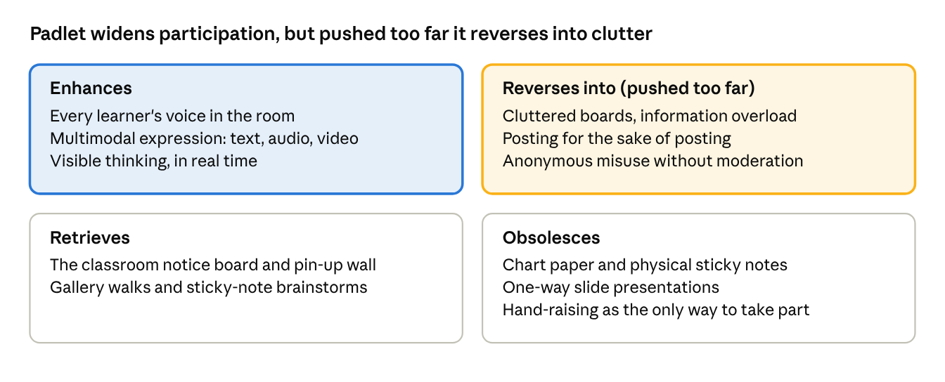
Padlet through McLuhan's Tetrad · 4 laws of media
Top row: what Padlet adds (blue) and what overuse turns it into (amber). Bottom row: what it revives and what it replaces.
Limitation | What to do about it
Needs internet, devices and digital readiness | Keep a paper fallback; pair students on shared devices
Free plan limits the number of boards | Reuse boards by clearing or archiving them; check school licences
Large groups create cluttered boards | Use sections, cap posts per student, split into group boards
Posts stay shallow without a clear prompt | Ask for reasoning or evidence; require a reply to a peer
Anonymous posts can be misused | Turn on moderation; anonymity visible to the teacher only
Privacy and age rules vary by school | Check policy and consent before use; no personal details in posts
Hard to judge individual depth of learning | Pair the board with a short individual reflection or conversation
Long walls are hard for screen-reader users | Keep boards short, use Stream or Columns, add alt text to images

Reuse, remix and contribute
Anyone may copy and adapt this toolkit; the only condition is credit to the author under CC BY 4.0.
Where it is published:
- This document, shared publicly as a web link
- A public GitHub repository holding the toolkit as Markdown, so others can suggest changes
- OER Commons, tagged Padlet, formative assessment, collaborative learning, Grades 6–12
- A public Padlet with the six activity boards as templates others can remix
Ways to adapt it: translate the prompts into another language, swap examples for your subject, or add an activity card in the same format (prompt, steps, assessment, accessibility).
To contribute: open an issue or pull request on the GitHub repository, or comment on this document. Contributions are released under the same CC BY 4.0 licence.

References and attribution
- McLuhan, M., & McLuhan, E. (1988). Laws of media: The new science. University of Toronto Press.
- Ritchhart, R., Church, M., & Morrison, K. (2011). Making thinking visible. Jossey-Bass. (Source of the See, Think, Wonder routine.)
- Ogle, D. M. (1986). K-W-L: A teaching model that develops active reading of expository text. The Reading Teacher, 39(6), 564–570.
- Wiley, D., & Hilton, J. (2018). Defining OER-enabled pedagogy. International Review of Research in Open and Distributed Learning, 19(4).
- Padlet and the Padlet Help Centre, for features and settings.
- Creative Commons Attribution 4.0 International.
- Peer feedback from the 2026 ETE presentations, MA Education and Technology, TISS.
Padlet is a trademark of Wallwisher, Inc.; this toolkit is independent and not endorsed by Padlet.

